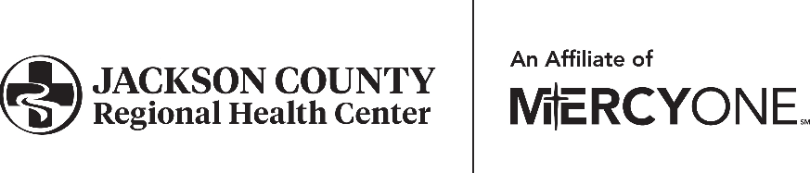

Human Resources Department

601 Hospital Dr • Maquoketa, IA 52060

P: 563.652.4015 • F: 563.652.4018

GHS_jcrhchr@mercyone.org

**STUDENT INFORMATION SHEET**

**PLEASE PRINT**

Name: Date of Birth: Age:

Address: City, Zip: County:

Phone: Email:

High School: Grade: Contact:

Please check one: Individual Under 18 years of age Individual 18 years of age and over

Optional

Race: Caucasian African American Native American Hispanic

Asian Other

Gender: Female Male

**EMERGENCY NOTIFICATION:**

Name: Relationship: Phone:

**DEPARTMENT INFORMATION:**

Indicate the department you will be shadowing in, the expected dates of the shadowing and contact level.

Observation Only

Department

Patient Contact

Dates of Shadowing

**I hereby certify that all of the information I have given on this Information Sheet is true and accurate to the best of my knowledge.**

Student Signature Date