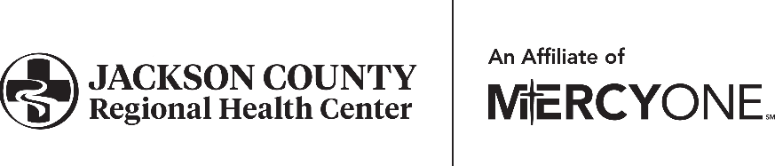

Human Resources Department

601 Hospital Drive • Maquoketa, IA 52060

P: 563.652.4015 • F: 563.652.4018

GHS_jcrhchr@merceyon.org

**AFFIRMATION & RELEASE OF LIABILITY**

**STUDENT 18 YEARS OF AGE OR OLDER**

I, , hereby acknowledge that I am cognizant of and understand that there are inherent dangers in my participating in the Jackson County Regional Health Center (JCRHC) Student Program, which include, but are not limited to, my encountering experiences which may be relatively new and may be taxing on my senses and being exposed to an environment that has sick and injured patients.

In consideration of my being allowed to participate in this program, I, on behalf of myself, my personal representatives, heirs, spouse, parents, siblings and children hereby:

1. Assume all risk of injury, death or property damage in connection with any of the above mentioned activities, situations and my presence at Jackson County Regional Health Center.
2. Release, waive, discharge, and covenant not to sue Jackson County Regional Health Center, its administration, board of directors, employees, and agents (referred to as the Released Parties) from any and all liability related to my participation in the JCRHC Student Program.
3. Agree to indemnify, save and hold harmless the Released Parties, and each of them, from any loss, liability, damage or cost (including, but not limited to, reasonable attorneys’ fees and other defense costs incurred) one or more of them may incur arising out of or related to my participation in the JCRHC Student Program.
4. Agree that this Affirmation and Release of Liability extends to all claims of wrongful acts of the Released Parties, whether sounding in tort, contract or other legal theory, and that this Affirmation and Release of Liability is intended to be as broad in scope as is permitted by the laws of the State of Iowa. I further agree that in the event that any portion of this Affirmation and Release of Liability is held invalid, the remaining provision shall, notwithstanding, continue in full legal force and effect to the greatest extent possible under Iowa law.

I hereby give my consent to Jackson County Regional Health Center, its physicians, staff, employees and volunteers to obtain medical care from any licensed physician, hospital or clinic, including transportation and emergency medical services, for me for any injury arising from my participation in the JCRHC Student Program. I understand that I am financially responsible for all charges for any such medical care.

I further state that I am at least eighteen (18) years of age and that I am competent to sign and have read this Affirmation and Release of Liability form and understand its terms. I understand that the terms of this Affirmation and Release of Liability are contractual and not a mere recital; and that I have signed this document freely and voluntarily without any inducement, assurance or guarantee being made to me and I intend my signature to be a complete and unconditional release of all liability to the greatest extent allowed by Iowa law.

Print Name

Parent’s Signature Date