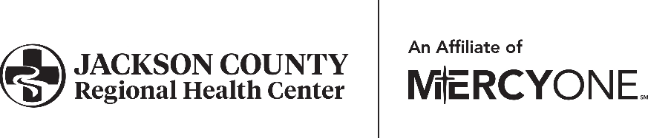

Human Resources Department

601 Hospital Dr. • Maquoketa, IA 52060

P: 563.652.4015 • F: 563.652.4018

GHS_jcrhchr@mercyone.org

**UNDERSTANDING OF HEALTH CARE CONFIDENTIALITY**

**REQUIRED BY IOWA & US FEDERAL LAW AND JCRHC**

**As a participant in the Student Program at Jackson County Regional Health Center, I, the undersigned, hereby acknowledge** that I have the responsibility for maintaining strict confidentiality of information shared with me or acquired by me as a part of my a student program and access at JCRHC. Anything that I learn while participating in the program that relates to patients, patient information, computer passwords, confidential information about an employee, physician, or management and any and all financial information regarding JCRHC is for my authorized use only while I am participating in the student program. I understand that such information may be discussed only as needed to perform the duties and responsibilities, if any, of the student program.

**I understand that I may not disseminate, convey, send, transmit, post or otherwise transfer** anything that I learn in the course of my participation as a student in the student program that involves any patient information, computer passwords, confidential information about an employee, physician, volunteer, other student in the shadow program or management and any and all financial information regarding JCRHC to anyone by any means, including, but not limited to, text messaging, instant messaging, email, cell phone, any social media (Facebook, MySpace, Twitter, etc.), whether currently in existence or developed in the future, and whether by words or in photographs.

**In consideration of my participation in the Student Program at JCRHC, I hereby agree, pledge and undertake** that I will not, at any time during my participation in the program with JCRHC, or at any time after my participation ends, access or use personal health information, or reveal or disclose to any persons or entities within or outside of JCRHC, any personal health information except as may be required in the course of my participation and in accordance with all applicable legislation, corporate and departmental laws, rules, regulations or policies governing the release of information.

**If I do not know whether or not I am allowed to discuss, access or use** any information that I have learned as a participant in the student program, I will ask an adult leader in the program before doing so.

**I understand** that my obligations outlined above will continue after my participation in the student program with JCRHC ends and, **I further understand** that my obligations concerning the protection of the confidentiality of personal health information relate to all personal health information, that I have acquired through my participation in the student program with JCRHC or within any of the healthcare facilities owned or managed by Jackson County Regional Health Center.

**I also understand** that unauthorized use or disclosure of confidential information will result in corrective action up to and including, but not limited to termination of participation in the student program with Jackson County Regional Health Center and the imposition of sanctions or fines pursuant to Iowa and Federal laws.

Print Name

Signature Date