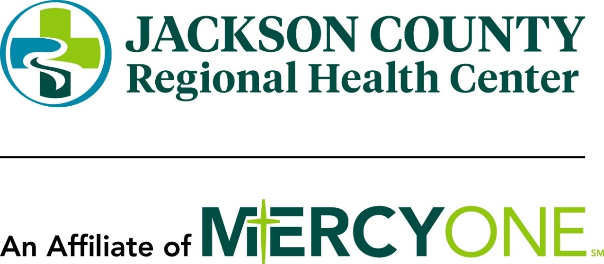

Community Health Needs Assessment and Implementation Plan
2025-2028

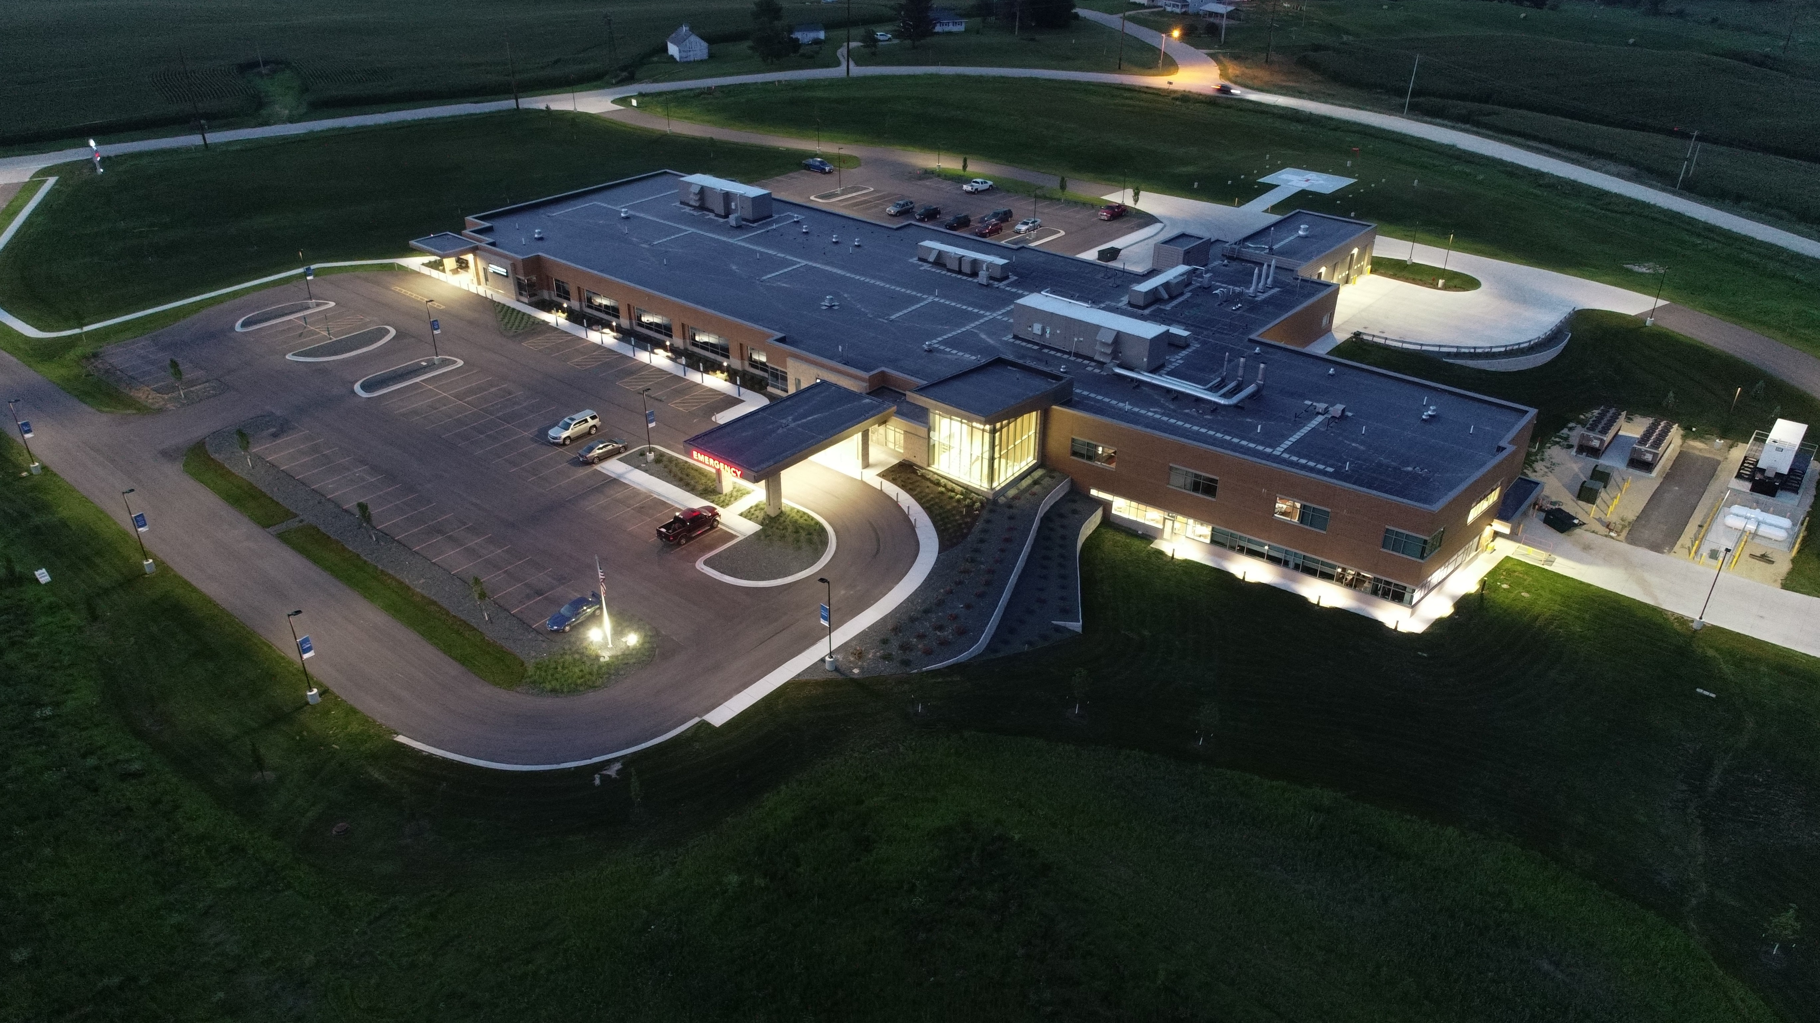

Table of Contents…………………………………………………………………………………………………………………Page 2
Introductions..................................................................................................................................….. Page 3
About Jackson County Regional Health Center……………………………………………………………………….Page 4
Services Offered…………………………………………………………………………………………………………………..Page 5
2025 Community Health Needs Assessment Definition……………………………………………………… Page 6
Approach and Process………………………………………………………………………………………………………… Page 6
Our Communities Demographics…………………………………………………………………………………….Page 7 & 8
Data Results……………………………………………………….…………………………………………………………. Page 9
Key Themes Identified by Stakeholders……………….…………………………………………………………….. Page 10
Stakeholders Input ………………..………………………………………………………………………………………. Page 11
Priorities…………………………………………………………….……………………………………………………. Page 12 & 13
Strategy and Implementation …………………………………………………………………………………………… Page 14
- Obesity and Physical Activity…………………………………………………………………………… Page 14
- Unintentional Falls & Aging-Related Injury……………….…………………………………… Page 15
- Substance Use & Behavioral Health……………………..……………………………………….. Page 16
- Access to Healthcare …………………………………………………………………………………….. Page 17
Conclusion……………………………………………………………………………………………………………………… Page 18

Introduction
The Patient Protection and Affordable Care Act (ACA) of 2010 established new requirements for nonprofit hospitals recognized as 501(c)(3) organizations. In this provision, non-profit hospitals and health systems are required to conduct a community health needs assessment every three years in order to maintain their tax-exempt status. The assessment requires broad community input and public health expertise. Hospitals must address each of the needs identified in the community health needs assessment and develop an implementation strategy for those they plan to address and focus on. This is an effort to ensure hospital services are in line and consistent with the needs of its community. The needs assessment must be reported on the organization’s Form 990 and the report must be made widely available to the public.
Jackson County Regional Health Center conducted a community health needs assessment from January 2025 to November 2025 to fulfill the requirement set forth in the ACA and to identify and address health needs of our area residents and communities.

Summary of ACA
The Patient Protection and Affordable Care Act (ACA), enacted by Congress in 2010, is landmark legislation designed to reform the U.S. health care system. Its key provisions address the interconnected issues of cost, access, and quality, influencing every individual and entity within our health care landscape. The ACA directly affects providers and public health agencies by introducing new processes, models, and centers aimed at expanding coverage and access while simultaneously reducing costs and enhancing quality. As these reforms take hold, their effects continue to resonate throughout the industry and across the nation.

About Jackson County Regional Health Center
Our Mission
To improve the health of our community by delivering quality individualized care to every patient, every time.
Our Vision
To become the preferred health partner for the greater Jackson County area through the development of a progressive, consumer focused health system.
Our Values
Our Journey in healthcare is to deliver Compassionate care while ensuring Respect and Honesty toward the patients and Community we serve.
Jackson County Regional Health Center is located in Maquoketa, Iowa. The history of Jackson County Regional Health Center begins in May 1950, when Jackson County Public Hospital was constructed. This facility served the rural communities of Jackson County as well as communities in neighboring counties of Clinton, Dubuque, and Jones. As the community need expanded, multiple additions and square footage were added to the facility.
As time went on, the facility’s size and service offerings changed. From 2016-2018, community stakeholders, hospital trustees, administration, hospital employees, and other various interested parties participated in conversations regarding what the future of Jackson County Regional Health Center would look like. In March of 2018, the JCRHC Board of Trustees voted to build a new hospital, suited to fit the ever changing health care landscape in our rural community.
Groundbreaking of the new 71,000 square foot Jackson County Regional Health Center was in June 2019. Construction of the new facility was completed in early 2021, and the new facility officially opened on March 4, 2021. The new hospital facility provides flexibility and efficiency suited to the needs of health care in Jackson County. Patients and visitors enter on the main level, and have access to all services through one main hallway. Stairs or elevators can be used to access the lower level, where administration, cafeteria, and classrooms are located.
Jackson County Regional Health Center recently celebrated the addition of an MRI machine to its facility, offering locally available diagnostic services intended to improve access to care for patients in its service area.
Jackson County Regional Health Center has a professional and supportive staff of over 160 employees who address many aspects of healthcare within our community. Jackson County Regional Health Center is licensed annually by the Iowa State Department of Health. In May 2001 Jackson County Regional Health Center was awarded critical access hospital status. Jackson County Regional Health Center is licensed as a 25-bed critical access hospital and level 4 trauma center that provides high-quality, compassionate care for individuals with a variety of medical needs in its service. It also acts as a central collaborating partner for a multitude of area community based services.
Jackson County Regional Health Center provides the following services:
Hospital Services:
- Cardiac Rehabilitation | - Occupational Therapy
- Cardiopulmonary | - Physical Therapy
- Emergency Department | - Pulmonary Rehabilitation
- Infusion Center | - Radiology
- Inpatient Care | - Speech Therapy
- Laboratory

Specialty Clinic Services:
- Allergy | - Orthopedic
- Cardiology | - Pain Management
- Ear, Nose, & Throat (ENT) | - Podiatry
- Ophthalmology | - Rheumatology

Surgical Services:
- Cataract Surgery | - Pain
- Ear, Nose, & Throat (ENT) | - Podiatry
- Endoscopy | - Orthopedics

Community Services:
- Diabetes Education | - Fitness Center
- Infection Prevention | - Script Assist
- Senior Health Insurance Information Program (SHIIP) | - Jackson County Hospital Foundation/Auxiliary

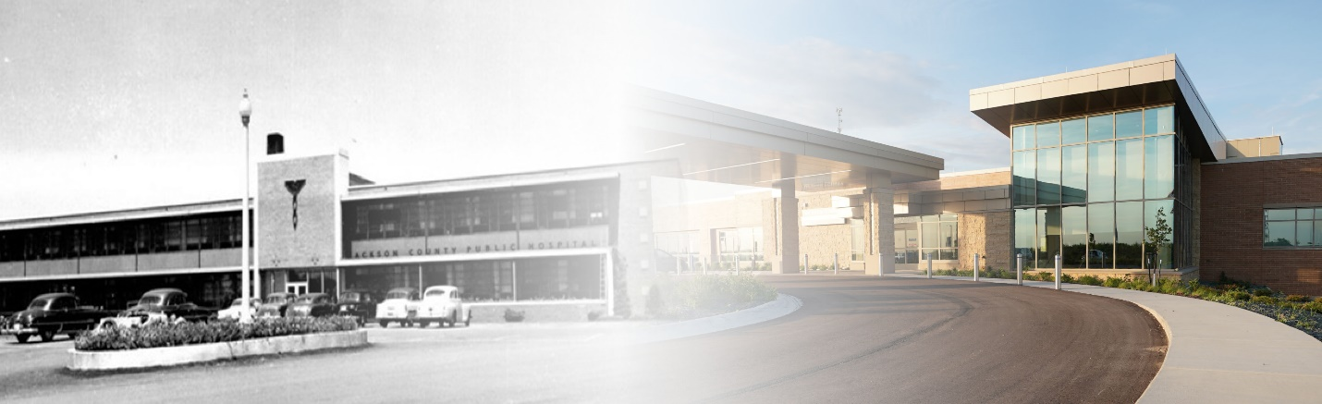

2025 Community Health Needs Assessment
The community health needs assessment was conducted by Jackson County Regional Health Center during calendar year 2025 as required by the Patient Protection and Affordable Care Act (PPACA). Its purpose is to better understand and improve the overall health of our community.
Key Components of the Community Health Needs Assessment include:
- Collaborative Effort
Conducted in partnership with Jackson County Public Health
- Data-Driven Process
Includes a combination of community surveys, public health data, and stakeholder feedback.
- Identifying Priorities
Focuses on the key health and socioeconomic issues affecting Jackson County residents.
- Strategic Planning
Findings are used to develop a targeted implementation plan with coordinated programs and services.
- Ongoing Evaluation
The assessment is evaluated regularly to track progress identify priorities, guide initiatives, track progress, and is designed to adapt to changing community needs.
APPROACH AND PROCESS
JCRHC used a structured, collaborative approach to complete the 2025 Community Health Needs Assessment, incorporating both quantitative data analysis and qualitative input gathered through a series of formal and informal meetings with community partners. The assessment process included reviewing county-level demographic, socioeconomic, and health indicator data, as well as engaging with key stakeholders such as Public Health, EMS, school representatives, behavioral health providers, and community organizations. In January 2025, Jackson County Regional Health Center began work on a comprehensive community health needs assessment. Over the course of several months, numerous members participated in ongoing discussions, cross-sector workgroups, routine coordination meetings, and situational conversations that provided valuable insight into emerging health concerns, service gaps, and opportunities for community collaboration.
These multiple points of contact helped validate and enhance the quantitative findings, allowing the hospital to develop a comprehensive picture of the health needs in Jackson County. Stakeholder themes were gathered from both formal engagements; such as scheduled consultations, planning meetings, and collaborative initiatives and from informal exchanges that occur naturally through daily operations, professional relationships, and shared service delivery. This blended approach enhanced the assessment’s ability to reflect real-time community experience, strengthened alignment with partner organizations, and provided valuable insight into the challenges and strengths of the community. The resulting priority areas and strategic goals were developed using this multi-layered process, ensuring they are grounded in evidence, informed by stakeholder perspectives, and reflective of the hospital’s commitment to improving community health.

Our Community dEMOGRAPHICS
Jackson County Regional Health Center is located in Maquoketa, IA, which is the largest town in Jackson County, Iowa. The following data collection was integrated into the assessment from the Iowa State University Extension and Outreach- Data for Decision Makers. If there is meaningful variance from the state average in category, the state average is listed in parentheses next to the associated data point.
Key Geographic Features:
- Size: Roughly, 650 total square miles (around 636 sq mi land, 14 sq mi water).
- Borders: The Mississippi River forms its eastern boundary, separating it from Illinois; it's also bordered by Dubuque (N), Jones (W), and Clinton (S) Counties in Iowa, and Jo Daviess & Carroll Counties in Illinois.
- Terrain: Part of the unique Driftless Area, known for its unglaciated, hilly landscape.
- Major Waterways: Besides the Mississippi, the Maquoketa River flows through it.
- Highways: US-52, US-61, and US-67 are key routes.
Major Cities & Towns:
- Maquoketa (County Seat)
- Bellevue
- Andrew, Preston, Sabula, Miles
1. Community Description & Demographics
Total Population: 19,485 (2020 Census)
- Population change 2010–2020: -1.83%, (Iowa +4.73%).
Population by Sex (2020):
- Male: 9,750
- Female: 9,735
Population Distribution by Community (2020):
- Maquoketa: 6,128
- Bellevue: 2,363
- Sabula: 506
- Preston: 949

Age Structure (2020):
- Under 18: 21.7%
- Ages 18–24: 6.8%
- Ages 25–44: 21.4%
- Ages 45–64: 28.2%
- Ages 65+: 22.0% (Iowa: 18.0%)
- Median age: 45.2 years (Iowa: 38.6)

Racial Composition (2020):
- White: 94.7% (Iowa 84.5%)
- Black/African American: 0.8%
- Asian: 0.2%
- Two or more races: 2.6%
- Hispanic origin: 1.2%

- Housing & Livability Indicators
Housing Occupancy (2019–2023):
- Total housing units: 9,272
- Vacant units: 10.5% (Iowa 8.6%)
- Owner-occupied: 78.6%
- Renter-occupied: 21.4%

3. Socioeconomic Indicators
Median Household Income:
$71,605 (Iowa: $73,147)
Income Breakdown (2019–2023):
- < $15,000: 8.6%
- $15,000–$34,999: 12.9%
- $50,000–$99,999: 32.9%
- $100,000+: 31.3%
Educational Attainment (age 25+):
- High school graduate or higher: 93.8%
- Bachelor’s degree or higher: 18.4% (Iowa: 30.9%)
Jackson County has significantly fewer college-educated adults.

Employment Status:
- Labor force participation: 62.9% (Iowa: 66.5%)
- Unemployment: 4.7% (Iowa 3.6%)
Median Earnings:
- Overall: $42,935
- Males: $52,679
- Females: $33,838 (gender gap similar to state)
Occupational Distribution:
- Management/Business/Science/Arts: 32.7%
- Sales & Office: 20.4%
- Production/Transportation: 19.3% (Iowa 16.9%)
- Natural resources/construction: 14.6%

Indicates a mix of agricultural and manufacturing-heavy employment in Jackson County
DATA Results
- Primary Health Data Overview
Jackson County is a predominantly rural county in eastern Iowa with a 2020 population of 19,485, a decline of 1.83% from 2010. The population is older than the state overall, with 22% of residents aged 65 or older, compared to 18% statewide.
The county experiences significant health burdens related to chronic disease, obesity, falls, substance use, and access to care limitations, all of which are intensified by an aging population, high physical inactivity rates, and limited availability of healthcare providers.
This assessment uses verified county-level data from the 2025 ISU Extension Health Data for Decision Makers report.
1. Chronic Disease & Risk Factors
Jackson County faces rising rates of obesity, physical inactivity, and diabetes:
- Obesity: Increased from 37.5% (2020) to 41.8% (2022) — (Iowa 37.8%).
- Physical inactivity: Increased to 27.8% in 2022, (Iowa 24.9%).
- Diabetes: Increased from 8.6% (2021) to 9.9% (2022).
- Hospital data shows a substantial burden of chronic disease–related utilization:
2. Behavioral Health & Substance Use
- Behavioral health risk factors remain high:
- Smoking: 18.1% (2022), above the state rate of 15.5%.
- Excessive drinking: 23.7% (2022).
- Annual burden: 6-8 mortalities annually related alcohol abuse, drug abuse, and suicide
- Low access to substance abuse treatment
- Low provider availability
  - Mental health 1 provider: 880 residents (Iowa 1:440)

3. Falls & Unintentional Injury
Jackson County experiences high and persistent fall-related ER visits and hospitalizations:
With 22% of residents age 65+ and 42% of adults 75+ reporting a disability, fall prevention is a major health concern.
4. Food Insecurity & Social Determinants
Children in the county experience elevated food insecurity:
- Child food insecurity: Consistently 13–16%
- Overall food insecurity: Typically 9.5–12.9%
Food assistance usage has remained high over the last decade, reflecting economic strain. This is reflected in public assistance and food pantry utilization.

- Key Themes Identified Through Stakeholder Input
Consistent themes emerged from routine collaboration, professional meetings, and community discussion channels. Stakeholders emphasized the following:
1. Growing concerns about older adults living independently with mobility limitations
Stakeholders reported increasing challenges related to fall risk, home safety, and chronic conditions affecting the ability of older adults to remain safely at home. EMS and senior service providers noted frequent calls involving falls, frailty, and medication-related issues.
2. Persistent barriers to mental health access, especially for youth and older adults
Stakeholders identified an at risk rural population, limited mental health provider availability, long wait times, and lack of consistent youth mental health support as major concerns. Providers and school representatives highlighted rising anxiety, depression, behavioral challenges, and difficulty connecting families with timely services.
3. Increasing substance use and difficulty accessing substance abuse treatment. Alcohol and amphetamines were common substances cited for their high abuse levels in the community.
Community partners, including notably Jackson County Public Health and Jackson County EMS, noted ongoing concerns about alcohol misuse, episodic methamphetamine use, and limited access to recovery support services within the county. Transportation, stigma, and lack of local providers were cited as barriers.
4. Growing food insecurity among children, seniors, and low-income families
Food pantry leaders and community organizations reported rising demand for food assistance, with more families relying on community resources each month over time. County school district representative partners identified challenges related to weekend, holiday, and planned school break nutrition gaps, rising living costs and limited local access to fresh nutritious food.
5. Difficulty accessing specialty care and primary care, especially in rural parts of the county
Stakeholders emphasized transportation barriers, declining availability of local primary care providers, and increased reliance on out-of-county facilities for specialty care including cardiology, endocrinology, and behavioral health. This limited access disproportionately affects older adults and low-income residents.
6. Concerns about chronic disease management and preventable hospital utilization
Stakeholders noted high burdens of chronic conditions including obesity, diabetes, COPD, and heart disease and expressed concern about limited chronic disease management resources in the community.
7. Ongoing safety concerns related to impaired driving, farm injuries, and environmental hazards
Law enforcement and EMS identified impaired driving and roadway safety as ongoing issues. Farm-related injuries were mentioned as a concern in rural populations, especially older farmers who may have limited access to care. EMS and hospital staff identified agricultural related injuries as a health burden impacting Jackson County residents.

How Stakeholder Input Influenced the Final Priority Needs
Stakeholder input was essential in confirming community-level health concerns, prioritizing needs, and shaping goals and strategies in the implementation plan.
Stakeholder perspectives aligned closely with the quantitative data and directly supported the prioritization of the following needs:
- Obesity & Physical Inactivity: reinforced by concerns about chronic disease and functional limitations in older adults.
- Falls & Injuries: strongly supported by EMS, Iowa Trauma Patient Registry data, and Physical and Occupational Rehab reports of high fall volume and mobility issues.
- Behavioral Health & Substance Use: highlighted across schools, EMS, and Public Health.
- Chronic Disease Burden: stakeholders consistently cited diabetes, COPD, and heart disease as ongoing challenges.
- Food Insecurity & Social Determinants: validated through reports from food pantries, schools, and community agencies.
- Healthcare Access: emphasized by nearly all stakeholders as a barrier for rural residents.

PRIORITIES
The Jackson County Regional Health Center leadership team collaborated to determine criteria, priorities, and reasoning for the prioritization as detailed below:
Criteria used:
- Magnitude and severity of the issue
- Health disparities and impact on vulnerable populations
- Preventability
- Hospital and community capacity to impact
- Community input themes
- Availability of resources and partnerships

Final Priority List- Approved by JCRHC trustees December 16th, 2025
- Obesity & Physical Inactivity
- Unintentional Falls & Aging-Related Injuries
- Substance Use & Behavioral Health
- Access to Healthcare

Why These Were Prioritized
- Obesity and physical inactivity affect a greater number of residents in Jackson County than state average, and the conditions contributes disproportionately to diabetes, cardiovascular disease, disability, and falls.
- Falls, particularly in the elderly population, represent one of the highest-volume causes of emergency room ER visits and hospitalizations in the county. Jackson County Regional Health Center is positioned to collaborate with multiple stakeholders to deploy a multi-pronged fall prevention program in the county.
- Substance use and behavioral health needs are rising, and have been identified by multiple stakeholders as a driver for worsened health disparities in the service area. Behavioral health and substance use trends reflect a chronic and rising need.
- Poor access to health care is a key driver of chronic disease burden in the service area. Chronic disease drives a large share of hospital utilization.

Jackson County Regional Health Center is confident in its capacity and capability to positively influence these priority areas for the communities we serve. These needs align closely with our mission, fall within our scope of services, and represent areas where our efforts can create meaningful impact across the care continuum. The Board of Trustees and Jackson County Regional Health Center administration team remain are fully committed to advancing high-quality, local healthcare. Focusing on these four final priorities focused priority areas and their associated strategic plans are well positioned to support measurable improvement in community health. The Jackson County Regional Health Center team agrees commitment to action in these priority areas are a reflection of the our dedication of the facility to being a being a trusted partner in the wellbeing of Jackson County residents and those in our service area and ensuring that our strategies address the most pressing needs identified through the assessment.

While we recognize that there are multiple issues that warrant consideration as priority areas, the final priority list above represents the areas that met inclusion after careful consideration using the criteria listed above. We appreciate that community needs are dynamic, and intend to utilize this document in conjunction with previous and future needs assessments and our public health partners to regularly reevaluate our priorities and associated strategies, ensuring they are a reflection of the needs of the communities we serve.

Health Needs Not Selected for Focused Implementation
Chronic Disease Burden
Chronic disease was identified as a significant health concern in Jackson County; however, it was not selected as a standalone implementation priority. This need is addressed indirectly through strategies focused on reducing obesity and increasing physical activity, which are expected to positively impact chronic conditions such as diabetes, heart disease, and respiratory illness. Improvements in lifestyle behaviors and preventive care are anticipated to result in measurable improvements in chronic disease outcomes over time.
Food Insecurity
Food insecurity remains an important community issue; however, it was not selected for focused implementation due to the presence of established programs and resources currently addressing this need. Local food pantries, community organizations, and the Jackson County Foundation provide ongoing support and coordination to assist individuals and families experiencing food insecurity. At this time, no significant gaps or additional opportunities for hospital-led intervention were identified.

STRATEGY AND IMPLEMENTATION
The hospital used a systematic process to align its goals and strategic initiatives with the priority health needs identified in the Community Health Needs Assessment. Assessment data, community stakeholder feedback, and resource analyses were reviewed to ensure that each priority area was matched with targeted goals and evidence-based strategies to meet the objectives. This alignment ensures that the hospital’s investments, programs, and partnerships remain focused on the highest-impact needs and reflect coordinated planning with public health frameworks.
1. Obesity & Physical Activity
Current Efforts
- Promotion of hospital deployed nutrition education
- Hospital-based dietician consultation offered in collaboration with inpatient and local clinic services
- Referrals to life-style management and weight management support
- Supporting a local weekly, fee free community walk and run event lead by hospital staff
- Hospital based education and resources provided to staff and patients citing benefits of healthy eating, physical activity, and preventive care
- Hospital based gym and exercise space. The hospital currently provides nutrition education, chronic disease management support, and referrals to lifestyle and weight-management programs. Staff regularly counsel patients on healthy eating, physical activity, and preventive care.
- Continue hospital collaboration with local Farmer’s Market and food pantry to promote consumption of healthy, nutritious food, particularly in populations vulnerable to obesity and food scarcity
Continuing & Improving Efforts
- Deploy collaborative efforts with Jackson County public health to expand opportunities for community education and participation
- Strengthen partnerships with local organizations who work in physical activity to increase community participation
- Increasing awareness of physical and occupational services available at the hospital to vulnerable and at risk population to improve knowledge of safe and beneficial movement
Opportunities
- Increase number of group-based classes for workshops focused on fitness physical activity, healthy eating, or diabetes and obesity and diabetes prevention.
- Partner with community groups to create support walking clubs, activity challenges, and or safe places for exercise.
- Work with local schools and or youth programs to support early healthy weight and activity habits.
- Promote and support built-environment improvements such as trails, sidewalks, and parks through collaboration with city and county partners.

2. Unintentional Falls & Aging-Related Injury
Current Efforts
- Annually evaluate EMS, emergency department, and inpatient hospital data to assess burden of accidental falls
- Continue to work with long-term care facilities in the service area to identify at risk adults and help connect them with resources to improve their mobility and built environment. This includes engagement of the patient’s support network, family, and when appropriate physical and occupational therapy services
- Regularly discuss fall-risk screening with local clinics to engage in screenings when patients interface with the health care system
- Hospital staff provide patients with education on home safety and mobility
Continuing & Improving Efforts
- Continue to utilize fall risk screenings, particularly in patients who are elderly, obese, or physically reconditioned
- Ensure educational material is updated to reflect best practice guidelines and literature related to fall prevention
- Work with strategic partners to identify at-risk populations regularly
The hospital will continue using fall risk screenings and strengthen follow-up care for high-risk patients. Educational materials and safety guidance printouts for patients and families to help them better manage mobility challenges, reduce environmental hazards in the home, and improve balance and strength. Increase engagement of hospital-based physical therapy and occupational therapy services to ensure collaborations with clinics, long-term care facilities, and hospital based services are optimized and deployed appropriately to maximize benefit to residents in service area
Opportunities
- Expand community awareness of hospital-based and community-based programs focused on home safety, balance, and mobility.
- Offer balance or fall-prevention classes in partnership with senior centers.
- Conduct targeted outreach to older adults based on trauma data trends.
- Increase collaboration with home health, physical therapy, and aging services to support safer aging at home. Introduce a formal fall prevention program driven by physical and occupational therapy services with a goal to decrease healthcare utilization related to fall visits

3. Substance Use & Behavioral Health
Current Efforts
- Hospital-based behavioral health screenings
- Hospital-based substance abuse screenings
- Hospital and clinic based referrals to behavioral health and substance abuse therapies
- EMS and law enforcement engagement with emergency department services for at risk persons
- Hospital staff assistance to patients in introducing and navigating crisis resources
- Engagement with community resource worker in bridging resources in at risk populations identified by EMS, law enforcement, hospital staff, or local schools
The hospital screens patients for behavioral health and substance use concerns and provides referrals to community mental health and treatment providers. Staff regularly assist patients in navigating available services and crisis resources.
Continuing & Improving Efforts
- Encourage open, compassionate integration of behavioral health screenings into primary and emergency care services
- Support timely coordination of care between healthcare and behavioral health resources
- Engage in regular conversation with local clinics and behavioral health resources to strengthen relationships and understand reciprocal needs and service capabilities
The hospital will continue integrating behavioral health screening into primary and emergency care. Plans include expanding emergency room tele-mental health options, strengthening relationships with local providers, and improving warm-handoff processes to support timely treatment connections.
Opportunities
- Increase access to emergency room telehealth counseling and/or psychiatric care through identified psychiatric service provider
- Provide more Increase community education on mental health, substance use, and stigma reduction.
- Explore partnerships to create more robust local recovery support groups and/or crisis response pathways.

4. Access to Healthcare
Current Efforts
- Hospital-based emergency care
- Hospital-based specialty care clinics
- Hospital-based laboratory services
- Hospital-based radiology services
- Active recruitment of additional medical providers
- Collaborative discussions with current community providers involving succession planning
- Working to create awareness of services and assessing to ensure patients in the service area are getting timely care close to home
- Collaborating with outlying hospitals to coordinate patient care through consultation services
- Collaborating with clinical providers and outlying providers for utilization of hospital- based infusion center to improve ability to receive care close to home for residents
The hospital offers emergency care, specialty clinics, and diagnostic services locally. Efforts are ongoing to recruit additional providers and ensure that patients receive timely care close to home.
Continuing & Improving Efforts
- Provider and specialty service recruitment
- MRI machine at hospital became operational in 2025. Working to increase awareness of services and access to consistent staffing
Opportunities
- Strengthen partnerships with local transportation services to support patients with travel-related barriers
- Work with clinics and point-of-care access points to increase knowledge of available services
- Discussion with hospital-based providers to identify areas of need in specialty clinics
- Strengthen partnerships with local transportation services to support patients with travel barriers.
- Increase community outreach to help residents understand available services and how to access care.

Conclusion and Next Steps
The completion of this Community Health Needs Assessment provides a clear foundation for action and collaboration. Through a combination of data analysis, stakeholder input, and ongoing community engagement, Jackson County Regional Health Center identified priority health needs that reflect both current challenges and opportunities for improvement across the care continuum. These findings will guide the development and implementation of a targeted Community Health Improvement Plan focused on obesity and physical activity, unintentional falls and aging-related injury, substance use and behavioral health, and access to healthcare.
Moving forward, the hospital will work closely with community partners, public health agencies, and regional organizations to implement evidence-based strategies that address these priorities. Progress will be monitored regularly, and strategies will be refined as needed to respond to changing community needs. Through continued collaboration, data-driven decision-making, and alignment with the hospital’s mission, Jackson County Regional Health Center remains committed to improving health outcomes and enhancing the quality of life for the communities it serves.
Acknowledgement and Appreciation
Jackson County Regional Health Center would like to sincerely thank the community partners and stakeholders who contributed their time, insight, and ongoing collaboration throughout the Community Health Needs Assessment process. We are grateful for the valuable perspectives and dedication shared by our Jackson County Public Health, Jackson County school districts, Maquoketa Police Department, Jackson County Sheriff’s Office, local food pantries, among others. Their commitment to serving our community and improving the health and well-being of Jackson County residents was instrumental in identifying priority needs and shaping future health improvement efforts. Through continued partnership and shared purpose, we look forward to working together to strengthen community health and access to quality care for all.

