**2021 Community Health Needs Assessment**

**Jackson County, IA**

*Sponsored by*

**Jackson County Regional Health Center, Maquoketa**

Contents

Executive Summary 2

Location 2

Demographics 2

Total Population 2

Change in Total Population 7

Female Population 9

Families with Children 11

Median Age 13

Population Under Age 18 15

Male Population 18

Population Age 0‐4 20

Population Age 5‐17 23

Population Age 18‐64 25

Population Age 18‐24 28

Population Age 25‐34 31

Population Age 35‐44 33

Population Age 45‐54 36

Population Age 55‐64 38

Population Age 65+ 41

Population with Any Disability 43

Population in Limited English Households 47

Population with Limited English Proficiency 47

Population Geographic Mobility 50

Foreign‐Born Population 52

Hispanic Population 52

Urban and Rural Population 55

Veteran Population 57

Social & Economic Factors 59

Children Eligible for Free/Reduced Price Lunch 59

Food Insecurity Rate 61

Head Start 62

High School Graduation Rate (Ed*Facts*) 63

High School Graduation Rate by Student Race and Ethnicity 63

High School Graduation Rate (NCES) 64

Households with No Motor Vehicle 65

Housing Cost Burden (30%) 66

Income ‐ Families Earning Over $75,000 68

Income ‐ Inequality (GINI Index) 70

Income ‐ Median Family Income 70

Income ‐ Per Capita Income 72

Income ‐ Public Assistance Income 73

Insurance ‐ Population Receiving Medicaid 74

Insurance ‐ Uninsured Adults 76

Insurance ‐ Uninsured Children 77

Insurance ‐ Uninsured Population 78

Lack of Social or Emotional Support 82

Population Receiving SNAP Benefits (ACS) 82

Population Receiving SNAP Benefits (SAIPE) 83

Population with Associate's Level Degree or Higher 84

Population with Bachelor's Degree or Higher 85

Population with No High School Diploma 85

Poverty ‐ Children Below 100% FPL 87

Poverty ‐ Children Below 200% FPL 90

Poverty ‐ Population Below 100% FPL 90

Poverty ‐ Population Below 185% FPL 93

Poverty ‐ Population Below 200% FPL 93

Poverty ‐ Population Below 50% FPL 94

Student Reading Proficiency (4th Grade) 94

Teen Births 95

Unemployment Rate 96

Violent Crime 98

Physical Environment 98

Air Quality ‐ Ozone 98

Air Quality ‐ Particulate Matter 2.5 99

Climate & Health ‐ Drought Severity 100

Climate & Health ‐ High Heat Index Days 101

Food Access ‐ Fast Food Restaurants 102

Food Access ‐ Food Desert Census Tracts 103

Food Access ‐ Grocery Stores 104

Food Access ‐ Low Food Access 105

Food Access ‐ Low Income & Low Food Access 105

Food Access ‐ Modified Retail Food Environment Index 106

Food Access ‐ SNAP‐Authorized Food Stores 108

Food Access ‐ WIC‐Authorized Food Stores 108

Housing ‐ Assisted Housing 109

Housing ‐ Housing Unit Age 111

Housing ‐ LIHTC 113

Housing ‐ Mortgage Lending 114

Housing ‐ Overcrowded Housing 116

Housing ‐ Substandard Housing 116

Housing ‐ Vacancy Rate 119

Liquor Store Access 120

Recreation and Fitness Facility Access 121

Use of Public Transportation 122

Clinical Care 123

Access to Dentists 123

Access to Mental Health Providers 124

Access to Primary Care 124

Cancer Screening ‐ Mammogram 125

Cancer Screening ‐ Pap Test 126

Dental Care Utilization 127

Cancer Screening ‐ Sigmoidoscopy or Colonoscopy 127

Diabetes Management ‐ Hemoglobin A1c Test 129

Facilities Designated as Health Professional Shortage Areas 130

Federally Qualified Health Centers 130

High Blood Pressure Management 131

HIV Screenings 132

Lack of a Consistent Source of Primary Care 133

Lack of Prenatal Care 134

Pneumonia Vaccination 134

Population Living in a Health Professional Shortage Area 135

Preventable Hospital Events 135

Recent Primary Care Visit 137

Health Behaviors 137

Alcohol Consumption 137

Alcohol Expenditures 138

Fruit/Vegetable Consumption 139

Fruit/Vegetable Expenditures 140

Physical Inactivity 141

Soda Expenditures 142

Tobacco Expenditures 143

Tobacco Usage ‐ Current Smokers 143

Tobacco Usage ‐ Former or Current Smokers 144

Tobacco Usage ‐ Quit Attempt 145

Walking or Biking to Work 146

Health Outcomes 146

Asthma Prevalence 146

Cancer Incidence ‐ Breast 147

Cancer Incidence ‐ Cervical 148

Cancer Incidence ‐ Colon and Rectum 149

Cancer Incidence ‐ Lung 150

Cancer Incidence ‐ Prostate 152

Depression (Medicare Population) 153

Diabetes (Adult) 154

Diabetes (Medicare Population) 156

Heart Disease (Adult) 157

Heart Disease (Medicare Population) 159

High Blood Pressure (Adult) 160

High Blood Pressure (Medicare Population) 161

High Cholesterol (Adult) 163

High Cholesterol (Medicare Population) 164

Infant Mortality 165

Low Birth Weight 166

Mortality ‐ Cancer 168

Mortality ‐ Coronary Heart Disease 170

Mortality ‐ Drug Poisoning 172

Mortality ‐ Heart Disease 173

Mortality ‐ Homicide 175

Mortality ‐ Lung Disease 177

Mortality ‐ Motor Vehicle Crash 179

Mortality ‐ Pedestrian Motor Vehicle Crash 181

Mortality ‐ Premature Death 181

Mortality ‐ Stroke 182

Mortality ‐ Suicide 184

Mortality ‐ Unintentional Injury 186

Obesity 188

Overweight 189

Poor Dental Health 191

Poor General Health 192

STI ‐ Chlamydia Incidence 192

STI ‐ Gonorrhea Incidence 194

STI ‐ HIV Prevalence 195

# Executive Summary

Insert Text Here

# Location

Jackson County, IA

# Demographics

## Total Population

A total of 19,395 people live in the 636.03 square mile report area defined for this assessment according to the U.S. Census Bureau American Community Survey 2014‐18 5‐year estimates. The population density for this area, estimated at 30.49 persons per square mile, is less than the national average population density of 91.42 persons per square mile.

|  |  |  |  |
| --- | --- | --- | --- |
| **Report Area** | **Total Population** | **Total Land Area  (Square Miles)** | **Population Density  (Per Square Mile)** |
| Jackson County, IA | 19,395 | 636.03 | 30.49 |
| Iowa | 3,132,499 | 55,856.49 | 56.08 |
| United States | 322,903,030 | 3,532,068.58 | 91.42 |

*Data Source: US Census Bureau,* [*American Community Survey*](http://www.census.gov/acs/www/)*. 2014‐18. Source geography: Tract*

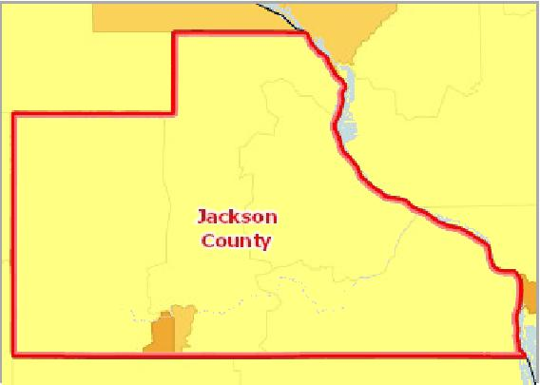

[](https://engagementnetwork.org/map-room/?ids=29196,t11&def=t11:FIPS%20In%20('19097')&bbox=-10120449.27515,5164829.551058,-10034264.57655,5219471.283242) View larger map

**Population, Density (Persons per Sq Mile) by Tract, ACS 2014‐18**

Over 5,000

1,001 ‐ 5,000

501 ‐ 1,000

51 ‐ 500

Under 51

No Data or Data Suppressed

Jackson County, IA



Total Population by Gender

This indicator reports the total population of the report area by gender.

|  |  |  |  |  |
| --- | --- | --- | --- | --- |
| **Report Area** | **Male** | **Female** | **Male, Percent** | **Female, Percent** |
| Jackson County, IA | 9,712 | 9,683 | 50.07% | 49.93% |
| Iowa | 1,554,481 | 1,578,018 | 49.62% | 50.38% |
| United States | 158,984,190 | 163,918,840 | 49.24% | 50.76% |

Total Population by Gender

Jackson County, IA



**Female: 49.9% Male: 50.1%**

Total Population by Age Groups, Total

This indicator reports the total population of the report area by age groups

|  |  |  |  |  |  |  |  |  |
| --- | --- | --- | --- | --- | --- | --- | --- | --- |
| **Report Area** | **Age 0‐4** | **Age 5‐17** | **Age 18‐24** | **Age 25‐34** | **Age 35‐44** | **Age 45‐54** | **Age 55‐64** | **Age 65+** |
| Jackson County, IA | 1,159 | 3,165 | 1,439 | 1,917 | 2,080 | 2,700 | 3,009 | 3,926 |
| Iowa | 197,430 | 532,602 | 321,094 | 393,533 | 371,017 | 389,588 | 413,923 | 513,312 |
| United States | 19,836,850 | 53,716,390 | 30,903,719 | 44,567,976 | 40,763,210 | 42,589,573 | 41,286,731 | 49,238,581 |

Total Population by Age Groups, Total

Jackson County, IA

Total Population by Age Groups, Percent

This indicator reports the percentage of age groups in the population of the report area.

|  |  |  |  |  |  |  |  |  |
| --- | --- | --- | --- | --- | --- | --- | --- | --- |
| **Report Area** | **Age 0‐4** | **Age 5‐17** | **Age 18‐24** | **Age 25‐34** | **Age 35‐44** | **Age 45‐54** | **Age 55‐64** | **Age 65+** |
| Jackson County, IA | 5.98% | 16.32% | 7.42% | 9.88% | 10.72% | 13.92% | 15.51% | 20.24% |
| Iowa | 6.30% | 17.00% | 10.25% | 12.56% | 11.84% | 12.44% | 13.21% | 16.39% |
| United States | 6.14% | 16.64% | 9.57% | 13.80% | 12.62% | 13.19% | 12.79% | 15.25% |

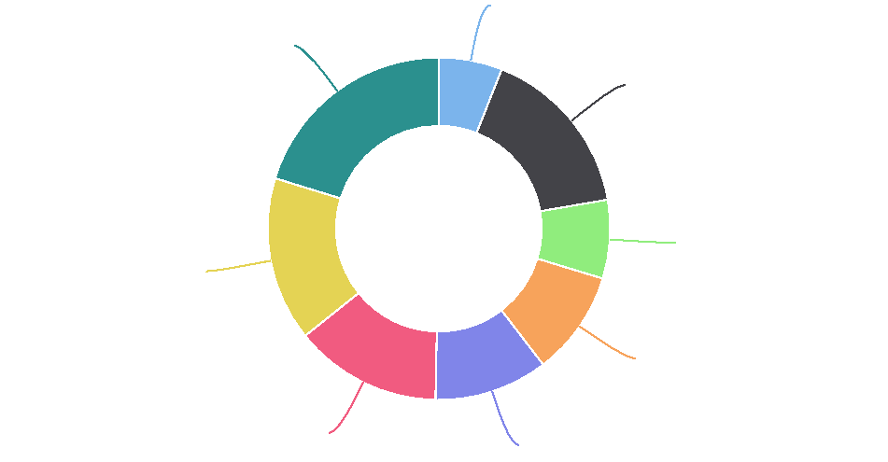

**Age 0-4: 6.0%**

**Age 65+: 20.2%**

**Age 5-17: 16.3%**

**Age 18-24: 7.4%**

**Age 55-64: 15.5%**

**Age 25-34: 9.9%**

**Age 45-54: 13.9%**

**Age 35-44: 10.7%**

Total Population by Age Groups, Percent

25

|  |  |  |  |  |  |  |  |  |  |  |  |  |  |  |  |  |  |  |  |  |  |  |  |  |  |  |  |  |  |  |  |  |  |  |  |  |  |  |  |
| --- | --- | --- | --- | --- | --- | --- | --- | --- | --- | --- | --- | --- | --- | --- | --- | --- | --- | --- | --- | --- | --- | --- | --- | --- | --- | --- | --- | --- | --- | --- | --- | --- | --- | --- | --- | --- | --- | --- | --- |
|  | 20 |  |  |  |  |  |  |  |  |  |  |  |  |  |  |  |  |  |  |  |  |  |  |  |  |  |  |  |  |  |  |  |  |  |  |  |  |  |  |
|  |  |  |  |  |  |  |  |  |  |  |  |  |  |  |  |  |  |  |  |  |  |  |  |  |  |  |  |  |  |  |  |  |  | |  |  |  |  |
|  |  |  |  |  |  |  |  |  |  |  |  |  |  |  |  |  |  |  |  |  |  |  |  |  |  |  |  |  |  |  |  |  |  |  |  |  |
|  |  |  |  |  |  |  |  |  |  |  |  |  |  |  |  |  |  |  |  |  |  |  |  |  |  |  |  |  |  |  |  |  |  |  |  |  |  |
|  |  |  |  |  |  |  |  |  |  |  |  |  |  |  |  |  |  |  |  |  |  |  |  |  |  |  |  |  |  |  |  |  |  |  |  |  |  |
|  | 15 |  |  |  |  |  |  |  |  |  |  |  |  |  |  |  |  |  |  |  |  |  |  |  |  |  |  |  |  |  |  |  |  |  |  |  | |
|  |  |  |  |  |  |  |  |  |  |  |  |  |  |  |  |  |  |  |  |  |  |  |  |  |  |  |  |  |  |  |  |  |  |  |
|  |  |  |  |  |  |  |  |  |  |  |  |  |  |  |  |  |  |  |  |  |  |  |  |  |  |  |  |  |  |  |  |  |  |  |  |
| % |  |  |  |  |  |  |  |  |  |  |  |  |  |  |  |  |  |  |  |  |  |  |  |  |  |  |  |  |  |  |  |  |  |  |
|  |  |  |  |  |  |  |  |  |  |  |  |  |  |  |  |  |  |  |  |  |  |  |  |  |  |  |  |  |  |  |  |  |  |
|  |  |  |  |  |  |  |  |  |  |  |  |  |  |  |  |  |  |  |  |  |  |  |  |  |  |  |  |  |  |  |  |  |  |
|  |  |  |  |  |  |  |  |  |  |  |  |  |  |  |  |  |  |  |  |  |  |  |  |  |  |  |  |  |  |  |  |  |  |  |
|  | 10 |  |  |  |  |  |  |  |  |  |  |  |  |  |  |  |  |  |  |  |  |  |  |  |  |  |  |  |  |  |  |  |  |  |
|  |  |  |  |  |  |  |  |  |  |  |  |  | |  |  |  |  |  |  |  |  |  |  |  |  |  |  |  |  |  |  |  |  |
|  |  |  |  |  |  |  |  |  |  |  |  |  |  |  |  |  |  |  |  |  |  |  |  |  |  |  |  |  |  |  |  |
|  |  |  |  |  |  |  |  |  |  |  |  |  |  |  |  |  |  |  |  |  |  |  |  |  |  |  |  |  |  |  |  |
|  |  |  |  |  |  |  |  |  |  |  |  |  |  |  |  |  |  |  |  |  |  |  |  |  |  |  |  |  |  |  |  |  |
|  | 5  0 |  |  |  |  |  |  |  |  |  |  |  |  |  |  |  |  |  |  |  |  |  |  |  |  |  |  |  |  |  |  |  |
|  |  |  |  |  |  |  |  |  |  |  |  |  |  |  |  |  |  |  |  |  |  |  |  |  |  |  |  |  |  |  |
|  |  |  |  |  |  |  |  |  |  |  |  |  |  |  |  |  |  |  |  |  |  |  |  |  |  |  |  |  |  |  |  |  |  |  |  |  |  |  |

Age 0-4 Age 5-17 Age 18-24 Age 25-34 Age 35-44 Age 45-54 Age 55-64 Age 65+

Jackson County, IA Iowa United States



Total Population by Race Alone, Total

This indicator reports the total population of the report area by race alone.

|  |  |  |  |  |  |  |  |
| --- | --- | --- | --- | --- | --- | --- | --- |
| **Report Area** | **White** | **Black** | **Asian** | **Native American / Alaska  Native** | **Native Hawaiian / Pacific  Islander** | **Some Other  Race** | **Multiple  Races** |
| Jackson County, IA | 18,776 | 99 | 80 | 7 | 131 | 30 | 272 |
| Iowa | 2,827,889 | 109,911 | 75,083 | 11,549 | 3,129 | 39,168 | 65,770 |
| United States | 234,904,818 | 40,916,113 | 17,574,550 | 2,699,073 | 582,718 | 15,789,961 | 10,435,797 |

Total Population by Race Alone, Total

Jackson County, IA

Total Population by Race Alone, Percent

This indicator reports the percentage of population by race alone in the report area.

|  |  |  |  |  |  |  |  |
| --- | --- | --- | --- | --- | --- | --- | --- |
| **Report Area** | **White** | **Black** | **Asian** | **Native American or Alaska  Native** | **Native Hawaiian or Pacific  Islander** | **Some Other  Race** | **Multiple  Race** |
| Jackson County, IA | 96.81% | 0.51% | 0.41% | 0.04% | 0.68% | 0.15% | 1.40% |
| Iowa | 90.28% | 3.51% | 2.40% | 0.37% | 0.10% | 1.25% | 2.10% |
| United States | 72.75% | 12.67% | 5.44% | 0.84% | 0.18% | 4.89% | 3.23% |

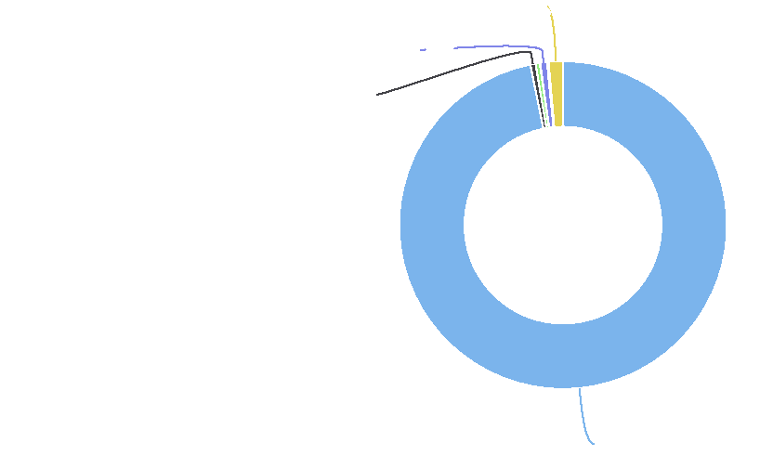

**Multiple Races: 1.4%**

**Native Hawaiian / Pacific Islander: 0.7%**

**Black: 0.5%**

**White: 96.8%**

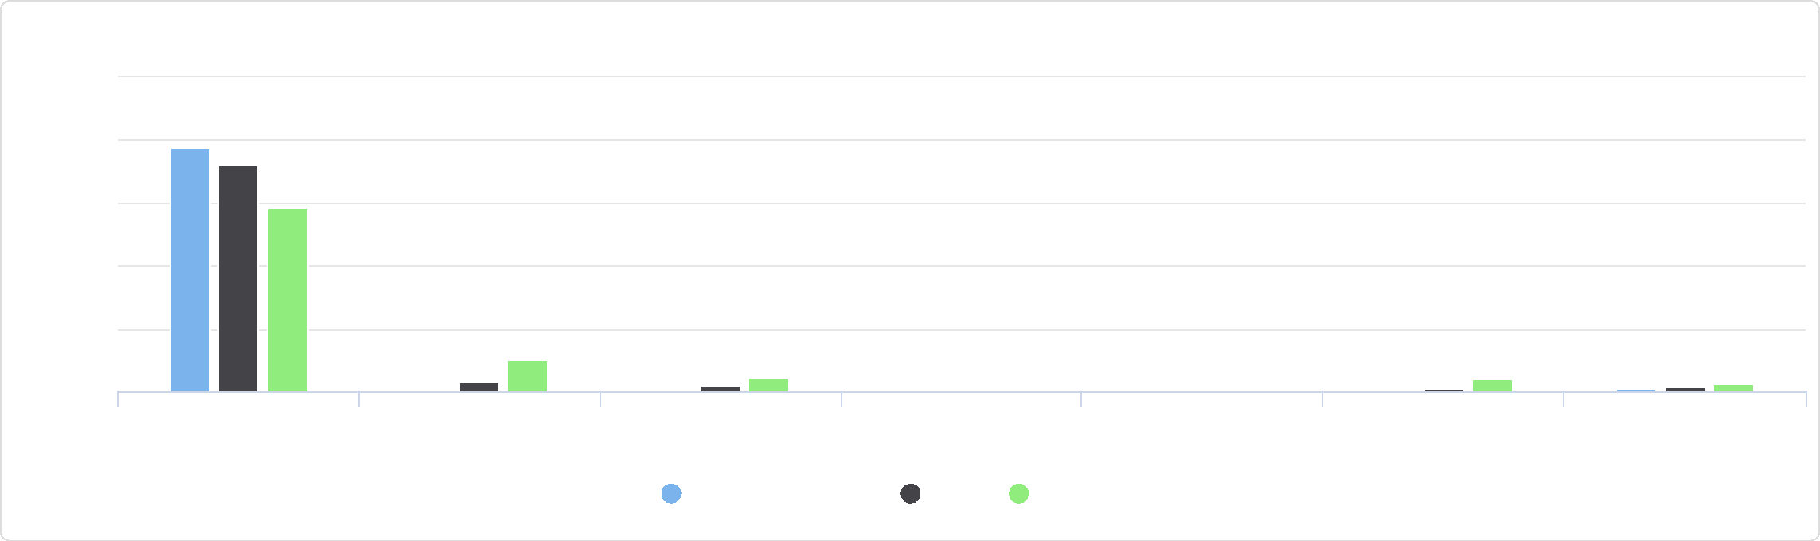

Native Hawaiian or Pacific Islander

Some Other Race Multiple Race

White Black Asian Native American or Alaska

Native

Total Population by Race Alone, Percent

125

100

Jackson County, IA Iowa United States

%

25

75

50

0

Total Population by Ethnicity Alone

This indicator reports the total population of the report area by ethnicity alone.

|  |  |  |  |  |  |
| --- | --- | --- | --- | --- | --- |
| **Report Area** | **Total  Population** | **Hispanic or Latino  Population** | **Hispanic or Latino Population,  Percent** | **Non‐Hispanic  Population** | **Non‐Hispanic Population,  Percent** |
| Jackson  County, IA | 19,395 | 276 | 1.42% | 19,119 | 98.58% |
| Iowa | 3,132,499 | 183,296 | 5.85% | 2,949,203 | 94.15% |
| United States | 322,903,030 | 57,517,935 | 17.81% | 265,385,095 | 82.19% |

Total Population by Ethnicity Alone

Jackson County, IA

**Non-Hispanic Population: 98.6%**

Hispanic Population by Race Alone, Total

This indicator reports the total of Hispanic or Latino population in the report area by race alone.

|  |  |  |  |  |  |  |  |
| --- | --- | --- | --- | --- | --- | --- | --- |
| **Report Area** | **White** | **Black** | **Asian** | **Native American or Alaska  Native** | **Native Hawaiian or Pacific  Islander** | **Some Other  Race** | **Multiple  Races** |
| Jackson County, IA | 239 | 0 | 0 | 0 | 0 | 30 | 7 |
| Iowa | 132,001 | 2,440 | 443 | 2,482 | 266 | 36,362 | 9,302 |
| United States | 37,723,641 | 1,200,196 | 207,381 | 563,594 | 57,616 | 15,035,465 | 2,730,042 |



**Hispanic or Latino Population: 1.4%**

Hispanic Population by Race Alone, Total

Jackson County, IA

Hispanic Population by Race Alone, Percent

This indicator reports the percentage of Hispanic or Latino population in the report area by race alone.

|  |  |  |  |  |  |  |  |
| --- | --- | --- | --- | --- | --- | --- | --- |
| **Report Area** | **White** | **Black** | **Asian** | **Native American or Alaska  Native** | **Native Hawaiian or Pacific  Islander** | **Some Other  Race** | **Multiple  Races** |
| Jackson County, IA | 86.59% | 0.00% | 0.00% | 0.00% | 0.00% | 10.87% | 2.54% |
| Iowa | 72.02% | 1.33% | 0.24% | 1.35% | 0.15% | 19.84% | 5.07% |
| United States | 65.59% | 2.09% | 0.36% | 0.98% | 0.10% | 26.14% | 4.75% |

Non‐Hispanic Population by Race Alone, Total

This indicator reports the total of non‐hispanic population in the report area by race alone.

|  |  |  |  |  |  |  |  |
| --- | --- | --- | --- | --- | --- | --- | --- |
| **Report Area** | **White** | **Black** | **Asian** | **Native American or Alaska Native** | **Native Hawaiian or Pacific  Islander** | **Some Other  Race** | **Multiple  Races** |
| Jackson County, IA | 18,537 | 99 | 80 | 7 | 131 | 0 | 265 |
| Iowa | 2,695,888 | 107,471 | 74,640 | 9,067 | 2,863 | 2,806 | 56,468 |
| United States | 197,181,177 | 39,715,917 | 17,367,169 | 2,135,479 | 525,102 | 754,496 | 7,705,755 |

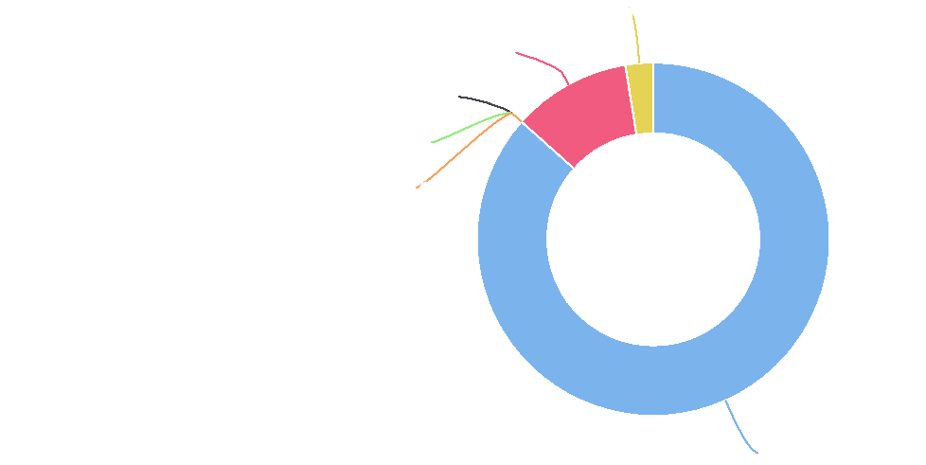

**Multiple Races: 2.5%**

**Some Other Race: 10.9%**

**Black: 0.0% Asian: 0.0%**

**Native American / Alaska Native: 0.0%**

**White: 86.6%**

Hispanic Population by Race Alone, Percent

100

|  |  |  |  |  |  |  |  |  |  |  |  |
| --- | --- | --- | --- | --- | --- | --- | --- | --- | --- | --- | --- |
|  | 75 |  |  |  |  |  |  |  |  |  |  |
|  |  |  |  |  |  |  |  |  |  |  |
|  |  |  |  |  |  |  |  |  |  |  |  |
|  |  |  |  |  |  |  |  |  |  |  |  |
| % | 50  25 |  |  |  |  |  |  |  |  |  |  |
|  |  |  |  |  |  |  |  |  |  |
|  |  |  |  |  |  |  |  |  |  |  |
|  |  |  |  |  |  |  |  |  |  |  |  |
|  | 0 |  |  |  |  |  |  |  |  |  |  |
|  |  |  |  |  |  |  |  |  |  |  |

White Black Asian Native American or Alaska Native Hawaiian or Pacific Some Other Race Multiple Races

Native Islander

Jackson County, IA Iowa United States



Non-Hispanic Population by Race Alone, Total

Jackson County, IA

Non‐Hispanic Population by Race Alone, Percent

This indicator reports the percentage of non‐Hispanic population in the report area by race alone.

|  |  |  |  |  |  |  |  |
| --- | --- | --- | --- | --- | --- | --- | --- |
| **Report Area** | **White** | **Black** | **Asian** | **Native American or Alaska  Native** | **Native Hawaiian or Pacific  Islander** | **Some Other  Race** | **Multiple  Races** |
| Jackson County, IA | 96.96% | 0.52% | 0.42% | 0.04% | 0.69% | 0.00% | 1.39% |
| Iowa | 91.41% | 3.64% | 2.53% | 0.31% | 0.10% | 0.10% | 1.91% |
| United States | 74.30% | 14.97% | 6.54% | 0.80% | 0.20% | 0.28% | 2.90% |

## Change in Total Population

According to the United States Census Bureau Decennial Census, between 2000 and 2010 the population in the report area fell by ‐448 persons, a change of ‐2.21%. A significant positive or negative shift in total population over time impacts healthcare providers and the utilization of community resources.

|  |  |  |  |  |
| --- | --- | --- | --- | --- |
| **Report Area** | **Total Population, 2000 Census** | **Total Population,  2010 Census** | **Population Change, 2000‐2010** | **Population Change, 2000‐2010, Percent** |
| Jackson County, IA | 20,296 | 19,848 | ‐448 | ‐2.21% |
| Iowa | 2,926,325 | 3,046,355 | 120,030 | 4.1% |
| United States | 280,405,781 | 307,745,539 | 27,339,758 | 9.75% |

*Data Source: US Census Bureau,* [*Decennial Census*](http://www.census.gov/)*. 2000 ‐ 2010. Source geography: Tract*

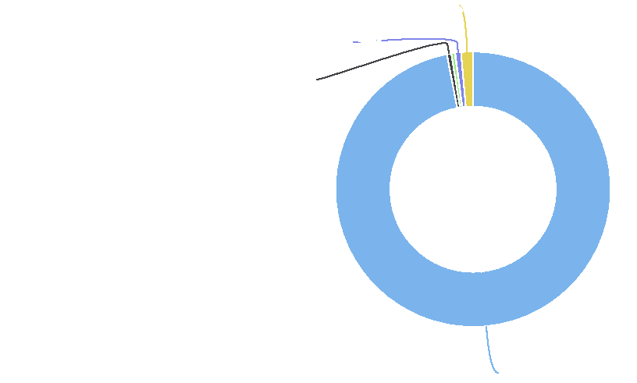

**Multiple Races: 1.4%**

**Native Hawaiian / Pacific Islander: 0.7%**

**Black: 0.5%**

**White: 97.0%**

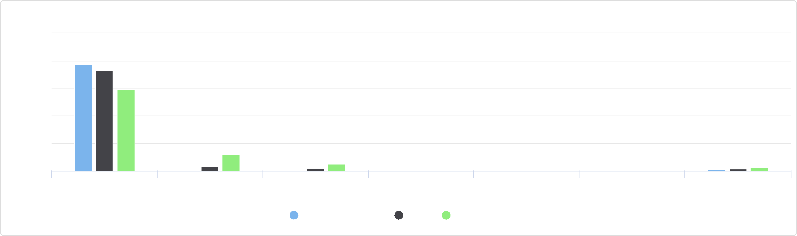

Native Hawaiian or Pacific Islander

Some Other Race Multiple Races

White Black Asian Native American or Alaska

Native

Non-Hispanic Population by Race Alone, Percent

125

100

Jackson County, IA Iowa United States

%

25

75

50

0

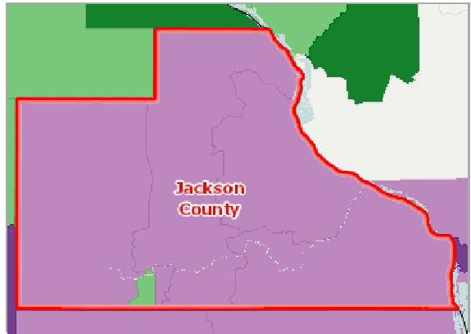

[](https://engagementnetwork.org/map-room/?ids=2085,t11&def=t11:FIPS%20In%20('19097')&bbox=-10120449.27515,5164829.551058,-10034264.57655,5219471.283242) View larger map

**Population Change, Percent by Tract, US Census 2000 ‐ 2010**

Over 10.0% Increase ( + ) 1.0 ‐ 10.0% Increase ( + ) Less Than 1.0% Change ( +/‐ ) 1.0 ‐ 10.0% Decrease ( ‐ ) Over 10.0% Decrease ( ‐ ) No Population or No Data Jackson County, IA



Population Change (2000‐2010) by Gender

This indicator reports the population change of the report area by gender.

|  |  |  |  |  |
| --- | --- | --- | --- | --- |
| **Report Area** | **Male Population Change,  Total** | **Male Population Change,  Percent** | **Female Population Change,**  **Total** | **Female Population Change,  Percent** |
| Jackson County, IA | ‐151 | ‐1.51% | ‐297 | ‐2.88% |
| Iowa | 72,803 | 5.07% | 47,226 | 3.17% |
| United States | 13,738,020 | 10.02% | 13,601,733 | 9.55% |

Population Change (2000‐2010) by Hispanic Origin

This indicator reports the Hispanic or Latino population change in the report area.

|  |  |  |  |  |
| --- | --- | --- | --- | --- |
| **Report Area** | **Hispanic Population  Change, Total** | **Hispanic Population Change, Percent** | **Non‐Hispanic Population  Change, Total** | **Non‐Hispanic Population Change, Percent** |
| Jackson  County, IA | 99 | 81.82% | ‐547 | ‐2.71% |
| Iowa | 69,070 | 83.75% | 50,961 | 1.79% |
| United States | 15,152,943 | 42.93% | 12,099,099 | 4.92% |

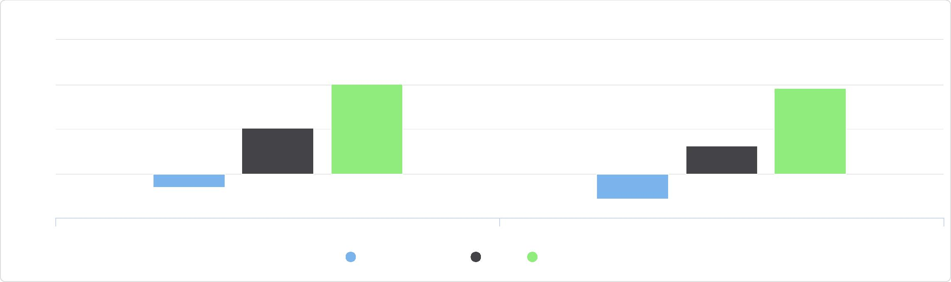

Population Change (2000-2010) by Gender

15

10

5

0

-5

%

Male Population Change, Percent Female Population Change, Percent

Jackson County, IA Iowa United States

Population Change (2000-2010) by Hispanic Origin

100

|  |  |  |  |  |  |  |  |  |
| --- | --- | --- | --- | --- | --- | --- | --- | --- |
|  | 75  50  25  0 |  |  |  |  |  |  |  |
|  |  |  |  |  |  |  |
| % |  |  |  |  |  |  |
|  |  |  |  |  |  |  |
|  |  |  |  |  |  |  |

-25

Hispanic Population Change, Percent Non-Hispanic Population Change, Percent

Jackson County, IA Iowa United States



Total Population Change (2000‐2010) by Race

This indicator reports the total population change of the report area by race.

|  |  |  |  |  |  |  |  |
| --- | --- | --- | --- | --- | --- | --- | --- |
| **Report Area** | **White** | **Black** | **American Indian or Alaska  Native** | **Asian** | **Native Hawaiian or Pacific  Islander** | **Some Other  Race** | **Multiple  Race** |
| Jackson County, IA | ‐746 | 41 | 16 | 28 | 66 | 37 | 110 |
| Iowa | 32,920 | 27,295 | 2,095 | 16,459 | 994 | 18,712 | 21,555 |
| United States | 12,199,518 | 5,189,316 | 521,420 | 4,433,864 | 141,446 | 3,703,567 | 2,190,889 |

Percent Population Change (2000‐2010) by Race

This indicator reports the percentage of population change of the report area by race.

|  |  |  |  |  |  |  |  |
| --- | --- | --- | --- | --- | --- | --- | --- |
| **Report Area** | **White** | **Black** | **American Indian or Alaska  Native** | **Asian** | **Native Hawaiian or Pacific  Islander** | **Some Other  Race** | **Multiple  Race** |
| Jackson County, IA | ‐3.71% | 205% | 66.67% | 147.37% | 286.96% | 123.33% | 115.79% |
| Iowa | 1.2% | 44.13% | 23.31% | 44.93% | 98.51% | 50.01% | 67.83% |
| United States | 5.8% | 15.43% | 22.56% | 43.72% | 47.37% | 24.2% | 32.61% |

## Female Population

A total of 9,683 females reside in the report area according to the U.S. Census Bureau American Community Survey 2014‐18 5‐

Percent Population Change (2000-2010) by Race

400

300

|  |  |  |  |  |  |  |  |  |  |  |  |  |  |  |  |  |
| --- | --- | --- | --- | --- | --- | --- | --- | --- | --- | --- | --- | --- | --- | --- | --- | --- |
|  | 200  100 |  |  |  |  |  |  |  |  |  |  |  |  |  |  |  |
|  |  |  |  | |  |  |  |  |  |  |  |  |  |  |  |
| % |  |  |  |  |  |  |  |  |  |  |  |  |  |
|  |  |  |  |  |  |  |  |  |  |  |  |
|  | 0 |  |  |  |  |  |  |  |  |  |
|  |  |  |  |  |  |  |  |  |  |

White Black American Indian or Alaska Asian Native Hawaiian or Pacific Some Other Race Multiple Race

Native Islander

-100

Jackson County, IA Iowa United States



year estimates. Females represent 49.93% of the total population in the area, which is less than the national average of 50.76%.

|  |  |  |  |
| --- | --- | --- | --- |
| **Report Area** | **Total Population** | **Female Population** | **Percent Female Population** |
| Jackson County, IA | 19,395 | 9,683 | 49.93% |
| Iowa | 3,132,499 | 1,578,018 | 50.38% |
| United States | 322,903,030 | 163,918,840 | 50.76% |

*Data Source: US Census Bureau,* [*American Community Survey*](http://www.census.gov/acs/www/)*. 2014‐18. Source geography: Tract*

**Female Population, Percent by Tract, ACS 2014‐18**

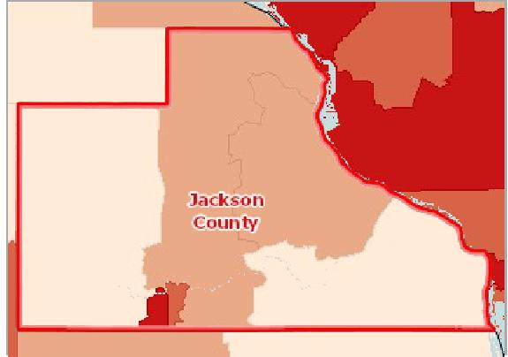

[](https://engagementnetwork.org/map-room/?ids=29307,t11&def=t11:FIPS%20In%20('19097')&bbox=-10120449.27515,5164829.551058,-10034264.57655,5219471.283242) View larger map

Over 52.0%

50.1 ‐ 52.0%

48.1 ‐ 50.0%

Under 48.1%

No Female Population Reported

No Data or Data Suppressed

Jackson County, IA



Female Population by Ethnicity Alone

|  |  |  |  |  |
| --- | --- | --- | --- | --- |
| **Report Area** | **Hispanic or Latino** | **Not Hispanic or Latino** | **Hispanic or Latino, Percent** | **Not Hispanic or Latino, Percent** |
| Jackson County, IA | 122 | 9,561 | 44.20% | 50.01% |
| Iowa | 88,272 | 1,489,746 | 48.16% | 50.51% |
| United States | 28,458,344 | 135,460,496 | 49.48% | 51.04% |

Female Population by Race Alone, Percent

|  |  |  |  |  |  |  |  |
| --- | --- | --- | --- | --- | --- | --- | --- |
| **Report Area** | **White** | **Black or African  American** | **Native American or Alaska Native** | **Asian** | **Native Hawaiian or Pacific  Islander** | **Some Other Race** | **Multiple  Race** |
| Jackson  County, IA | 50.07% | 19.19% | 28.57% | 32.50% | 52.67% | 20.00% | 58.82% |
| Iowa | 50.52% | 46.97% | 49.61% | 50.59% | 51.45% | 46.26% | 51.98% |
| United States | 50.56% | 52.21% | 50.41% | 52.52% | 50.10% | 48.65% | 50.06% |

Female Population by Ethnicity Alone

60

|  |  |  |  |  |  |  |
| --- | --- | --- | --- | --- | --- | --- |
|  | 40  20  0 |  |  |  |  |  |
| % |  |  |  |
|  |  |  |  |
|  |  |  |  |  |  |

Hispanic / Latino Not Hispanic / Latino

Jackson County, IA Iowa United States



Female Population by Race Alone, Percent

75

|  |  |  |  |  |  |  |  |  |  |  |  |  |  |  |  |  |  |  |  |  |  |  |  |  |  |  |  |  |  |
| --- | --- | --- | --- | --- | --- | --- | --- | --- | --- | --- | --- | --- | --- | --- | --- | --- | --- | --- | --- | --- | --- | --- | --- | --- | --- | --- | --- | --- | --- |
|  |  |  |  |  |  |  |  |  |  |  |  |  |  |  |  |  |  |  |  |  |  |  |  |  |  |  |  |  |  |
|  | 50 |  |  |  |  |  |  |  |  |  |  |  |  |  |  |  |  |  |  |  |  |  |  |  |  |  |  |  |  |
|  |  |  |  |  |  |  |  |  | |  |  |  |  |  |  |  |  |  |  |  |  |  |  |  |  |
| % |  |  |  |  |  |  |  |  |  |  |  |  |  |  |  |  |  |  |  |  |  |  |
|  |  |  |  |  |  |  |  |  |  |  |  |  |  |  |  |  |  |  |  |  |  |
|  |  |  |  |  |  |  |  |  |  |  |  |  |  |  |  |  |  |  |  |  |  |  |
|  | 25 |  |  |  |  |  |  |  |  |  |  |  |  |  |  |  |  |  |  |  |  |  |
|  |  |  |  |  |  |  |  |  |  |  |  |  |  |  |  |  |  |  |  |  |  |
|  |  |  |  |  |  |  |  |  |  |  |  |  |  |  |  |  |  |  |  |  |  |  |
|  |  |  |  |  |  |  |  |  |  |  |  |  |  |  |  |  |  |  |  |  |  |  |
|  | 0 |  |  |  |  |  |  |  |  |  |  |  |  |  |  |  |  |  |  |  |  |  |
|  |  |  |  |  |  |  |  |  |  |  |  |  |  |  |  |  |  |  |  |  |  |  |  |  |  |  |  |  |

White Black or African American Native American or Alaska Asian Native Hawaiian or Pacific Some Other Race Multiple Race

Native Islander

Jackson County, IA Iowa United States



Female Population by Race Alone, Total

|  |  |  |  |  |  |  |  |
| --- | --- | --- | --- | --- | --- | --- | --- |
| **Report Area** | **White** | **Black or African  American** | **Native American or Alaska Native** | **Asian** | **Native Hawaiian or Pacific Islander** | **Some Other Race** | **Multiple Race** |
| Jackson  County, IA | 9,401 | 19 | 2 | 26 | 69 | 6 | 160 |
| Iowa | 1,428,756 | 51,627 | 5,730 | 37,988 | 1,610 | 18,119 | 34,188 |
| United States | 118,769,015 | 21,360,553 | 1,360,698 | 9,230,798 | 291,929 | 7,681,318 | 5,224,529 |

Female Population by Race Alone, Total

Jackson County, IA

## Families with Children

According to the most recent American Community Survey estimates, 28.17% of all occupied households in the report area are family households with one or more child(ren) under the age of 18. As [defined](http://www2.census.gov/programs-surveys/acs/tech_docs/subject_definitions/2018_ACSSubjectDefinitions.pdf#page=75&zoom=auto,78,370) by the US Census Bureau, a family household is any housing unit in which the householder is living with one or more individuals related to him or her by birth, marriage, or adoption. A non‐family household is any household occupied by the householder alone, or by the householder and one or more unrelated individuals.

|  |  |  |  |  |
| --- | --- | --- | --- | --- |
| **Report Area** | **Total**  **Households** | **Total Family  Households** | **Families with Children (Under Age 18)** | **Families with Children (Under Age 18), Percent of Total Households** |
| Jackson  County, IA | 8,236 | 5,414 | 2,320 | 28.17% |
| Iowa | 1,256,855 | 800,510 | 371,350 | 29.55% |
| United States | 119,730,128 | 78,697,103 | 37,228,998 | 31.09% |

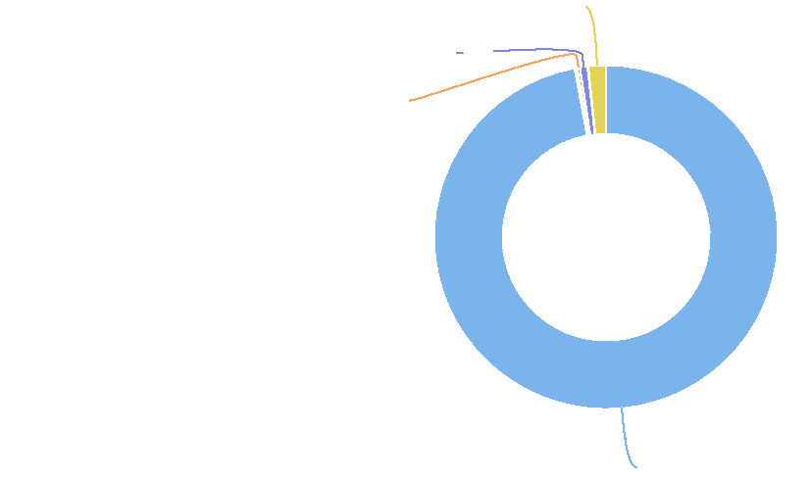

**Multiple Race: 1.7%**

**Native Hawaiian or Pacific Islander: 0.7%**

**Asian: 0.3%**

**White: 97.1%**

|  |  |  |  |  |  |  |  |
| --- | --- | --- | --- | --- | --- | --- | --- |
| **Report Area** | **White** | **Black or African  American** | **Native American or Alaska Native** | **Asian** | **Native Hawaiian or Pacific  Islander** | **Some Other Race** | **Multiple  Race** |
| Jackson  County, IA | 42.04% | 100.00% | No data | 43.48% | 100.00% | No data | 100.00% |
| Iowa | 44.47% | 72.58% | 62.47% | 66.84% | 81.77% | 72.25% | 66.25% |
| United States | 43.83% | 56.61% | 56.65% | 52.40% | 60.41% | 66.68% | 59.10% |

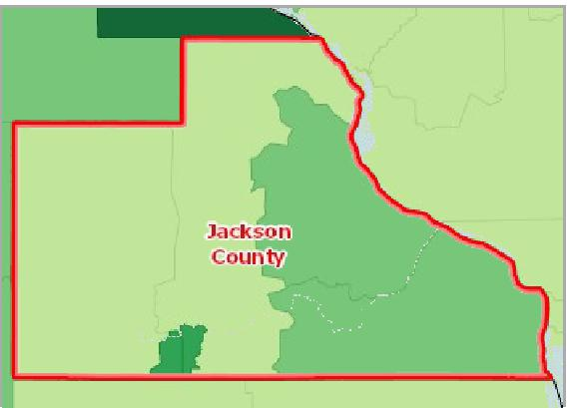

[](https://engagementnetwork.org/map-room/?ids=30312,t11&def=t11:FIPS%20In%20('19097')&bbox=-10120449.27515,5164829.551058,-10034264.57655,5219471.283242) View larger map

**Households with Children (Age 0‐17), Percent by Tract, ACS 2014‐18**

Over 35.0%

31.6 ‐ 35.0%

28.1 ‐ 31.5%

Under 28.1%

No Data or Data Suppressed

Jackson County, IA



Family Households with Children by Ethnicity Alone

|  |  |  |  |  |
| --- | --- | --- | --- | --- |
| **Report Area** | **Hispanic or Latino** | **Not Hispanic or Latino** | **Hispanic or Latino, Percent** | **Not Hispanic or Latino, Percent** |
| Jackson County, IA | 30 | 2,290 | 52.63% | 42.75% |
| Iowa | 26,592 | 343,404 | 73.85% | 44.92% |
| United States | 7,579,968 | 29,490,814 | 64.08% | 44.10% |

Family Households with Children by Race Alone, Percent

Family Households with Children by Ethnicity Alone

100

|  |  |  |  |  |  |  |
| --- | --- | --- | --- | --- | --- | --- |
|  | 75  50  25  0 |  |  |  |  |  |
| % |  |  |  |  |  |
|  |  |  |  |
|  |  |  |  |
|  |  |  |  |  |  |

Hispanic or Latino, Percent Not Hispanic or Latino, Percent

Jackson County, IA Iowa United States



Family Households with Children by Race Alone, Percent

150

100

%

50









0

|  |  |  |
| --- | --- | --- |
| White Black or African American Native American or Alaska  Native | Asian Native Hawaiian or Pacific  Islander | Some Other Race Multiple Race |

Jackson County, IA Iowa United States



Family Households with Children by Race Alone, Total

|  |  |  |  |  |  |  |  |
| --- | --- | --- | --- | --- | --- | --- | --- |
| **Report Area** | **Non‐Hispanic White** | **Black or African  American** | **Native American or  Alaska Native** | **Asian** | **Native Hawaiian or  Pacific Islander** | **Some Other Race** | **Multiple Race** |
| Jackson County, IA | 2,235 | 7 | 0 | 10 | 30 | 0 | 38 |
| Iowa | 331,252 | 15,321 | 1,523 | 10,300 | 507 | 6,052 | 5,041 |
| United States | 26,343,562 | 5,077,324 | 333,195 | 2,154,970 | 71,438 | 2,185,344 | 904,949 |

Family Households with Children by Race Alone, Total

Jackson County, IA

## Median Age

Of the estimated 19,409 total population in the report area, the median age of all persons is 44.6. This indicates that the report population as a whole generally trends older than the state, which has a median age of 38.1. These data are based on the latest U.S. Census Bureau American Community Survey 5‐year estimates.

|  |  |  |
| --- | --- | --- |
| **Report Area** | **Total Population** | **Median Age** |
| Jackson County, IA | 19,409 | 44.6 |
| Iowa | 3,132,499 | 38.1 |
| United States | 322,903,030 | 37.9 |

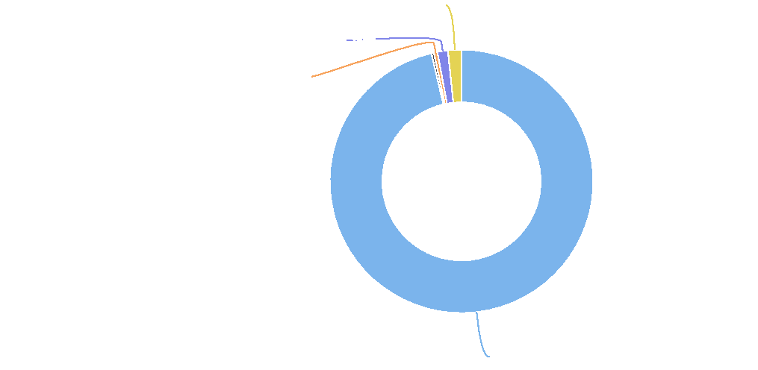

**Multiple Race: 1.6%**

**Native Hawaiian or Pacific Islander: 1.3%**

**Asian: 0.4%**

**Non-Hispanic White: 96.3%**

**Median Age by Tract, ACS 2014‐18**

Over 45.0

40.1 ‐ 45.0

35.1 ‐ 40.0

Under 35.1

No Data or Data Suppressed

Jackson County, IA

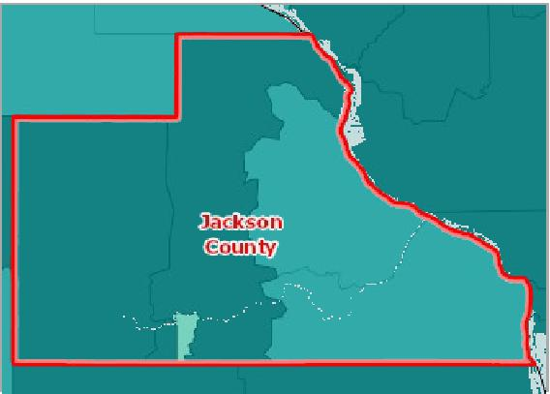

[](https://engagementnetwork.org/map-room/?ids=29197,t11&def=t11:FIPS%20In%20('19097')&bbox=-10120449.27515,5164829.551058,-10034264.57655,5219471.283242) View larger map



Population Median Age by Gender

This indicator reports the median age of the population by gender.

|  |  |  |
| --- | --- | --- |
| **Report Area** | **Male** | **Female** |
| Jackson County, IA | 43.3 | 46.4 |
| Iowa | 36.9 | 39.3 |
| United States | 36.6 | 39.3 |

Population Median Age by Race Alone

This indicator reports the median age of the population by race alone.

|  |  |  |  |  |  |  |  |  |  |
| --- | --- | --- | --- | --- | --- | --- | --- | --- | --- |
| **Report Area** | **White** | **Black or African  American** | **Native American or Alaska  Native** | | **Asian** | **Native Hawaiian or Pacific  Islander** | **Some Other  Race** | | **Multiple  Race** |
| Jackson County, IA | 45.5 | 35.4 | No data |  | 44.5 | 26.5 | No data |  | 15.6 |
| Iowa | 40.0 | 26.6 |  | 33.0 | 29.6 | 27.5 |  | 27.7 | 15.6 |
| United States | 40.6 | 33.9 |  | 32.8 | 36.8 | 31.9 |  | 29.6 | 20.1 |

Population Median Age by Gender

|  |  |  |  |
| --- | --- | --- | --- |
| 60  40  20  0 |  |  |  |
|  |  | |
|  |
|  |
|  | Male Female |  |

Jackson County, IA Iowa United States



Population Median Age by Race Alone

60

|  |  |  |  |  |  |  |  |  |  |  |  |  |  |  |  |  |  |  |  |  |  |  |  |  |  |  |
| --- | --- | --- | --- | --- | --- | --- | --- | --- | --- | --- | --- | --- | --- | --- | --- | --- | --- | --- | --- | --- | --- | --- | --- | --- | --- | --- |
| 40 |  |  |  |  |  |  |  |  |  |  |  |  |  |  |  |  |  |  |  |  |  |  |  |  |  |  |
|  |  |  |  |  |  |  |  |  |  |  |  |  |  |  |  |  |  |  |  |  |  |  |  |
|  |  |  |  |  |  |  |  |  |  |  |  |  |  |  |  |  |  |  |  |  |  |  |  |  |
|  |  |  |  |  |  |  |  |  |  |  |  |  |  |  |  |  |  |  |  |  |  |  |  |  |
|  |  |  |  |  |  |  |  |  |  |  |  |  |  |  |  |  |  |  |  |  |  |  |  |
|  |  |  |  |  |  |  |  |  |  |  |  |  |  |  |  |  |  |  |  |  |  |  |  |
| 20 |  |  |  |  |  |  |  |  |  |  |  |  |  |  |  |  |  |  |  |  |  |  |  |
|  |  |  |  |  |  |  |  |  |  |  |  |  |  |  |  |  |  |  |  |  |
|  |  |  |  |  |  |  |  |  |  |  |  |  |  |  |  |  |  |  |  |  |  |
| 0 |  |  |  |  |  |  |  |  |  |  |  |  |  |  |  |  |  |  |  |  |  |
|  |  |  |  |  |  |  |  |  |  |  |  |  |  |  |  |  |  |  |  |  |  |  |  |  |  |

White Black or African American Native American or Alaska Asian Native Hawaiian or Pacific Some Other Race Multiple Race

Native Islander

Jackson County, IA Iowa United States



Population Median Age by Ethnicity

This indicator reports the median age of the population by ethnicity.

|  |  |  |
| --- | --- | --- |
| **Report Area** | **Hispanic or Latino** | **Not Hispanic or Latino** |
| Jackson County, IA | 33.3 | 45.7 |
| Iowa | 23.3 | 41.0 |
| United States | 28.9 | 43.4 |

## Population Under Age 18

Of the estimated 19,395 total population in the report area, an estimated 4,324 persons are under the age of 18, representing 22.29% of the population. These data are based on the latest U.S. Census Bureau American Community Survey 5‐year estimates. The number of persons under age 18 is relevant because this population has unique needs which should be considered separately from other age groups.

|  |  |  |  |
| --- | --- | --- | --- |
| **Report Area** | **Total Population** | **Population Age 0‐17** | **Population Age 0‐17, Percent** |
| Jackson County, IA | 19,395 | 4,324 | 22.29% |
| Iowa | 3,132,499 | 730,032 | 23.31% |
| United States | 322,903,030 | 73,553,240 | 22.78% |

Population Median Age by Ethnicity

60

|  |  |  |  |  |  |
| --- | --- | --- | --- | --- | --- |
| 40  20  0 |  |  |  |  |  |
|  |  |  |  |
|  |  |  |
|  |  |  |  |  |

Hispanic or Latino Not Hispanic or Latino

Jackson County, IA Iowa United States



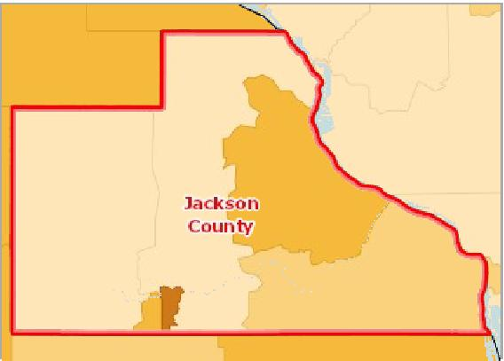

[](https://engagementnetwork.org/map-room/?ids=29198,t11&def=t11:FIPS%20In%20('19097')&bbox=-10120449.27515,5164829.551058,-10034264.57655,5219471.283242) View larger map

**Population Age 0‐17, Percent by Tract, ACS 2014‐18**

Over 26.0%

23.1 ‐ 26.0%

20.1 ‐ 23.0%

Under 20.1%

No Data or Data Suppressed

Jackson County, IA



Population Under Age 18 by Gender

This indicator reports the percentage of population that is under age 18 by gender.

|  |  |  |  |  |
| --- | --- | --- | --- | --- |
| **Report Area** | **Male** | **Female** | **Male, Percent** | **Female, Percent** |
| Jackson County, IA | 2,205 | 2,119 | 22.70% | 21.88% |
| Iowa | 372,694 | 357,338 | 23.98% | 22.64% |
| United States | 37,585,573 | 35,967,667 | 23.64% | 21.94% |

Population Under Age 18 by Ethnicity Alone

This indicator reports the percentage of population that is under age 18 by ethnicity alone.

|  |  |  |  |  |
| --- | --- | --- | --- | --- |
| **Report Area** | **Hispanic or Latino** | **Not Hispanic or Latino** | **Hispanic or Latino, Percent** | **Not Hispanic or Latino, Percent** |
| Jackson County, IA | 101 | 4,223 | 36.59% | 22.09% |
| Iowa | 72,496 | 657,536 | 9.93% | 90.07% |
| United States | 18,347,823 | 55,205,417 | 31.90% | 20.80% |

Population Under Age 18 by Gender

30

|  |  |  |  |  |  |  |
| --- | --- | --- | --- | --- | --- | --- |
|  | 20  10  0 |  |  |  |  |  |
| % |  |  |  |
|  |  |  |  |
|  |  |  |  |  |  |

Male, Percent Female, Percent

Jackson County, IA Iowa United States



Population Under Age 18 by Ethnicity Alone

100

75

50

25

0

%

Hispanic or Latino, Percent Not Hispanic or Latino, Percent

Jackson County, IA Iowa United States



Population Under Age 18 by Ethnicity Alone

This indicator reports the proportion of the population aged 0 to 17 that is Hispanic or Latino.

|  |  |  |  |  |
| --- | --- | --- | --- | --- |
| **Report Area** | **Hispanic or Latino** | **Not Hispanic or Latino** | **Hispanic or Latino, Percent** | **Not Hispanic or Latino, Percent** |
| Jackson County, IA | 101 | 4,223 | 2.34% | 97.66% |
| Iowa | 72,496 | 657,536 | 9.93% | 90.07% |
| United States | 18,347,823 | 55,205,417 | 24.94% | 75.06% |

Population Under Age 18 by Ethnicity Alone

Jackson County, IA

**Not Hispanic / Latino: 97.7%**

Population Under Age 18 by Race Alone, Percent

This indicator reports the percentage of population that is under age 18 by race alone.

|  |  |  |  |  |  |  |  |
| --- | --- | --- | --- | --- | --- | --- | --- |
| **Report Area** | **White** | **Black or African  American** | **Native American or Alaska Native** | **Asian** | **Native Hawaiian or Pacific  Islander** | **Some Other Race** | **Multiple  Race** |
| Jackson  County, IA | 21.70% | 25.25% | 28.57% | 8.75% | 41.22% | No data | 59.19% |
| Iowa | 22.06% | 32.44% | 26.58% | 23.16% | 35.16% | 31.05% | 56.12% |
| United States | 21.00% | 25.26% | 27.15% | 19.97% | 25.25% | 29.83% | 45.98% |



**Hispanic / Latino: 2.3%**

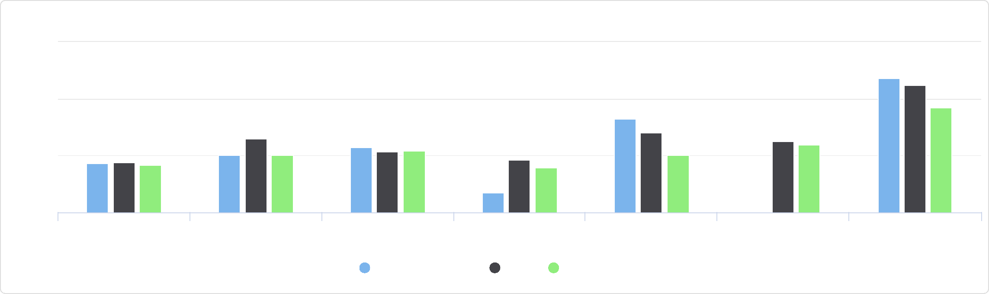

Some Other Race Multiple Race

Asian Native Hawaiian or Pacific

Islander

White Black or African American Native American or Alaska

Native

Population Under Age 18 by Race Alone, Percent

75

Jackson County, IA Iowa United States

%

25

50

0

Population Under Age 18 by Race Alone, Total

This indicator reports the proportion of each race (alone) making up the population under age 18.

|  |  |  |  |  |  |  |  |
| --- | --- | --- | --- | --- | --- | --- | --- |
| **Report Area** | **White** | **Black or African  American** | **Native American or Alaska Native** | **Asian** | **Native Hawaiian or Pacific Islander** | **Some Other Race** | **Multiple  Race** |
| Jackson  County, IA | 4,075 | 25 | 2 | 7 | 54 | 0 | 161 |
| Iowa | 623,749 | 35,657 | 3,070 | 17,386 | 1,100 | 12,163 | 36,907 |
| United States | 49,319,083 | 10,335,967 | 732,763 | 3,509,294 | 147,127 | 4,710,700 | 4,798,306 |

Population Under Age 18 by Race Alone, Total

Jackson County, IA

## Male Population

A total of 9,712 males reside in the report area according to the U.S. Census Bureau American Community Survey 2014‐18 5‐ year estimates. Males represent 50.07% of the total population in the area, which is greater than the national average of 49.24%.

|  |  |  |  |
| --- | --- | --- | --- |
| **Report Area** | **Total Population** | **Male Population** | **Percent Male Population** |
| Jackson County, IA | 19,395 | 9,712 | 50.07% |
| Iowa | 3,132,499 | 1,554,481 | 49.62% |
| United States | 322,903,030 | 158,984,190 | 49.24% |

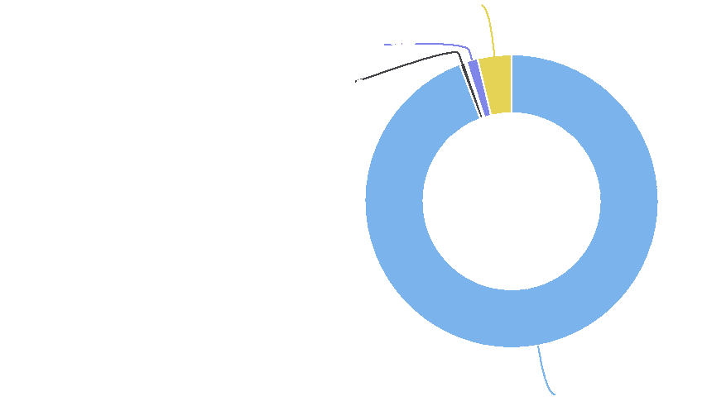

**Multiple Race: 3.7%**

**Native Hawaiian or Pacific Islander: 1.2%**

**Black or African American: 0.6%**

**White: 94.2%**

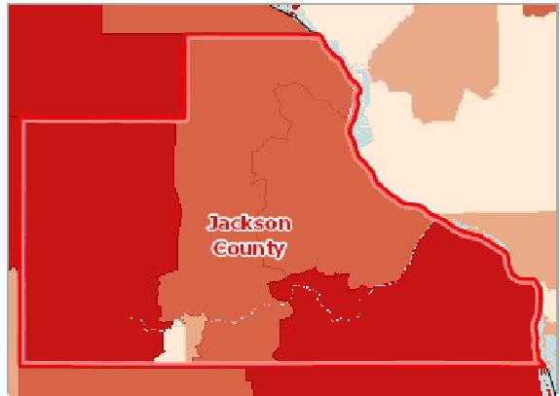

[](https://engagementnetwork.org/map-room/?ids=29309,t11&def=t11:FIPS%20In%20('19097')&bbox=-10120449.27515,5164829.551058,-10034264.57655,5219471.283242) View larger map

**Male Population, Percent by Tract, ACS 2014‐18**

Over 52.0% 50.1 ‐ 52.0% 48.1 ‐ 50.0% Under 48.1% No Male Population Reported No Data or Data Suppressed Jackson County, IA



Male Population by Ethnicity Alone

|  |  |  |  |  |
| --- | --- | --- | --- | --- |
| **Report Area** | **Hispanic or Latino** | **Not Hispanic or Latino** | **Hispanic or Latino, Percent** | **Not Hispanic or Latino, Percent** |
| Jackson County, IA | 154 | 9,558 | 55.80% | 49.99% |
| Iowa | 95,024 | 1,459,457 | 51.84% | 49.49% |
| United States | 29,059,591 | 129,924,599 | 50.52% | 48.96% |

Male Population by Race Alone, Percent

|  |  |  |  |  |  |  |  |
| --- | --- | --- | --- | --- | --- | --- | --- |
| **Report Area** | **White** | **Black or African  American** | **Native American or Alaska Native** | **Asian** | **Native Hawaiian or Pacific  Islander** | **Some Other Race** | **Multiple  Race** |
| Jackson  County, IA | 49.93% | 80.81% | 71.43% | 67.50% | 47.33% | 80.00% | 41.18% |
| Iowa | 49.48% | 53.03% | 50.39% | 49.41% | 48.55% | 53.74% | 48.02% |
| United States | 49.44% | 47.79% | 49.59% | 47.48% | 49.90% | 51.35% | 49.94% |

Male Population by Ethnicity Alone

60

|  |  |  |  |  |  |  |
| --- | --- | --- | --- | --- | --- | --- |
|  | 40  20  0 |  |  |  |  |  |
| % |  |  |  |
|  |  |  |  |
|  |  |  |  |  |  |

Hispanic or Latino Not Hispanic or Latino

Jackson County, IA Iowa United States



Male Population by Race Alone, Percent

100

|  |  |  |  |  |  |  |  |  |  |  |  |  |  |  |  |  |  |  |  |  |  |  |  |  |  |  |  |  |  |  |
| --- | --- | --- | --- | --- | --- | --- | --- | --- | --- | --- | --- | --- | --- | --- | --- | --- | --- | --- | --- | --- | --- | --- | --- | --- | --- | --- | --- | --- | --- | --- |
|  | 75 |  |  |  |  |  |  |  |  |  |  |  |  |  |  |  |  |  |  |  |  |  |  |  |  |  |  |  |  |  |
|  |  |  |  |  |  |  |  |  |  |  |  |  |  |  |  |  |  |  |  |  |  |  |  |  |  |  |  |  |
|  |  |  |  |  |  |  |  |  |  |  |  |  |  |  |  |  |  |  |  |  |  |  |  |  |  |  |  |  |  |
|  |  |  |  |  |  |  |  |  |  |  |  |  |  |  |  |  |  |  |  |  |  |  |  |  |  |  |  |  |  |
| % | 50 |  |  |  |  |  |  |  |  |  |  |  |  |  |  |  |  |  |  |  |  |  |  |  |  |  |  |  |  |
|  |  |  |  |  |  |  |  |  |  |  |  |  |  |  |  |  |  |  |  |  |  |  |  |  |  |  |
|  |  |  |  |  |  |  |  |  |  |  |  |  |  |  |  |  |  |  |  |  |  |  |  |  |  |  |
|  |  |  |  |  |  |  |  |  |  |  |  |  |  |  |  |  |  |  |  |  |  |  |  |  |  |
|  | 25  0 |  |  |  |  |  |  |  |  |  |  |  |  |  |  |  |  |  |  |  |  |  |  |  |  |
|  |  |  |  |  |  |  |  |  |  |  |  |  |  |  |  |  |  |  |  |  |  |  |  |  |
|  |  |  |  |  |  |  |  |  |  |  |  |  |  |  |  |  |  |  |  |  |  |  |  |  |  |  |  |  |  |

White Black or African American Native American or Alaska Asian Native Hawaiian or Pacific Some Other Race Multiple Race

Native Islander

Jackson County, IA Iowa United States



Male Population by Race Alone, Total

|  |  |  |  |  |  |  |  |
| --- | --- | --- | --- | --- | --- | --- | --- |
| **Report Area** | **Non‐Hispanic White** | **Black or African  American** | **Native American or  Alaska Native** | **Asian** | **Native Hawaiian or  Pacific Islander** | **Some Other Race** | **Multiple Race** |
| Jackson County, IA | 9,375 | 80 | 5 | 54 | 62 | 24 | 112 |
| Iowa | 1,399,133 | 58,284 | 5,819 | 37,095 | 1,519 | 21,049 | 31,582 |
| United States | 116,135,803 | 19,555,560 | 1,338,375 | 8,343,752 | 290,789 | 8,108,643 | 5,211,268 |

Male Population by Race Alone, Total

Jackson County, IA

## Population Age 0‐4

Of the estimated 19,395 total population in the report area, an estimated 1,159 are children under the age of 5, representing 5.98% of the population. These data are based on the latest U.S. Census Bureau American Community Survey 5‐year estimates. The number of children under age 5 is relevant because this population has unique needs which should be considered separately from other age groups.

|  |  |  |  |
| --- | --- | --- | --- |
| **Report Area** | **Total Population** | **Population Age 0‐4** | **Percent Population Age 0‐4** |
| Jackson County, IA | 19,395 | 1,159 | 5.98% |
| Iowa | 3,132,499 | 197,430 | 6.30% |
| United States | 322,903,030 | 19,836,850 | 6.14% |

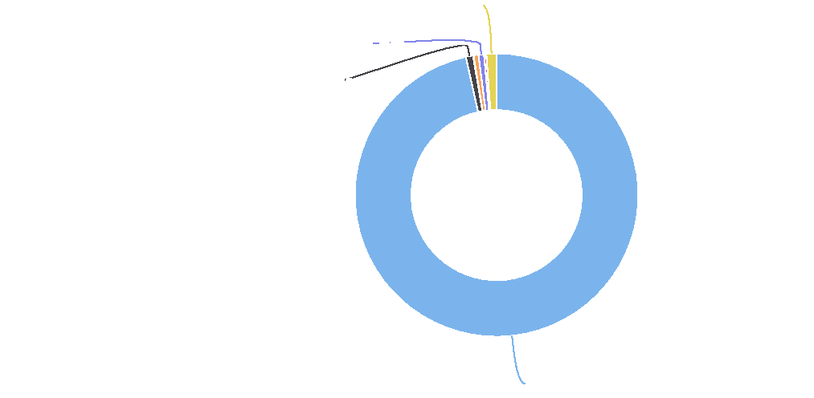

**Multiple Race: 1.2%**

**Native Hawaiian or Pacific Islander: 0.6%**

**Black or African American: 0.8%**

**Non-Hispanic White: 96.5%**

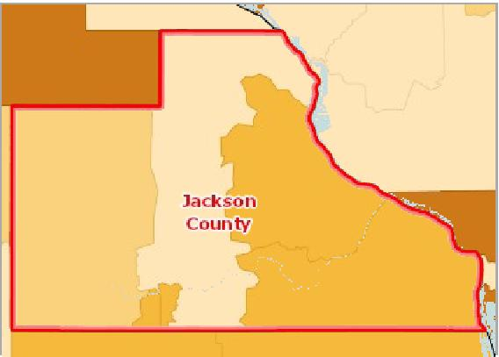

[](https://engagementnetwork.org/map-room/?ids=29199,t11&def=t11:FIPS%20In%20('19097')&bbox=-10120449.27515,5164829.551058,-10034264.57655,5219471.283242) View larger map

**Population Age 0‐4, Percent by Tract, ACS 2014‐18**

Over 7.0%

6.1 ‐ 7.0%

5.1 ‐ 6.0%

Under 5.1%

No Data or Data Suppressed

Jackson County, IA



Population Age 0‐4 by Gender

The table below reports the percentage of the population that is under age 5 by gender. Among the male population in the report area, 6.16% are aged 0‐4 years. Among the female population, 5.79% are aged 0‐4 years.

|  |  |  |  |  |
| --- | --- | --- | --- | --- |
| **Report Area** | **Male** | **Female** | **Male, Percent** | **Female, Percent** |
| Jackson County, IA | 598 | 561 | 6.16% | 5.79% |
| Iowa | 100,506 | 96,924 | 6.47% | 6.14% |
| United States | 10,146,960 | 9,689,890 | 6.38% | 5.91% |

Population Age 0‐4 by Ethnicity Alone

|  |  |  |  |  |
| --- | --- | --- | --- | --- |
| **Report Area** | **Hispanic or Latino** | **Not Hispanic or Latino** | **Hispanic or Latino, Percent** | **Not Hispanic or Latino, Percent** |
| Jackson County, IA | 29 | 1,130 | 10.51% | 5.91% |
| Iowa | 20,543 | 176,887 | 11.21% | 6.00% |
| United States | 5,141,740 | 14,695,110 | 8.94% | 5.54% |

Population Age 0-4 by Gender

7.5

|  |  |  |  |  |  |  |
| --- | --- | --- | --- | --- | --- | --- |
|  | 5  2.5  0 |  |  |  |  |  |
| % |  |  |  |
|  |  |  |  |
|  |  |  |  |  |  |

Male, Percent Female, Percent

Jackson County, IA Iowa United States



Population Age 0-4 by Ethnicity Alone

15

|  |  |  |  |  |  |  |
| --- | --- | --- | --- | --- | --- | --- |
|  | 10  5  0 |  |  |  |  |  |
| % |  |  |  |  |
|  |  |  |  |
|  |  |  |  |  |  |

Hispanic or Latino, Percent Not Hispanic or Latino, Percent

Jackson County, IA Iowa United States



Population Age 0‐4 by Race Alone, Percent

|  |  |  |  |  |  |  |  |
| --- | --- | --- | --- | --- | --- | --- | --- |
| **Report Area** | **White** | **Black or African  American** | **Native American or Alaska  Native** | **Asian** | **Native Hawaiian or Pacific  Islander** | **Some Other  Race** | **Multiple  Race** |
| Jackson County, IA | 5.41% | 9.09% | 0.00% | 0.00% | 16.79% | 0.00% | 41.18% |
| Iowa | 5.87% | 9.34% | 6.49% | 6.13% | 11.57% | 8.72% | 18.30% |
| United States | 5.58% | 6.76% | 7.06% | 5.29% | 6.92% | 8.08% | 14.64% |

Population Age 0‐4 by Race Alone, Total

|  |  |  |  |  |  |  |  |
| --- | --- | --- | --- | --- | --- | --- | --- |
| **Report Area** | **Non‐Hispanic White** | **Black or African  American** | **Native American or Alaska Native** | **Asian** | **Native Hawaiian or Pacific Islander** | **Some Other Race** | **Multiple Race** |
| Jackson  County, IA | 1,016 | 9 | 0 | 0 | 22 | 0 | 112 |
| Iowa | 166,006 | 10,262 | 750 | 4,599 | 362 | 3,414 | 12,037 |
| United States | 13,108,010 | 2,765,798 | 190,673 | 928,870 | 40,305 | 1,275,498 | 1,527,696 |

Population Age 0-4 by Race Alone, Percent

White Black or African American Native American or Alaska Asian Native Hawaiian or Pacific Some Other Race Multiple Race

Native Islander

60

Jackson County, IA Iowa United States



40

%

20

0

Population Age 0-4 by Race Alone, Total

Jackson County, IA

## Population Age 5‐17

Of the estimated 19,395 total population in the report area, an estimated 3,165 persons are youth between the ages of 5 and 17, representing 16.32% of the population. These data are based on the latest U.S. Census Bureau American Community Survey 5‐year estimates. The number of young persons in the report area is relevant because this population has needs which should be considered separately from other age groups.

|  |  |  |  |
| --- | --- | --- | --- |
| **Report Area** | **Total Population** | **Population Age 5‐17** | **Population Age 5‐17, Percent** |
| Jackson County, IA | 19,395 | 3,165 | 16.32% |
| Iowa | 3,132,499 | 532,602 | 17.00% |
| United States | 322,903,030 | 53,716,390 | 16.64% |

*Data Source: US Census Bureau,* [*American Community Survey*](http://www.census.gov/acs/www/)*. 2014‐18. Source geography: Tract*

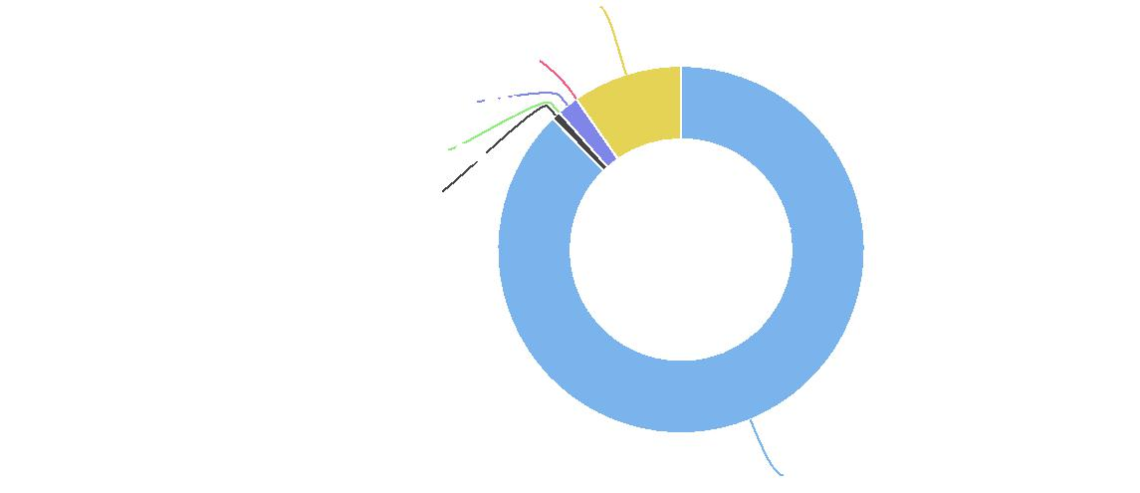

**Multiple Race: 9.7%**

**Some Other Race: 0.0%**

**Native Hawaiian or Pacific Islander: 1.9%**

**Native American or Alaska Native: 0.0%**

**Black or African American: 0.8%**

**Non-Hispanic White: 87.7%**

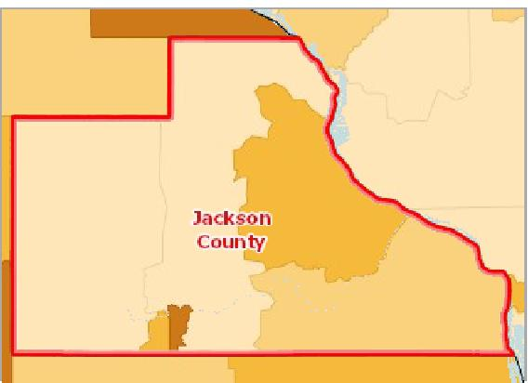

[](https://engagementnetwork.org/map-room/?ids=29200,t11&def=t11:FIPS%20In%20('19097')&bbox=-10120449.27515,5164829.551058,-10034264.57655,5219471.283242) View larger map

**Population Age 5‐17, Percent by Tract, ACS 2014‐18**

Over 19.0%

17.1 ‐ 19.0%

15.1 ‐ 17.0%

Under 15.1%

No Data or Data Suppressed

Jackson County, IA



Population Age 5‐17 by Gender

The table below reports the percentage of the population that is age 5 to 17 by gender. Among the male population in the report area, 16.55% are aged 5‐17 years. Among the female population, 16.09% are aged 5‐17 years.

|  |  |  |  |  |
| --- | --- | --- | --- | --- |
| **Report Area** | **Male** | **Female** | **Male, Percent** | **Female, Percent** |
| Jackson County, IA | 1,607 | 1,558 | 16.55% | 16.09% |
| Iowa | 272,188 | 260,414 | 17.51% | 16.50% |
| United States | 27,438,613 | 26,277,777 | 17.26% | 16.03% |

Population Age 5-17 by Gender

20

|  |  |  |  |  |  |  |
| --- | --- | --- | --- | --- | --- | --- |
|  | 15  10  5  0 |  |  |  |  |  |
| % |  |  |  |
|  |  |  |
|  |  |  |  |
|  |  |  |  |  |  |

Male, Percent Female, Percent

Jackson County, IA Iowa United States



Population Age 5‐17 by Ethnicity Alone

This indicator reports the percentage of population that are at age 5‐17 by ethnicity alone. In the report area, 26.09% of the Hispanic or Latino population and 16.18% of the Non‐Hispanic or Latino population are between the ages of 5‐17.

|  |  |  |  |  |
| --- | --- | --- | --- | --- |
| **Report Area** | **Hispanic or Latino** | **Not Hispanic or Latino** | **Hispanic or Latino, Percent** | **Non‐Hispanic or Latino, Percent** |
| Jackson County, IA | 72 | 3,093 | 26.09% | 16.18% |
| Iowa | 51,953 | 480,649 | 28.34% | 16.30% |
| United States | 13,206,083 | 40,510,307 | 22.96% | 15.26% |

Population Age 5‐17 by Race Alone, Percent

This indicator reports the percentage of each race (alone) making up the population aged 5 ‐ 17.

|  |  |  |  |  |  |  |  |
| --- | --- | --- | --- | --- | --- | --- | --- |
| **Report Area** | **White** | **Black or African  American** | **Native American or Alaska Native** | **Asian** | **Native Hawaiian or Pacific  Islander** | **Some Other Race** | **Multiple  Race** |
| Jackson  County, IA | 16.29% | 16.16% | 28.57% | 8.75% | 24.43% | 0.00% | 18.01% |
| **Iowa** | **16.19%** | **23.11%** | **20.09%** | **17.03%** | **23.59%** | **22.34%** | **37.81%** |
| United States | 15.42% | 18.50% | 20.08% | 14.68% | 18.33% | 21.76% | 31.34% |

Population Age 5-17 by Ethnicity Alone

30

|  |  |  |  |  |  |  |
| --- | --- | --- | --- | --- | --- | --- |
|  | 20  10  0 |  |  |  |  |  |
| % |  |  |  |  |
|  |  |  |  |
|  |  |  |  |  |  |

Hispanic or Latino, Percent Non-Hispanic or Latino, Percent

Jackson County, IA Iowa United States



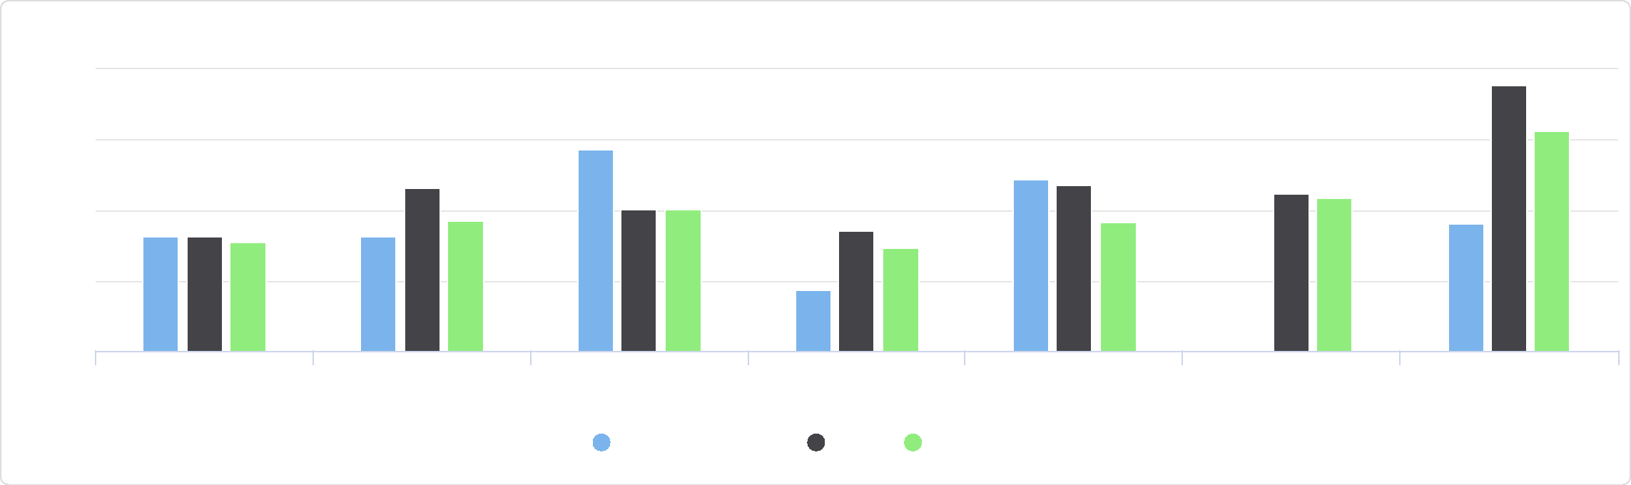

%

20

Some Other Race Multiple Race

Asian Native Hawaiian or Pacific

Islander

White Black or African American Native American or Alaska

Native

Population Age 5-17 by Race Alone, Percent

Jackson County, IA Iowa United States

40

30

10

0

Population Age 5‐17 by Race Alone, Total

This indicator reports the proportion of each race (alone) making up the population aged 5 ‐ 17.

|  |  |  |  |  |  |  |  |
| --- | --- | --- | --- | --- | --- | --- | --- |
| **Report Area** | **White** | **Black or African  American** | **Native American or Alaska Native** | **Asian** | **Native Hawaiian or Pacific Islander** | **Some Other Race** | **Multiple  Race** |
| Jackson  County, IA | 3,059 | 16 | 2 | 7 | 32 | 0 | 49 |
| Iowa | 457,743 | 25,395 | 2,320 | 12,787 | 738 | 8,749 | 24,870 |
| United States | 36,211,073 | 7,570,169 | 542,090 | 2,580,424 | 106,822 | 3,435,202 | 3,270,610 |

Population Age 5-17 by Race Alone, Total

Jackson County, IA

## Population Age 18‐64

Of the estimated 19,395 total population in the report area, an estimated 11,145 persons are between the ages of 18 and 64, representing 57.46% of the population. These data are based on the latest U.S. Census Bureau American Community Survey 5‐ year estimates. The number of adults in the report area is relevant because this population has unique needs which should be considered separately from other age groups.

|  |  |  |  |
| --- | --- | --- | --- |
| **Report Area** | **Total Population** | **Population Age 18‐64** | **Population Age 18‐64, Percent** |
| Jackson County, IA | 19,395 | 11,145 | 57.46% |
| Iowa | 3,132,499 | 1,889,155 | 60.31% |
| United States | 322,903,030 | 200,111,209 | 61.97% |

*Data Source: US Census Bureau,* [*American Community Survey*](http://www.census.gov/acs/www/)*. 2014‐18. Source geography: Tract*

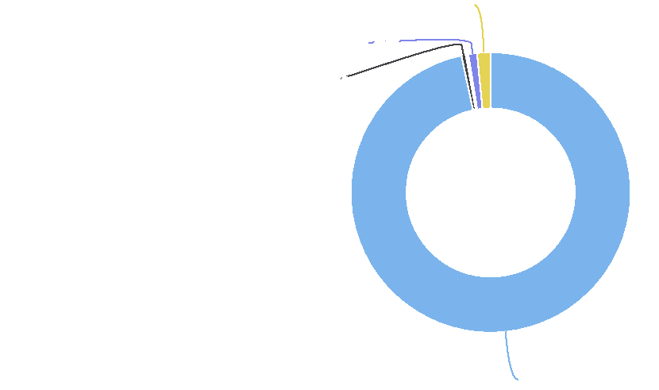

**Multiple Race: 1.5%**

**Native Hawaiian or Pacific Islander: 1.0%**

**Black or African American: 0.5%**

**White: 96.7%**

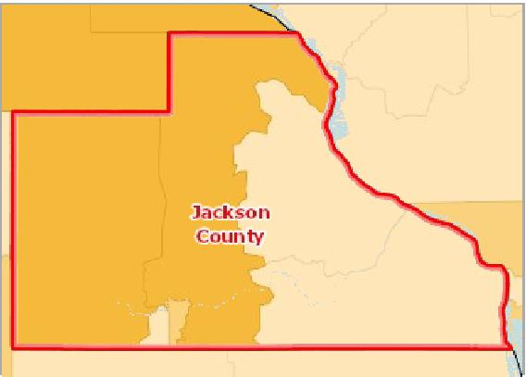

[](https://engagementnetwork.org/map-room/?ids=29201,t11&def=t11:FIPS%20In%20('19097')&bbox=-10120449.27515,5164829.551058,-10034264.57655,5219471.283242) View larger map

**Population Age 18‐64, Percent by Tract, ACS 2014‐18**

Over 63.0%

60.1 ‐ 63.0%

57.1 ‐ 60.0%

Under 57.1%

No Data or Data Suppressed

Jackson County, IA



Population Age 18‐64 by Gender

The table below reports the percentage of the population that is age 18 to 64 by gender. Among the male population in the report area, 59.06% are aged 18‐64 years. Among the female population, 55.86% are aged 18‐64 years.

|  |  |  |  |  |
| --- | --- | --- | --- | --- |
| **Report Area** | **Male  Age 18‐64** | **Female  Age 18‐64** | **Male Age 18‐64, Percent** | **Female Age 18‐64, Percent** |
| Jackson County, IA | 5,736 | 5,409 | 59.06% | 55.86% |
| Iowa | 954,447 | 934,708 | 61.40% | 59.23% |
| United States | 99,617,317 | 100,493,892 | 62.66% | 61.31% |

Population Age 18-64 by Gender

Population Age 18‐64 by Ethnicity Alone

This indicator reports the percentage of population that are at age 18 to 64 by ethnicity alone. In the report area, 53.62% of Hispanic / Latino population are at age 18‐64, and 57.52% of non Hispanic / Latino population are at age 18‐64.

|  |  |  |  |  |
| --- | --- | --- | --- | --- |
| **Report Area** | **Hispanic or Latino  Age 18‐64** | **Not Hispanic or Latino  Age 18‐64** | **Hispanic or Latino  Age 18‐64, Percent** | **Not Hispanic or Latino Age 18‐64, Percent** |
| Jackson County, IA | 148 | 10,997 | 53.62% | 57.52% |
| Iowa | 104,914 | 1,784,241 | 57.24% | 60.50% |
| United States | 35,214,538 | 164,896,671 | 61.22% | 62.13% |

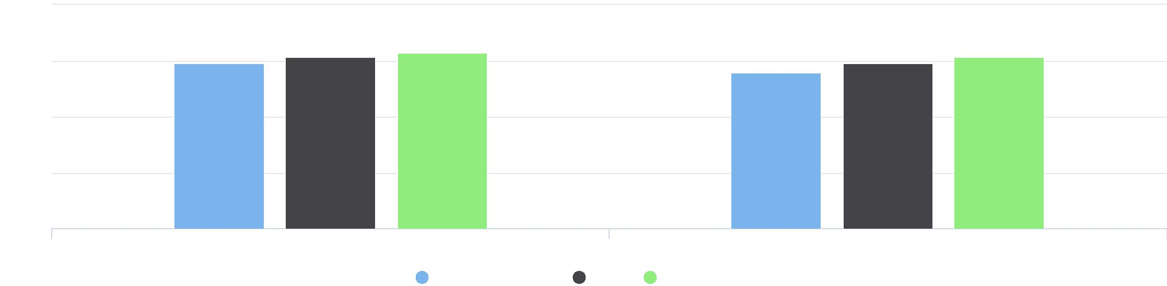

80

60

%

40

20

0

Percent of Males Percent of Female

Jackson County, IA Iowa United States

Population Age 18-64 by Ethnicity Alone

Population Age 18‐64 by Ethnicity Alone

This indicator reports the percentage of population that are between the ages of 18 – 64 by ethnicity alone. In the report area, 1.33% of Hispanic / Latino population and 98.67% of non Hispanic / Latino population are between the ages of 18 – 64.

|  |  |  |  |  |
| --- | --- | --- | --- | --- |
| **Report Area** | **Hispanic or Latino  Age 18+** | **Not Hispanic or Latino  Age 18+** | **Hispanic or Latino  Age 18+, Percent** | **Not Hispanic or Latino Age 18+, Percent** |
| Jackson County, IA | 148 | 10,997 | 1.33% | 98.67% |
| Iowa | 104,914 | 1,784,241 | 5.55% | 94.45% |
| United States | 35,214,538 | 164,896,671 | 17.60% | 82.40% |

Population Age 18-64 by Ethnicity Alone

Jackson County, IA

**Not Hispanic / Latino: 98.7%**

Population Age 18‐64 by Race Alone, Percent

This indicator reports the percentage of population that are at age 18 to 64 by race alone.

|  |  |  |  |  |  |  |  |
| --- | --- | --- | --- | --- | --- | --- | --- |
| **Report Area** | **White Age 18‐**  **64** | **Black or African  American  Age 18‐64** | **Native American or Alaska**  **Native**  **Age 18‐64** | **Asian Age 18‐**  **64** | **Native Hawaiian or Pacific**  **Islander**  **Age 18‐64** | **Some Other  Race  Age 18‐64** | **Multiple  Race  Age 18‐64** |
| Jackson  County, IA | 57.56% | 74.75% | 71.43% | 57.50% | 58.78% | 100.00% | 38.60% |
| Iowa | 60.30% | 62.15% | 64.04% | 71.05% | 61.30% | 66.02% | 41.11% |
| United States | 61.57% | 63.86% | 62.96% | 68.03% | 66.38% | 64.63% | 48.96% |

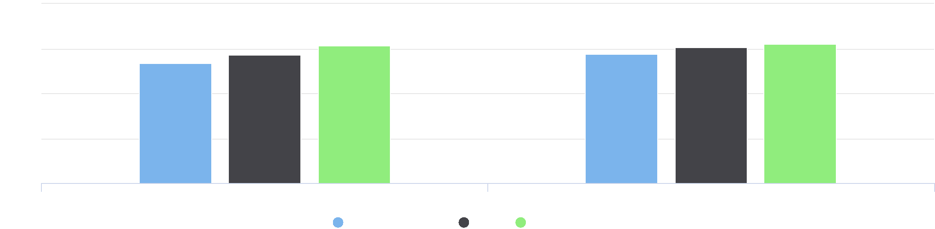

80

60

%

40

20

0

Hispanic / Latino Not Hispanic / Latino

Jackson County, IA Iowa United States



**Hispanic / Latino: 1.3%**

Population Age 18-64 by Race Alone, Percent

150

100









%

50

0

|  |  |  |
| --- | --- | --- |
| White Black or African American Native American / Alaska  Native | Asian Native Hawaiian / Pacific  Islander | Some Other Race Multiple Race |

Jackson County, IA Iowa United States



Population Age 18‐64 by Race Alone, Total

This indicator reports the proportion of each race (alone) making up the population aged 18 to 64.

|  |  |  |  |  |  |  |  |
| --- | --- | --- | --- | --- | --- | --- | --- |
| **Report Area** | **White  Age 18‐64** | **Black or African  American  Age 18‐64** | **Native American or Alaska**  **Native**  **Age 18‐64** | **Asian Age 18‐64** | **Native Hawaiian or  Pacific Islander  Age 18‐64** | **Some Other  Race  Age 18‐64** | **Multiple  Race  Age 18‐64** |
| Jackson  County, IA | 10,808 | 74 | 5 | 46 | 77 | 30 | 105 |
| Iowa | 1,705,289 | 68,309 | 7,396 | 53,347 | 1,918 | 25,860 | 27,036 |
| United States | 144,625,680 | 26,128,386 | 1,699,376 | 11,956,623 | 386,792 | 10,205,157 | 5,109,195 |

Population Age 18-64 by Race Alone, Total

Jackson County, IA

## Population Age 18‐24

Of the estimated 19,395 total population in the report area, an estimated 1,439 persons are between the ages of 18 and 24, representing 7.42% of the population. These data are based on the latest U.S. Census Bureau American Community Survey 5‐ year estimates. The number of young adults in the report area is relevant because this population has unique needs which should be considered separately from other age groups.

|  |  |  |  |
| --- | --- | --- | --- |
| **Report Area** | **Total Population** | **Population Age 18‐24** | **Percent Population Age 18‐24** |
| Jackson County, IA | 19,395 | 1,439 | 7.42% |
| Iowa | 3,132,499 | 321,094 | 10.25% |
| United States | 322,903,030 | 30,903,719 | 9.57% |

*Data Source: US Census Bureau,* [*American Community Survey*](http://www.census.gov/acs/www/)*. 2014‐18. Source geography: Tract*

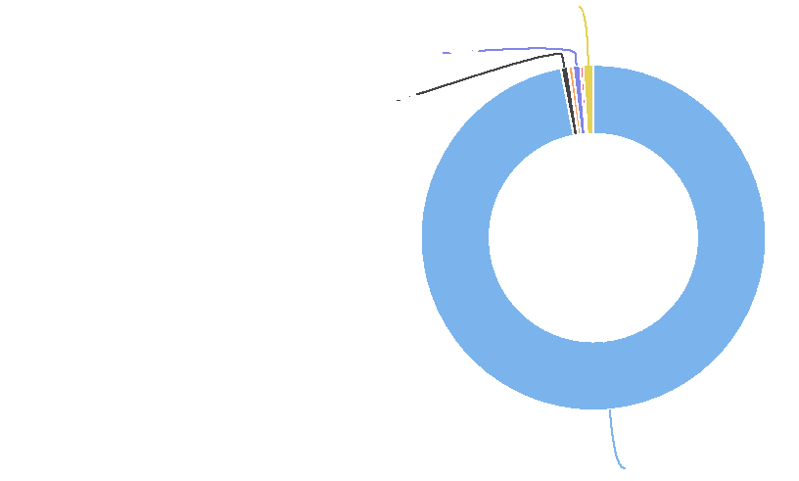

**Multiple Race: 0.9%**

**Native Hawaiian / Pacific Islander: 0.7%**

**Black or African American: 0.7%**

**White: 97.0%**

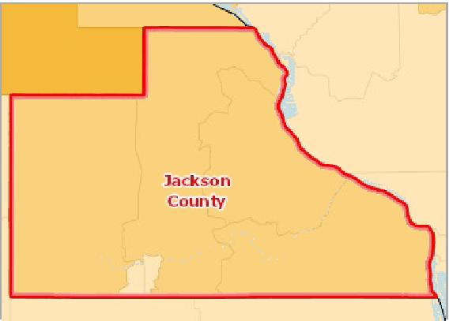

[](https://engagementnetwork.org/map-room/?ids=29202,t11&def=t11:FIPS%20In%20('19097')&bbox=-10120449.27515,5164829.551058,-10034264.57655,5219471.283242) View larger map

**Population Age 18‐24, Percent by Tract, ACS 2014‐18**

Over 11.0%

9.1 ‐ 11.0%

7.1 ‐ 9.0%

Under 7.1%

No Data or Data Suppressed

Jackson County, IA



Population Age 18‐24 by Gender

The table below reports the percentage of the population that is age 18 to 24 by gender. Among the male population in the report area, 8.02% are aged 18‐24 years. Among the female population, 6.82% are aged 18‐24 years.

|  |  |  |  |  |
| --- | --- | --- | --- | --- |
| **Report Area** | **Male** | **Female** | **Male, Percent** | **Female, Percent** |
| Jackson County, IA | 779 | 660 | 8.02% | 6.82% |
| Iowa | 165,297 | 155,797 | 10.63% | 9.87% |
| United States | 15,846,667 | 15,057,052 | 9.97% | 9.19% |

Population Age 18‐24 by Ethnicity Alone

|  |  |  |  |  |
| --- | --- | --- | --- | --- |
| **Report Area** | **Hispanic or Latino** | **Not Hispanic or Latino** | **Hispanic or Latino, Percent** | **Not Hispanic or Latino, Percent** |
| Jackson County, IA | 11 | 1,428 | 3.99% | 7.47% |
| Iowa | 24,160 | 296,934 | 13.18% | 10.07% |
| United States | 6,710,463 | 24,193,256 | 11.67% | 9.12% |

Population Age 18-24 by Gender

12.5

|  |  |  |  |  |  |
| --- | --- | --- | --- | --- | --- |
|  | 10 7.5 5 2.5  0 |  |  |  |  |
|  |  |  |  |
| % |  |  |
|  |  |  |
|  |  |  |
|  |  |  |  |  |

Male, Percent Female, Percent

Jackson County, IA Iowa United States



Population Age 18-24 by Ethnicity Alone

Population Age 18‐24 by Race Alone, Percent

|  |  |  |  |  |  |  |  |
| --- | --- | --- | --- | --- | --- | --- | --- |
| **Report Area** | **White** | **Black or African  American** | **Native American or Alaska  Native** | **Asian** | **Native Hawaiian or Pacific  Islander** | **Some Other  Race** | **Multiple  Race** |
| Jackson  County, IA | 7.23% | 0.00% | 0.00% | 0.00% | 3.82% | 0.00% | 27.94% |
| Iowa | 9.76% | 14.24% | 11.88% | 17.23% | 7.51% | 14.64% | 13.95% |
| United States | 8.95% | 11.29% | 11.12% | 9.69% | 12.07% | 12.05% | 12.37% |

Population Age 18‐24 by Race Alone, Total

|  |  |  |  |  |  |  |  |
| --- | --- | --- | --- | --- | --- | --- | --- |
| **Report Area** | **Non‐Hispanic White** | **Black or African  American** | **Native American or  Alaska Native** | **Asian** | **Native Hawaiian or  Pacific Islander** | **Some Other Race** | **Multiple Race** |
| Jackson County, IA | 1,358 | 0 | 0 | 0 | 5 | 0 | 76 |
| Iowa | 275,994 | 15,648 | 1,372 | 12,940 | 235 | 5,733 | 9,172 |
| United States | 21,018,470 | 4,617,941 | 300,265 | 1,703,132 | 70,328 | 1,903,045 | 1,290,538 |

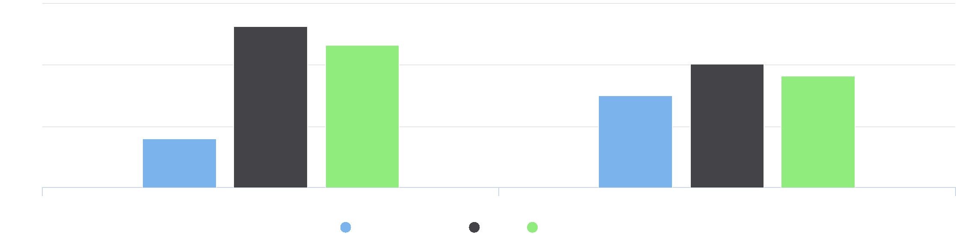

15

Hispanic or Latino, Percent Not Hispanic or Latino, Percent

Jackson County, IA Iowa United States

%

10

0

5

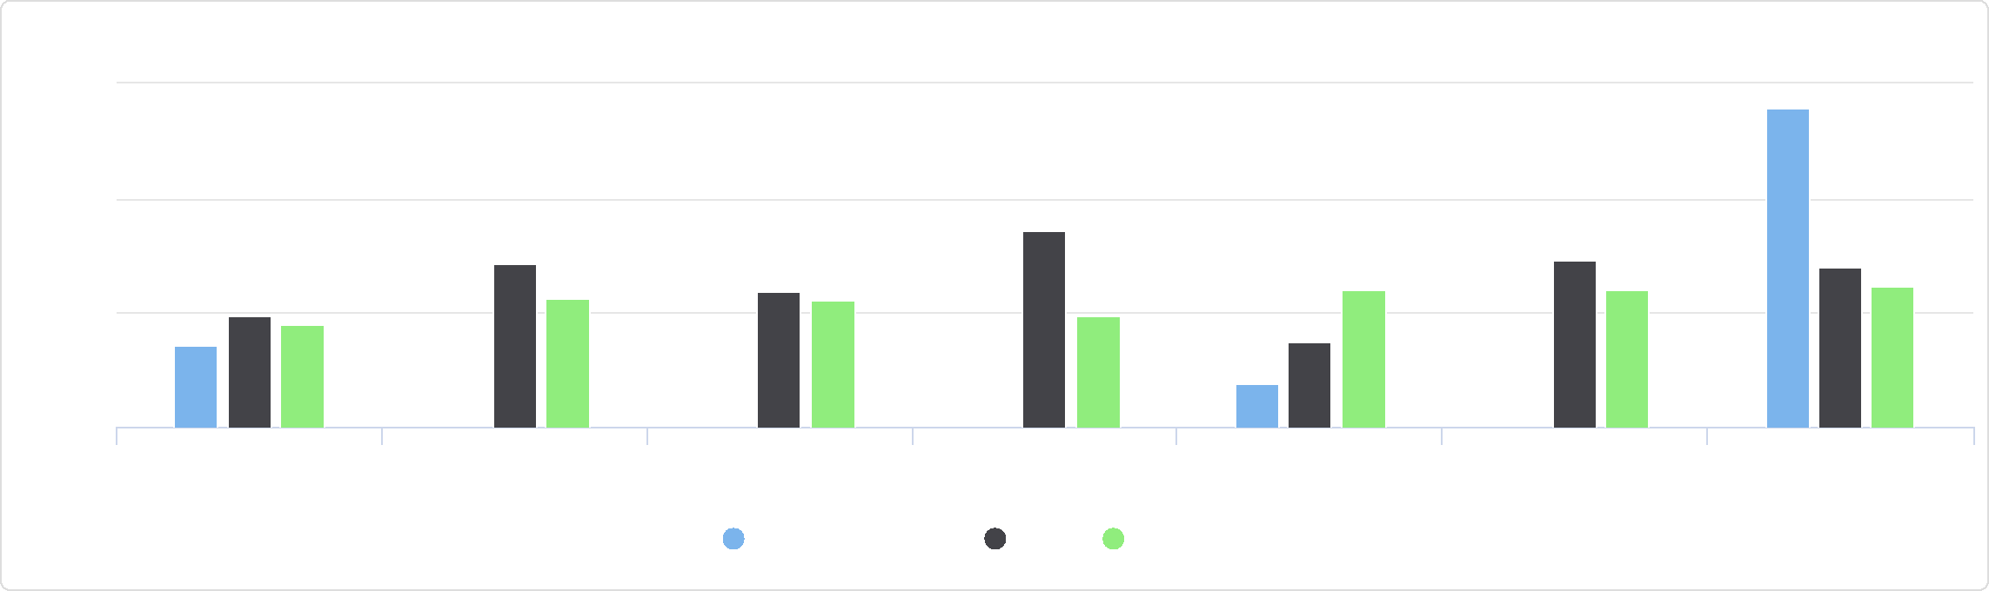

Some Other Race Multiple Race

Asian Native Hawaiian or Pacific

Islander

White Black or African American Native American or Alaska

Native

Population Age 18-24 by Race Alone, Percent

30

Jackson County, IA Iowa United States

%

20

10

0

Population Age 18-24 by Race Alone, Total

Jackson County, IA

## Population Age 25‐34

Of the estimated 19,395 total population in the report area, an estimated 1,917 persons are between the ages of 25 and 34, representing 9.88% of the population. These data are based on the latest U.S. Census Bureau American Community Survey 5‐ year estimates. The number of young adults in the report area is relevant because this population has unique needs which should be considered separately from other age groups.

|  |  |  |  |
| --- | --- | --- | --- |
| **Report Area** | **Total Population** | **Population Age 25‐34** | **Percent Population Age 25‐34** |
| Jackson County, IA | 19,395 | 1,917 | 9.88% |
| Iowa | 3,132,499 | 393,533 | 12.56% |
| United States | 322,903,030 | 44,567,976 | 13.80% |

*Data Source: US Census Bureau,* [*American Community Survey*](http://www.census.gov/acs/www/)*. 2014‐18. Source geography: Tract*

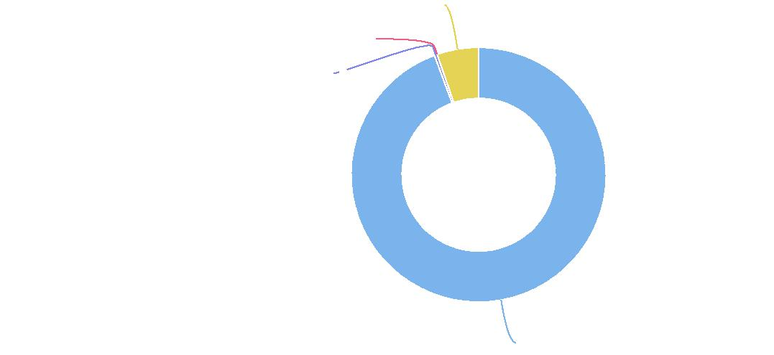

**Multiple Race: 5.3%**

**Some Other Race: 0.0%**

**Native Hawaiian or Pacific Islander: 0.3%**

**Non-Hispanic White: 94.4%**

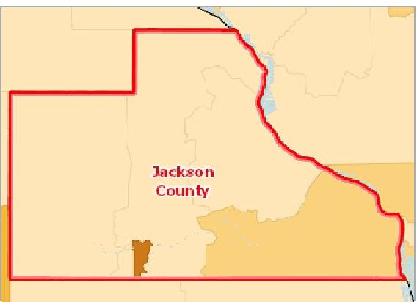

[](https://engagementnetwork.org/map-room/?ids=29203,t11&def=t11:FIPS%20In%20('19097')&bbox=-10120449.27515,5164829.551058,-10034264.57655,5219471.283242) View larger map

**Population Age 25‐34, Percent by Tract, ACS 2014‐18**

Over 14.0%

12.1 ‐ 14.0%

10.1 ‐ 12.0%

Under 10.1%

No Data or Data Suppressed

Jackson County, IA



Population Age 25‐34 by Gender

The table below reports the percentage of the population that is age 25 to 34 by gender. Among the male population in the report area, 10.31% are aged 25‐34 years. Among the female population, 9.46% are aged 25‐34 years.

|  |  |  |  |  |
| --- | --- | --- | --- | --- |
| **Report Area** | **Male** | **Female** | **Male, Percent** | **Female, Percent** |
| Jackson County, IA | 1,001 | 916 | 10.31% | 9.46% |
| Iowa | 200,831 | 192,702 | 12.92% | 12.21% |
| United States | 22,550,492 | 22,017,484 | 14.18% | 13.43% |

Population Age 25-34 by Gender

15

|  |  |  |  |  |  |  |
| --- | --- | --- | --- | --- | --- | --- |
|  | 10  5  0 |  |  |  |  |  |
| % |  |  |  |
|  |  |  |  |
|  |  |  |  |  |  |

Male, Percent Female, Percent

Jackson County, IA Iowa United States



Population Age 25‐34 by Ethnicity Alone

|  |  |  |  |  |
| --- | --- | --- | --- | --- |
| **Report Area** | **Hispanic or Latino** | **Not Hispanic or Latino** | **Hispanic or Latino, Percent** | **Not Hispanic or Latino, Percent** |
| Jackson County, IA | 39 | 1,878 | 14.13% | 9.82% |
| Iowa | 27,918 | 365,615 | 15.23% | 12.40% |
| United States | 9,110,263 | 35,457,713 | 15.84% | 13.36% |

Population Age 25‐34 by Race Alone, Percent

|  |  |  |  |  |  |  |  |
| --- | --- | --- | --- | --- | --- | --- | --- |
| **Report Area** | **White** | **Black or African  American** | **Native American or Alaska Native** | **Asian** | **Native Hawaiian or Pacific  Islander** | **Some Other Race** | **Multiple  Race** |
| Jackson  County, IA | 9.85% | 7.07% | 0.00% | 27.50% | 19.85% | 20.00% | 2.21% |
| Iowa | 12.14% | 17.51% | 15.09% | 19.77% | 21.44% | 16.61% | 11.05% |
| United States | 13.11% | 15.00% | 14.80% | 17.18% | 17.76% | 17.16% | 13.52% |

Population Age 25-34 by Ethnicity Alone

20

|  |  |  |  |  |  |
| --- | --- | --- | --- | --- | --- |
|  | 15  10  5  0 |  |  |  |  |
| % |  |  |  |
|  |  |
|  |  |  |
|  |  |  |  |  |

Hispanic or Latino, Percent Not Hispanic or Latino, Percent

Jackson County, IA Iowa United States



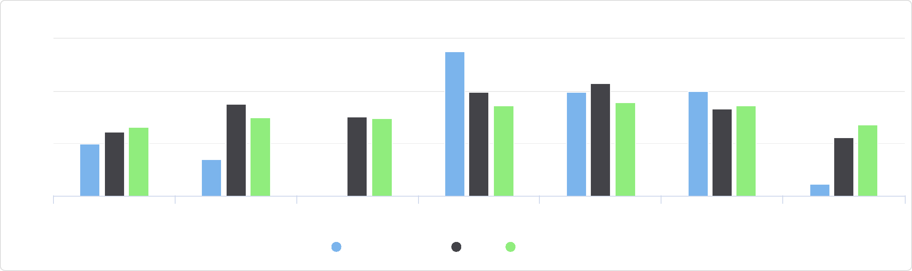

Some Other Race Multiple Race

Asian Native Hawaiian or Pacific

Islander

White Black or African American Native American or Alaska

Native

Population Age 25-34 by Race Alone, Percent

30

Jackson County, IA Iowa United States

%

20

10

0

Population Age 25‐34 by Race Alone, Total

|  |  |  |  |  |  |  |  |
| --- | --- | --- | --- | --- | --- | --- | --- |
| **Report Area** | **Non‐Hispanic White** | **Black or African  American** | **Native American or  Alaska Native** | **Asian** | **Native Hawaiian or  Pacific Islander** | **Some Other Race** | **Multiple Race** |
| Jackson County, IA | 1,850 | 7 | 0 | 22 | 26 | 6 | 6 |
| Iowa | 343,260 | 19,244 | 1,743 | 14,846 | 671 | 6,504 | 7,265 |
| United States | 30,788,591 | 6,136,316 | 399,364 | 3,019,418 | 103,467 | 2,709,570 | 1,411,250 |

Population Age 25-34 by Race Alone, Total

Jackson County, IA

## Population Age 35‐44

Of the estimated 19,395 total population in the report area, an estimated 2,080 persons are between the ages of 35 and 44, representing 10.72% of the population. These data are based on the latest U.S. Census Bureau American Community Survey 5‐ year estimates. The number of adults in the report area is relevant because this population has unique needs which should be considered separately from other age groups.

|  |  |  |  |
| --- | --- | --- | --- |
| **Report Area** | **Total Population** | **Population Age 35‐44** | **Percent Population Age 35‐44** |
| Jackson County, IA | 19,395 | 2,080 | 10.72% |
| Iowa | 3,132,499 | 371,017 | 11.84% |
| United States | 322,903,030 | 40,763,210 | 12.62% |

*Data Source: US Census Bureau,* [*American Community Survey*](http://www.census.gov/acs/www/)*. 2014‐18. Source geography: Tract*

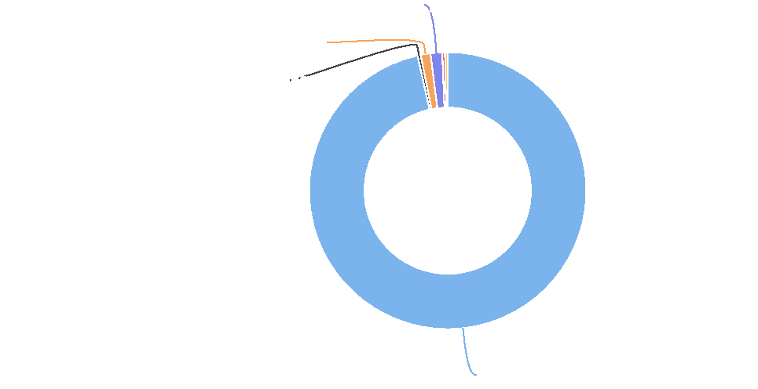

**Native Hawaiian or Pacific Islander: 1.4%**

**Asian: 1.1%**

**Black or African American: 0.4%**

**Non-Hispanic White: 96.5%**

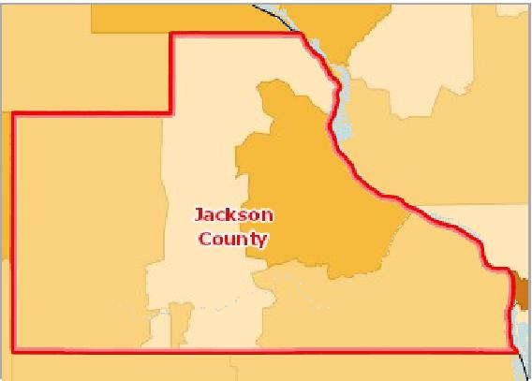

[](https://engagementnetwork.org/map-room/?ids=29204,t11&def=t11:FIPS%20In%20('19097')&bbox=-10120449.27515,5164829.551058,-10034264.57655,5219471.283242) View larger map

**Population Age 35‐44, Percent by Tract, ACS 2014‐18**

Over 14.0%

12.1 ‐ 14.0%

10.1 ‐ 12.0%

Under 10.1%

No Data or Data Suppressed

Jackson County, IA



Population Age 35‐44 by Gender

The table below reports the percentage of the population that is age 35 to 44 by gender. Among the male population in the report area, 11.24% are aged 35‐44 years. Among the female population, 10.20% are aged 35‐44 years.

|  |  |  |  |  |
| --- | --- | --- | --- | --- |
| **Report Area** | **Male** | **Female** | **Male, Percent** | **Female, Percent** |
| Jackson County, IA | 1,092 | 988 | 11.24% | 10.20% |
| Iowa | 188,086 | 182,931 | 12.10% | 11.59% |
| United States | 20,308,605 | 20,454,605 | 12.77% | 12.48% |

Population Age 35‐44 by Ethnicity Alone

|  |  |  |  |  |
| --- | --- | --- | --- | --- |
| **Report Area** | **Hispanic or Latino** | **Not Hispanic or Latino** | **Hispanic or Latino, Percent** | **Not Hispanic or Latino, Percent** |
| Jackson County, IA | 62 | 2,018 | 22.46% | 10.55% |
| Iowa | 24,935 | 346,082 | 13.60% | 11.73% |
| United States | 8,287,301 | 32,475,909 | 14.41% | 12.24% |

Population Age 35-44 by Gender

15

|  |  |  |  |  |  |  |
| --- | --- | --- | --- | --- | --- | --- |
|  | 10  5  0 |  |  |  |  |  |
| % |  |  |  |
|  |  |  |  |
|  |  |  |  |  |  |

Male, Percent Female, Percent

Jackson County, IA Iowa United States



Population Age 35-44 by Ethnicity Alone

30

|  |  |  |  |  |  |  |
| --- | --- | --- | --- | --- | --- | --- |
|  | 20  10  0 |  |  |  |  |  |
| % |  |  |  |  |
|  |  |  |  |
|  |  |  |  |  |  |

Hispanic or Latino, Percent Not Hispanic or Latino, Percent

Jackson County, IA Iowa United States



Population Age 35‐44 by Race Alone, Percent

|  |  |  |  |  |  |  |  |
| --- | --- | --- | --- | --- | --- | --- | --- |
| **Report Area** | **White** | **Black or African  American** | **Native American or Alaska Native** | **Asian** | **Native Hawaiian or Pacific  Islander** | **Some Other Race** | **Multiple  Race** |
| Jackson  County, IA | 10.44% | 66.67% | 0.00% | 13.75% | 9.16% | 80.00% | 2.57% |
| Iowa | 11.69% | 12.89% | 13.62% | 17.00% | 18.18% | 16.73% | 7.44% |
| United States | 12.22% | 12.94% | 12.91% | 16.21% | 14.62% | 15.63% | 9.73% |

Population Age 35‐44 by Race Alone, Total

|  |  |  |  |  |  |  |  |
| --- | --- | --- | --- | --- | --- | --- | --- |
| **Report Area** | **Non‐Hispanic White** | **Black or African  American** | **Native American or  Alaska Native** | **Asian** | **Native Hawaiian or  Pacific Islander** | **Some Other Race** | **Multiple Race** |
| Jackson County, IA | 1,960 | 66 | 0 | 11 | 12 | 24 | 7 |
| Iowa | 330,498 | 14,166 | 1,573 | 12,762 | 569 | 6,553 | 4,896 |
| United States | 28,705,780 | 5,292,518 | 348,503 | 2,848,710 | 85,173 | 2,467,274 | 1,015,252 |

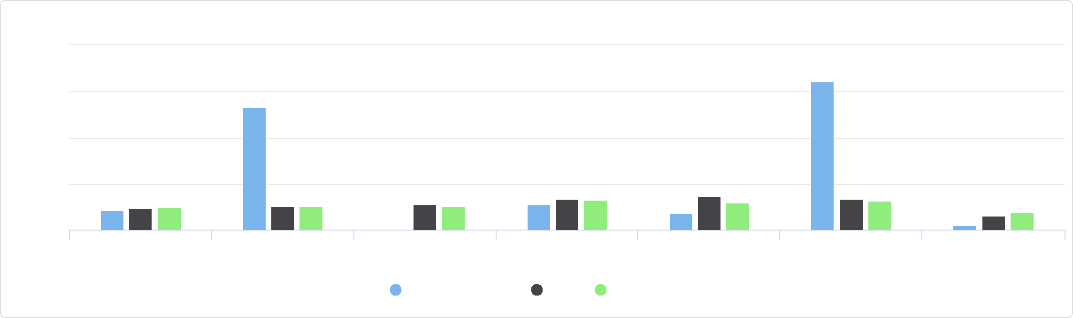

Some Other Race Multiple Race

Asian Native Hawaiian or Pacific

Islander

White Black or African American Native American or Alaska

Native

Population Age 35-44 by Race Alone, Percent

100

Jackson County, IA Iowa United States

%

25

75

50

0

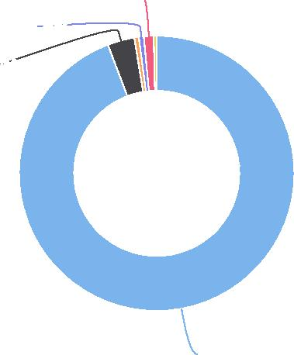

Jackson County, IA

## Population Age 45‐54

Of the estimated 19,395 total population in the report area, an estimated 2,700 persons are between the ages of 45 and 54, representing 13.92% of the population. These data are based on the latest U.S. Census Bureau American Community Survey 5‐ year estimates. The number of adults in the report area is relevant because this population has unique needs which should be considered separately from other age groups.

|  |  |  |  |
| --- | --- | --- | --- |
| **Report Area** | **Total Population** | **Population Age 45‐54** | **Percent Population Age 45‐54** |
| Jackson County, IA | 19,395 | 2,700 | 13.92% |
| Iowa | 3,132,499 | 389,588 | 12.44% |
| United States | 322,903,030 | 42,589,573 | 13.19% |

*Data Source: US Census Bureau,* [*American Community Survey*](http://www.census.gov/acs/www/)*. 2014‐18. Source geography: Tract*

**Some Other Race: 1.2%**

**Native Hawaiian or Pacific Islander: 0.6%**

**Black or African American: 3.2%**

**Non-Hispanic White: 94.2%**

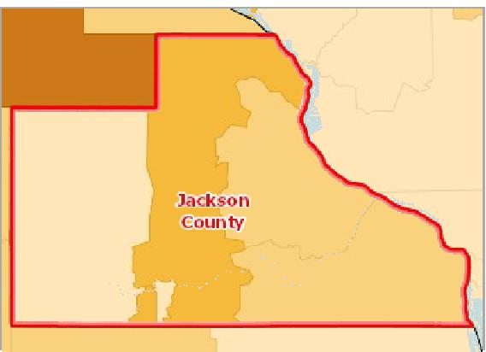

[](https://engagementnetwork.org/map-room/?ids=29205,t11&def=t11:FIPS%20In%20('19097')&bbox=-10120449.27515,5164829.551058,-10034264.57655,5219471.283242) View larger map

**Population Age 45‐54, Percent by Tract, ACS 2014‐18**

Over 17.0%

15.1 ‐ 17.0%

13.1 ‐ 15.0%

Under 13.1%

No Data or Data Suppressed

Jackson County, IA



Population Age 45‐54 by Gender

The table below reports the percentage of the population that is age 45 to 54 by gender. Among the male population in the report area, 13.69% are aged 45‐54 years. Among the female population, 14.15% are aged 45‐54 years.

|  |  |  |  |  |
| --- | --- | --- | --- | --- |
| **Report Area** | **Male** | **Female** | **Male, Percent** | **Female, Percent** |
| Jackson County, IA | 1,330 | 1,370 | 13.69% | 14.15% |
| Iowa | 195,176 | 194,412 | 12.56% | 12.32% |
| United States | 20,998,089 | 21,591,484 | 13.21% | 13.17% |

Population Age 45-54 by Gender

15

|  |  |  |  |  |  |  |
| --- | --- | --- | --- | --- | --- | --- |
|  | 10  5  0 |  |  |  |  |  |
| % |  |  |  |
|  |  |  |  |
|  |  |  |  |  |  |

Male, Percent Female, Percent

Jackson County, IA Iowa United States



Population Age 45‐54 by Ethnicity Alone

|  |  |  |  |  |
| --- | --- | --- | --- | --- |
| **Report Area** | **Hispanic or Latino** | **Not Hispanic or Latino** | **Hispanic or Latino, Percent** | **Not Hispanic or Latino, Percent** |
| Jackson County, IA | 15 | 2,685 | 5.43% | 14.04% |
| Iowa | 17,712 | 371,876 | 9.66% | 12.61% |
| United States | 6,648,870 | 35,940,703 | 11.56% | 13.54% |

Population Age 45‐54 by Race Alone, Percent

|  |  |  |  |  |  |  |  |
| --- | --- | --- | --- | --- | --- | --- | --- |
| **Report Area** | **White** | **Black or African  American** | **Native American or Alaska Native** | **Asian** | **Native Hawaiian or Pacific  Islander** | **Some Other Race** | **Multiple  Race** |
| Jackson  County, IA | 14.19% | 1.01% | 71.43% | 5.00% | 16.79% | 0.00% | 1.10% |
| Iowa | 12.74% | 10.30% | 11.66% | 10.85% | 8.37% | 12.00% | 5.34% |
| United States | 13.50% | 13.00% | 12.72% | 13.80% | 11.96% | 12.21% | 7.54% |

Population Age 45-54 by Ethnicity Alone

15

|  |  |  |  |  |  |
| --- | --- | --- | --- | --- | --- |
|  | 10  5  0 |  |  |  |  |
| % |  |  |
|  |  |  |
|  |  |  |  |  |

Hispanic or Latino, Percent Not Hispanic or Latino, Percent

Jackson County, IA Iowa United States



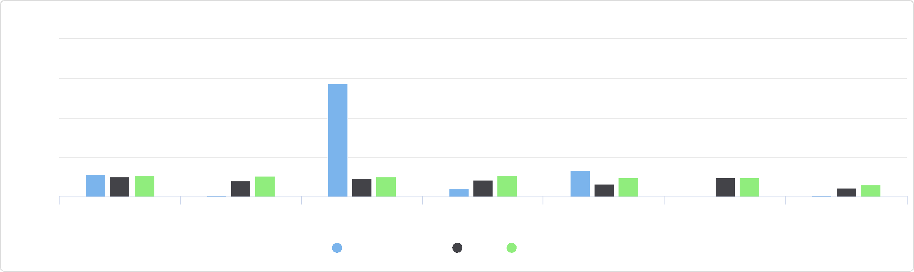

Some Other Race Multiple Race

Asian Native Hawaiian or Pacific

Islander

White Black or African American Native American or Alaska

Native

Population Age 45-54 by Race Alone, Percent

100

75

Jackson County, IA Iowa United States

%

25

50

0

|  |  |  |  |  |  |  |  |
| --- | --- | --- | --- | --- | --- | --- | --- |
| **Report Area** | **Non‐Hispanic White** | **Black or African  American** | **Native American or  Alaska Native** | **Asian** | **Native Hawaiian or  Pacific Islander** | **Some Other Race** | **Multiple Race** |
| Jackson County, IA | 2,665 | 1 | 5 | 4 | 22 | 0 | 3 |
| Iowa | 360,294 | 11,322 | 1,347 | 8,149 | 262 | 4,700 | 3,514 |
| United States | 31,716,241 | 5,320,138 | 343,247 | 2,425,021 | 69,678 | 1,928,589 | 786,659 |

Population Age 45-54 by Race Alone, Total

Jackson County, IA

## Population Age 55‐64

Of the estimated 19,395 total population in the report area, an estimated 3,009 persons are between the ages of 55 and 64, representing 15.51% of the population. These data are based on the latest U.S. Census Bureau American Community Survey 5‐ year estimates. The number of adults in the report area is relevant because this population has unique needs which should be considered separately from other age groups.

|  |  |  |  |
| --- | --- | --- | --- |
| **Report Area** | **Total Population** | **Population Age 55‐64** | **Percent Population Age 55‐64** |
| Jackson County, IA | 19,395 | 3,009 | 15.51% |
| Iowa | 3,132,499 | 413,923 | 13.21% |
| United States | 322,903,030 | 41,286,731 | 12.79% |

*Data Source: US Census Bureau,* [*American Community Survey*](http://www.census.gov/acs/www/)*. 2014‐18. Source geography: Tract*

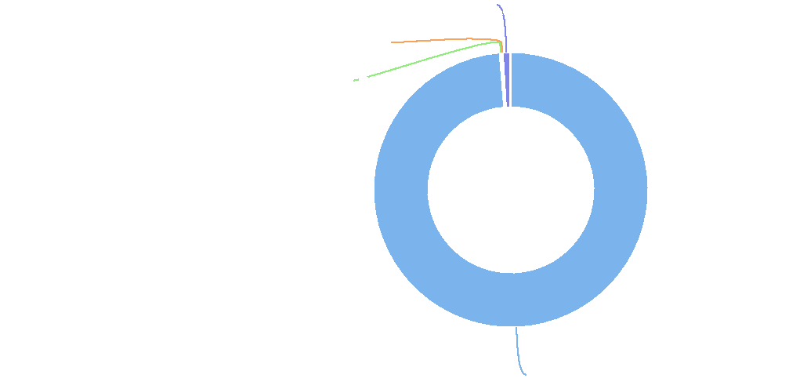

**Native Hawaiian or Pacific Islander: 0.8%**

**Asian: 0.1%**

**Native American or Alaska Native: 0.2%**

**Non-Hispanic White: 98.7%**

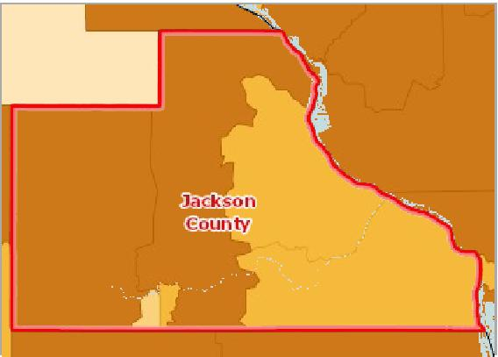

[](https://engagementnetwork.org/map-room/?ids=29206,t11&def=t11:FIPS%20In%20('19097')&bbox=-10120449.27515,5164829.551058,-10034264.57655,5219471.283242) View larger map

**Population Age 55‐64, Percent by Tract, ACS 2014‐18**

Over 15.0%

13.1 ‐ 15.0%

11.1 ‐ 13.0%

Under 11.1%

No Data or Data Suppressed

Jackson County, IA



Population Age 55‐64 by Gender

The table below reports the percentage of the population that is age 55 to 64 by gender. Among the male population in the report area, 15.79% are aged 55‐64 years. Among the female population, 15.23% are aged 55‐64 years.

|  |  |  |  |  |
| --- | --- | --- | --- | --- |
| **Report Area** | **Male** | **Female** | **Male, Percent** | **Female, Percent** |
| Jackson County, IA | 1,534 | 1,475 | 15.79% | 15.23% |
| Iowa | 205,057 | 208,866 | 13.19% | 13.24% |
| United States | 19,913,464 | 21,373,267 | 12.53% | 13.04% |

Population Age 55-64 by Gender

Population Age 55‐64 by Ethnicity Alone

|  |  |  |  |  |
| --- | --- | --- | --- | --- |
| **Report Area** | **Hispanic or Latino** | **Not Hispanic or Latino** | **Hispanic or Latino, Percent** | **Not Hispanic or Latino, Percent** |
| Jackson County, IA | 21 | 2,988 | 7.61% | 15.63% |
| Iowa | 10,189 | 403,734 | 5.56% | 13.69% |
| United States | 4,457,641 | 36,829,090 | 7.75% | 13.88% |

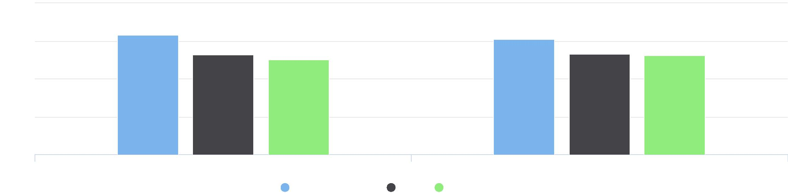

20

15

%

10

5

0

Male, Percent Female, Percent

Jackson County, IA Iowa United States

Population Age 55-64 by Ethnicity Alone

20

|  |  |  |  |  |  |
| --- | --- | --- | --- | --- | --- |
|  | 15  10  5  0 |  |  |  |  |
| % |  |  |  |
|  |  |  |
|  |  |  |
|  |  |  |  |  |

Hispanic or Latino, Percent Not Hispanic or Latino, Percent

Jackson County, IA Iowa United States



Population Age 55‐64 by Race Alone, Percent

|  |  |  |  |  |  |  |  |
| --- | --- | --- | --- | --- | --- | --- | --- |
| **Report Area** | **White** | **Black or African  American** | **Native American or Alaska Native** | **Asian** | **Native Hawaiian or Pacific  Islander** | **Some Other Race** | **Multiple  Race** |
| Jackson  County, IA | 15.84% | 0.00% | 0.00% | 11.25% | 9.16% | 0.00% | 4.78% |
| Iowa | 13.98% | 7.21% | 11.78% | 6.19% | 5.78% | 6.05% | 3.33% |
| United States | 13.79% | 11.64% | 11.41% | 11.15% | 9.98% | 7.58% | 5.80% |

Population Age 55‐64 by Race Alone, Total

|  |  |  |  |  |  |  |  |
| --- | --- | --- | --- | --- | --- | --- | --- |
| **Report Area** | **Non‐Hispanic White** | **Black or African  American** | **Native American or  Alaska Native** | **Asian** | **Native Hawaiian or  Pacific Islander** | **Some Other Race** | **Multiple Race** |
| Jackson County, IA | 2,975 | 0 | 0 | 9 | 12 | 0 | 13 |
| Iowa | 395,243 | 7,929 | 1,361 | 4,650 | 181 | 2,370 | 2,189 |
| United States | 32,396,598 | 4,761,473 | 307,997 | 1,960,342 | 58,146 | 1,196,679 | 605,496 |

Population Age 55-64 by Race Alone, Percent

20

|  |  |  |  |  |  |  |  |  |  |  |  |  |  |  |  |  |  |  |  |  |  |  |  |
| --- | --- | --- | --- | --- | --- | --- | --- | --- | --- | --- | --- | --- | --- | --- | --- | --- | --- | --- | --- | --- | --- | --- | --- |
|  | 15 |  |  |  |  |  |  |  |  |  |  |  |  |  |  |  |  |  |  |  |  |  |  |
|  |  |  |  |  |  |  |  |  |  |  |  |  |  |  |  |  |  |  |  |  |  |
|  |  |  |  |  |  |  |  |  |  |  |  |  |  |  |  |  |  |  |  |  |  |  |
| % | 10 |  |  |  |  |  |  |  |  |  |  |  |  |  |  |  |  |  |  |  |  |  |
|  |  |  |  |  |  |  |  | |  |  |  |  |  |  |  |  |  |
|  |  |  |  |  |  |  |  |  |  |  |  |  |  |  |  |  |  |
|  |  |  |  |  |  |  |  |  |  |  |  |  |  |  |  |  |
|  | 5 |  |  |  |  |  |  |  |  |  |  |  |  |  |  |  |
|  |  |  |  |  |  |  |  |  |  |  |  |  |  |  |  |
|  |  |  |  |  |  |  |  |  |  |  |  |  |  |  |  |
|  |  |  |  |  |  |  |  |  |  |  |  |  |  |  |  |  |
|  | 0 |  |  |  |  |  |  |  |  |  |  |  |  |  |  |  |
|  |  |  |  |  |  |  |  |  |  |  |  |  |  |  |  |  |  |  |  |  |  |  |

White Black or African American Native American or Alaska Asian Native Hawaiian or Pacific Some Other Race Multiple Race

Native Islander

Jackson County, IA Iowa United States



Population Age 55-64 by Race Alone, Total

Jackson County, IA   
**Multiple Race: 0.4%**

## Population Age 65+

Of the estimated 19,395 total population in the report area, an estimated 3,926 persons are adults aged 65 and older, representing 20.24% of the population. These data are based on the latest U.S. Census Bureau American Community Survey 5‐ year estimates. The number of older adults in the report area is relevant because this population has unique needs which should be considered separately from other age groups.

|  |  |  |  |
| --- | --- | --- | --- |
| **Report Area** | **Total Population** | **Population Age 65+** | **Population Age 65+, Percent** |
| Jackson County, IA | 19,395 | 3,926 | 20.24% |
| Iowa | 3,132,499 | 513,312 | 16.39% |
| United States | 322,903,030 | 49,238,581 | 15.25% |

*Data Source: US Census Bureau,* [*American Community Survey*](http://www.census.gov/acs/www/)*. 2014‐18. Source geography: Tract*

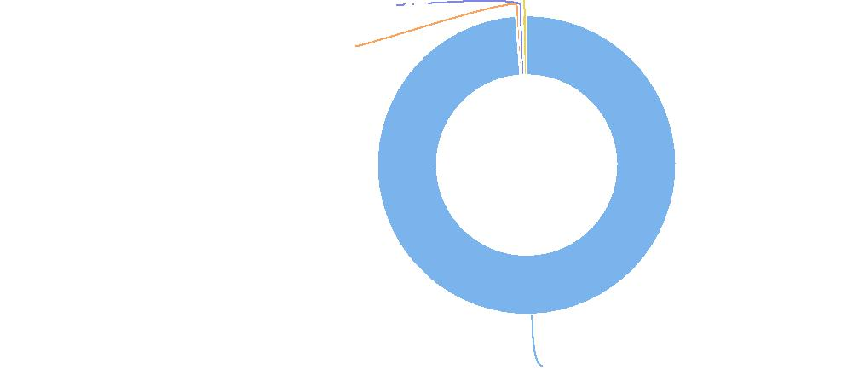

**Native Hawaiian or Pacific Islander: 0.4%**

**Asian: 0.3%**

**Non-Hispanic White: 98.9%**

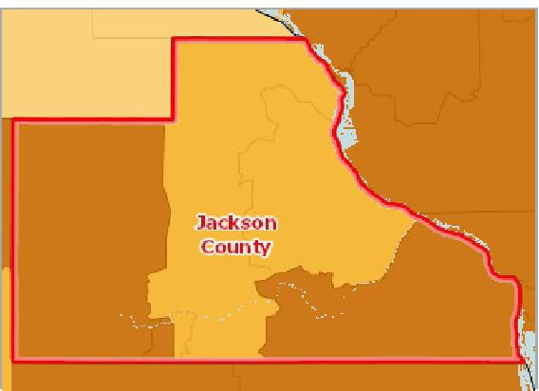

[](https://engagementnetwork.org/map-room/?ids=29207,t11&def=t11:FIPS%20In%20('19097')&bbox=-10120449.27515,5164829.551058,-10034264.57655,5219471.283242) View larger map

**Population Age 65+, Percent by Tract, ACS 2014‐18**

Over 20.0%

16.1 ‐ 20.0%

12.1 ‐ 16.0%

Under 12.1%

No Data or Data Suppressed

Jackson County, IA



Population Age 65+ by Gender

The table below reports the percentage of the population that is age 65 or older by gender. Among the male population in the report area, 15.99% are aged 65 years or older. Among the female population, 22.26% are aged 65 years or older.

|  |  |  |  |  |
| --- | --- | --- | --- | --- |
| **Report Area** | **Male** | **Female** | **Male, Percent** | **Female, Percent** |
| Jackson County, IA | 1,553 | 2,155 | 15.99% | 22.26% |
| Iowa | 201,845 | 285,972 | 12.98% | 18.12% |
| United States | 19,630,586 | 27,457,281 | 12.35% | 16.75% |

Population Age 65+ by Gender

30

|  |  |  |  |  |  |
| --- | --- | --- | --- | --- | --- |
|  | 20  10  0 |  |  |  |  |
| % |  |  |  |
|  |  |  |
|  |  |  |  |  |

Male, Percent Female, Percent

Jackson County, IA Iowa United States



Population Age 65+ by Ethnicity Alone

This indicator reports the percentage of population that are at age 65+ by ethnicity alone. In the report area, 9.78% of Hispanic / Latino population are at age 65+, and 20.39% of non Hispanic / Latino population are at age 65+.

|  |  |  |  |  |
| --- | --- | --- | --- | --- |
| **Report Area** | **Hispanic or Latino** | **Not Hispanic or Latino** | **Hispanic or Latino, Percent** | **Not Hispanic or Latino, Percent** |
| Jackson County, IA | 27 | 3,899 | 9.78% | 20.39% |
| Iowa | 5,886 | 507,426 | 3.21% | 17.21% |
| United States | 3,955,574 | 45,283,007 | 6.88% | 17.06% |

Population Age 65+ by Race Alone, Percent

This indicator reports the percentage of each race (alone) making up the population aged 65 or older.

|  |  |  |  |  |  |  |  |
| --- | --- | --- | --- | --- | --- | --- | --- |
| **Report Area** | **White** | **Black or African  American** | **Native American or Alaska Native** | **Asian** | **Native Hawaiian or Pacific  Islander** | **Some Other Race** | **Multiple  Race** |
| Jackson  County, IA | 20.73% | 0.00% | 0.00% | 33.75% | 0.00% | 0.00% | 2.21% |
| Iowa | 17.64% | 5.41% | 9.38% | 5.79% | 3.55% | 2.92% | 2.78% |
| United States | 17.44% | 10.88% | 9.89% | 12.00% | 8.37% | 5.54% | 5.06% |

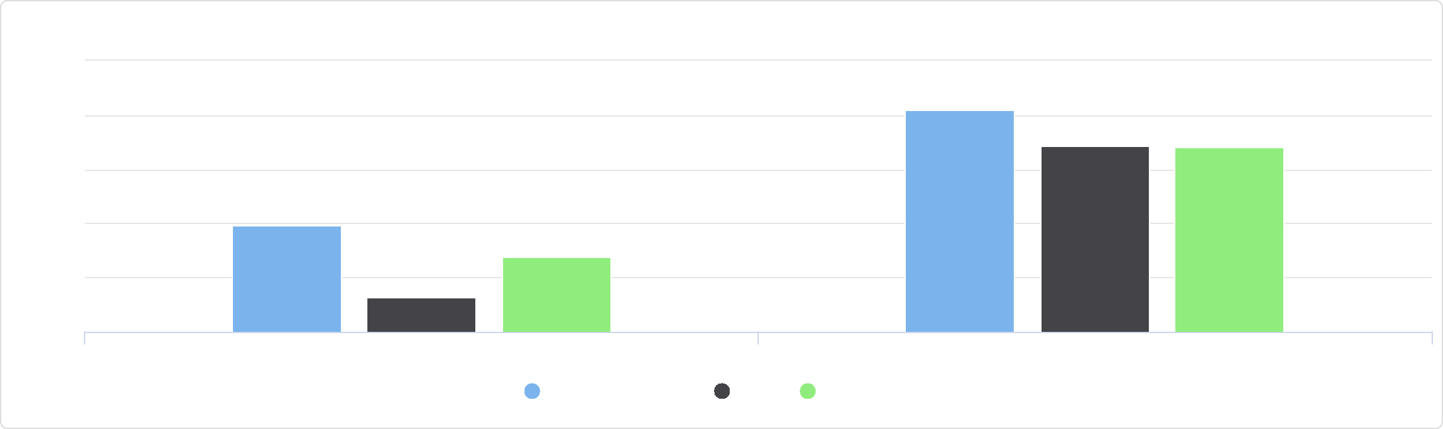

Population Age 65+ by Ethnicity Alone

25

Hispanic or Latino, Percent Not Hispanic or Latino, Percent

Jackson County, IA Iowa United States

%

20

15

10

0

5

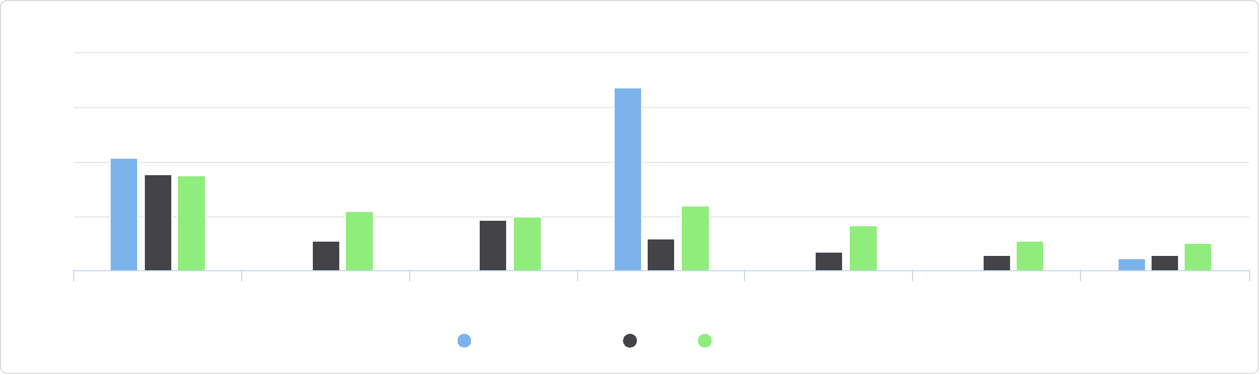

Some Other Race Multiple Race

Asian Native Hawaiian or Pacific

Islander

White Black or African American Native American or Alaska

Native

Population Age 65+ by Race Alone, Percent

40

Jackson County, IA Iowa United States

%

20

30

10

0

Population Age 65+ by Race Alone, Total

This indicator reports the proportion of each race (alone) making up the population aged 65 or older.

|  |  |  |  |  |  |  |  |
| --- | --- | --- | --- | --- | --- | --- | --- |
| **Report Area** | **Non‐Hispanic White** | **Black or African  American** | **Native American or  Alaska Native** | **Asian** | **Native Hawaiian or  Pacific Islander** | **Some Other Race** | **Multiple Race** |
| Jackson County, IA | 3,893 | 0 | 0 | 27 | 0 | 0 | 6 |
| Iowa | 498,851 | 5,945 | 1,083 | 4,350 | 111 | 1,145 | 1,827 |
| United States | 40,960,055 | 4,451,760 | 266,934 | 2,108,633 | 48,799 | 874,104 | 528,296 |

Population Age 65+ by Race Alone, Total

Jackson County, IA

## Population with Any Disability

This indicator reports the percentage of the total civilian non‐institutionalized population with a disability. The report area has a total population of 19,194 for whom disability status has been determined, of which 2,317 or 12.07% have any disability. This indicator is relevant because disabled individuals comprise a vulnerable population that requires targeted services and outreach by providers.

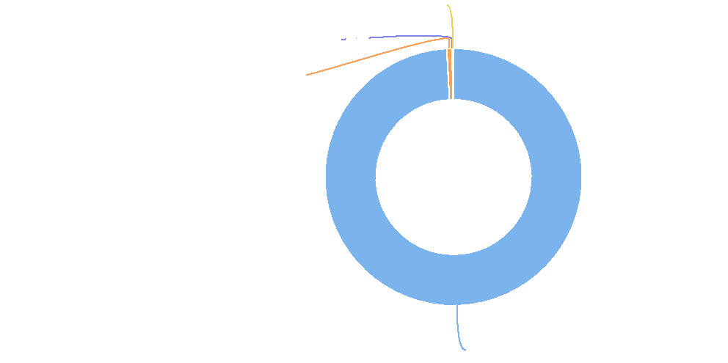

**Multiple Race: 0.2%**

**Native Hawaiian or Pacific Islander: 0.0%**

**Asian: 0.7%**

**Non-Hispanic White: 99.2%**

|  |  |  |  |
| --- | --- | --- | --- |
| **Report Area** | **Total Population**  **(For Whom Disability Status Is**  **Determined)** | **Population with a  Disability** | **Population with a Disability,  Percent** |
| Jackson County, IA | 19,194 | 2,317 | **12.07%** |
| Iowa | 3,088,842 | 358,366 | 11.60% |
| United States | 317,941,631 | 40,071,666 | 12.60% |

Population with a Disability, Percent

|  |  |
| --- | --- |
|  | |
|  | 0% 20%  Jackson County (12.07%)  Iowa (11.60%)  United States (12.60%) |

*Note: This indicator is compared to the state average.*

*Data Source: US Census Bureau,* [*American Community Survey*](http://www.census.gov/acs/www/)*. 2014‐18. Source geography: Tract*

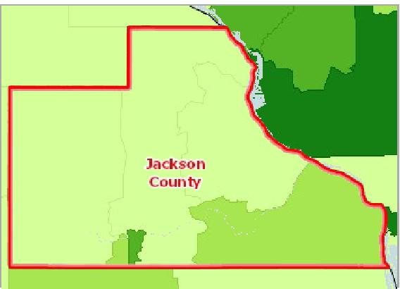

[](https://engagementnetwork.org/map-room/?ids=29555,t11&def=t11:FIPS%20In%20('19097')&bbox=-10120449.27515,5164829.551058,-10034264.57655,5219471.283242) View larger map

Over 18.0%

15.1 ‐ 18.0%

12.1 ‐ 15.0%

Under 12.1%

No Data or Data Suppressed

Jackson County, IA

**Disabled Population, Percent by Tract, ACS 2014‐18**



Population with Any Disability by Gender

This indicator reports the percentage of the total civilian non‐institutionalized population with a disability by gender.

|  |  |  |  |  |
| --- | --- | --- | --- | --- |
| **Report Area** | **Male** | **Female** | **Male, Percent** | **Female, Percent** |
| Jackson County, IA | 1,247 | 1,070 | 12.94% | 11.19% |
| Iowa | 179,114 | 179,252 | 11.71% | 11.50% |
| United States | 19,374,640 | 20,697,026 | 12.47% | 12.73% |

Population with Any Disability by Age Group, Percent

This indicator reports the percentage of the total civilian non‐institutionalized population with a disability by age group.

|  |  |  |  |
| --- | --- | --- | --- |
| **Report Area** | **Under Age 18** | **Age 18 ‐ 64** | **Age 65 +** |
| Jackson County, IA | 5.34% | 8.44% | 30.58% |
| Iowa | 4.14% | 9.29% | 31.52% |
| United States | 4.17% | 10.30% | 34.97% |

Population with Any Disability by Gender

15

|  |  |  |  |  |  |  |
| --- | --- | --- | --- | --- | --- | --- |
|  | 10  5  0 |  |  |  |  |  |
| % |  |  |  |
|  |  |  |  |
|  |  |  |  |  |  |

Male, Percent Female, Percent

Jackson County, IA Iowa United States



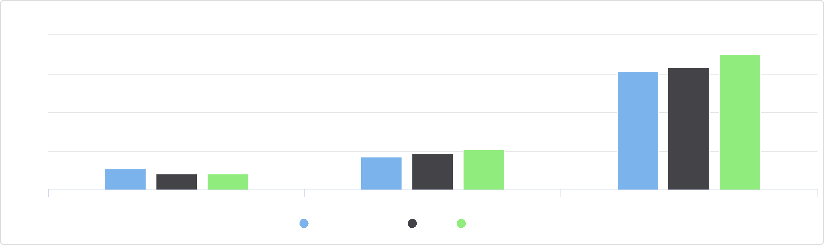

Population with Any Disability by Age Group, Percent

40

Under Age 18 Age 18 - 64 Age 65 +

Jackson County, IA Iowa United States

%

20

30

10

0

Population with Any Disability by Age Group, Total

This indicator reports the proportion of the total civilian non‐institutionalized population with a disability by age group.

|  |  |  |  |
| --- | --- | --- | --- |
| **Report Area** | **Under Age 18** | **Age 18‐64** | **Age 65+** |
| Jackson County, IA | 231 | 938 | 1,148 |
| Iowa | 30,123 | 173,749 | 154,494 |
| United States | 3,065,179 | 20,240,504 | 16,765,983 |

Population with Any Disability by Ethnicity Alone

This indicator reports the percentage of the total civilian non‐institutionalized population with a disability by ethnicity alone.

|  |  |  |  |  |
| --- | --- | --- | --- | --- |
| **Report Area** | **Hispanic or Latino** | **Not Hispanic or Latino** | **Hispanic or Latino, Percent** | **Not Hispanic or Latino, Percent** |
| Jackson County, IA | 13 | 2,304 | 4.73% | 12.18% |
| Iowa | 12,472 | 345,894 | 0.80% | 11.90% |
| United States | 5,067,077 | 35,004,589 | 3.12% | 13.40% |

Population with Any Disability by Age Group, Total

Jackson County, IA

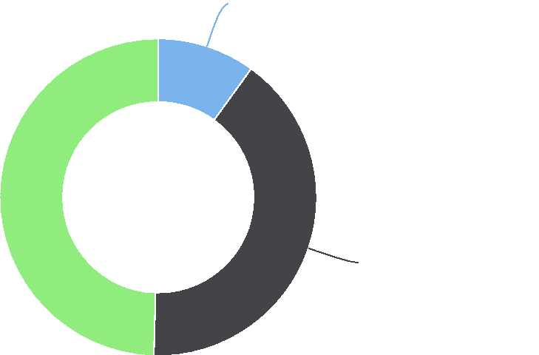

**Under Age 18: 10.0%**

**Age 18-64: 40.5%**

**Age 65+: 49.5%**

Population with Any Disability by Ethnicity Alone

15

|  |  |  |  |  |  |  |  |  |
| --- | --- | --- | --- | --- | --- | --- | --- | --- |
|  | 10  5 |  |  |  |  |  |  |  |
| % |  |  |  |  |  |  |
|  |  |  |  |  |  |  |
|  |  |  |  |  |  |  |  |
|  |  |  |  |  |  |  |  |
|  | 0 |  |  |  |  |  |  |
|  |  |  |  |  |  |  |  |

Hispanic / Latino Not Hispanic / Latino

Jackson County, IA Iowa United States



Population with Any Disability by Race Alone, Percent

This indicator reports the percentage of the total civilian non‐institutionalized population with a disability by race alone.

|  |  |  |  |  |  |  |  |
| --- | --- | --- | --- | --- | --- | --- | --- |
| **Report Area** | **White** | **Black or African  American** | **Native American or Alaska  Native** | **Asian** | **Native Hawaiian or Pacific  Islander** | **Some Other  Race** | **Multiple  Race** |
| Jackson  County, IA | 12.25% | 0.00% | 0.00% | 3.75% | 11.45% | 0.00% | 8.61% |
| Iowa | 11.90% | 10.51% | 17.30% | 5.30% | 6.23% | 6.40% | 10.15% |
| United States | 13.12% | 13.95% | 16.83% | 6.98% | 10.73% | 8.23% | 10.93% |

Population with Any Disability by Race Alone, Total

This indicator reports the proportion of the total civilian non‐institutionalized population with a disability by race alone.

|  |  |  |  |  |  |  |  |
| --- | --- | --- | --- | --- | --- | --- | --- |
| **Report Area** | **Non‐Hispanic White** | **Black or African  American** | **Native American or  Alaska Native** | **Asian** | **Native Hawaiian or  Pacific Islander** | **Some Other Race** | **Multiple Race** |
| Jackson County, IA | 2,276 | 0 | 0 | 3 | 15 | 0 | 23 |
| Iowa | 332,067 | 11,145 | 1,910 | 3,965 | 194 | 2,492 | 6,593 |
| United States | 30,406,200 | 5,535,003 | 443,140 | 1,219,941 | 61,092 | 1,283,869 | 1,122,421 |

Population with Any Disability by Race Alone, Percent

20

|  |  |  |  |  |  |  |  |  |  |  |  |  |  |  |  |  |  |  |  |  |  |  |
| --- | --- | --- | --- | --- | --- | --- | --- | --- | --- | --- | --- | --- | --- | --- | --- | --- | --- | --- | --- | --- | --- | --- |
|  | 15 |  |  |  |  |  |  |  |  |  |  |  |  |  |  |  |  |  |  |  |  |  |
|  |  |  |  |  |  |  |  |  |  |  |  |  |  |  |  |  |  |  |  |  |
|  |  |  |  |  |  |  |  |  |  |  |  |  |  |  |  |  |  |  |  |  |
|  |  |  |  |  |  |  |  |  |  |  |  |  |  |  |  |  |  |  |  |  |
| % | 10 |  |  |  |  |  |  |  |  |  |  |  |  |  |  |  |  |  |
|  |  |  |  |  |  |  |  |  |  |  |  |  |  |  |  |  |
|  |  |  |  |  |  |  |  |  |  |  |  |  |  |  |  |  |  |  |
|  | 5 |  |  |  |  |  |  |  |  |  |  |  |  |  |  |  |  |
|  |  |  |  |  |  |  |  |  |  |  |  |  |  |  |  |
|  |  |  |  |  |  |  |  |  |  |  |  |  |  |  |  |  |
|  | 0 |  |  |  |  |  |  |  |  |  |  |  |  |  |  |  |
|  |  |  |  |  |  |  |  |  |  |  |  |  |  |  |  |  |  |  |  |  |  |

White Black or African American Native American or Alaska Asian Native Hawaiian or Pacific Some Other Race Multiple Race

Native Islander

Jackson County, IA Iowa United States



Population with Any Disability by Race Alone, Total

Jackson County, IA

## Population in Limited English Households

This indicator reports the percentage of the population aged 5 and older living in Limited English speaking households. A “Limited English speaking household” is one in which no member 14 years old and over 72 speaks only English at home or 0.39% speaks a language other than English at home and speaks English “Very well.” This indicator is significant as it identifies households and populations that may need English‐language assistance.

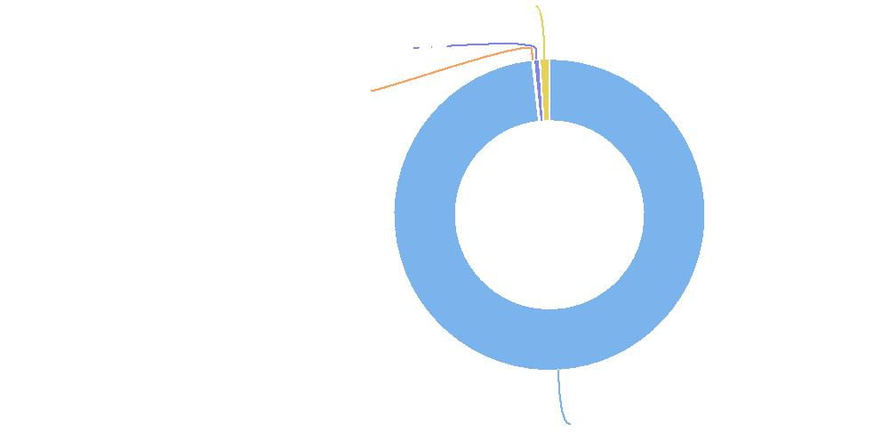

**Multiple Race: 1.0%**

**Native Hawaiian or Pacific Islander: 0.6%**

**Asian: 0.1%**

**Non-Hispanic White: 98.2%**

Linguistically Isolated Population, Percent

|  |  |
| --- | --- |
|  | |
| 0% 15% | |
|  | Jackson County (0.39%)  Iowa (1.98%)  United States (4.35%) |

|  |  |  |  |
| --- | --- | --- | --- |
| **Report Area** | **Total Population Age**  **5+** | **Linguistically Isolated  Population** | **Linguistically Isolated Population,  Percent** |
| Jackson County, IA | 18,236 | 72 | **0.39%** |
| Iowa | 2,935,069 | 58,007 | 1.98% |
| United States | 303,066,180 | 13,181,780 | 4.35% |

*Note: This indicator is compared to the state average.*

*Data Source: US Census Bureau,* [*American Community Survey*](http://www.census.gov/acs/www/)*. 2014‐18. Source geography: Tract*

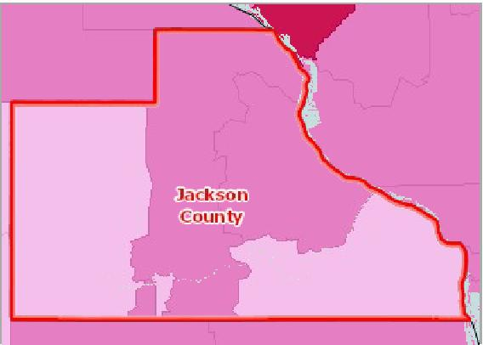

[](https://engagementnetwork.org/map-room/?ids=31062,t11&def=t11:FIPS%20In%20('19097')&bbox=-10120449.27515,5164829.551058,-10034264.57655,5219471.283242) View larger map

**Population in Linguistically Isolated Households, Percent by Tract, ACS 2014‐18**

Over 3.0%

1.1 ‐ 3.0%

0.1 ‐ 1.1%

No Population in Linguistically Isolated Households

No Data or Data Suppressed

Jackson County, IA



## Population with Limited English Proficiency

This indicator reports the percentage of the population aged 5 and older who speak a language other than English at home and speak English less than "very well." This indicator is relevant because an inability to speak English well creates barriers to **healthcare access, provider communications, and health literacy/education.**

|  |  |  |  |
| --- | --- | --- | --- |
| **Report Area** | **Population  Age 5+** | **Population Age 5+ with Limited  English Proficiency** | **Population Age 5+ with Limited English  Proficiency, Percent** |
| Jackson County, IA | 18,236 | 111 | **0.61%** |
| Iowa | 2,935,069 | 97,003 | 3.30% |
| United States | 303,066,180 | 25,647,781 | 8.46% |

Population Age 5+ with Limited English Proficiency, Percent

|  |  |
| --- | --- |
|  | |
| 0% 25% | |
|  | Jackson County (0.61%)  Iowa (3.30%)  United States (8.46%) |

*Note: This indicator is compared to the state average.*

*Data Source: US Census Bureau,* [*American Community Survey*](http://www.census.gov/acs/www/)*. 2014‐18. Source geography: Tract*

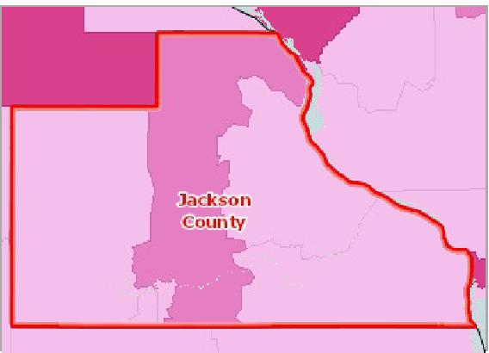

[](https://engagementnetwork.org/map-room/?ids=31063,t11&def=t11:FIPS%20In%20('19097')&bbox=-10120449.27515,5164829.551058,-10034264.57655,5219471.283242) View larger map

Over 4.0%

2.1 ‐ 4.0%

1.1 ‐ 2.0%

Under 1.1%

No Data or Data Suppressed

Jackson County, IA

**Population with Limited English Proficiency, Percent by Tract, ACS 2014‐18**



Population with Limited English Proficiency by Ethnicity Alone

Data Source: US Census Bureau, American Community Survey. 2014‐18. Source geography: Tract

|  |  |  |  |  |
| --- | --- | --- | --- | --- |
| **Report Area** | **Hispanic or Latino** | **Not Hispanic or Latino** | **Hispanic or Latino, Percent** | **Not Hispanic or Latino, Percent** |
| Jackson County, IA | 18 | 93 | 7.29% | 0.52% |
| Iowa | 45,773 | 51,230 | 28.12% | 1.85% |
| United States | 15,893,564 | 9,754,217 | 30.35% | 3.89% |

Population with Limited English Proficiency by Race Alone, Percent

Data Source: US Census Bureau, American Community Survey. 2014‐18. Source geography: Tract

Population with Limited English Proficiency by Ethnicity Alone

40

|  |  |  |  |  |  |  |  |  |  |  |  |  |  |
| --- | --- | --- | --- | --- | --- | --- | --- | --- | --- | --- | --- | --- | --- |
|  | 30  20  10 |  |  |  |  |  |  |  |  |  |  |  |  |
|  |  |  |  |  | |  |  |  |  |  |  |  |
| % |  |  |  |  |  |  |  |  |  |  |
|  |  |  |  |  |  |  |  |  |  |
|  |  |  |  |  |  |  |  |  |  |  |
|  |  |  |  |  |  |  |  |  |  |  |  |
|  |  |  |  |  |  |  |  |  |  |  |  |
|  |  |  |  |  |  |  |  |  |  |  |  |
|  | 0 |  |  |  |  |  |  |  |  |  |  |
|  |  |  |  |  |  |  |  |  |  |  |  |  |

Hispanic or Latino, Percent Not Hispanic or Latino, Percent

Jackson County, IA Iowa United States



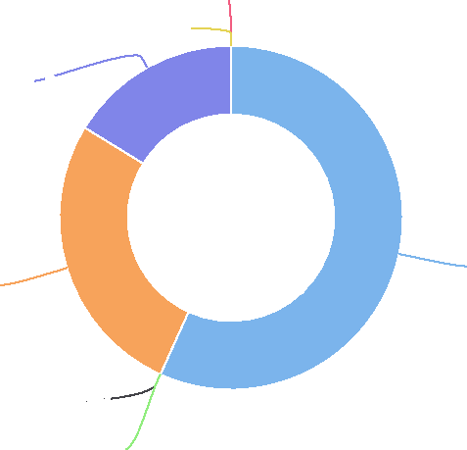

|  |  |  |  |  |  |  |  |
| --- | --- | --- | --- | --- | --- | --- | --- |
| **Report Area** | **White** | **Black or African  American** | **Native American or Alaska  Native** | **Asian** | **Native Hawaiian or Pacific  Islander** | **Some Other  Race** | **Multiple  Race** |
| Jackson County, IA | 0.35% | 0.00% | 0.00% | 0.17% | 0.10% | 0.00% | 0.00% |
| Iowa | 1.63% | 0.32% | 0.01% | 1.04% | 0.02% | 0.55% | 0.07% |
| United States | 5.82% | 0.53% | 0.08% | 2.49% | 0.03% | 2.35% | 0.25% |

Population with Limited English Proficiency by Race Alone, Total

Data Source: US Census Bureau, American Community Survey. 2014‐18. Source geography: Tract

|  |  |  |  |  |  |  |  |
| --- | --- | --- | --- | --- | --- | --- | --- |
| **Report Area** | **Non‐Hispanic White** | **Black or African  American** | **Native American or  Alaska Native** | **Asian** | **Native Hawaiian or  Pacific Islander** | **Some Other Race** | **Multiple Race** |
| Jackson County, IA | 63 | 0 | 0 | 30 | 18 | 0 | 0 |
| Iowa | 43,409 | 8,524 | 346 | 27,795 | 540 | 14,561 | 1,828 |
| United States | 12,911,069 | 1,171,430 | 187,528 | 5,532,712 | 69,139 | 5,212,138 | 563,765 |

Population with Limited English Proficiency by Race Alone, Total

Jackson County, IA

Population with Limited English Proficiency by Language Spoken at Home

Data Source: US Census Bureau, American Community Survey. 2014‐18. Source geography: Tract

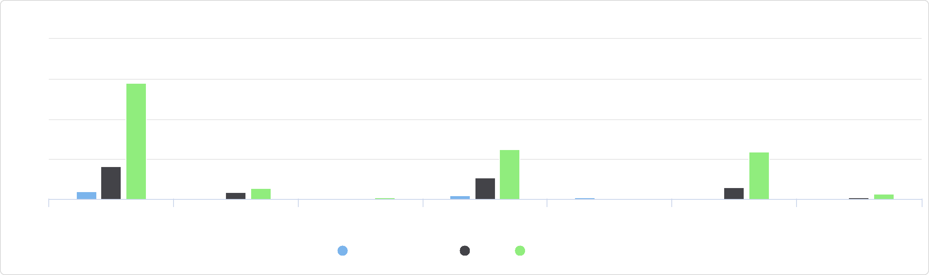

Some Other Race Multiple Race

Asian Native Hawaiian or Pacific

Islander

White Black or African American Native American or Alaska

Native

Population with Limited English Proficiency by Race Alone, Percent

8

6

Jackson County, IA Iowa United States

%

4

2

0

**Some Other Race: 0.0%**

**Multiple Race: 0.0%**

**Native Hawaiian or Pacific Islander: 16.2%**

**Asian: 27.0%**

**Black or African American: 0.0%   
Native American or Alaska Native: 0.0%**

**Non-Hispanic White: 56.8%**

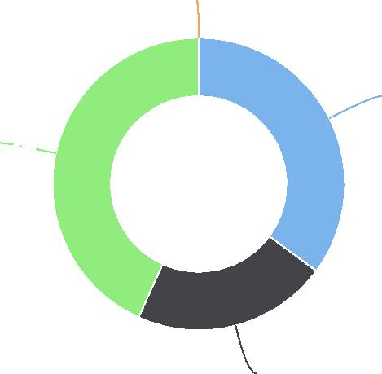

|  |  |  |  |  |
| --- | --- | --- | --- | --- |
| **Report Area** | **Spanish** | **Other Indo‐European Languages** | **Asian and Pacific Island Languages** | **Other Languages** |
| Jackson County, IA | 39 | 24 | 48 | 0 |
| Iowa | 48,880 | 14,264 | 25,679 | 8,180 |
| United States | 16,309,621 | 3,425,770 | 4,908,308 | 1,004,082 |

Population with Limited English Proficiency by Language Spoken at Home

Jackson County, IA

## Population Geographic Mobility

This indicator reports information about population in‐migration by assessing changes in residence within a one year period. Of the 19,123 persons residing in the report area, an estimated 5.20% relocated to the area, according to the latest American Community Survey 5‐year estimates. Persons who moved to a new household from outside of their current county of residence, from outside their state of residence, or from abroad are considered part of the in‐migrated population. Persons who moved to a new household from a different household within their current county of residence are not included.

|  |  |  |  |
| --- | --- | --- | --- |
| **Report Area** | **Total Population** | **Population In‐Migration** | **Percent Population In‐Migration** |
| Jackson County, IA | 19,123 | 994 | 5.20% |
| Iowa | 3,094,074 | 206,199 | 6.66% |
| United States | 319,157,088 | 19,865,252 | 6.22% |

*Data Source: US Census Bureau,* [*American Community Survey*](http://www.census.gov/acs/www/)*. 2014‐18. Source geography: Tract*

**Other Languages: 0.0%**

**Spanish: 35.1%**

**Asian and Pacific Island Languages: 43.2%**

**Other Indo-European Languages: 21.6%**

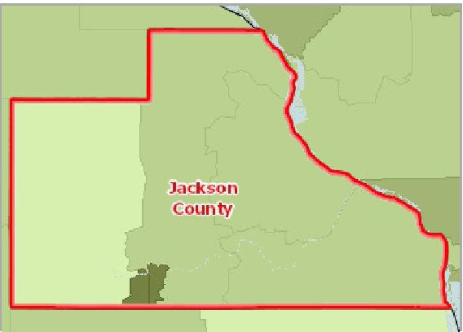

[](https://engagementnetwork.org/map-room/?ids=31100,t11&def=t11:FIPS%20In%20('19097')&bbox=-10120449.27515,5164829.551058,-10034264.57655,5219471.283242) View larger map

**Population Migrated from Outside of the County, State, or Country, Percent of Total Population by Tract, ACS 2014‐18**

Over 8.0%

5.1 ‐ 8.0%

2.1 ‐ 5.0%

Under 2.1%

No Data or Data Suppressed

Jackson County, IA



Population In‐Migration by Ethnicity Alone

|  |  |  |  |  |
| --- | --- | --- | --- | --- |
| **Report Area** | **Hispanic or Latino** | **Not Hispanic or Latino** | **Hispanic or Latino, Percent** | **Not Hispanic or Latino, Percent** |
| Jackson County, IA | 12 | 982 | 4.58% | 0.06% |
| Iowa | 15,599 | 190,600 | 8.71% | 0.54% |
| United States | 2,997,622 | 16,867,630 | 5.30% | 1.14% |

Population In-Migration by Ethnicity Alone

Population In‐Migration by Race Alone, Total

|  |  |  |  |  |  |  |  |
| --- | --- | --- | --- | --- | --- | --- | --- |
| **Report Area** | **Non‐Hispanic White** | **Black or African  American** | **Native American or  Alaska Native** | **Asian** | **Native Hawaiian or  Pacific Islander** | **Some Other Race** | **Multiple Race** |
| Jackson County, IA | 784 | 20 | 5 | 36 | 27 | 6 | 116 |
| Iowa | 168,680 | 15,063 | 1,238 | 9,279 | 262 | 4,100 | 7,577 |
| United States | 13,943,869 | 2,576,374 | 175,542 | 1,529,587 | 42,963 | 781,329 | 815,588 |

Population In-Migration by Race Alone, Total

Jackson County, IA

Population In‐Migration by Race Alone, Percent

|  |  |  |  |  |  |  |  |
| --- | --- | --- | --- | --- | --- | --- | --- |
| **Report Area** | **White** | **Black or African  American** | **Native American or Alaska  Native** | **Asian** | **Native Hawaiian or Pacific  Islander** | **Some Other  Race** | **Multiple  Race** |
| Jackson  County, IA | 4.23% | 21.28% | 71.43% | 45.00% | 20.61% | 20.00% | 51.56% |
| Iowa | 6.03% | 13.93% | 10.78% | 12.49% | 8.60% | 10.70% | 11.91% |
| United States | 6.00% | 6.38% | 6.59% | 8.79% | 7.46% | 5.02% | 8.05% |

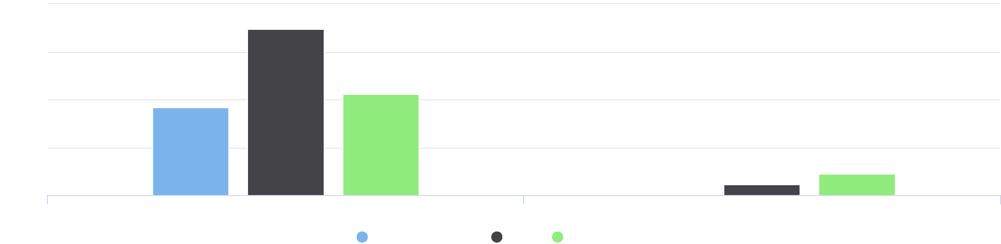

10

Hispanic or Latino, Percent Not Hispanic or Latino, Percent

Jackson County, IA Iowa United States

%

2.5

7.5

0

5



**Multiple Race: 11.7%**

**Some Other Race: 0.6%**

**Native Hawaiian or Pacific Islander: 2.7%**

**Asian: 3.6%**

**Native American or Alaska Native: 0.5%**

**Black or African American: 2.0%**

**Non-Hispanic White: 78.9%**

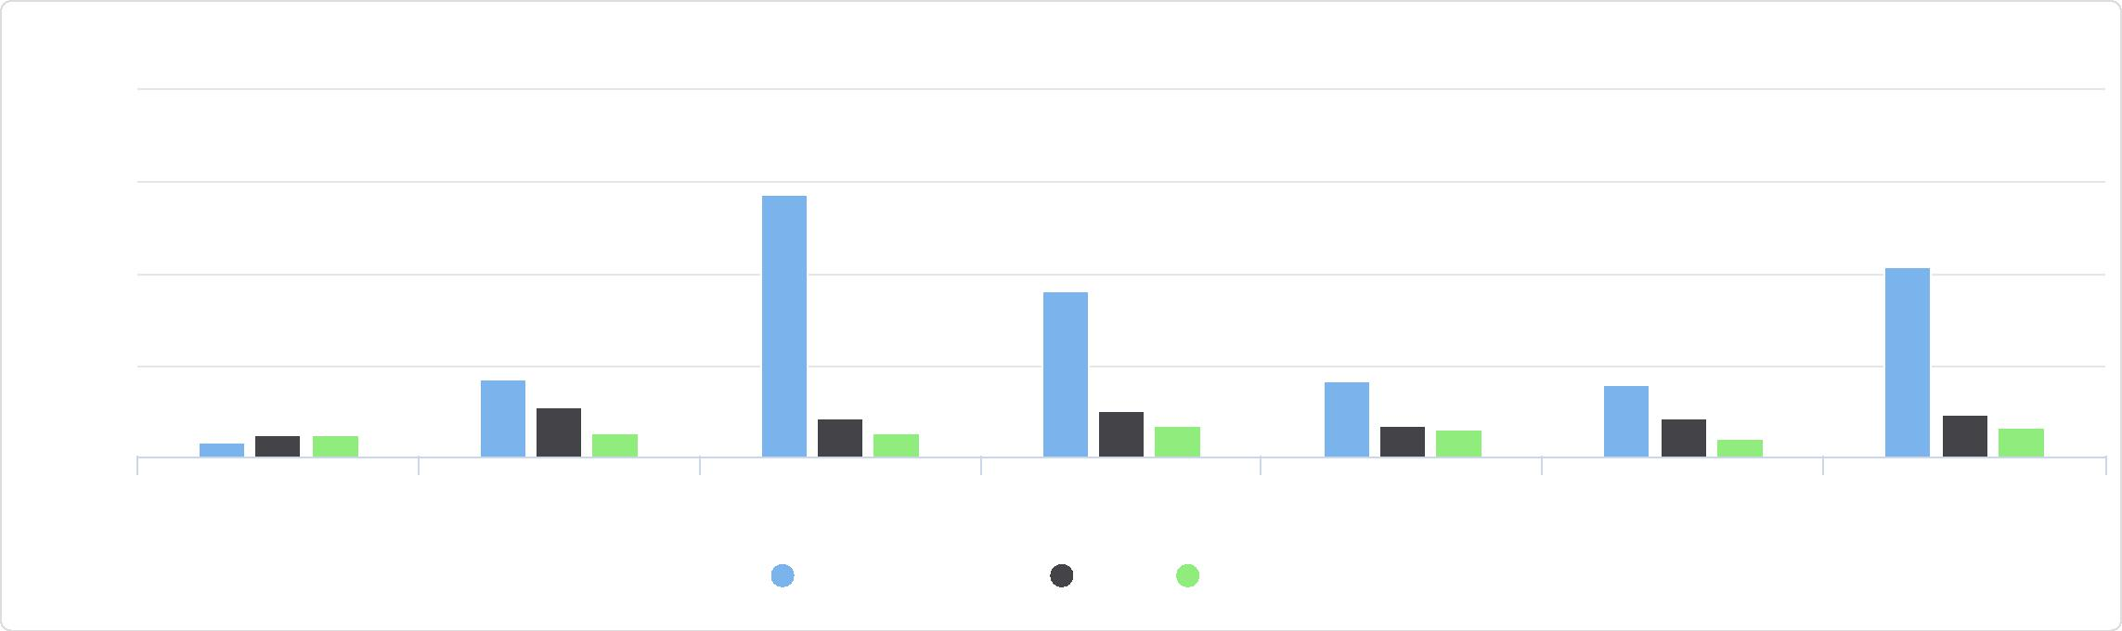

Some Other Race Multiple Race

Asian Native Hawaiian or Pacific

Islander

White Black or African American Native American or Alaska

Native

Population In-Migration by Race Alone, Percent

100

75

Jackson County, IA Iowa United States

%

25

50

0

## Foreign‐Born Population

This indicator reports the percentage of the population that is foreign‐born. The foreign‐born population includes anyone who was not a U.S. citizen or a U.S. national at birth. This includes any non‐citizens, as well as persons born outside of the U.S. who have become naturalized citizens. The native U.S. population includes any person born in the United States, Puerto Rico, a U.S. Island Area (such as Guam), or abroad of American (U.S. citizen) parent or parents. The latest figures from the U.S. Census Bureau show that 202 persons in the report area are of foreign birth, which represents 1.04% of the report area population. This percentage is less than the national average of 13.48%.

|  |  |  |  |  |  |
| --- | --- | --- | --- | --- | --- |
| **Report Area** | **Total Population** | **Naturalized U.S.  Citizens** | **Population Without U.S.  Citizenship** | **Total Foreign‐Birth  Population** | **Foreign‐Birth Population, Percent of  Total Population** |
| Jackson County, IA | 19,395 | 133 | 69 | 202 | 1.04% |
| Iowa | 3,132,499 | 61,476 | 100,396 | 161,872 | 5.17% |
| United States | 322,903,030 | 21,250,009 | 22,289,490 | 43,539,499 | 13.48% |

*Data Source: US Census Bureau,* [*American Community Survey*](http://www.census.gov/acs/www/)*. 2014‐18. Source geography: Tract*

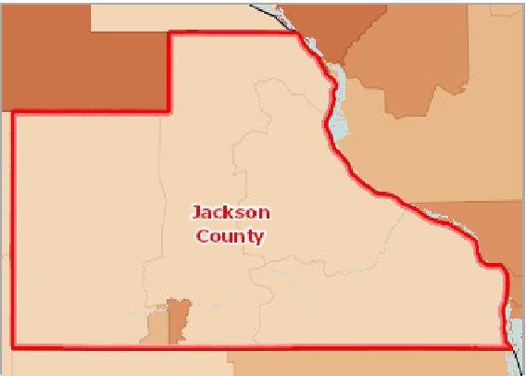

[](https://engagementnetwork.org/map-room/?ids=29983,t11&def=t11:FIPS%20In%20('19097')&bbox=-10120449.27515,5164829.551058,-10034264.57655,5219471.283242) View larger map

**Foreign‐Born Population (Non‐Citizen or Naturalized), Percent by Tract, ACS 2014‐18**

Over 5.0%

2.1 ‐ 5.0%

1.1 ‐ 2.0%

Under 1.1%

No Data or Data Suppressed

Jackson County, IA



## Hispanic Population

The estimated population that is of Hispanic, Latino, or Spanish origin in the report area is 276. This represents 1.42% of the total report area population, which is less than the national rate of 17.81%. Origin can be viewed as the heritage, nationality group, lineage, or country of birth of the person or the person’s parents or ancestors before their arrival in the United States. People who identify their origin as Hispanic, Latino, or Spanish may be of any race.

|  |  |  |  |  |  |
| --- | --- | --- | --- | --- | --- |
| **Report Area** | **Total  Population** | **Non‐Hispanic  Population** | **Percent Population Non‐  Hispanic** | **Hispanic or Latino  Population** | **Percent Population Hispanic or Latino** |
| Jackson County, IA | 19,395 | 19,119 | 98.58% | 276 | 1.42% |
| Iowa | 3,132,499 | 2,949,203 | 94.15% | 183,296 | 5.85% |
| United States | 322,903,030 | 265,385,095 | 82.19% | 57,517,935 | 17.81% |

*Data Source: US Census Bureau,* [*American Community Survey*](http://www.census.gov/acs/www/)*. 2014‐18. Source geography: Tract*

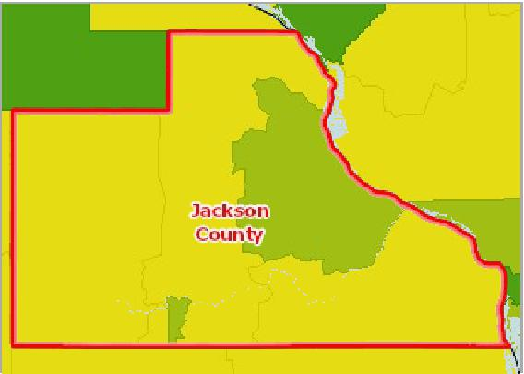

[](https://engagementnetwork.org/map-room/?ids=29323,t11&def=t11:FIPS%20In%20('19097')&bbox=-10120449.27515,5164829.551058,-10034264.57655,5219471.283242) View larger map

**Population, Hispanic or Latino, Percent by Tract, ACS 2014‐18**

Over 10.0%

5.1 ‐ 10.0%

2.1 ‐ 5.0%

Under 2.1%

No Hispanic Population Reported

No Data or Data Suppressed

Jackson County, IA



Hispanic Population by Gender

|  |  |  |  |  |
| --- | --- | --- | --- | --- |
| **Report Area** | **Male** | **Female** | **Male, Percent** | **Female, Percent** |
| Jackson County, IA | 154 | 122 | 55.80% | 44.20% |
| Iowa | 95,024 | 88,272 | 51.84% | 48.16% |
| United States | 29,059,591 | 28,458,344 | 50.52% | 49.48% |

Hispanic Population by Race Alone, Percent

|  |  |  |  |  |  |  |  |
| --- | --- | --- | --- | --- | --- | --- | --- |
| **Report Area** | **White** | **Black or African  American** | **Native American or Alaska  Native** | **Asian** | **Native Hawaiian or Pacific  Islander** | **Some Other  Race** | **Multiple  Race** |
| Jackson  County, IA | 86.59% | 0.00% | 0.00% | 0.00% | 0.00% | 10.87% | 2.54% |
| Iowa | 72.02% | 1.33% | 1.35% | 0.24% | 0.15% | 19.84% | 5.07% |
| United States | 65.59% | 2.09% | 0.98% | 0.36% | 0.10% | 26.14% | 4.75% |

Hispanic Population by Gender

60

|  |  |  |  |  |  |  |  |  |  |
| --- | --- | --- | --- | --- | --- | --- | --- | --- | --- |
|  |  |  |  |  |  |  |  |  |  |
|  |  |  |  |  |  |  |  |  |
|  |  | 40 | |  |  |  |  |
|  |  |  |  |  |  |
|  |  |  |  |  |  |  |  |
| % |  |  |  |  |  |  |  |
|  |  |  |  |  |  |  |  |
|  |  | 20 | |  |  |  |  |
|  |  |  |  |  |  |
|  |  |  |  |  |  |  |  |
|  |  |  | 0 |  |  |  |  |
|  |  |  |  |  |  |  |  |  |

Male, Percent Female, Percent

Jackson County, IA Iowa United States



Hispanic Population by Race Alone, Percent

100

|  |  |  |  |  |  |  |  |  |  |  |  |
| --- | --- | --- | --- | --- | --- | --- | --- | --- | --- | --- | --- |
|  | 75 |  |  |  |  |  |  |  |  |  |  |
|  |  |  |  |  |  |  |  |  |  |  |
|  |  |  |  |  |  |  |  |  |  |  |  |
|  |  |  |  |  |  |  |  |  |  |  |  |
| % | 50  25 |  |  |  |  |  |  |  |  |  |  |
|  |  |  |  |  |  |  |  |  |  |
|  |  |  |  |  |  |  |  |  |  |  |
|  |  |  |  |  |  |  |  |  |  |  |  |
|  | 0 |  |  |  |  |  |  |  |  |  |  |
|  |  |  |  |  |  |  |  |  |  |  |

White Black or African American Native American or Alaska Asian Native Hawaiian or Pacific Some Other Race Multiple Race

Native Islander

Jackson County, IA Iowa United States



Hispanic Population by Race Alone, Total

|  |  |  |  |  |  |  |  |
| --- | --- | --- | --- | --- | --- | --- | --- |
| **Report Area** | **Non‐Hispanic White** | **Black or African  American** | **Native American or Alaska Native** | **Asian** | **Native Hawaiian or Pacific Islander** | **Some Other Race** | **Multiple Race** |
| Jackson  County, IA | 239 | 0 | 0 | 0 | 0 | 30 | 7 |
| Iowa | 132,001 | 2,440 | 2,482 | 443 | 266 | 36,362 | 9,302 |
| United States | 37,723,641 | 1,200,196 | 563,594 | 207,381 | 57,616 | 15,035,465 | 2,730,042 |

Hispanic Population by Race Alone, Total

Jackson County, IA

Hispanic Population by Age Group

|  |  |  |  |  |  |  |  |  |
| --- | --- | --- | --- | --- | --- | --- | --- | --- |
| **Report Area** | **Age 0‐4** | **Age 5‐17** | **Age 18‐24** | **Age 25‐34** | **Age 35‐44** | **Age 45‐54** | **Age 55‐64** | **Age 65+** |
| Jackson County, IA | 29 | 72 | 11 | 39 | 62 | 15 | 21 | 27 |
| Iowa | 20,543 | 51,953 | 24,160 | 27,918 | 24,935 | 17,712 | 10,189 | 5,886 |
| United States | 5,141,740 | 13,206,083 | 6,710,463 | 9,110,263 | 8,287,301 | 6,648,870 | 4,457,641 | 3,955,574 |



**Multiple Race: 2.5%**

**Some Other Race: 10.9%**

**Black or African American: 0.0% Native American or Alaska Native: 0.0%**

**Asian: 0.0%**

**Non-Hispanic White: 86.6%**

Hispanic Population by Age Group

Jackson County, IA

## Urban and Rural Population

This indicator reports the percentage of population living in urban and rural areas. Urban areas are identified using population density, count, and size thresholds. Urban areas also include territory with a high degree of impervious surface (development). Rural areas are all areas that are not urban. Of the report areas 19,848 population, 9,275 or 46.73% of the population is classified urban while 10,573 or 53.27% is rural.

|  |  |  |  |  |  |
| --- | --- | --- | --- | --- | --- |
| **Report Area** | **Total Population** | **Urban Population** | **Rural Population** | **Urban Population, Percent** | **Rural Population, Percent** |
| Jackson County, IA | 19,848 | 9,275 | 10,573 | 46.73% | 53.27% |
| Iowa | 3,046,355 | 1,950,256 | 1,096,099 | 64.02% | 35.98% |
| United States | 312,471,327 | 252,746,527 | 59,724,800 | 80.89% | 19.11% |

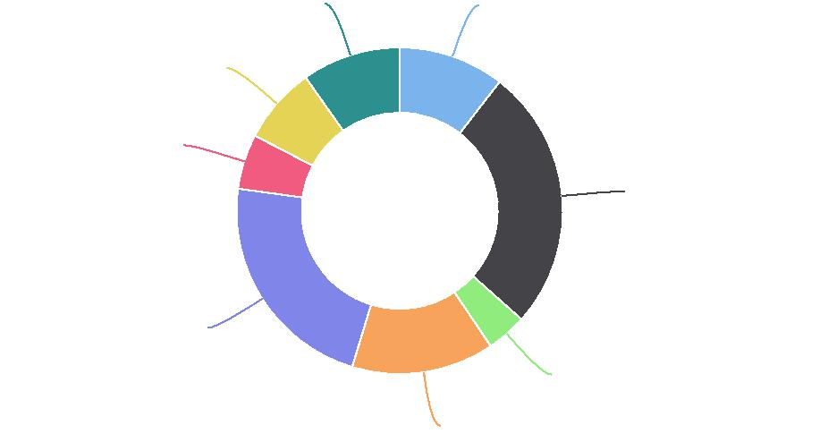

**Age 65+: 9.8%**

**Age 55-64: 7.6%**

**Age 45-54: 5.4%**

**Age 0-4: 10.5%**

**Age 5-17: 26.1%**

**Age 35-44: 22.5%**

**Age 18-24: 4.0%**

**Age 25-34: 14.1%**

*Data Source: US Census Bureau,* [*Decennial Census*](http://www.census.gov/)*. 2010. Source geography: Tract*

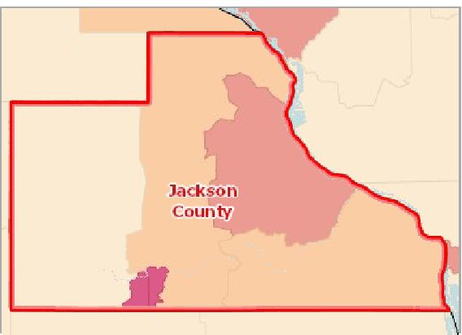

[](https://engagementnetwork.org/map-room/?ids=981,t11&def=t11:FIPS%20In%20('19097')&bbox=-10120449.27515,5164829.551058,-10034264.57655,5219471.283242) View larger map

100% Urban Population

90.1 ‐ 99.9%

50.1 ‐ 90.0%

Under 50.1%

No Urban Population

No Data or Data Suppressed

Jackson County, IA

**Urban Population, Percent by Tract, US Census 2010**



Rural Population, Total by Age Group

This indicator reports the total rural population of the report area by age group.

|  |  |  |  |
| --- | --- | --- | --- |
| **Report Area** | **Population Under Age 18** | **Population Age 18‐64** | **Population Age 65 +** |
| Jackson County, IA | 2,433 | 6,368 | 1,772 |
| Iowa | 266,008 | 644,110 | 185,981 |
| United States | 13,907,394 | 36,734,957 | 9,082,449 |

Rural Population, Total by Age Group

Jackson County, IA

**Population Age 65 +: 16.8%**

**Population Age 18-64: 60.2%**

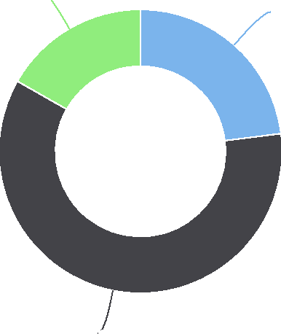

**Population Under Age 18: 23.0%**

Rural Population, Percent by Age Group

|  |  |  |  |
| --- | --- | --- | --- |
| **Report Area** | **Population Under Age 18** | **Population Age 18‐64** | **Population Age 65 +** |
| Jackson County, IA | 52.83% | 55.13% | 47.98% |
| Iowa | 36.54% | 34.53% | 41.07% |
| United States | 18.52% | 18.69% | 22.26% |

Rural Population, Total by Race Alone

This indicator reports the total rural population of the report area by race alone.

|  |  |  |  |  |  |  |  |
| --- | --- | --- | --- | --- | --- | --- | --- |
| **Report Area** | **White** | **Black or African  American** | **Native American or Alaska Native** | **Asian** | **Native Hawaiian or Pacific Islander** | **Some Other Race** | **Multiple  Race** |
| Jackson  County, IA | 10,414 | 13 | 12 | 30 | 0 | 24 | 80 |
| Iowa | 1,065,697 | 5,115 | 3,089 | 4,331 | 312 | 8,224 | 9,331 |
| United States | 52,457,879 | 3,533,008 | 1,043,048 | 399,200 | 40,683 | 1,242,870 | 1,008,112 |

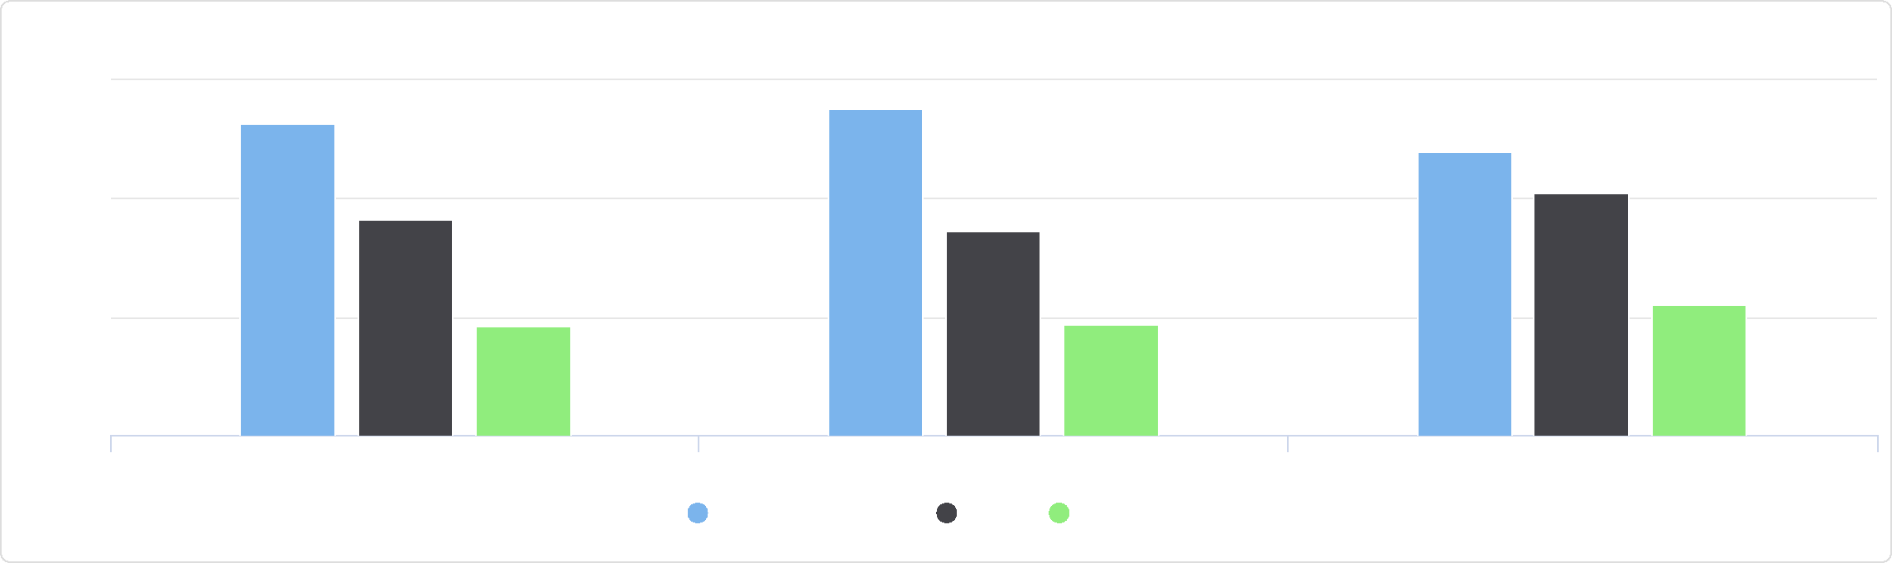

Rural Population, Percent by Age Group

60

Population Under Age 18 Population Age 18-64 Population Age 65 +

Jackson County, IA Iowa United States

%

40

20

0

Rural Population, Total by Race Alone

Jackson County, IA

Rural Population, Percent by Race Alone

This indicator reports the percentage of rural population in the report area by race alone.

|  |  |  |  |  |  |  |  |
| --- | --- | --- | --- | --- | --- | --- | --- |
| **Report Area** | **White** | **Black or African  American** | **Native American or Alaska Native** | **Asian** | **Native Hawaiian or Pacific  Islander** | **Some Other Race** | **Multiple  Race** |
| Jackson  County, IA | 53.85% | 21.31% | 30.00% | 63.83% | 0.00% | 35.82% | 39.02% |
| Iowa | 38.31% | 5.74% | 27.87% | 8.16% | 15.58% | 14.65% | 17.50% |
| United States | 23.17% | 8.97% | 35.33% | 2.72% | 7.53% | 6.41% | 11.04% |

## Veteran Population

This indicator reports the percentage of the population age 18 and older that served (even for a short time), but is not currently serving, on active duty in the U.S. Army, Navy, Air Force, Marine Corps, or the Coast Guard, or that served in the U.S. Merchant Marine during World War II. Of the 15,071 population of the report area, 1,447 or 9.60% are veterans.

|  |  |  |  |
| --- | --- | --- | --- |
| **Report Area** | **Total Population Age 18+** | **Total Veterans** | **Veterans, Percent of Total Population** |
| Jackson County, IA | 15,071 | 1,447 | 9.60% |
| Iowa | 2,400,834 | 188,867 | 7.87% |
| United States | 248,322,822 | 18,611,432 | 7.49% |

*Data Source: US Census Bureau,* [*American Community Survey*](http://www.census.gov/acs/www/)*. 2014‐18. Source geography: Tract*

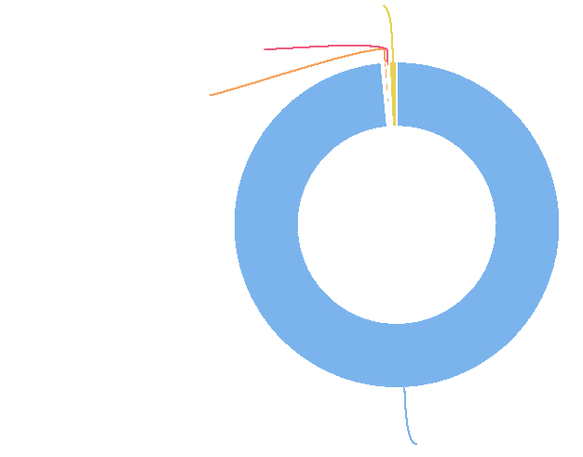

**Multiple Race: 0.8%**

**Some Other Race: 0.2%**

**Asian: 0.3%**

**White: 98.5%**

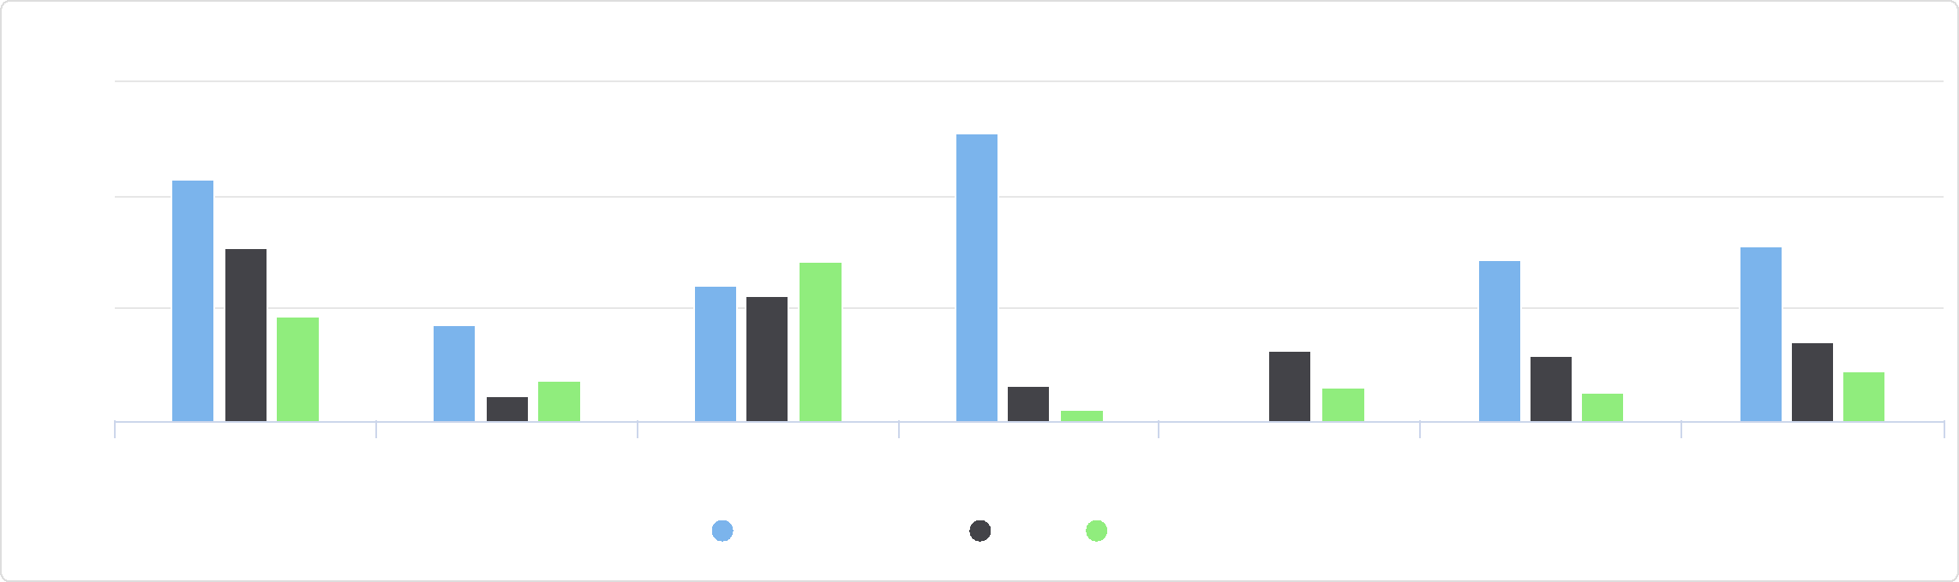

Some Other Race Multiple Race

Asian Native Hawaiian or Pacific

Islander

White Black or African American Native American or Alaska

Native

Rural Population, Percent by Race Alone

75

Jackson County, IA Iowa United States

%

25

50

0

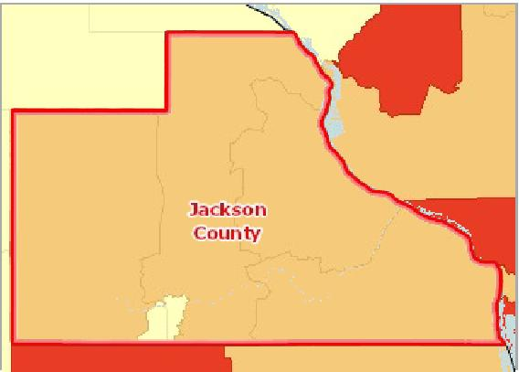

[](https://engagementnetwork.org/map-room/?ids=31562,t11&def=t11:FIPS%20In%20('19097')&bbox=-10120449.27515,5164829.551058,-10034264.57655,5219471.283242) View larger map

**Veterans, Percent of Total Population by Tract, ACS 2014‐18**

Over 13%

11.1 ‐ 13.0%

9.1 ‐ 11.0%

Under 9.1%

No Data or Data Suppressed

Jackson County, IA



Veteran Population by Gender

This indicator reports the veteran population in the report area by gender.

|  |  |  |  |  |
| --- | --- | --- | --- | --- |
| **Report Area** | **Male** | **Female** | **Male, Percent** | **Female, Percent** |
| Jackson County, IA | 1,354 | 93 | 18.04% | 1.23% |
| Iowa | 176,371 | 12,496 | 14.94% | 1.02% |
| United States | 17,003,235 | 1,608,197 | 14.11% | 1.26% |

Veteran Population by Gender

Jackson County, IA

Veteran Population by Age Group, Total

This indicator reports the total veteran population in the report area by age group.

|  |  |  |  |  |  |
| --- | --- | --- | --- | --- | --- |
| **Report Area** | **Age 18‐34** | **Age 35‐54** | **Age 55‐64** | **Age 65‐74** | **Age 75+** |
| Jackson County, IA | 134 | 338 | 191 | 436 | 348 |
| Iowa | 14,147 | 40,219 | 30,708 | 53,611 | 50,182 |
| United States | 1,645,406 | 4,397,264 | 3,356,119 | 4,885,436 | 4,327,207 |

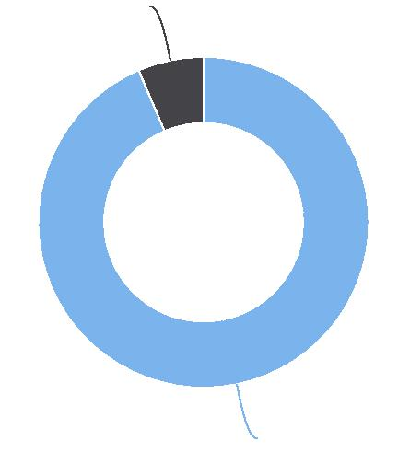

**Female: 6.4%**

**Male: 93.6%**

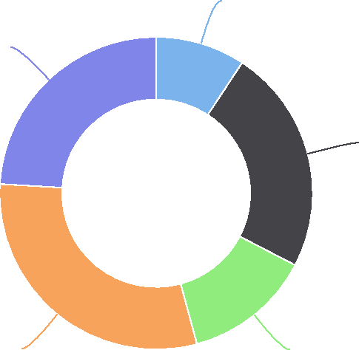

Veteran Population by Age Group, Total

Jackson County, IA

Veteran Population by Age Group, Percent

This indicator reports the percentage of veterans in the report area by age group.

|  |  |  |  |  |  |
| --- | --- | --- | --- | --- | --- |
| **Report Area** | **Age 18‐34** | **Age 35‐54** | **Age 55‐64** | **Age 65‐74** | **Age 75+** |
| Jackson County, IA | 3.99% | 7.07% | 6.35% | 20.45% | 19.40% |
| Iowa | 1.98% | 5.29% | 7.42% | 19.17% | 21.48% |
| United States | 2.20% | 5.29% | 8.13% | 17.12% | 20.90% |

# Social & Economic Factors

## Children Eligible for Free/Reduced Price Lunch

Free or reduced price lunches are served to qualifying students in families with income between under 185 percent (reduced price) or under 130% (free lunch) of the US federal poverty threshold as part of the federal National School Lunch Program (NSLP).

Out of 2,797 total public school students in the report area, 1,282 were eligible for the free or reduced price lunch program in the latest report year. This represents 45.8% of public school students, which is higher than the state average of 42.5%.

**Age 18-34: 9.3%**

**Age 75+: 24.0%**

**Age 35-54: 23.4%**

**Age 65-74: 30.1% Age 55-64: 13.2%**

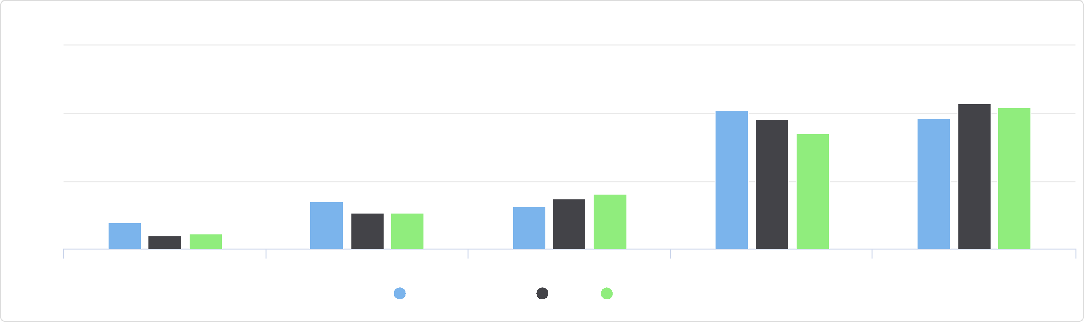

Veteran Population by Age Group, Percent

30

Age 18-34 Age 35-54 Age 55-64 Age 65-74 Age 75+

Jackson County, IA Iowa United States

%

20

10

0

|  |  |  |  |
| --- | --- | --- | --- |
| **Report Area** | **Total  Students** | **Students Eligible for Free or Reduced Price Lunch** | **Students Eligible for Free or Reduced Price  Lunch, Percent** |
| Jackson  County, IA | 2,797 | 1,282 | **45.8%** |
| Iowa | 506,310 | 215,291 | 42.5% |
| United States | 50,744,629 | 25,124,175 | 49.5% |

Percentage of Students Eligible for Free or Reduced Price School

Lunch

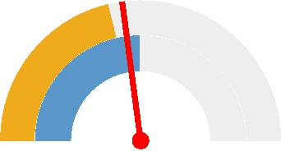

0% 100%

Jackson County (45.8%)

Iowa (42.5%)

United States (49.5%)



*Note: This indicator is compared to the state average.*

*Data Source: National Center for Education Statistics,* [*NCES ‐ Common Core of Data*](http://nces.ed.gov/)*. 2018‐19. Source geography: Address*

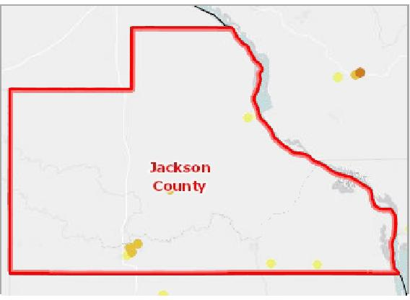

[](https://engagementnetwork.org/map-room/?ids=32548,t11&def=t11:FIPS%20In%20('19097')&bbox=-10120449.27515,5164829.551058,-10034264.57655,5219471.283242) View larger map

Over 90.0% 75.1% ‐ 90.0% 50.1% ‐ 75.0% 20.1% ‐ 50.0% Under 20.1% Not Reported Jackson County, IA

**Students Eligible for Free or Reduced‐Price Lunch, NCES CCD 2018‐19**



Children Eligible for Free or Reduced Price Lunch by School Year, 2012‐13 through 2018‐19

The table below shows local, state, and national trends in student free and reduced lunch eligibility by percent.

|  |  |  |  |  |  |  |  |
| --- | --- | --- | --- | --- | --- | --- | --- |
| **Report Area** | **2012‐13** | **2013‐14** | **2014‐15** | **2015‐16** | **2016‐17** | **2017‐18** | **2018‐19** |
| Jackson County, IA | 41.1% | 40.7% | 40.7% | 43.2% | 44.1% | 44.1% | 45.8% |
| Iowa | 40.9% | 40.9% | 40.7% | 41.5% | 40.9% | 40.9% | 42.5% |
| United States | 51.8% | 52.4% | 52.3% | 52.7% | 52.1% | 52.1% | 52.4% |

Children Eligible for Free or Reduced Price Lunch by School Year, 2012-13 through 2018-19

Children Eligible for Free or Reduced Price Lunch by Eligibility

The table below displays the number and percentage of students eligible for free or reduced price lunch by income eligibility category. Percentages in the table below are out of the total student population.

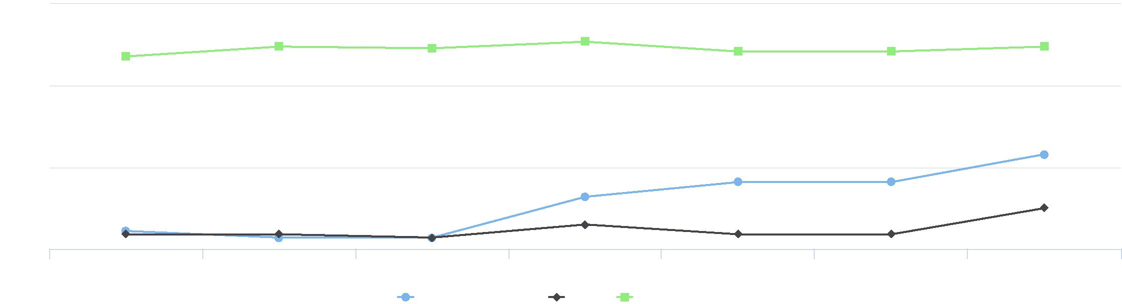

50

45

40

2012-13 2013-14 2014-15 2015-16 2016-17 2017-18 2018-19

Jackson County, IA Iowa United States

55

%

|  |  |  |  |  |
| --- | --- | --- | --- | --- |
| **Report Area** | **Free Lunch, Total** | **Free Lunch, Percent** | **Reduced Lunch, Total** | **Reduced Lunch, Percent** |
| Jackson County, IA | 1,105 | 39.5% | 177 | 6.3% |
| Iowa | 179,977 | 35.5% | 35,287 | 7.0% |
| United States | 21,661,831 | 43.0% | 2,568,683 | 5.1% |

The chart below displays the percentage of the students in each eligibility category out of the total number of students eligible for free or reduced price lunch.

Children Eligible for Free or Reduced Price Lunch by Eligibility

Jackson County, IA

## Food Insecurity Rate

This indicator reports the estimated percentage of the population that experienced food insecurity at some point during the report year. Food insecurity is the household‐level economic and social condition of limited or uncertain access to adequate food.

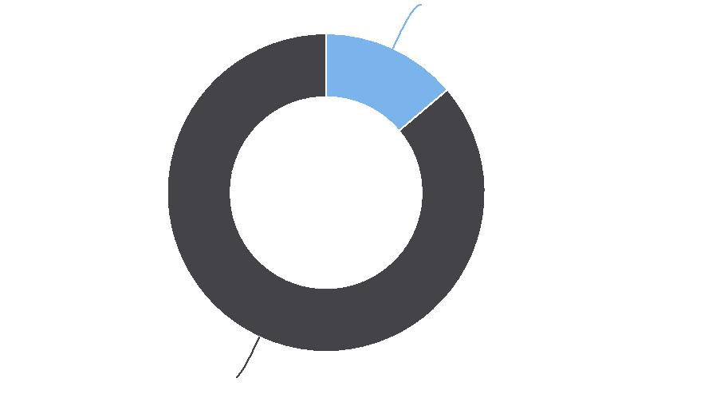

**Reduced Lunch, Total: 13.8%**

**Free Lunch, Total: 86.2%**

|  |  |  |  |
| --- | --- | --- | --- |
| **Report Area** | **Total Population** | **Food Insecure Population, Total** | **Food Insecurity Rate** |
| Jackson County, IA | 19,369 | 2,150 | **11.10%** |
| Iowa | 3,136,606 | 341,890 | 10.90% |
| United States | 325,717,422 | 41,133,950 | 12.63% |

*Note: This indicator is compared to the state average.*

*Data Source:* [*Feeding America*](http://feedingamerica.org/)*. 2017. Source geography: County*

Percentage of Total Population with Food Insecurity

|  |  |
| --- | --- |
|  | |
|  | 0% 50%  Jackson County (11.10%)  Iowa (10.90%)  United States (12.63%) |

**Food Insecure Population, Percent by County, Feeding America 2017**

Over 18.0%   
15.1 ‐ 18.0%   
12.1 ‐ 15.0%   
Under 12.1%   
Jackson County, IA



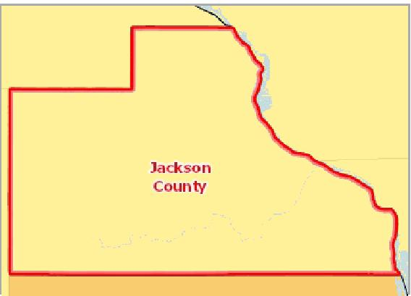

[](https://engagementnetwork.org/map-room/?ids=27006,t11&def=t11:FIPS%20In%20('19097')&bbox=-10120449.27515,5164829.551058,-10034264.57655,5219471.283242) View larger map

Food Insecurity ‐ Food Insecure Children

This indicator reports the estimated percentage of the population under age 18 that experienced food insecurity at some point during the report year. Food insecurity is the household‐level economic and social condition of limited or uncertain

access to adequate food.

|  |  |  |  |  |  |  |
| --- | --- | --- | --- | --- | --- | --- |
| **Report Area** | **Population Under Age 18** | | **Food Insecure Children, Total** | | **Child Food Insecurity Rate** | |
| Jackson County, IA |  | 4,345 |  | 730 |  | 16.80% |
| Iowa | No data |  | No data |  | No data |  |
| United States |  | 73,641,039 |  | 13,411,620 |  | 18.21% |

Food Insecurity ‐ Food Insecure Population Ineligible for Assistance

This indicator reports the estimated percentage of the total population and the population under age 18 that experienced food insecurity at some point during the report year, but are ineligible for State or Federal nutrition assistance. Food insecurity is the household‐level economic and social condition of limited or uncertain access to adequate food. Assistance eligibility is determined based on household income of the food insecure households relative to the maximum income‐to‐poverty ratio for assistance programs (SNAP, WIC, school meals, CSFP and TEFAP).

|  |  |  |  |  |
| --- | --- | --- | --- | --- |
| **Report Area** | **Food Insecure  Population** | **Food Insecure Population Ineligible for  Assistance, Percent** | **Food Insecure  Children** | **Food Insecure Children Ineligible for  Assistance, Percent** |
| Jackson County, IA | 2,150 | 43.00% | 730 | 43.00% |
| Iowa | 341,890 | 43.00% | 111,520 | 42.00% |
| United States | 41,133,950 | 33.00% | 13,411,620 | 35.00% |

## Head Start

Head Start is a program designed to help children from birth to age five who come from families at or below poverty level. The program’s goal is to help children become ready for kindergarten while also providing the needed requirements to thrive, including health care and food support.

This indicator reports the number and rate of Head Start program facilities per 10,000 children under age 5. Head Start facility data is acquired from the US Department of Health and Human Services (HHS) 2018 Head Start locator. Population data is from the 2010 US Decennial Census. The report area has a total 0 Head Start programs with a rate of 0 per 10,000 children under 5 years old.

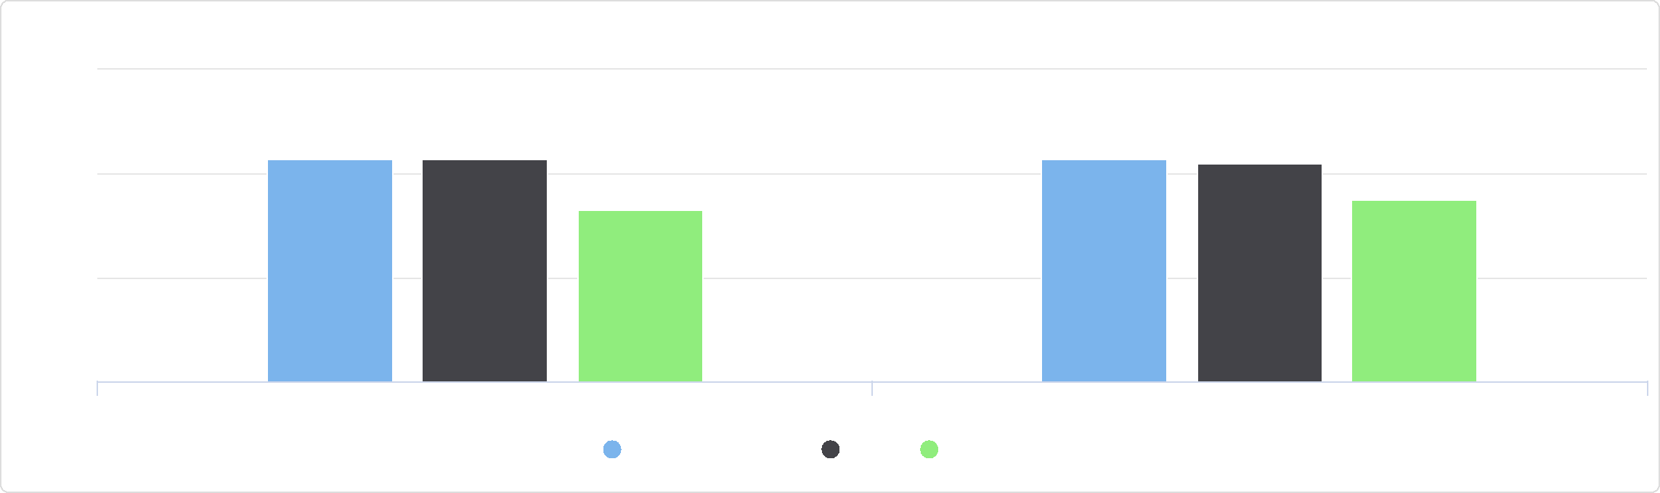

%

Food Insecurity - Food Insecure Population Ineligible for Assistance

60

40

20

0

Pct. Total Pop. Ineligible:% Pct. Children Ineligible:%

Jackson County, IA Iowa United States

|  |  |  |  |
| --- | --- | --- | --- |
| **Report Area** | **Children Under Age**  **5** | **Total Head Start  Programs** | **Head Start Programs, Rate (Per 10,000  Children)** |
| Jackson County, IA | 1,122 | 0 | **0** |
| Iowa | 202,123 | 266 | 13.16 |
| United States | 20,426,118 | 21,511 | 10.53 |

*Note: This indicator is compared to the state average.*

*Data Source: US Department of Health & Human Services,* [*Administration for Children and Families*](http://www.acf.hhs.gov/)*. 2019. Source geography: Address*

Head Start Programs Rate (Per 10,000 Children Under Age 5)

|  |  |
| --- | --- |
|  | |
| 0 50 | |
|  | Jackson County, IA (0)  Iowa (13.16)  United States (10.53) |

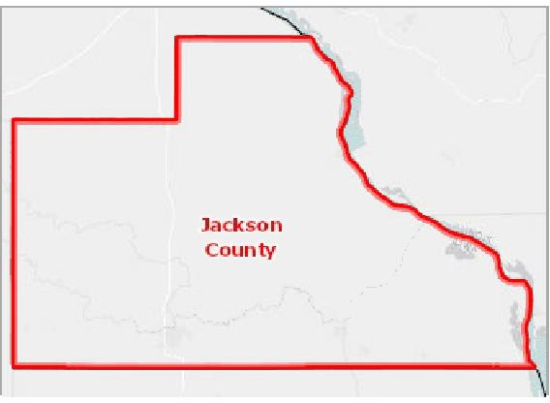

[](https://engagementnetwork.org/map-room/?ids=9074,t11&def=t11:FIPS%20In%20('19097')&bbox=-10120449.27515,5164829.551058,-10034264.57655,5219471.283242) View larger map

**Head Start Facilities, All Facilities, ACF 2019**

Head Start Facilities, All Facilities, ACF 2019 Jackson County, IA



## High School Graduation Rate (Ed*Facts*)

The adjusted cohort graduation rate (ACGR) is a graduation metric that follows a “cohort” of first‐time 9th graders in a particular school year, and adjust this number by adding any students who transfer into the cohort after 9th grade and subtracting any students who transfer out, emigrate to another country, or pass away. The ACGR is the percentage of the students in this cohort who graduate within four years. In the report area, the adjusted cohort graduation rate was 92.7% during the most recently reported school year. Students in the report area performed better than the state, which had an ACGR of 91.1%.

|  |  |  |  |
| --- | --- | --- | --- |
| **Report Area** | **Adjusted Student Cohort** | **Number of Diplomas Issued** | **Cohort Graduation Rate** |
| Jackson County, IA | 193 | 179 | **92.7%** |
| Iowa | 35,353 | 32,198 | 91.1% |
| United States | 3,180,487 | 2,778,988 | 87.4% |

*Note: This indicator is compared to the state average.*

*Data Source: US Department of Education,* [*EDFacts*](https://www2.ed.gov/about/inits/ed/edfacts/index.html)*. Additional data analysis by* [*CARES*](http://cares.missouri.edu)*. 2017‐18. Source geography: School District*

Adjusted Cohort Graduation Rate

|  |  |
| --- | --- |
|  | |
| 0% 100% | |
|  | Jackson County (92.7%)  Iowa (91.1%)  United States (87.4%) |

**On‐Time Graduation, Rate by School District (Secondary), ED*Facts* 2017‐18**

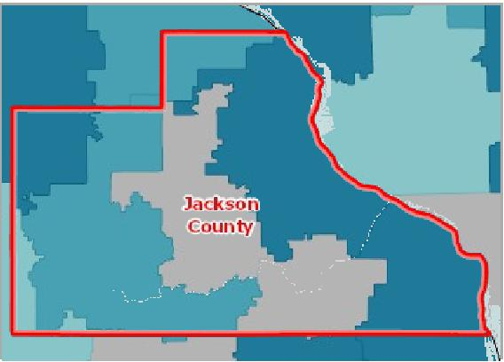

[](https://engagementnetwork.org/map-room/?ids=32550,t11&def=t11:FIPS%20In%20('19097')&bbox=-10120449.27515,5164829.551058,-10034264.57655,5219471.283242) View larger map

Over 94.0%

85.1 ‐ 94.0%

75.1 ‐ 85.0%

Under 75.1%

No Data or Data Suppressed

Jackson County, IA



## High School Graduation Rate by Student Race and Ethnicity

The table and chart below display local, state, and national variation in cohort graduation rates by student race and ethnicity. *Note: Data are suppressed for some school districts for population groups when the "universe" population falls below a certain threshold. County, state, and national summaries are aggregates of district level data and may not represent all students when*

*suppression has occurred* .

|  |  |  |  |  |
| --- | --- | --- | --- | --- |
| **Report Area** | **Non‐Hispanic White** |  | **Black or African American** | **Hispanic or Latino** |
| Jackson County, IA | 95.0% | No data |  | 0.0% |
| Iowa | 92.1% |  | 79.8% | 80.8% |
| United States | 90.5% |  | 81.6% | 83.0% |

High School Graduation Rate by Year, 2012‐13 through 2017‐18

The table below shows local, state, and national trends in cohort graduation rates.

*Note: Data for some states are omitted each year when they fail to meet federal reporting standards or deadlines. Use caution*

*when comparing national trends as the "universe" population may differ over time*.

|  |  |  |  |  |  |  |
| --- | --- | --- | --- | --- | --- | --- |
| **Report Area** | **2012‐13** | **2013‐14** | **2014‐15** | **2015‐16** | **2016‐17** | **2017‐18** |
| Jackson County, IA | 86.4% | 89.9% | 90.7% | 91.9% | 90.8% | 92.7% |
| Iowa | 89.3% | 90.3% | 90.3% | 90.8% | 90.6% | 91.1% |
| United States | 83.2% | 84.3% | 84.3% | 86.1% | 86.8% | 87.4% |

## High School Graduation Rate (NCES)

Within the report area 92.70% of students are receiving their high school diploma within four years. This is greater than the Healthy People 2020 target of 82.4%. This indicator is relevant because research suggests education is one the strongest predictors of health ([Freudenberg & Ruglis, 2007](http://www.cdc.gov/pcd/issues/2007/oct/07_0063.htm)).

High School Graduation Rate by Student Race and Ethnicity

100

|  |  |  |  |  |  |  |  |  |
| --- | --- | --- | --- | --- | --- | --- | --- | --- |
|  | 75  50  25  0 |  |  |  |  |  |  |  |
| % |  |  |  |  |
|  |  |  |  |
|  |  |  |  |  |
|  |  |  |  |  |  |  |  |

Non-Hispanic White Black or African American Hispanic or Latino

Jackson County, IA Iowa United States



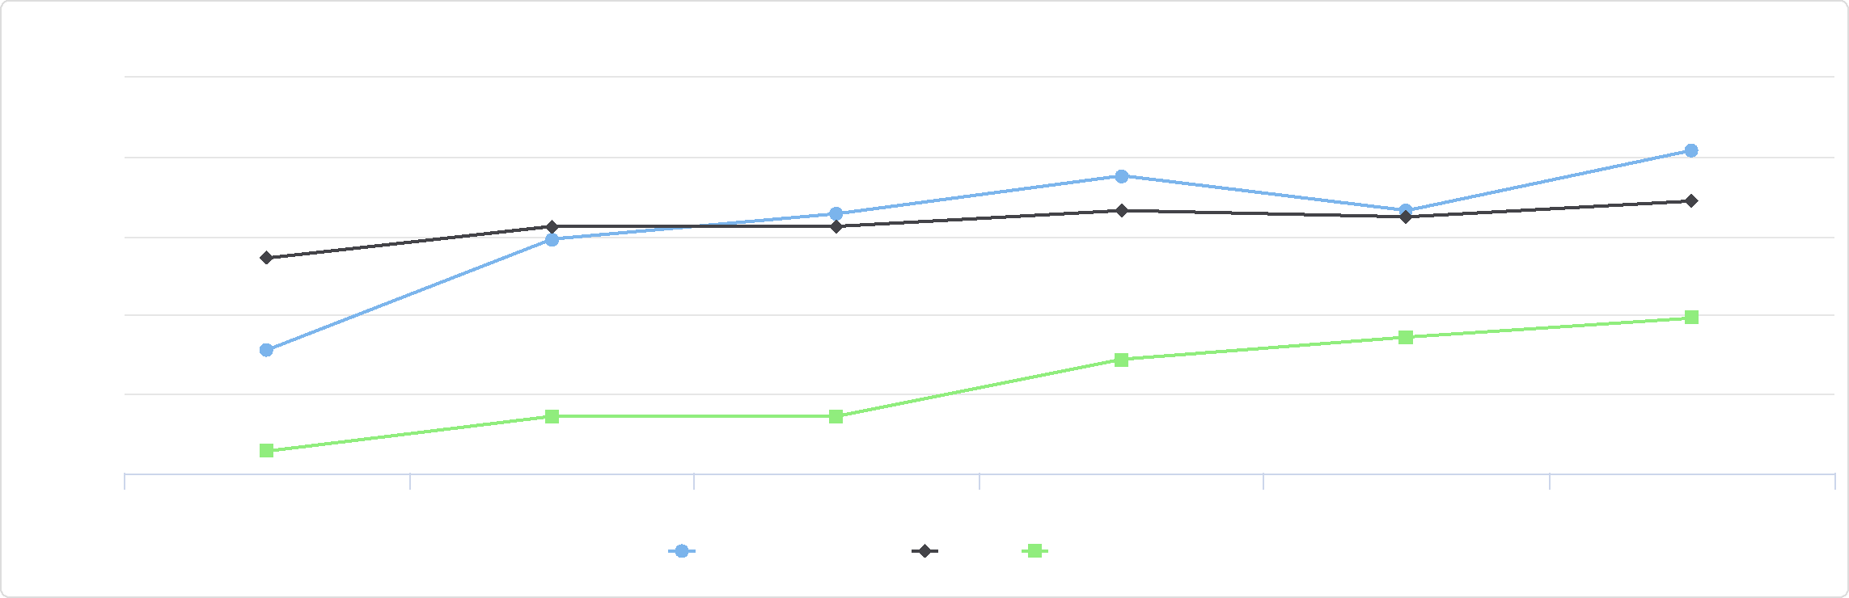

%

High School Graduation Rate by Year, 2012-13 through 2017-18

95

92.5

90

87.5

85

82.5

2012-13 2013-14 2014-15 2015-16 2016-17 2017-18

Jackson County, IA Iowa United States

|  |  |  |  |
| --- | --- | --- | --- |
| **Report Area** | **Average Freshman Base  Enrollment** | **Estimated Number of Diplomas  Issued** | **On‐Time Graduation  Rate** |
| Jackson County, IA | 330.00 | 306.00 | **92.70** |
| Iowa | 39,571.00 | 33,926.00 | 85.7 |
| United States | 4,024,345.00 | 3,039,015.00 | 75.50 |

On-Time Graduation Rate

|  |  |
| --- | --- |
|  | |
|  | 0 100  Jackson County (92.70)  Iowa (85.7)  United States (75.50) |

*Note: This indicator is compared to the state average.*

*Data Source: National Center for Education Statistics,* [*NCES ‐ Common Core of Data*](http://nces.ed.gov/)*. 2008‐09. Source geography: County*

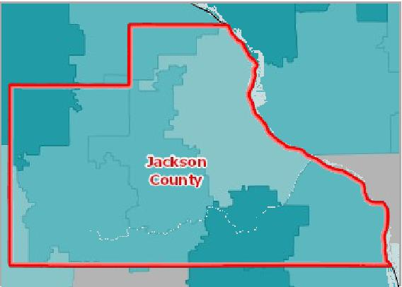

[](https://engagementnetwork.org/map-room/?ids=506,t11&def=t11:FIPS%20In%20('19097')&bbox=-10120449.27515,5164829.551058,-10034264.57655,5219471.283242) View larger map

Over 94.1%

85.1 ‐ 94.0%

75.1 ‐ 85.0%

Under 75.1%

No Data or Data Suppressed

Jackson County, IA

**On‐Time Graduation, Rate by School District (Secondary), NCES CCD 2008‐ 09**



## Households with No Motor Vehicle

This indicator reports the number and percentage of households with no motor vehicle based on the latest 5‐year American Community Survey estimates. Of the 8,236 total households in the report area, 554 or 6.73% are without a motor vehicle.

|  |  |  |  |
| --- | --- | --- | --- |
| **Report Area** | **Total Occupied  Households** | **Households with No Motor  Vehicle** | **Households with No Motor Vehicle,  Percent** |
| Jackson County, IA | 8,236 | 554 | **6.73%** |
| Iowa | 1,256,855 | 71,845 | 5.72% |
| United States | 119,730,128 | 10,424,934 | 8.71% |

*Note: This indicator is compared to the state average.*

*Data Source: US Census Bureau,* [*American Community Survey*](http://www.census.gov/acs/www/)*. 2014‐18. Source geography: Tract*

Percentage of Households with No Motor Vehicle

|  |  |
| --- | --- |
|  | |
| 0% 20% | |
|  | Jackson County (6.73%)  Iowa (5.72%)  United States (8.71%) |

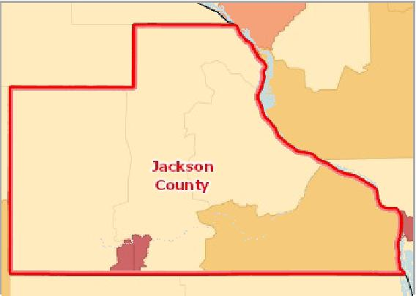

[](https://engagementnetwork.org/map-room/?ids=30465,t11&def=t11:FIPS%20In%20('19097')&bbox=-10120449.27515,5164829.551058,-10034264.57655,5219471.283242) View larger map

**Households with No Vehicle, Percent by Tract, ACS 2014‐18**

Over 8.0%

6.1 ‐ 8.0%

4.1 ‐ 6.0%

Under 4.1%

No Data or Data Suppressed

Jackson County, IA



Households with No Motor Vehicle by Tenure

|  |  |  |  |  |
| --- | --- | --- | --- | --- |
| **Report Area** | **Owner‐Occupied  Households** | **Owner‐Occupied Households,  Percent** | **Renter‐Occupied  Households** | **Renter‐Occupied Households,  Percent** |
| Jackson County, IA | 225 | 3.46% | 329 | 18.97% |
| Iowa | 19,363 | 2.17% | 52,482 | 14.47% |
| United States | 2,430,345 | 3.18% | 7,994,589 | 18.47% |

## Housing Cost Burden (30%)

This indicator reports the percentage of the households where housing costs exceed 30% of total household income. This indicator provides information on the cost of monthly housing expenses for owners and renters. The information offers a measure of housing affordability and excessive shelter costs. The data also serve to aid in the development of housing programs to meet the needs of people at different economic levels. Of the 8,236 total households in the report area, 1,626 or 19.74% of the population live in cost burdened households.

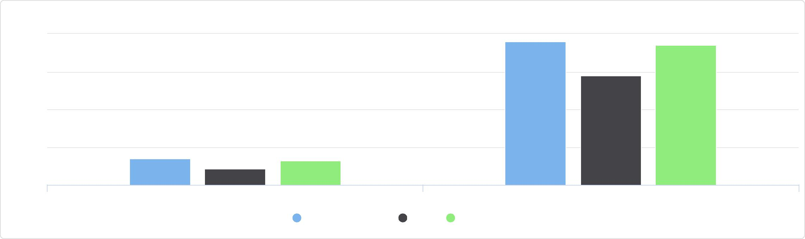

Households with No Motor Vehicle by Tenure

20

Percentage of Owner-Occupied Households with No Vehicle Percentage of Renter-Occupied Households with No Vehicle

Jackson County, IA Iowa United States

%

15

10

0

5

|  |  |  |  |
| --- | --- | --- | --- |
| **Report Area** | **Total**  **Households** | **Cost Burdened Households (Housing Costs Exceed  30% of Income)** | **Cost Burdened Households, Percent** |
| Jackson  County, IA | 8,236 | 1,626 | **19.74%** |
| Iowa | 1,256,855 | 290,917 | 23.15% |
| United States | 119,730,128 | 37,771,047 | 31.55% |

*Note: This indicator is compared to the state average.*

*Data Source: US Census Bureau,* [*American Community Survey*](http://www.census.gov/acs/www/)*. 2014‐18. Source geography: Tract*

Percentage of Households where   
Housing Costs Exceed 30% of   
Income

|  |  |
| --- | --- |
|  | |
|  | 0% 50% Jackson County (19.74%) Iowa (23.15%)  United States (31.55%) |

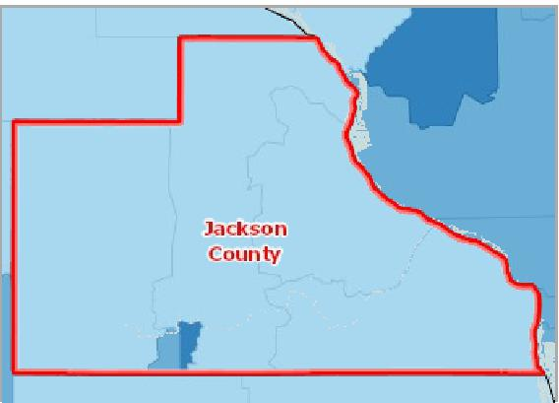

[](https://engagementnetwork.org/map-room/?ids=30506,t11&def=t11:FIPS%20In%20('19097')&bbox=-10120449.27515,5164829.551058,-10034264.57655,5219471.283242) View larger map

**Cost Burdened Households (Housing Costs Exceed 30% of Household Income), Percent by Tract, ACS 2014‐18**

Over 35.1%

28.1 ‐ 35.0%

21.1 ‐ 28.0%

Under 21.1%

No Data or Data Suppressed

Jackson County, IA



Cost Burdened Households by Tenure, Total

These data show the number of households that spend more than 30% of the household income on housing costs. In the

report area, there were 1,626 cost burdened households according to the U.S. Census Bureau American Community Survey (ACS) 2014‐2018 5‐year estimates. The data for this indicator is only reported for households where household housing costs and income earned was identified in the American Community Survey.

|  |  |  |  |  |
| --- | --- | --- | --- | --- |
| **Report Area** | **Cost Burdened  Households** | **Cost Burdened Rental  Households** | **Cost Burdened Owner Occupied**  **Households**  **(With Mortgage)** | **Cost Burdened Owner Occupied**  **Households**  **(With No Mortgage)** |
| Jackson  County, IA | 1,626 | 696 | 544 | 386 |
| Iowa | 290,917 | 144,448 | 107,678 | 38,791 |
| United States | 37,771,047 | 20,141,357 | 13,750,273 | 3,879,417 |

Cost Burdened Households by Tenure, Percent

These data show the percentage of households by tenure that are cost burdened. Cost burdened rental households (those that spent more than 30% of the household income on rental costs) represented 40.14% of all of the rental households in the report area, according to the U.S. Census Bureau American Community Survey (ACS) 2014‐2018 5‐year estimates. The data for this indicator is only reported for households where tenure, household housing costs, and income earned was identified in the American Community Survey.

|  |  |  |  |  |  |  |
| --- | --- | --- | --- | --- | --- | --- |
| **Report Area** | **Rental Households** | **Percentage of Rental  Households that are  Cost Burdened** | **Owner  Occupied  Households  (With  Mortgage)** | **Percentage of Owner Occupied  Households w/ Mortgages that  are Cost Burdened** | **Owner  Occupied  Households  (No  Mortgage)** | **Percentage of Owner Occupied  Households w/o Mortgages that  are Cost Burdened** |
| Jackson County, IA | 1,734 | 40.14% | 3,331 | 16.33% | 3,171 | 12.17% |
| Iowa | 362,703 | 39.83% | 542,373 | 19.85% | 351,779 | 11.03% |
| United States | 43,285,318 | 46.53% | 48,198,598 | 28.53% | 28,246,212 | 13.73% |

Cost Burdened Households by Tenure, Total

Jackson County, IA

**Owner-Occupied Households, No Mortgage: 23.7%**

**Owner-Occupied Households With Mortgage: 33.5%**

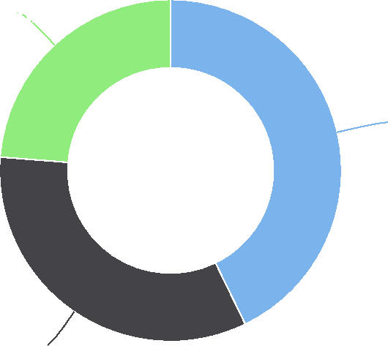

**Rental Households: 42.8%**

Cost Burdened Households by Tenure, Percent

60

|  |  |  |  |  |  |  |  |  |  |  |  |  |  |  |
| --- | --- | --- | --- | --- | --- | --- | --- | --- | --- | --- | --- | --- | --- | --- |
|  | 40  20 |  |  |  |  |  |  |  |  |  |  |  |  |  |
| % |  |  |  |  |  |  |  |  |  |  |  |  |
|  |  |  |  |  |  |  |  |  |  |  |  |
|  |  |  |  |  |  |  |  |  |  |  |  |  |
|  |  |  |  |  |  |  |  |  |  |  |  |  |
|  |  |  |  |  |  |  |  |  |  |  |  |  |
|  |  |  |  |  |  |  |  |  |  |  |  |  |
|  | 0 |  |  |  |  |  |  |  |  |  |  |  |
|  |  |  |  |  |  |  |  |  |  |  |  |  |  |

|  |  |  |  |
| --- | --- | --- | --- |
| Severly Cost Burdened  Rental Households |  | Severely Cost Burdened  Owner Occupied Households  (With Mortgage) | Severely Cost Burdened  Owner Occupied Households  (With No Mortgage) |
|  |  | Jackson County, IA Iowa United States |  |

## Income ‐ Families Earning Over $75,000

In the report area, 46.73%, or 2,530 families report a total annual income of $75,000 or greater. Total income includes all reported income from wages and salaries as well as income from self‐employment, interest or dividends, public assistance, retirement, and other sources. As [defined](http://www2.census.gov/programs-surveys/acs/tech_docs/subject_definitions/2018_ACSSubjectDefinitions.pdf#page=75&zoom=auto,78,370) by the US Census Bureau, a family household is any housing unit in which the householder is living with one or more individuals related to him or her by birth, marriage, or adoption. A non‐family household is any household occupied by the householder alone, or by the householder and one or more unrelated individuals.

|  |  |  |  |
| --- | --- | --- | --- |
| **Report Area** | **Total Families** | **Families with Income Over $75,000** | **Percent Families with Income Over $75,000** |
| Jackson County, IA | 5,414 | 2,530 | **46.73%** |
| Iowa | 800,510 | 398,983 | 49.84% |
| United States | 78,697,103 | 38,798,884 | 49.30% |

*Note: This indicator is compared to the state average.*

*Data Source: US Census Bureau,* [*American Community Survey*](http://www.census.gov/acs/www/)*. 2014‐18. Source geography: Tract*

Percent Families with Income Over

$75,000

|  |  |
| --- | --- |
|  | |
|  | 0% 75%  Jackson County (46.73%)  Iowa (49.84%)  United States (49.30%) |

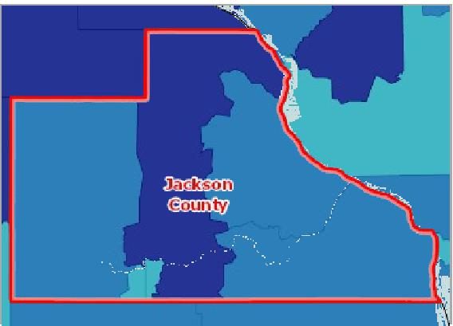

[](https://engagementnetwork.org/map-room/?ids=30617,t11&def=t11:FIPS%20In%20('19097')&bbox=-10120449.27515,5164829.551058,-10034264.57655,5219471.283242) View larger map

**Family Income Over $75,000, Percent by Tract, ACS 2014‐18**

Over 55.0%

40.1 ‐ 55.0%

25.1 ‐ 40.0%

Under 25.1%

No Data or Data Suppressed

Jackson County, IA



Families with Income Over $75,000 by Race Alone, Total

|  |  |  |  |  |  |  |  |
| --- | --- | --- | --- | --- | --- | --- | --- |
| **Report Area** | **Non‐Hispanic White** | **Black or African  American** | **Native American or  Alaska Native** | **Asian** | **Native Hawaiian or  Pacific Islander** | **Some Other Race** | **Multiple Race** |
| Jackson County, IA | 2,530 | 0 | 0 | 0 | 0 | 0 | 0 |
| Iowa | 382,691 | 3,977 | 628 | 7,252 | 103 | 2,261 | 2,071 |
| United States | 31,614,454 | 2,837,317 | 181,581 | 2,509,197 | 51,137 | 923,218 | 681,980 |

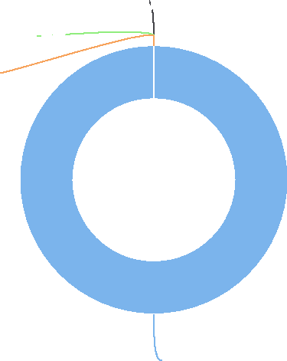

Families with Income Over $75,000 by Race Alone, Total

Jackson County, IA

Families with Income Over $75,000 by Race Alone, Percent

|  |  |  |  |  |  |  |  |
| --- | --- | --- | --- | --- | --- | --- | --- |
| **Report Area** | **White** | **Black or African  American** | **Native American or Alaska Native** | **Asian** | **Native Hawaiian or Pacific  Islander** | **Some Other Race** | **Multiple  Race** |
| Jackson  County, IA | 47.59% | 0.00% | No data | 0.00% | 0.00% | No data | 0.00% |
| Iowa | 51.37% | 18.84% | 25.76% | 47.06% | 16.61% | 26.99% | 27.22% |
| United States | 52.60% | 31.64% | 30.87% | 61.02% | 43.24% | 28.17% | 44.54% |

Families with Income Over $75,000 by Ethnicity Alone

|  |  |  |  |  |
| --- | --- | --- | --- | --- |
| **Report Area** | **Hispanic or Latino** | **Not Hispanic or Latino** | **Hispanic or Latino, Percent** | **Not Hispanic or Latino, Percent** |
| Jackson County, IA | 39 | 2,491 | 68.42% | 46.50% |
| Iowa | 10,122 | 388,861 | 28.11% | 50.86% |
| United States | 3,838,546 | 34,960,338 | 32.45% | 52.28% |

**Black or African American: 0.0%**

**Native American or Alaska Native: 0.0%**

**Asian: 0.0%**

**Non-Hispanic White: 100.0%**

Families with Income Over $75,000 by Race Alone, Percent

75

|  |  |  |  |  |  |  |  |  |  |  |  |  |  |  |  |  |  |  |  |  |  |  |
| --- | --- | --- | --- | --- | --- | --- | --- | --- | --- | --- | --- | --- | --- | --- | --- | --- | --- | --- | --- | --- | --- | --- |
|  |  |  |  |  |  |  |  |  |  |  |  |  |  |  |  |  |  |  |  |  |  |  |
|  | 50 |  |  |  |  |  |  |  |  |  |  |  |  |  |  |  |  |  |  |  |  |
|  |  |  |  |  |  |  |  |  |  |  |  |  |  |  |  |  |  |  |  |
|  |  |  |  |  |  |  |  |  |  |  |  |  |  |  |  |  |  |  |  |  |
| % |  |  |  |  |  |  |  |  |  |  |  |  |  |  |  |  |  |  |  |  |
|  |  |  |  |  |  |  |  |  |  |  |  |  |  |  |  |  |  |  |  |
|  | 25 |  |  |  |  |  |  |  |  |  |  |  |  |  |  |  |  |  |  |  |
|  |  |  |  |  |  |  |  |  |  |  |  |  |  |  |  |  |  |
|  |  |  |  |  |  |  |  |  |  |  |  |  |  |  |  |  |  |
|  |  |  |  |  |  |  |  |  |  |  |  |  |  |  |  |  |  |  |
|  |  |  |  |  |  |  |  |  |  |  |  |  |  |  |  |  |  |  |
|  | 0 |  |  |  |  |  |  |  |  |  |  |  |  |  |  |  |  |  |
|  |  |  |  |  |  |  |  |  |  |  |  |  |  |  |  |  |  |  |  |  |  |

White Black or African American Native American or Alaska Asian Native Hawaiian or Pacific Some Other Race Multiple Race

Native Islander

Jackson County, IA Iowa United States



Families with Income Over $75,000 by Ethnicity Alone

## Income ‐ Inequality (GINI Index)

This indicator reports income inequality using the Gini coefficient. Gini index values range between zero and one. A value of one indicates perfect inequality where only one house‐hold has any income. A value of zero indicates perfect equality, where all households have equal income.

Index values are acquired from the 2014‐18 American Community Survey and are not available for custom report areas or multi‐county areas.

|  |  |  |
| --- | --- | --- |
| **Report Area** | **Total Households** | **Gini Index Value** |
| Jackson County, IA | 8,236 | **0.43** |
| Iowa | 1,256,855 | 0.44 |
| United States | 119,730,128 | 0.48 |

*Note: This indicator is compared to the state average.*

*Data Source: US Census Bureau,* [*American Community Survey*](http://www.census.gov/acs/www/)*. 2014‐18. Source geography: Tract*

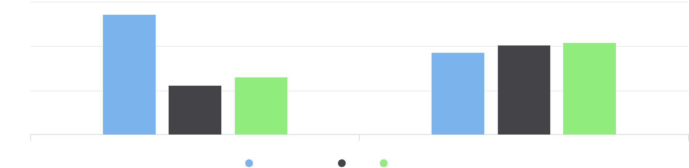

75

Hispanic / Latino Not Hispanic / Latino

Jackson County, IA Iowa United States

%

25

50

0

Gini Index Value

|  |  |
| --- | --- |
|  | |
| 0 1 | |
|  | Jackson County (0.43)  Iowa (0.44)  United States (0.48) |

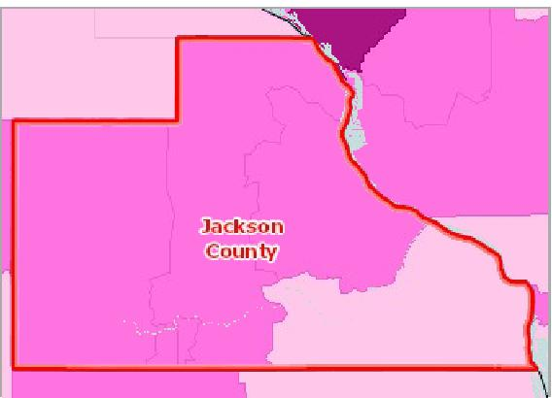

[](https://engagementnetwork.org/map-room/?ids=30893,t11&def=t11:FIPS%20In%20('19097')&bbox=-10120449.27515,5164829.551058,-10034264.57655,5219471.283242) View larger map

**Income Inequality (GINI), Index Value by Tract, ACS 2014‐18**

Over 0.460

0.431 ‐ 0.460

0.401 ‐ 0.430

Under 0.401

No Data or Data Suppressed

Jackson County, IA



## Income ‐ Median Family Income

This indicator reports median family income based on the latest 5‐year American Community Survey estimates. A family household is any housing unit in which the householder is living with one or more individuals related to him or her by birth, marriage, or adoption. Family income includes the incomes of all family members age 15 and older.

|  |  |  |  |
| --- | --- | --- | --- |
| **Report Area** | **Total Family Households** | **Average Family Income** | **Median Family Income** |
| Jackson County, IA | 5,414 | $82,010 | **$69,011** |
| Iowa | 800,510 | $91,704 | $74,794 |
| United States | 78,697,103 | $99,436 | $73,965 |

*Note: This indicator is compared to the state average.*

*Data Source: US Census Bureau,* [*American Community Survey*](http://www.census.gov/acs/www/)*. 2014‐18. Source geography: Tract*

Median Family Income

|  |  |
| --- | --- |
|  | |
|  | 0 80000  Jackson ($69,011) Iowa ($74,794)  United States ($73,965) |

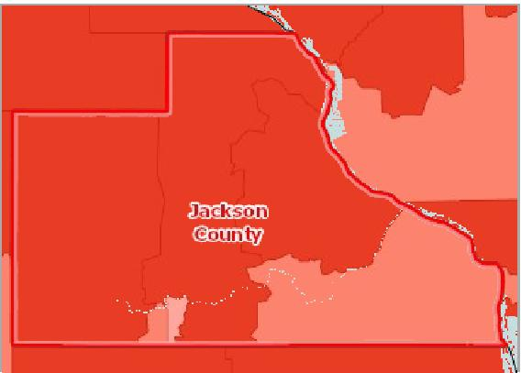

[](https://engagementnetwork.org/map-room/?ids=30619,t11&def=t11:FIPS%20In%20('19097')&bbox=-10120449.27515,5164829.551058,-10034264.57655,5219471.283242) View larger map

**Median Family Income by Tract, ACS 2014‐18**

Over $65,000

$55,001 ‐ $65,000

$45,001 ‐ $55,000

Under $45,001

No Data or Data Suppressed

Jackson County, IA



Median Family Income by Family Composition

|  |  |  |  |  |  |  |
| --- | --- | --- | --- | --- | --- | --- |
| **Report  Area** | **Married‐Couple Families without Children** | **Married‐Couple Families with Children** | **Single‐Males  without Children** | **Single‐Males  with Children** | **Single Females  without Children** | **Single Females  with Children** |
| Jackson County, IA | $69,706 | $92,956 | $65,357 | $46,797 | $43,938 | $19,688 |
| Iowa | $79,477 | $94,376 | $56,766 | $44,207 | $47,157 | $27,280 |
| United States | $84,289 | $95,854 | $58,168 | $42,637 | $48,841 | $27,335 |

Median Family Income by Race / Ethnicity of Householder

|  |  |  |  |  |  |  |  |  |
| --- | --- | --- | --- | --- | --- | --- | --- | --- |
| **Report Area** | **Non‐Hispanic White** | **Black** | **Asian** | **American Indian or  Alaska Native** | **Native Hawaiian or  Pacific Islander** | **Some Other Race** | **Multiple Race** | **Hispanic or  Latino** |
| Jackson County, IA | $70,298 | No data | No data | No data | $36,974 | No data | No data | $91,250 |
| Iowa | $77,736 | $32,283 | $71,831 | $42,961 | $35,988 | $48,989 | $47,648 | $48,798 |
| United States | $83,246 | $49,270 | $96,439 | $49,451 | $65,618 | $48,058 | $66,304 | $51,800 |

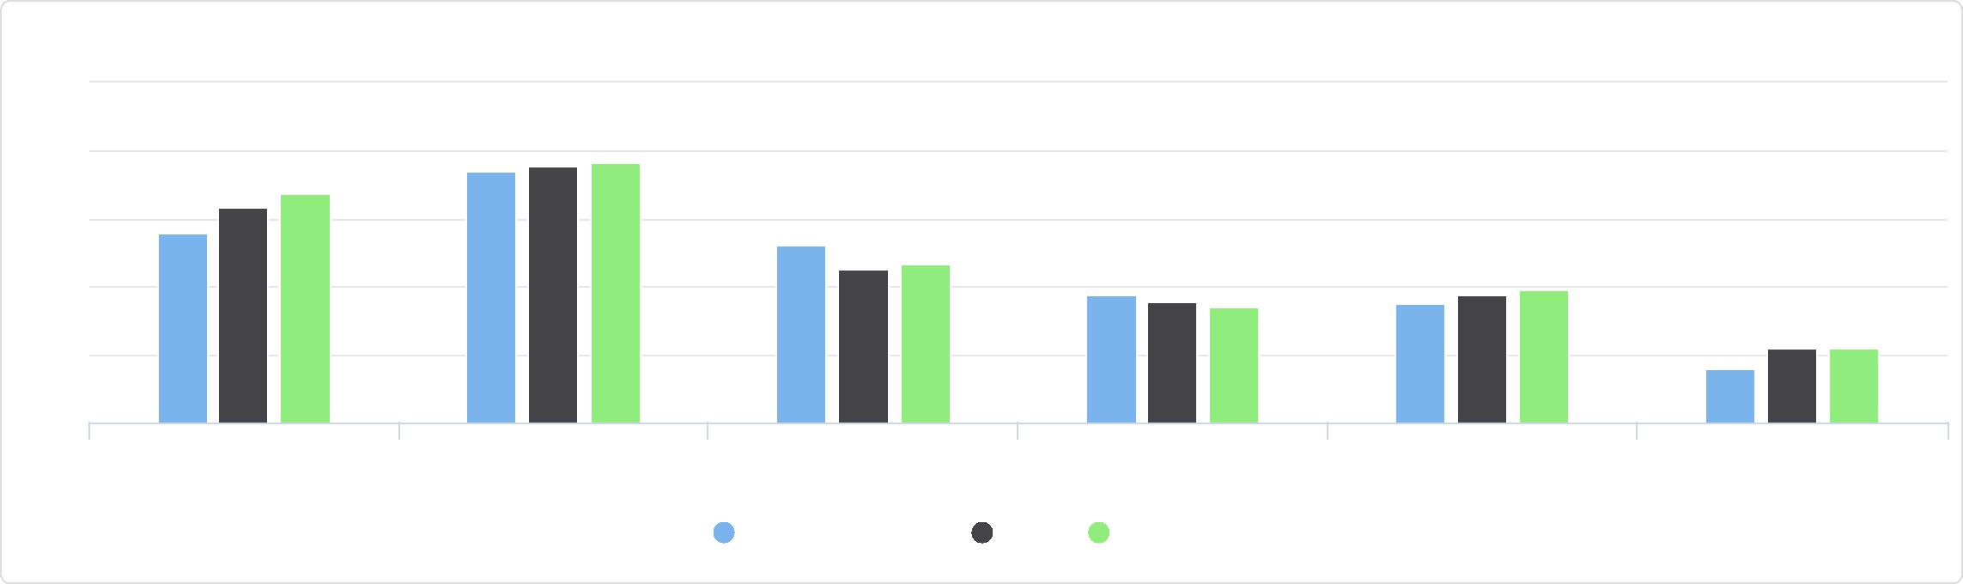

Married-Couple Families without Children

Married-Couple Families with Children

Single-Males without Children Single-Males with Children Single Females without

Children

Single Females with Children

Median Family Income by Family Composition

Jackson County, IA Iowa United States

125k

100k

75k

50k

25k

0

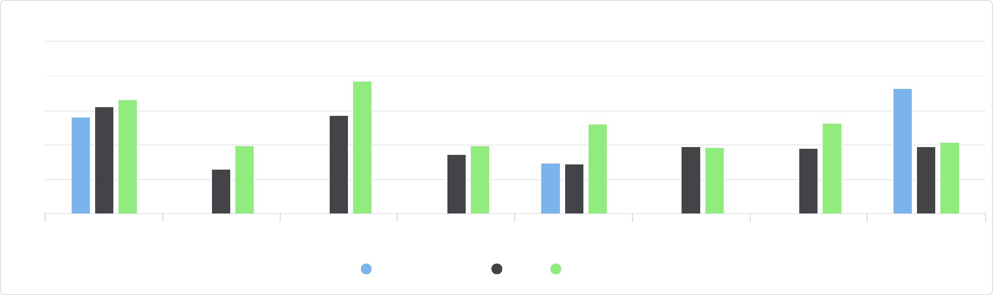

Native Hawaiian or Pacific Islander

Some Other Race Multiple Race Hispanic or Latino

Non-Hispanic White Black Asian American Indian or

Alaska Native

Median Family Income by Race / Ethnicity of Householder

125k

100k

75k

50k

25k

0

Jackson County, IA Iowa United States

## Income ‐ Per Capita Income

The per capita income for the report area is $29,207. This includes all reported income from wages and salaries as well as income from self‐employment, interest or dividends, public assistance, retirement, and other sources. The per capita income in this report area is the average (mean) income computed for every man, woman, and child in the specified area.

|  |  |  |  |
| --- | --- | --- | --- |
| **Report Area** | **Total Population** | **Total Income ($)** | **Per Capita Income ($)** |
| Jackson County, IA | 19,395 | $566,471,100 | **$29,207** |
| Iowa | 3,132,499 | $97,373,326,700 | $31,084 |
| United States | 322,903,030 | $10,533,302,424,400 | $32,620 |

*Note: This indicator is compared to the state average.*

*Data Source: US Census Bureau,* [*American Community Survey*](http://www.census.gov/acs/www/)*. 2014‐18. Source geography: Tract*

Per Capita Income ($)

|  |  |
| --- | --- |
|  | |
| 10000 50000 | |
|  | Jackson ($29,207)  Iowa ($31,084)  United States ($32,620) |

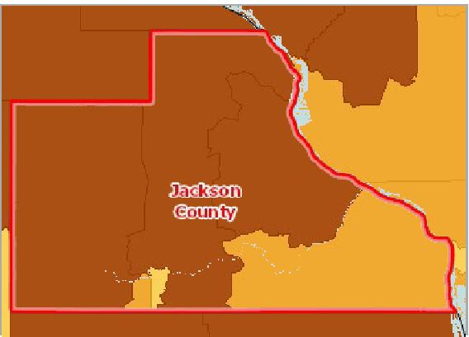

[](https://engagementnetwork.org/map-room/?ids=30745,t11&def=t11:FIPS%20In%20('19097')&bbox=-10120449.27515,5164829.551058,-10034264.57655,5219471.283242) View larger map

**Per Capita Income by Tract, ACS 2014‐18**

Over $30,000

$25,001 ‐ $30,000

$20,001 ‐ $25,000

Under $20,001

No Data or Data Suppressed

Jackson County, IA



Per Capita Income by Race Alone

This indicator reports the per capita income of the report area by race alone.

|  |  |  |  |  |  |  |  |
| --- | --- | --- | --- | --- | --- | --- | --- |
| **Report Area** | **White** | **Black or African  American** | **Native American or Alaska Native** | **Asian** | **Native Hawaiian or  Pacific Islander** | **Some Other Race** | **Multiple  Race** |
| Jackson  County, IA | $29,845.00 | $18,289.00 | $8,696.00 | $0.00 | $12,363.00 | $0.00 | $5,458.00 |
| Iowa | $32,404.00 | $16,677.00 | $27,634.00 | $18,622.00 | $19,250.00 | $18,668.00 | $12,543.00 |
| United States | $35,758.00 | $22,237.00 | $38,237.00 | $19,748.00 | $23,883.00 | $18,056.00 | $19,119.00 |

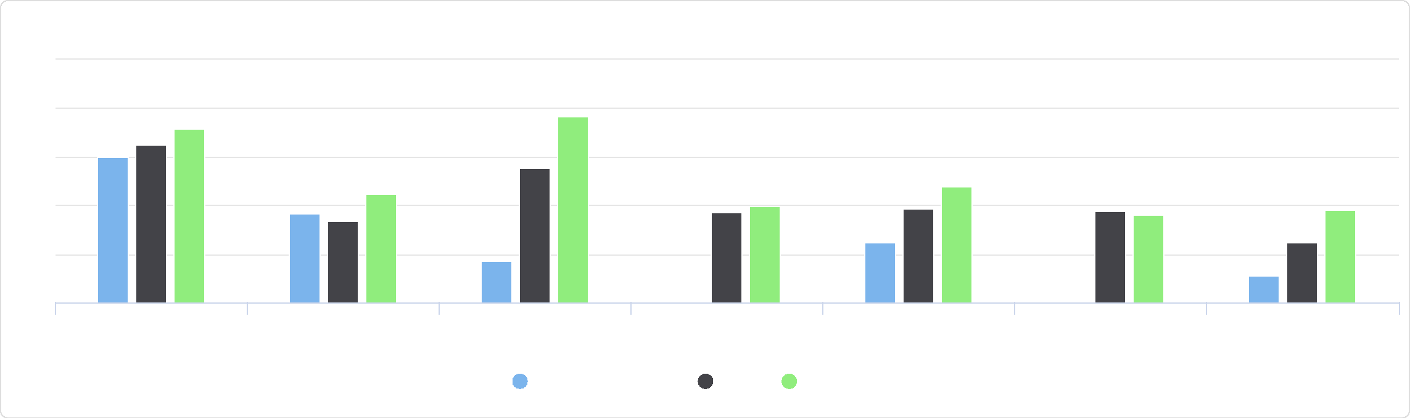

50k

40k

Some Other Race Multiple Race

Asian Native Hawaiian or Pacific

Islander

White Black or African American Native American or Alaska

Native

Per Capita Income by Race Alone

Jackson County, IA Iowa United States

30k

20k

10k

0

Per Capita Income by Ethnicity Alone

This indicator reports the per capita income of the report area by ethnicity alone.

|  |  |  |
| --- | --- | --- |
| **Report Area** | **Hispanic or Latino** | **Not Hispanic or Latino** |
| Jackson County, IA | $19,671.00 | $29,345.00 |
| Iowa | $16,895.00 | $31,967.00 |
| United States | $19,385.00 | $35,489.00 |

## Income ‐ Public Assistance Income

This indicator reports the percentage households receiving public assistance income. Public assistance income includes general assistance and Temporary Assistance to Needy Families (TANF). Separate payments received for hospital or other medical care (vendor payments) are excluded. This does not include Supplemental Security Income (SSI) or noncash benefits such as Food Stamps.

Per Capita Income by Ethnicity Alone

40k

|  |  |  |  |  |  |
| --- | --- | --- | --- | --- | --- |
| 30k  20k  10k  0 |  |  |  |  |  |
|  |  |  |  |
|  |  |  |  |
|  |  |  |
|  |  |  |  |  |

Hispanic or Latino Not Hispanic or Latino

Jackson County, IA Iowa United States



|  |  |  |  |
| --- | --- | --- | --- |
| **Report Area** | **Total**  **Households** | **Households with Public Assistance Income** | **Percent Households with Public Assistance**  **Income** |
| Jackson County, IA | 8,236 | 118 | **1.43%** |
| Iowa | 1,256,855 | 25,593 | 2.04% |
| United States | 119,730,128 | 2,939,063 | 2.45% |

Percent Households with Public Assistance Income

|  |  |
| --- | --- |
|  | |
| 0% 10% | |
|  | Jackson County (1.43%)  Iowa (2.04%)  United States (2.45%) |

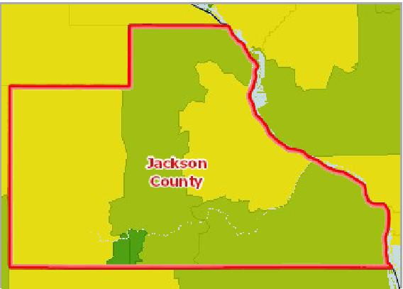

[](https://engagementnetwork.org/map-room/?ids=30886,t11&def=t11:FIPS%20In%20('19097')&bbox=-10120449.27515,5164829.551058,-10034264.57655,5219471.283242) View larger map

**Households with Public Assistance Income, Percent by Tract, ACS 2014‐18**

Over 3.0%

2.1 ‐ 3.0%

1.1 ‐ 2.0%

Under 1.1%

No Data or Data Suppressed

Jackson County, IA



Average Public Assistance Dollars Received

|  |  |  |  |
| --- | --- | --- | --- |
| **Report Area** | **Total Households Receiving Public Assistance**  **Income** | **Aggregate Public Assistance Dollars  Received** | **Average Public Assistance Received  (in USD)** |
| Jackson County, IA | 118 | $534,800 | $4,532 |
| Iowa | 25,593 | $66,541,700 | $2,599 |
| United States | 2,939,063 | $9,354,731,900 | $3,182 |

## Insurance ‐ Population Receiving Medicaid

This indicator reports the percentage of the population with insurance enrolled in Medicaid (or other means‐tested public health insurance). This indicator is relevant because it assesses vulnerable populations which are more likely to have multiple health access, health status, and social support needs; when combined with poverty data, providers can use this measure to identify gaps in eligibility and enrollment.

Average Public Assistance Dollars Received

6k

4k

2k

0

Average Public Assistance Received (in USD)

Jackson County, IA Iowa United States



Percent of Insured Population Receiving Medicaid

|  |  |
| --- | --- |
|  | |
|  | 0% 25%  Jackson County (22.00%)  Iowa (19.32%)  United States (22.18%) |

|  |  |  |  |  |
| --- | --- | --- | --- | --- |
| **Report  Area** | **Total Population  (For Whom Insurance  Status is Determined)** | **Population with Any  Health Insurance** | **Population  Receiving  Medicaid** | **Percent of Insured Population Receiving Medicaid** |
| Jackson County, IA | 19,194 | 18,324 | 4,032 | **22.00%** |
| Iowa | 3,088,842 | 2,936,373 | 567,337 | 19.32% |
| United States | 317,941,631 | 288,188,864 | 63,906,660 | 22.18% |

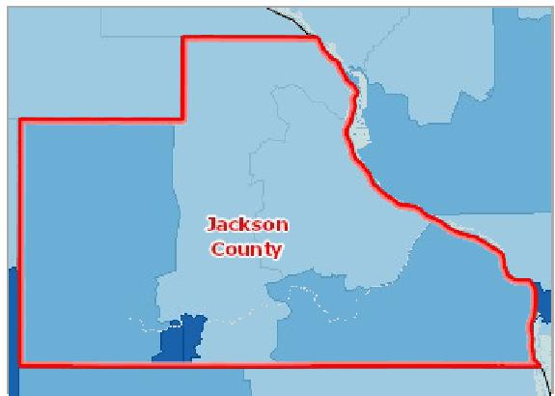

[](https://engagementnetwork.org/map-room/?ids=30948,t11&def=t11:FIPS%20In%20('19097')&bbox=-10120449.27515,5164829.551058,-10034264.57655,5219471.283242) View larger map

**Insured, Medicaid / Means‐Tested Coverage, Percent by Tract, ACS 2014‐ 18**

Over 25,0%

20.1 ‐ 25.0%

15.1 ‐ 20.0%

Under 15.1%

No Data or Data Suppressed

Jackson County, IA



Population Receiving Medicaid by Age Group, Percent

|  |  |  |  |
| --- | --- | --- | --- |
| **Report Area** | **Under Age 18** | **Age 18 ‐ 64** | **Age 65 +** |
| Jackson County, IA | 37.13% | 16.37% | 14.70% |
| Iowa | 34.76% | 13.57% | 10.38% |
| United States | 38.28% | 14.32% | 13.77% |

Population Receiving Medicaid by Age Group, Total

|  |  |  |  |
| --- | --- | --- | --- |
| **Report Area** | **Under Age 18** | **Age 18‐64** | **Age 65+** |
| Jackson County, IA | 1,703 | 1,777 | 552 |
| Iowa | 268,851 | 247,630 | 50,856 |
| United States | 29,795,069 | 27,509,492 | 6,602,099 |

Population Receiving Medicaid by Age Group, Percent

50

40

|  |  |  |  |  |  |  |  |  |
| --- | --- | --- | --- | --- | --- | --- | --- | --- |
|  | 30  20  10  0 |  |  |  |  |  |  |  |
| % |  |  |  |  |  |  |
|  |  |  |  |  |  |  |
|  |  |  |  |  |
|  |  |  |  |  |  |  |  |

Under Age 18 Age 18 - 64 Age 65 +

Jackson County, IA Iowa United States



Population Receiving Medicaid by Age Group, Total

Jackson County, IA

**Under Age 18: 42.2%**

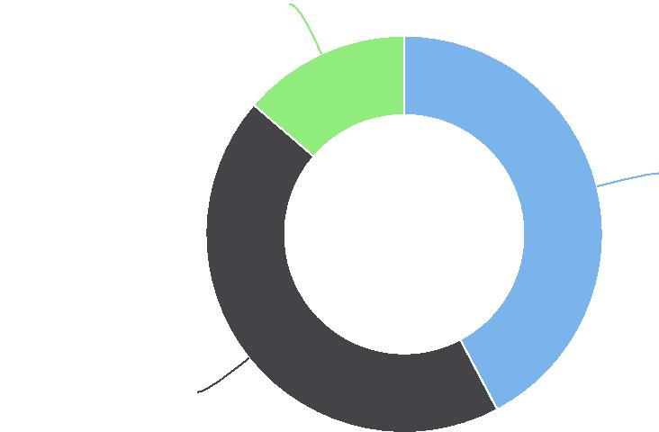

**Age 18-64: 44.1%**

**Age 65+: 13.7%**

## Insurance ‐ Uninsured Adults

The lack of health insurance is considered a *key driver* of health status.

This indicator reports the percentage of adults age 18 to 64 without health insurance coverage. This indicator is relevant because lack of insurance is a primary barrier to healthcare access including regular primary care, specialty care, and other health services that contributes to poor health status.

|  |  |  |  |  |  |
| --- | --- | --- | --- | --- | --- |
| **Report Area** | **Total  Population  Age 18 ‐ 64** | **Population with  Medical  Insurance** | **Percent Population  With Medical  Insurance** | **Population Without Medical Insurance** | **Percent Population  Without Medical  Insurance** |
| Jackson County, IA | 11,033 | 10,316 | 93.50% | 717 | **6.50%** |
| Iowa | 1,825,275 | 1,701,347 | 93.21% | 123,928 | 6.79% |
| United States | 195,883,847 | 171,496,973 | 87.55% | 24,386,874 | 12.45% |

*Note: This indicator is compared to the state average.*

*Data Source: US Census Bureau,* [*Small Area Health Insurance Estimates*](https://www.census.gov/programs-surveys/sahie.html)*. 2018. Source geography: County*

Percent Population Age 18-64 Without Medical Insurance

|  |  |
| --- | --- |
|  | |
| 0% 50% | |
|  | Jackson County (6.50%)  Iowa (6.79%)  United States (12.45%) |

**Uninsured Population, Age 18‐64, Percent by County, SAHIE 2018**

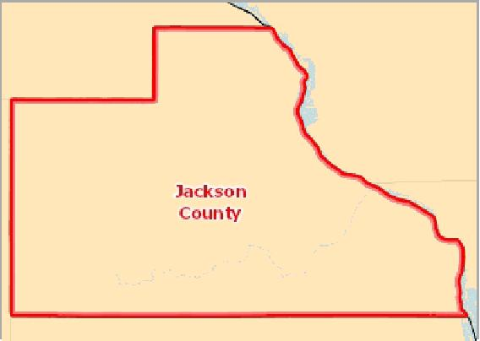

[](https://engagementnetwork.org/map-room/?ids=32308,t11&def=t11:FIPS%20In%20('19097')&bbox=-10120449.27515,5164829.551058,-10034264.57655,5219471.283242) View larger map

Over 27.0%

22.1 ‐ 27.0%

17.1 ‐ 22.0%

Under 17.1%

No Data or Data Suppressed

Jackson County, IA



Uninsured Population Age 18 ‐ 64 by Race / Ethnicity, Percent

|  |  |  |  |
| --- | --- | --- | --- |
| **Report Area** | **Non‐Hispanic White** | **Non‐Hispanic Black** | **Hispanic or Latino** |
| Iowa | 5.50% | 12.50% | 20.30% |
| United States | 8.63% | 14.26% | 24.95% |

*Note: No county data available. See data source and methodology for more details.*

Uninsured Population Age 18 - 64 by Race / Ethnicity, Percent

30

|  |  |  |  |  |  |  |  |  |  |  |
| --- | --- | --- | --- | --- | --- | --- | --- | --- | --- | --- |
|  | 20  10 |  |  |  |  |  |  |  |  |  |
| % |  |  |  |  |  |  |  |  |
|  |  |  |  |  |  |  |  |
|  |  |  |  |  |  |  |  |  |
|  |  |  |  |  |  |  |  |  |
|  | 0 |  |  |  |  |  |  |  |
|  |  |  |  |  |  |  |  |  |  |

Non-Hispanic White Non-Hispanic Black Hispanic or Latino

Iowa United States



Uninsured Population Age 18 ‐ 64, Percent by Year, 2011 through 2018

|  |  |  |  |  |  |  |  |
| --- | --- | --- | --- | --- | --- | --- | --- |
| **Report Area** | **2011** | **2012** | **2013** | **2014** | **2015** | **2016** | **2017** |
| Jackson County, IA | 13.80% | 13.40% | 13.40% | 9.60% | 7.50% | 6.10% | 6.30% |
| Iowa | 12.90% | 12.20% | 11.70% | 8.90% | 6.80% | 6.00% | 6.50% |
| United States | 21.11% | 20.76% | 20.44% | 16.37% | 13.21% | 12.08% | 12.25% |

## Insurance ‐ Uninsured Children

The lack of health insurance is considered a *key driver* of health status.

This indicator reports the percentage of children under age 19 without health insurance coverage. This indicator is relevant because lack of insurance is a primary barrier to healthcare access including regular primary care, specialty care, and other health services that contributes to poor health status.

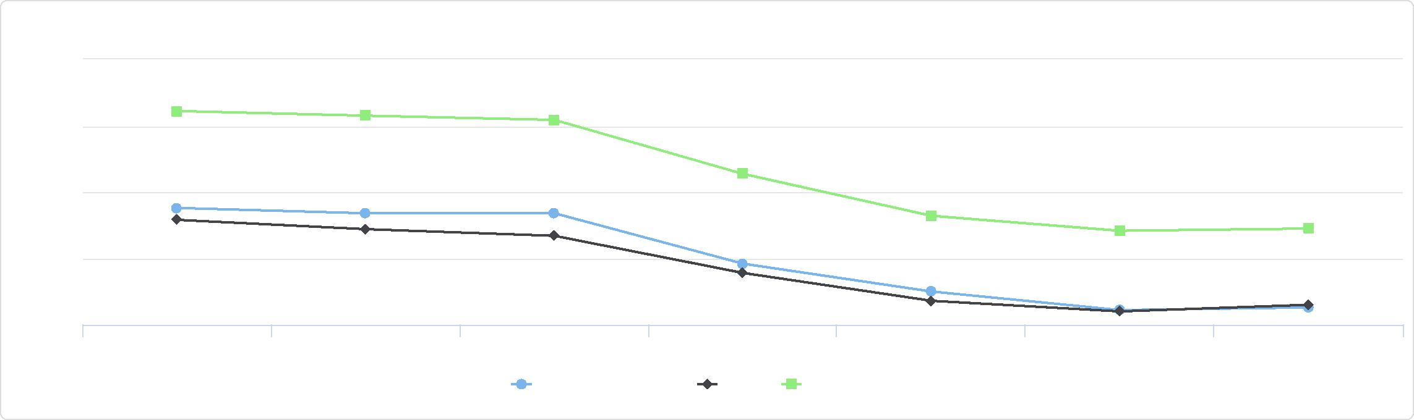

Uninsured Population Age 18 - 64, Percent by Year, 2011 through 2018

25

20

15

10

5

%

2011 2012 2013 2014 2015 2016 2017

Jackson County, IA Iowa United States

|  |  |  |  |  |  |
| --- | --- | --- | --- | --- | --- |
| **Report Area** | **Total  Population  Under Age 19** | **Population with  Medical  Insurance** | **Percent Population  With Medical  Insurance** | **Population Without Medical Insurance** | **Percent Population  Without Medical  Insurance** |
| Jackson County, IA | 4,491 | 4,344 | 96.73% | 147 | **3.27%** |
| Iowa | 752,877 | 732,463 | 97.29% | 20,414 | 2.71% |
| United States | 75,996,420 | 72,053,677 | 94.81% | 3,942,743 | 5.19% |

*Note: This indicator is compared to the state average.*

*Data Source: US Census Bureau,* [*Small Area Health Insurance Estimates*](https://www.census.gov/programs-surveys/sahie.html)*. 2018. Source geography: County*

Percent Population Under Age 19 Without Medical Insurance

|  |  |
| --- | --- |
|  | |
| 0% 50% | |
|  | Jackson County (3.27%)  Iowa (2.71%)  United States (5.19%) |

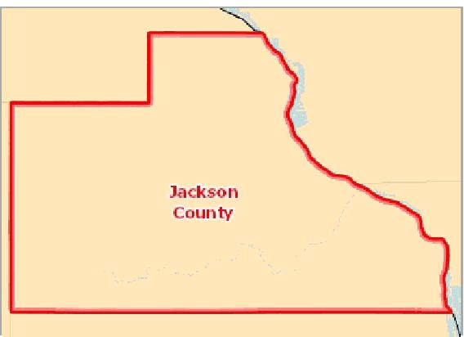

[](https://engagementnetwork.org/map-room/?ids=32324,t11&def=t11:FIPS%20In%20('19097')&bbox=-10120449.27515,5164829.551058,-10034264.57655,5219471.283242) View larger map

**Uninsured Population, Age 0‐18, Percent by County, SAHIE 2018**

Over 10.0%

8.1 ‐ 10.0%

6.1 ‐ 8.0%

Under 6.1%

No Data or Data Suppressed

Jackson County, IA



Uninsured Population Under Age 18, by Race / Ethnicity, Percent

|  |  |  |  |
| --- | --- | --- | --- |
| **Report Area** | **Non‐Hispanic White** | **Non‐Hispanic Black** | **Hispanic or Latino** |
| Iowa | 4.20% | 6.90% | 13.30% |
| United States | 6.73% | 10.14% | 18.48% |

*Note: No county data available. See data source and methodology for more details.*

Uninsured Population Under Age 18, Percent by Year, 2011 through 2018

|  |  |  |  |  |  |  |  |
| --- | --- | --- | --- | --- | --- | --- | --- |
| **Report Area** | **2011** | **2012** | **2013** | **2014** | **2015** | **2016** | **2017** |
| Jackson County, IA | 5.10% | 5.10% | 5.00% | 4.40% | 4.60% | 3.10% | 3.30% |
| Iowa | 4.40% | 4.10% | 4.40% | 3.40% | 3.60% | 2.60% | 2.90% |
| United States | 7.89% | 7.54% | 7.51% | 6.28% | 5.05% | 4.67% | 4.99% |

Uninsured Population Under Age 18, Percent by Year, 2011 through 2018

## Insurance ‐ Uninsured Population

The lack of health insurance is considered a *key driver* of health status.

In the report area 4.53% of the total civilian non‐institutionalized population are without health insurance coverage. The rate of uninsured persons in the report area is less than the state average of 4.94%. This indicator is relevant because lack of insurance is a primary barrier to healthcare access including regular primary care, specialty care, and other health services that contributes to poor health status.

Uninsured Population Under Age 18, by Race / Ethnicity, Percent

20

|  |  |  |  |  |  |  |  |  |  |  |  |
| --- | --- | --- | --- | --- | --- | --- | --- | --- | --- | --- | --- |
|  | 15  10 |  |  |  |  |  |  |  |  |  |  |
| % |  |  |  |  |  |  |  |  |  |
|  |  |  |  |  |  | |  |  |
|  | 5 |  |  |  |  |  |  |  |
|  |  |  |  |  |  |  |  |
|  |  |  |  |  |  |  |  |  |
|  | 0 |  |  |  |  |  |  |  |
|  |  |  |  |  |  |  |  |  |  |  |

Non-Hispanic White Non-Hispanic Black Hispanic or Latino

Iowa United States



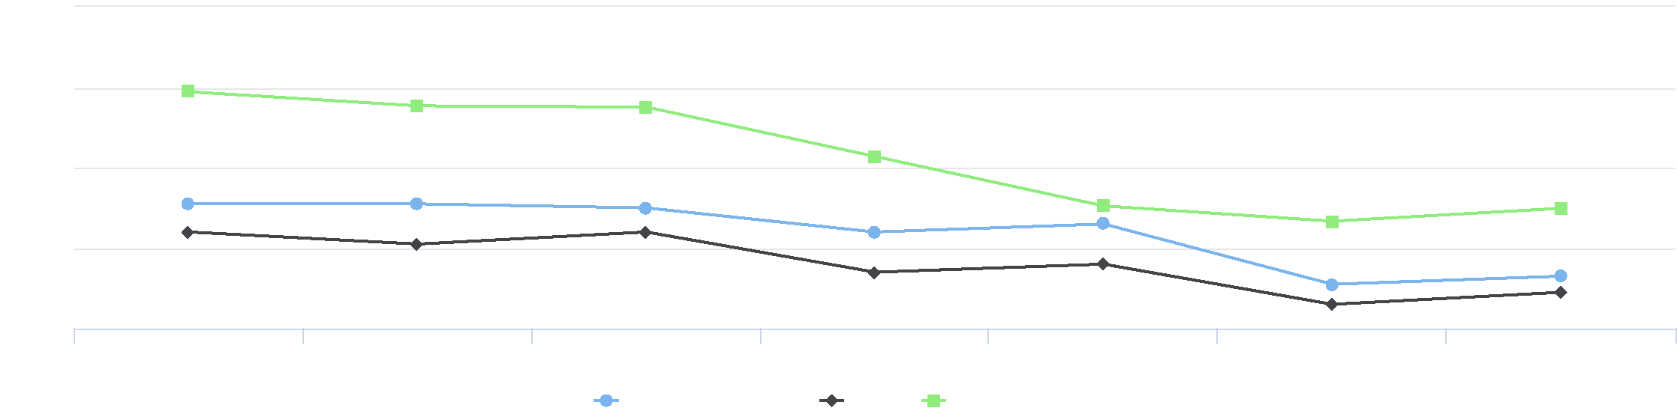

10

8

6

%

4

2

2011 2012 2013 2014 2015 2016 2017

Jackson County, IA Iowa United States

|  |  |  |  |
| --- | --- | --- | --- |
| **Report Area** | **Total Population**  **(For Whom Insurance Status is**  **Determined)** | **Uninsured  Population** | **Uninsured Population,  Percent** |
| Jackson County, IA | 19,194 | 870 | **4.53%** |
| Iowa | 3,088,842 | 152,469 | 4.94% |
| United States | 317,941,631 | 29,752,767 | 9.36% |

Uninsured Population, Percent

|  |  |
| --- | --- |
|  | |
| 0% 25% | |
|  | Jackson County (4.53%)  Iowa (4.94%)  United States (9.36%) |

*Note: This indicator is compared to the state average.*

*Data Source: US Census Bureau,* [*American Community Survey*](http://www.census.gov/acs/www/)*. 2014‐18. Source geography: Tract*

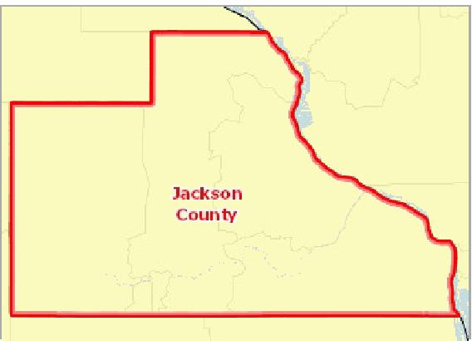

[](https://engagementnetwork.org/map-room/?ids=30939,t11&def=t11:FIPS%20In%20('19097')&bbox=-10120449.27515,5164829.551058,-10034264.57655,5219471.283242) View larger map

Over 20.0%

15.1 ‐ 20.0%

10.1 ‐ 15.0%

Under 10.1%

No Data or Data Suppressed

Jackson County, IA

**Uninsured Population, Percent by Tract, ACS 2014‐18**



Uninsured Population by Gender

This indicator reports the uninsured population by gender.

|  |  |  |  |  |
| --- | --- | --- | --- | --- |
| **Report Area** | **Male** | **Female** | **Male, Percent** | **Female, Percent** |
| Jackson County, IA | 474 | 396 | 4.92% | 4.14% |
| Iowa | 86,365 | 66,104 | 5.64% | 4.24% |
| United States | 16,190,262 | 13,562,505 | 10.42% | 8.34% |

Uninsured Population by Age Group, Percent

This indicator reports the percentage of uninsured population by age group.

|  |  |  |  |
| --- | --- | --- | --- |
| **Report Area** | **Under Age 18** | **Age 18 ‐ 64** | **Age 65 +** |
| Jackson County, IA | 2.90% | 6.53% | 0.75% |
| Iowa | 3.07% | 6.99% | 0.25% |
| United States | 5.22% | 13.16% | 0.82% |

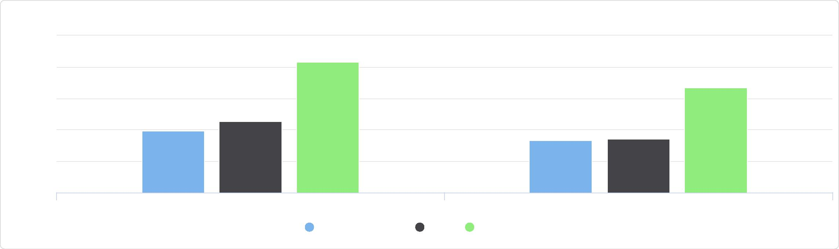

Uninsured Population by Gender

12.5

Male, Percent Female, Percent

Jackson County, IA Iowa United States

%

2.5

7.5

10

0

5

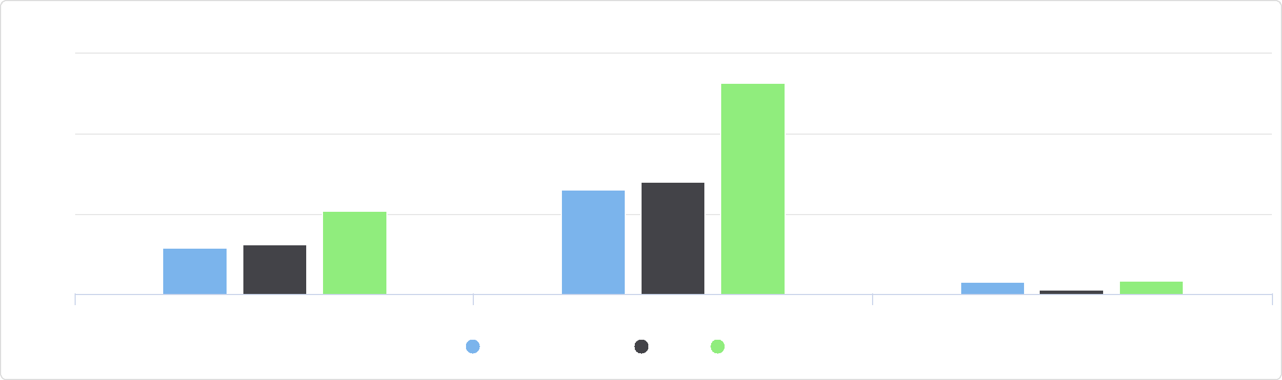

Uninsured Population by Age Group, Percent

15

Under Age 18 Age 18 - 64 Age 65 +

Jackson County, IA Iowa United States

%

10

0

5

Uninsured Population by Age Group, Total

This indicator reports the total uninsured population by age group.

|  |  |  |  |
| --- | --- | --- | --- |
| **Report Area** | **Under Age 18** | **Age 18‐64** | **Age 65+** |
| Jackson County, IA | 133 | 709 | 28 |
| Iowa | 23,736 | 127,522 | 1,211 |
| United States | 4,062,804 | 25,296,642 | 393,321 |

Uninsured Population by Age Group, Total

Jackson County, IA

Uninsured Population by Ethnicity Alone

This indicator reports the uninsured population by ethnicity alone.

|  |  |  |  |  |
| --- | --- | --- | --- | --- |
| **Report Area** | **Hispanic or Latino** | **Not Hispanic or Latino** | **Hispanic or Latino, Percent** | **Not Hispanic or Latino, Percent** |
| Jackson County, IA | 3 | 867 | 1.09% | 4.58% |
| Iowa | 27,314 | 125,155 | 15.03% | 4.31% |
| United States | 10,886,179 | 18,866,588 | 19.17% | 7.22% |

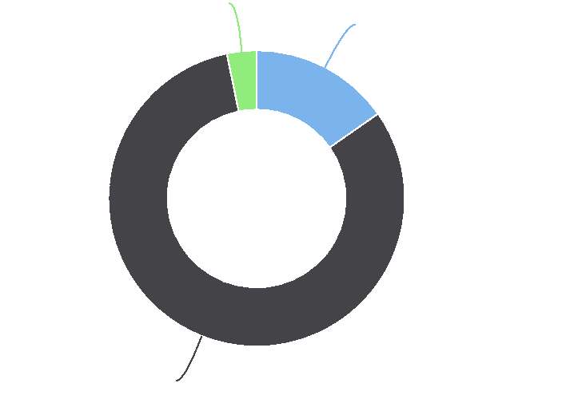

**Age 65+: 3.2%**

**Under Age 18: 15.3%**

**Age 18-64: 81.5%**

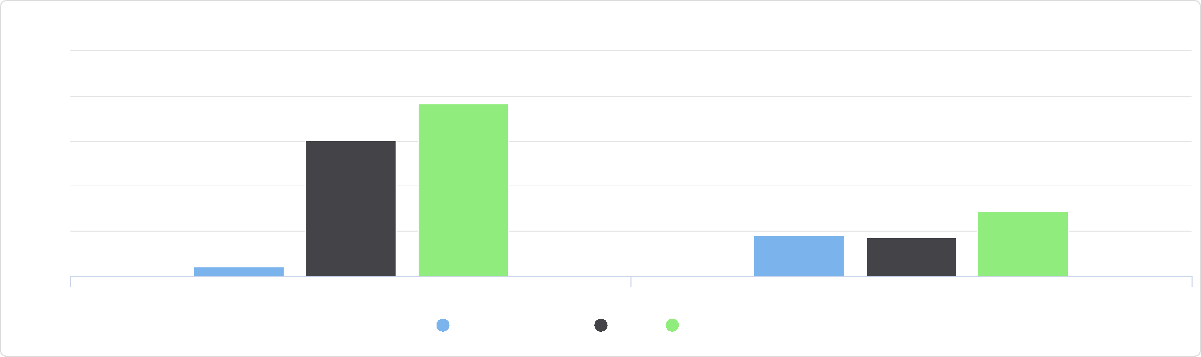

Uninsured Population by Ethnicity Alone

25

20

Hispanic or Latino, Percent Not Hispanic or Latino, Percent

Jackson County, IA Iowa United States

%

15

10

0

5

Uninsured Population by Race Alone, Percent

This indicator reports the percentage of uninsured population by race alone.

|  |  |  |  |  |  |  |  |
| --- | --- | --- | --- | --- | --- | --- | --- |
| **Report Area** | **Non‐Hispanic  White** | **Black or African  American** | **Native American or Alaska Native** | **Asian** | **Native Hawaiian or Pacific Islander** | **Some Other Race** | **Multiple  Race** |
| Jackson  County, IA | 4.20% | 43.88% | 0.00% | 0.00% | 41.22% | 0.00% | 1.12% |
| Iowa | 3.92% | 10.50% | 9.59% | 7.81% | 13.74% | 21.41% | 5.56% |
| United States | 6.31% | 10.82% | 20.12% | 7.53% | 10.61% | 21.31% | 8.13% |

Uninsured Population by Race Alone, Total

This indicator reports the total uninsured population by race alone.

|  |  |  |  |  |  |  |  |
| --- | --- | --- | --- | --- | --- | --- | --- |
| **Report Area** | **Non‐Hispanic White** | **Black or African  American** | **Native American or  Alaska Native** | **Asian** | **Native Hawaiian or  Pacific Islander** | **Some Other Race** | **Multiple Race** |
| Jackson County, IA | 770 | 43 | 0 | 0 | 54 | 0 | 3 |
| Iowa | 104,148 | 11,129 | 1,058 | 5,842 | 428 | 8,340 | 3,610 |
| United States | 12,272,640 | 4,292,174 | 529,847 | 1,315,879 | 60,430 | 3,324,190 | 834,741 |

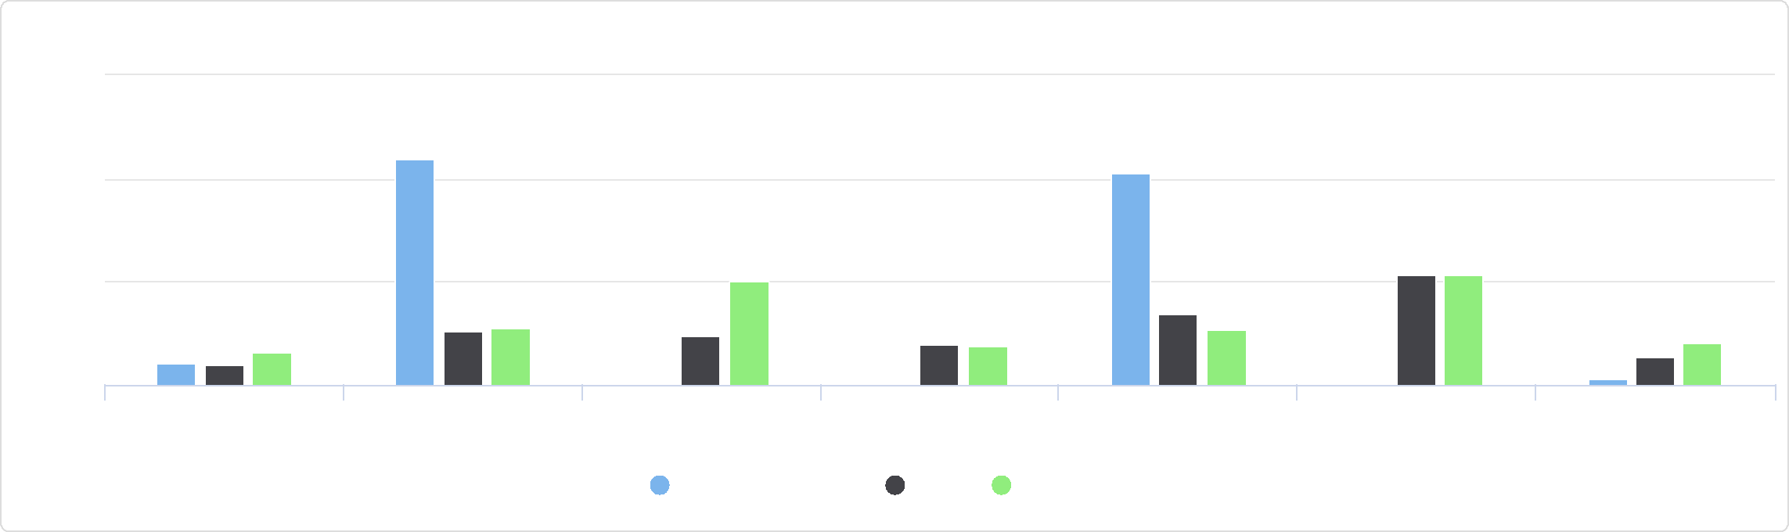

Some Other Race Multiple Race

Asian Native Hawaiian or Pacific

Islander

Non-Hispanic White Black or African American Native American or Alaska

Native

Uninsured Population by Race Alone, Percent

60

Jackson County, IA Iowa United States

%

40

20

0

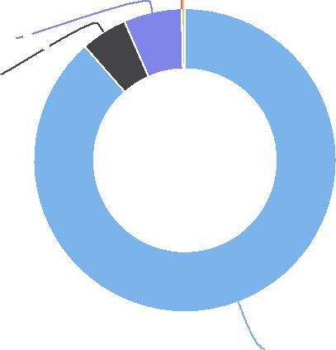

Uninsured Population by Race Alone, Total

Jackson County, IA   
**Multiple Race: 0.3%**

## Lack of Social or Emotional Support

This indicator reports the percentage of adults aged 18 and older who self‐report that they receive insufficient social and emotional support all or most of the time. This indicator is relevant because social and emotional support is critical for navigating the challenges of daily life as well as for good mental health. Social and emotional support is also linked to educational achievement and economic stability.

**Some Other Race: 0.0% Native Hawaiian or Pacific Islander: 6.2% Black or African American: 4.9%**

**Non-Hispanic White: 88.5%**

Percent Adults Without Adequate   
Social / Emotional Support   
(Age-Adjusted)

|  |  |
| --- | --- |
|  | |
| 0% 50% | |
|  | Jackson County (9.10%)  Iowa (15.30%)  United States (20.70%) |

|  |  |  |  |  |
| --- | --- | --- | --- | --- |
| **Report Area** | **Total Population Age 18+** | **Estimated Population Without Adequate Social / Emotional Support** | **Crude Percentage** | **Age‐Adjusted  Percentage** |
| Jackson County, IA | 15,242.00 | 1,433 | 9.40% | **9.10%** |
| Iowa | 2,307,562.00 | 355,365 | 15.40% | 15.30% |
| United  States | 232,556,016.00 | 48,104,656 | 20.70% | 20.70% |

*Note: This indicator is compared to the state average.*

*Data Source: Centers for Disease Control and Prevention,* [*Behavioral Risk Factor Surveillance System*](http://www.cdc.gov/brfss/)*. Accessed via the* [*Health Indicators Warehouse*](http://healthindicators.gov)*. US Department of Health & Human*

*Services,* [*Health Indicators Warehouse*](https://healthdata.gov/dataset/health-indicators-warehouse)*. 2006‐12. Source geography: County*

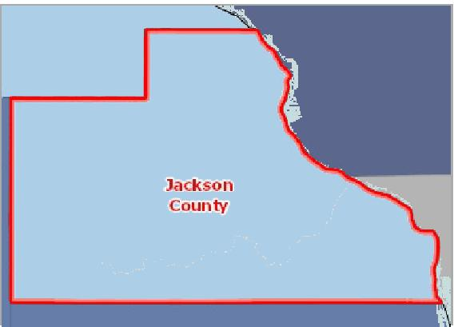

[](https://engagementnetwork.org/map-room/?ids=5451,t11&def=t11:FIPS%20In%20('19097')&bbox=-10120449.27515,5164829.551058,-10034264.57655,5219471.283242) View larger map

**Inadequate Social/Emotional Support, Percent of Adults Age 18+ by County, BRFSS 2006‐12**

Over 23.0%

19.1 ‐ 23.0%

15.1 ‐ 19.0%

Under 15.1%

No Data or Data Suppressed

Jackson County, IA



## Population Receiving SNAP Benefits (ACS)

In the report area, an estimate 928 or 11.27% households receive Supplemental Nutrition Assistance Program (SNAP) benefits. The value for the report area is less than the national average of 12.22%. This indicator is relevant because it assesses vulnerable populations which are more likely to have multiple health access, health status, and social support needs; when combined with poverty data, providers can use this measure to identify gaps in eligibility and enrollment.

|  |  |  |  |
| --- | --- | --- | --- |
| **Report Area** | **Total**  **Households** | **Households Receiving SNAP  Benefits** | **Percent Households Receiving SNAP  Benefits** |
| Jackson County, IA | 8,236 | 928 | **11.27%** |
| Iowa | 1,256,855 | 134,125 | 10.67% |
| United States | 119,730,128 | 14,635,287 | 12.22% |

Percent Households Receiving SNAP Benefits

|  |  |
| --- | --- |
|  | |
|  | 0% 25%  Jackson County (11.27%)  Iowa (10.67%)  United States (12.22%) |

*Note: This indicator is compared to the state average.*

*Data Source: US Census Bureau,* [*American Community Survey*](http://www.census.gov/acs/www/)*. 2014‐18. Source geography: Tract*

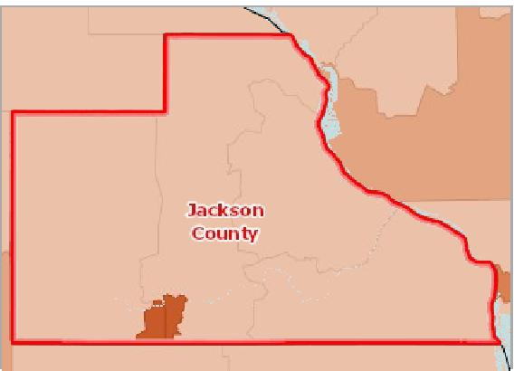

[](https://engagementnetwork.org/map-room/?ids=31424,t11&def=t11:FIPS%20In%20('19097')&bbox=-10120449.27515,5164829.551058,-10034264.57655,5219471.283242) View larger map

Over 19.0%

14.1 ‐ 19.0%

9.1 ‐ 14.0%

Under 9.1%

No Data or Data Suppressed

Jackson County, IA

**Households Receiving SNAP Benefits, Percent by Tract, ACS 2014‐18**



Households Receiving SNAP Benefits by Race/Ethnicity, Percent

|  |  |  |  |  |  |  |  |  |
| --- | --- | --- | --- | --- | --- | --- | --- | --- |
| **Report Area** | **Total  Population** | **Non‐Hispanic  White** | **Black** | **Asian** | **American Indian or Alaska  Native** | **Some Other  Race** | **Multiple  Race** | **Hispanic or  Latino** |
| Jackson County, IA | 11.27% | 10.44% | 100.00% | 43.48% | 0.00% | No data | 92.68% | 24.32% |
| Iowa | 10.67% | 8.93% | 36.70% | 10.75% | 25.80% | 19.29% | 24.91% | 20.55% |
| United States | 12.22% | 7.34% | 26.12% | 7.24% | 24.74% | 22.08% | 18.12% | 20.66% |

Households Receiving SNAP Benefits by Race/Ethnicity, Total

|  |  |  |  |  |  |  |  |
| --- | --- | --- | --- | --- | --- | --- | --- |
| **Report Area** | **Non‐Hispanic  White** | **Black** | **Asian** | **American Indian or Alaska  Native** | **Some Other  Race** | **Multiple  Race** | **Hispanic or  Latino** |
| Jackson County, IA | 849 | 7 | 10 | 0 | 0 | 38 | 18 |
| Iowa | 104,329 | 13,300 | 2,537 | 997 | 2,160 | 3,211 | 9,971 |
| United States | 6,739,271 | 3,835,425 | 402,872 | 215,206 | 930,773 | 436,053 | 3,207,250 |

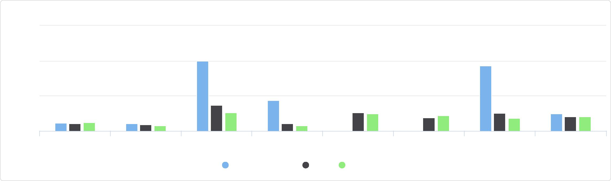

Some Other Race Multiple Race Hispanic or Latino

Total Population Non-Hispanic White Black Asian American Indian or

Alaska Native

Households Receiving SNAP Benefits by Race/Ethnicity, Percent

150

Jackson County, IA Iowa United States

%

100

50

0

Households Receiving SNAP Benefits by Race/Ethnicity, Total

Jackson County, IA

Median Income of Households Receiving SNAP Benefits

|  |  |
| --- | --- |
| **Report Area** | **Median Income of Households Receiving SNAP Benefits** |
| Jackson County, IA | $20,918 |
| Iowa | $22,793 |
| United States | $21,709 |

## Population Receiving SNAP Benefits (SAIPE)

The Supplemental Nutrition Assistance Program, or SNAP, is a federal program that provides nutrition benefits to low‐income individuals and families that are used at stores to purchase food. This indicator reports the average percentage of the population receiving SNAP benefits during the month of July during the most recent report year.

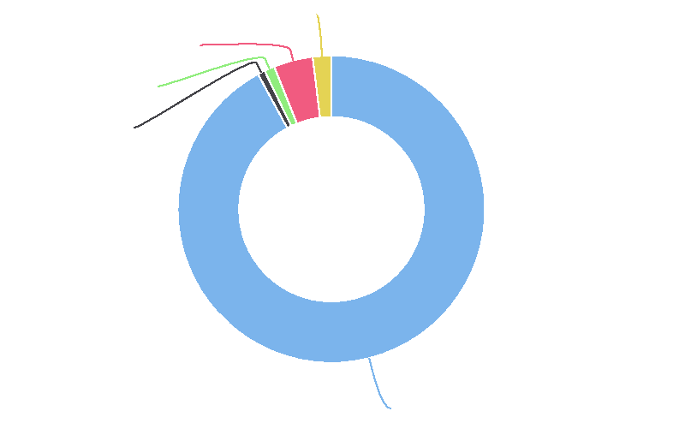

**Hispanic or Latino: 2.0%**

**Multiple Race: 4.1%**

**Asian: 1.1%**

**Black: 0.8%**

**Non-Hispanic White: 92.1%**

Median Income of Households Receiving SNAP Benefits

30k

20k

10k

0

Median Income of Households Receiving SNAP Benefits

Jackson County, IA Iowa United States



Percentage of Total Population Receiving SNAP Benefits

|  |  |
| --- | --- |
|  | |
| 0% 25% | |
|  | Jackson County (10.6%)  Iowa (11.2%)  United States (12.5%) |

|  |  |  |  |
| --- | --- | --- | --- |
| **Report Area** | **Total  Population** | **Population Receiving SNAP  Benefits** | **Population Receiving SNAP Benefits,  Percent** |
| Jackson County, IA | 19,368.00 | 2,052 | **10.6%** |
| Iowa | 3,143,637.00 | 351,674 | 11.2% |
| United States | 325,147,121.00 | 40,771,688 | 12.5% |

*Note: This indicator is compared to the state average.*

*Data Source: US Census Bureau,* [*Small Area Income & Poverty Estimates*](https://www.census.gov/programs-surveys/saipe.html)*. 2017. Source geography: County*

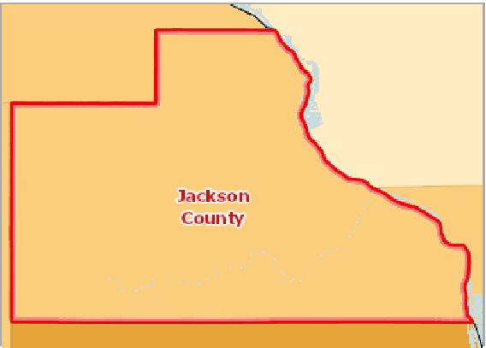

[](https://engagementnetwork.org/map-room/?ids=32406,t11&def=t11:FIPS%20In%20('19097')&bbox=-10120449.27515,5164829.551058,-10034264.57655,5219471.283242) View larger map

**Population Receiving SNAP Benefits, Percent by County, SAIPE 2017**

Over 22.0%

14.1 ‐ 22.0%

6.1 ‐ 14.0%

Under 6.1%

No Data or Data Suppressed

Jackson County, IA



Population Receiving SNAP Benefits by Year, 2007 through 2017

The table below reports local, state, and National trends in SNAP participation rates.

|  |  |  |  |  |  |  |  |  |  |  |  |
| --- | --- | --- | --- | --- | --- | --- | --- | --- | --- | --- | --- |
| **Report Area** | **2007** | **2008** | **2009** | **2010** | **2011** | **2012** | **2013** | **2014** | **2015** | **2016** | **2017** |
| Jackson County, IA | 8.5% | 8.7% | 10.7% | 11.5% | 13.0% | 13.7% | 13.9% | 12.9% | 11.8% | 10.9% | 10.6% |
| Iowa | 8.3% | 9.4% | 10.9% | 11.9% | 13.1% | 13.6% | 13.4% | 12.7% | 12.2% | 11.8% | 11.2% |
| United States | 9.1% | 10.4% | 12.6% | 14.1% | 14.8% | 15.1% | 14.8% | 14.4% | 13.9% | 13.2% | 12.5% |

## Population with Associate's Level Degree or Higher

30.83% of the population aged 25 and older, or 4,203 have obtained an Associate's level degree or higher. This indicator is relevant because educational attainment has been linked to positive health outcomes.

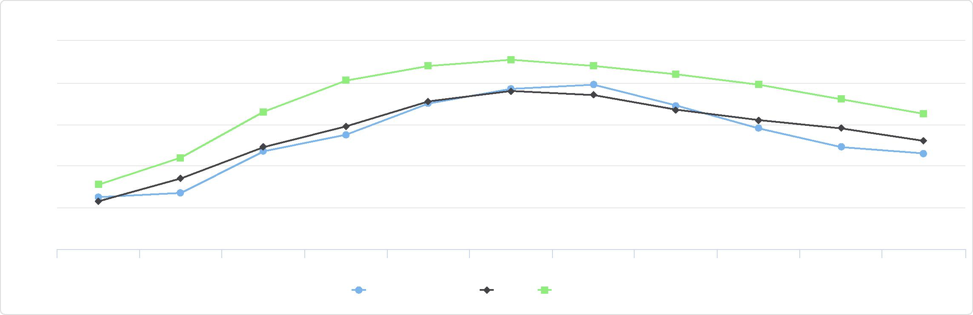

Population Receiving SNAP Benefits by Year, 2007 through 2017

16

6

2007 2008 2009 2010 2011 2012 2013 2014 2015 2016 2017

Jackson County, IA Iowa United States

%

14

12

10

8

Percent Population Age 25+ with Associate's Degree or Higher

|  |  |
| --- | --- |
|  | |
|  | 0% 100%  Jackson County (30.83%)  Iowa (39.66%)  United States (39.92%) |

|  |  |  |  |
| --- | --- | --- | --- |
| **Report Area** | **Total Population Age 25+** | **Population Age 25+ with Associate's Degree or Higher** | **Percent Population Age 25+ with  Associate's Degree or Higher** |
| Jackson County, IA | 13,632 | 4,203 | **30.83%** |
| Iowa | 2,081,373 | 825,440 | 39.66% |
| United  States | 218,446,071 | 87,205,374 | 39.92% |

**Population with an Associate Level Degree or Higher, Percent by Tract, ACS 2014‐18**

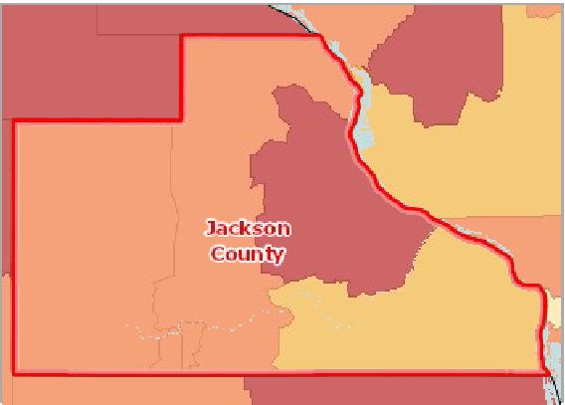

[](https://engagementnetwork.org/map-room/?ids=29661,t11&def=t11:FIPS%20In%20('19097')&bbox=-10120449.27515,5164829.551058,-10034264.57655,5219471.283242) View larger map

Over 32.0%

26.1 ‐ 32.0%

20.1 ‐ 26.0%

Under 20.1%

No Data or Data Suppressed

Jackson County, IA



## Population with Bachelor's Degree or Higher

18.84% of the population aged 25 and older, or 2,568 have obtained a Bachelor's level degree or higher. This indicator is relevant because educational attainment has been linked to positive health outcomes.

|  |  |  |  |
| --- | --- | --- | --- |
| **Report Area** | **Total Population Age 25+** | **Population Age 25+ with Bachelor's Degree or Higher** | **Population Age 25+ with Bachelor's Degree or Higher, Percent** |
| Jackson County, IA | 13,632 | 2,568 | **18.84%** |
| Iowa | 2,081,373 | 587,017 | 28.20% |
| United  States | 218,446,071 | 68,867,051 | 31.53% |

Population Age 25+ with   
Bachelor's Degree or Higher,   
Percent

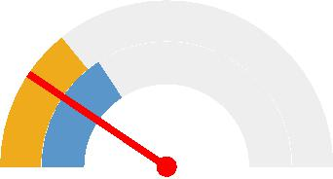

0% 100%

Jackson County (18.84%)

Iowa (28.20%)

United States (31.53%)



*Note: This indicator is compared to the state average.*

*Data Source: US Census Bureau,* [*American Community Survey*](http://www.census.gov/acs/www/)*. 2014‐18. Source geography: Tract*

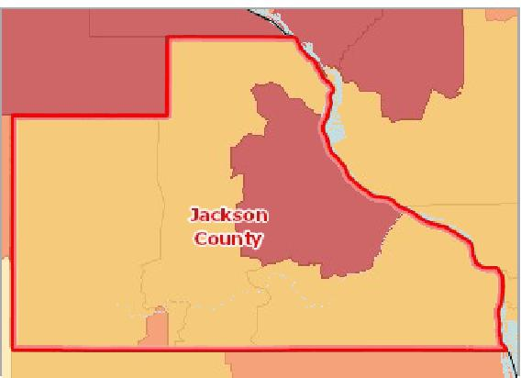

[](https://engagementnetwork.org/map-room/?ids=29659,t11&def=t11:FIPS%20In%20('19097')&bbox=-10120449.27515,5164829.551058,-10034264.57655,5219471.283242) View larger map

Over 23.0%

18.1 ‐ 23.0%

13.1 ‐ 18.0%

Under 13.1%

No Data or Data Suppressed

Jackson County, IA

**Population with a Bachelor's Degree or Higher, Percent by Tract, ACS 2014‐18**



## Population with No High School Diploma

Within the report area there are 1,046 persons aged 25 and older without a high school diploma (or equivalency) or higher. This represents 7.67% of the total population aged 25 and older. This indicator is relevant because educational attainment is linked to positive health outcomes ([Freudenberg & Ruglis, 2007](http://www.cdc.gov/pcd/issues/2007/oct/07_0063.htm)).

Population Age 25+ with No High School Diploma, Percent

|  |  |
| --- | --- |
|  | |
| 0% 50% | |
|  | Jackson County (7.67%)  Iowa (8.01%)  United States (12.34%) |

|  |  |  |  |
| --- | --- | --- | --- |
| **Report Area** | **Total Population Age 25+** | **Population Age 25+ with No High  School Diploma** | **Population Age 25+ with No High School  Diploma, Percent** |
| Jackson County, IA | 13,632 | 1,046 | **7.67%** |
| Iowa | 2,081,373 | 166,709 | 8.01% |
| United States | 218,446,071 | 26,948,057 | 12.34% |

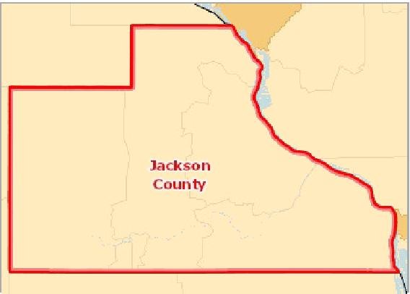

[](https://engagementnetwork.org/map-room/?ids=29653,t11&def=t11:FIPS%20In%20('19097')&bbox=-10120449.27515,5164829.551058,-10034264.57655,5219471.283242) View larger map

**Population with No High School Diploma (Age 25+), Percent by Tract, ACS 2014‐18**

Over 21.0%

16.1 ‐ 21.0%

11.1 ‐ 16.0%

Under 11.1%

No Data or Data Suppressed

Jackson County, IA



Population with No High School Diploma by Gender

|  |  |  |  |  |
| --- | --- | --- | --- | --- |
| **Report Area** | **Male** | **Female** | **Male, Percent** | **Female, Percent** |
| Jackson County, IA | 509 | 537 | 7.57% | 7.78% |
| Iowa | 89,246 | 77,463 | 8.78% | 7.27% |
| United States | 13,752,210 | 13,195,847 | 13.03% | 11.69% |

Population with No High School Diploma by Ethnicity Alone

|  |  |  |  |  |
| --- | --- | --- | --- | --- |
| **Report Area** | **Hispanic or Latino** | **Not Hispanic or Latino** | **Hispanic or Latino, Percent** | **Not Hispanic or Latino, Percent** |
| Jackson County, IA | 58 | 988 | 35.37% | 7.34% |
| Iowa | 33,536 | 133,173 | 38.71% | 6.68% |
| United States | 10,485,405 | 16,462,652 | 32.30% | 8.85% |

Population with No High School Diploma by Gender

15

|  |  |  |  |  |
| --- | --- | --- | --- | --- |
|  | 10  5  0 |  |  |  |
| % |  |  |
|  |  |  |
|  |  |  |  |

Male Female

Jackson County, IA Iowa United States



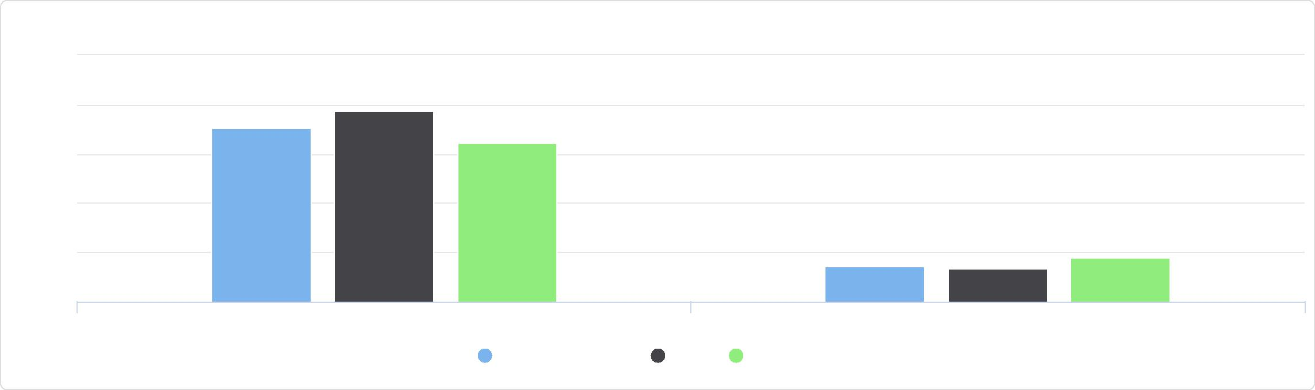

Population with No High School Diploma by Ethnicity Alone

50

40

Hispanic / Latino Not Hispanic / Latino

Jackson County, IA Iowa United States

%

20

30

10

0

Population with No High School Diploma by Race Alone, Percent

|  |  |  |  |  |  |  |  |
| --- | --- | --- | --- | --- | --- | --- | --- |
| **Report Area** | **White** | **Black or African  American** | **Native American or Alaska Native** | **Asian** | **Native Hawaiian or Pacific  Islander** | **Some Other Race** | **Multiple  Race** |
| Jackson  County, IA | 7.62% | 0.00% | 0.00% | 0.00% | 0.00% | 80.00% | 14.29% |
| Iowa | 7.00% | 16.47% | 15.56% | 19.33% | 22.24% | 46.47% | 10.43% |
| United States | 10.41% | 14.58% | 20.02% | 13.18% | 13.10% | 38.05% | 12.02% |

Population with No High School Diploma by Race Alone, Total

|  |  |  |  |  |  |  |  |
| --- | --- | --- | --- | --- | --- | --- | --- |
| **Report Area** | **White** | **Black** | **Asian** | **Native American or Alaska  Native** | **Native Hawaiian or Pacific  Islander** | **Some Other  Race** | **Multiple  Races** |
| Jackson County, IA | 1,017 | 0 | 0 | 0 | 0 | 24 | 5 |
| Iowa | 134,962 | 9,651 | 8,652 | 1,106 | 399 | 9,886 | 2,053 |
| United States | 17,139,502 | 3,784,442 | 1,629,131 | 333,586 | 47,861 | 3,491,195 | 522,340 |

Population with No High School Diploma by Race Alone, Total

Jackson County, IA   
**Multiple Races: 0.5%**

## Poverty ‐ Children Below 100% FPL

In the report area 16.35% or 685 children aged 0‐17 are living in households with income below the Federal Poverty Level (FPL). This indicator is relevant because poverty creates barriers to access including health services, healthy food, and other necessities that contribute to poor health status.

Population with No High School Diploma by Race Alone, Percent

100

|  |  |  |  |  |  |  |  |  |  |  |  |  |  |  |  |  |  |  |  |  |  |  |
| --- | --- | --- | --- | --- | --- | --- | --- | --- | --- | --- | --- | --- | --- | --- | --- | --- | --- | --- | --- | --- | --- | --- |
|  | 75  50 |  |  |  |  |  |  |  |  |  |  |  |  |  |  |  |  |  |  |  |  |  |
| % |  |  |  |  |  |  |  |  |  |  |  |  |  |  |  |  |  |  |  |  |
|  |  |  |  |  |  |  |  |  |  |  |  |  |  |  |  |  |  |  |  |
|  | 25 |  |  |  |  |  |  |  |  |  |  |  |  |  |  |  |  |  |  |  |  |
|  |  |  |  |  |  |  |  |  |  |  |  |  |  |  |  |  |  |  |  |  |
|  |  |  |  |  |  |  |  |  |  |  |  |  |  |  |  |  |  |  |  |  |  |
|  |  |  |  |  |  |  |  |  |  |  |  |  |  |  |  |  |  |  |  |  |  |
|  |  |  |  |  |  |  |  |  |  |  |  |  |  |  |  |  |  |  |  |  |  |
|  |  |  |  |  |  |  |  |  |  |  |  |  |  |  |  |  |  |  |  |  |  |
|  |  |  |  |  |  |  |  |  |  |  |  |  |  |  |  |  |  |  |  |  |  |
|  | 0 |  |  |  |  |  |  |  |  |  |  |  |  |  |  |  |  |  |  |  |  |
|  |  |  |  |  |  |  |  |  |  |  |  |  |  |  |  |  |  |  |  |  |  |

White Black or African American Native American or Alaska Asian Native Hawaiian or Pacific Some Other Race Multiple Race

Native Islander

Jackson County, IA Iowa United States



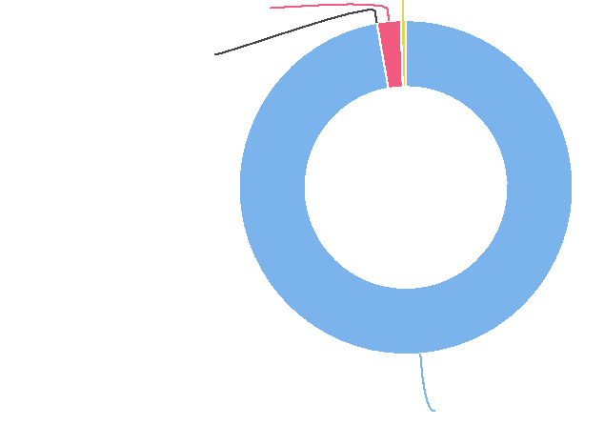

**Some Other Race: 2.3%**

**Black: 0.0%**

**White: 97.2%**

|  |  |  |  |  |
| --- | --- | --- | --- | --- |
| **Report Area** | **Total  Population** | **Population Under Age**  **18** | **Population  Under Age 18 in  Poverty** | **Percent Population Under Age 18 in  Poverty** |
| Jackson County, IA | 19,060 | 4,190 | 685 | **16.35%** |
| Iowa | 3,030,572 | 715,448 | 101,496 | 14.19% |
| United States | 314,943,184 | 72,382,641 | 14,117,014 | 19.50% |

Percent Population Under Age 18 in Poverty

|  |  |
| --- | --- |
|  | |
|  | 0% 50%  Jackson County (16.35%)  Iowa (14.19%)  United States (19.50%) |

*Note: This indicator is compared to the state average.*

*Data Source: US Census Bureau,* [*American Community Survey*](http://www.census.gov/acs/www/)*. 2014‐18. Source geography: Tract*

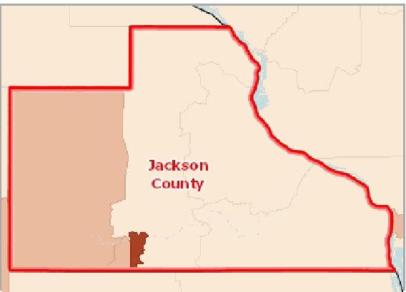

[](https://engagementnetwork.org/map-room/?ids=31356,t11&def=t11:FIPS%20In%20('19097')&bbox=-10120449.27515,5164829.551058,-10034264.57655,5219471.283242) View larger map

Over 30.0%

22.6 ‐ 30.0%

15.1 ‐ 22.5%

Under 15.1%

No Population Age 0‐17 Reported

No Data or Data Suppressed

Jackson County, IA

**Population Below the Poverty Level, Children (Age 0‐17), Percent by Tract, ACS 2014‐18**



Children in Poverty by Gender

|  |  |  |  |  |
| --- | --- | --- | --- | --- |
| **Report Area** | **Male** | **Female** | **Male, Percent** | **Female, Percent** |
| Jackson County, IA | 376 | 309 | 17.48% | 15.15% |
| Iowa | 51,624 | 49,872 | 14.16% | 14.21% |
| United States | 7,173,125 | 6,943,889 | 19.41% | 19.60% |

Children in Poverty by Ethnicity Alone

|  |  |  |  |  |
| --- | --- | --- | --- | --- |
| **Report Area** | **Hispanic or Latino** | **Not Hispanic or Latino** | **Hispanic or Latino, Percent** | **Not Hispanic or Latino, Percent** |
| Jackson County, IA | 15 | 670 | 20.00% | 16.28% |
| Iowa | 19,486 | 82,010 | 27.51% | 12.72% |
| United States | 5,127,592 | 8,989,422 | 28.36% | 16.55% |

Children in Poverty by Gender

25

|  |  |  |  |  |  |  |
| --- | --- | --- | --- | --- | --- | --- |
|  | 20 15 10 5  0 |  |  |  |  |  |
|  |  |  |  |  |  |
| % |  |  |  |
|  |  |  |  |
|  |  |  |  |
|  |  |  |  |  |  |

Male, Percent Female, Percent

Jackson County, IA Iowa United States



Children in Poverty by Ethnicity Alone

30

|  |  |  |  |  |  |  |
| --- | --- | --- | --- | --- | --- | --- |
|  | 20  10  0 |  |  |  |  |  |
| % |  |  |  |  |
|  |  |  |  |
|  |  |  |  |  |  |

Hispanic or Latino, Percent Not Hispanic or Latino, Percent

Jackson County, IA Iowa United States



Children in Poverty by Race Alone, Percent

|  |  |  |  |  |  |  |  |
| --- | --- | --- | --- | --- | --- | --- | --- |
| **Report Area** | **Non‐Hispanic  White** | **Black or African  American** | **Native American or Alaska Native** | **Asian** | **Native Hawaiian or Pacific Islander** | **Some Other Race** | **Multiple Race** |
| Jackson  County, IA | 14.78% | 72.00% | 0.00% | 71.43% | 0.00% | No data | 46.88% |
| Iowa | 10.19% | 44.22% | 30.39% | 12.02% | 39.70% | 31.01% | 23.54% |
| United States | 11.69% | 34.79% | 33.21% | 11.29% | 24.79% | 31.16% | 19.64% |

Children in Poverty by Race Alone, Total

|  |  |  |  |  |  |  |  |
| --- | --- | --- | --- | --- | --- | --- | --- |
| **Report Area** | **Non‐Hispanic White** | **Black or African  American** | **Native American or Alaska Native** | **Asian** | **Native Hawaiian or Pacific Islander** | **Some Other Race** | **Multiple Race** |
| Jackson  County, IA | 572 | 18 | 0 | 5 | 0 | 0 | 75 |
| Iowa | 57,151 | 15,170 | 874 | 2,054 | 430 | 3,712 | 8,382 |
| United States | 4,306,236 | 3,522,808 | 236,154 | 392,859 | 35,459 | 1,442,736 | 926,442 |

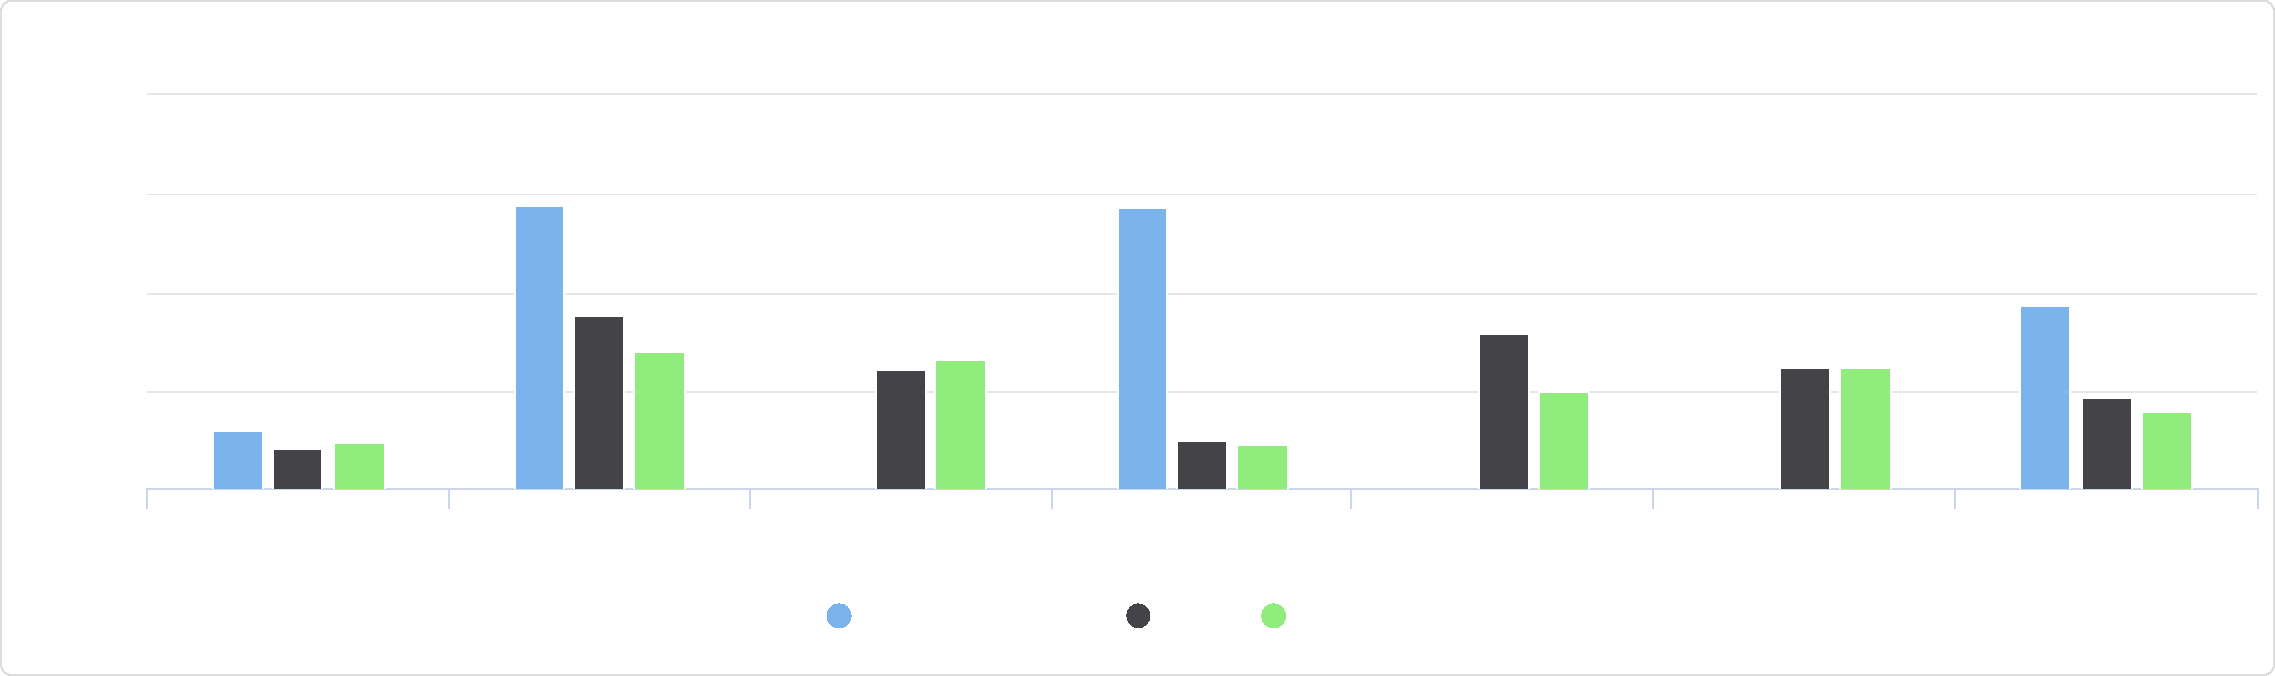

Some Other Race Multiple Race

Asian Native Hawaiian or Pacific

Islander

Non-Hispanic White Black or African American Native American or Alaska

Native

Children in Poverty by Race Alone, Percent

100

75

Jackson County, IA Iowa United States

%

25

50

0

Children in Poverty by Race Alone, Total

Jackson County, IA

## Poverty ‐ Children Below 200% FPL

In the report area 34.63% or 1,451 children are living in households with income below 200% of the Federal Poverty Level (FPL). This indicator is relevant because poverty creates barriers to access including health services, healthy food, and other necessities that contribute to poor health status.



**Multiple Race: 11.2%**

**Native Hawaiian or Pacific Islander: 0.0%**

**Some Other Race: 0.0%**

**Asian: 0.7%**

**Black or African American: 2.7%**

**Non-Hispanic White: 85.4%**

Percent Population Under Age 18 at or Below 200% FPL

|  |  |
| --- | --- |
|  | |
|  | 0% 100%  Jackson County (34.63%)  Iowa (35.09%)  United States (41.23%) |

|  |  |  |  |
| --- | --- | --- | --- |
| **Report Area** | **Total  Population  Under Age  18** | **Population Under Age 18 at or Below 200% FPL** | **Percent Population Under Age 18 at or  Below 200% FPL** |
| Jackson  County, IA | 4,190 | 1,451 | **34.63%** |
| Iowa | 715,448 | 251,041 | 35.09% |
| United States | 72,382,641 | 29,845,052 | 41.23% |

*Note: This indicator is compared to the state average.*

*Data Source: US Census Bureau,* [*American Community Survey*](http://www.census.gov/acs/www/)*. 2014‐18. Source geography: Tract*

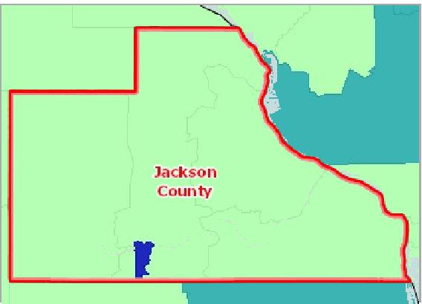

[](https://engagementnetwork.org/map-room/?ids=31170,t11&def=t11:FIPS%20In%20('19097')&bbox=-10120449.27515,5164829.551058,-10034264.57655,5219471.283242) View larger map

**Population Below 200% Poverty Level, Children (Age 0‐17), Percent by Tract, ACS 2014‐18**

Over 56.0%

47.1 ‐ 56.0%

38.1 ‐ 47.0%

Under 38.1%

No Population Age 0‐17 Reported

No Data or Data Suppressed

Jackson County, IA



## Poverty ‐ Population Below 100% FPL

Poverty is considered a *key driver* of health status.

Within the report area 12.39% or 2,361 individuals are living in households with income below the Federal Poverty Level (FPL). This indicator is relevant because poverty creates barriers to access including health services, healthy food, and other **necessities that contribute to poor health status.**

|  |  |  |  |
| --- | --- | --- | --- |
| **Report Area** | **Total Population** | **Population in Poverty** | **Population in Poverty, Percent** |
| Jackson County, IA | 19,060 | 2,361 | **12.39%** |
| Iowa | 3,030,572 | 353,634 | 11.67% |
| United States | 314,943,184 | 44,257,979 | 14.05% |

*Note: This indicator is compared to the state average.*

*Data Source: US Census Bureau,* [*American Community Survey*](http://www.census.gov/acs/www/)*. 2014‐18. Source geography: Tract*

Population in Poverty, Percent

|  |  |
| --- | --- |
|  | |
|  | 0% 25%  Jackson County (12.39%)  Iowa (11.67%)  United States (14.05%) |

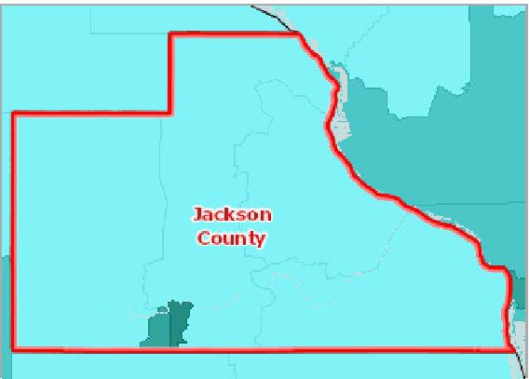

[](https://engagementnetwork.org/map-room/?ids=31354,t11&def=t11:FIPS%20In%20('19097')&bbox=-10120449.27515,5164829.551058,-10034264.57655,5219471.283242) View larger map

**Population Below the Poverty Level, Percent by Tract, ACS 2014‐18**

Over 20.0%

15.1 ‐ 20.0%

10.1 ‐ 15.0%

Under 10.1%

No Data or Data Suppressed

Jackson County, IA



Population in Poverty by Gender

This indicator reports the population in poverty in the report area by gender.

|  |  |  |  |  |
| --- | --- | --- | --- | --- |
| **Report Area** | **Male** | **Female** | **Male, Percent** | **Female, Percent** |
| Jackson County, IA | 970 | 1,391 | 10.13% | 14.67% |
| Iowa | 156,851 | 196,783 | 10.45% | 12.87% |
| United States | 19,737,150 | 24,520,829 | 12.80% | 15.26% |

Population in Poverty by Ethnicity Alone

This indicator reports the population in poverty in the report area by ethnicity alone.

|  |  |  |  |  |
| --- | --- | --- | --- | --- |
| **Report Area** | **Hispanic or Latino** | **Not Hispanic or Latino** | **Hispanic or Latino, Percent** | **Not Hispanic or Latino, Percent** |
| Jackson County, IA | 74 | 2,287 | 29.72% | 12.16% |
| Iowa | 38,719 | 314,915 | 21.78% | 11.04% |
| United States | 11,849,315 | 32,408,664 | 21.02% | 12.53% |

Population in Poverty by Gender

20

|  |  |  |  |  |  |  |
| --- | --- | --- | --- | --- | --- | --- |
|  | 15  10  5  0 |  |  |  |  |  |
| % |  |  |  |  |
|  |  |  |
|  |  |  |  |
|  |  |  |  |  |  |

Male, Percent Female, Percent

Jackson County, IA Iowa United States



Population in Poverty by Ethnicity Alone

40

|  |  |  |  |  |  |  |
| --- | --- | --- | --- | --- | --- | --- |
|  | 30  20 |  |  |  |  |  |
| % |  |  |  |  |  |
|  |  |  |  |
|  | 10  0 |  |  |  |  |
|  |  |  |  |
|  |  |  |  |  |  |

Hispanic / Latino Not Hispanic / Latino

Jackson County, IA Iowa United States



Population in Poverty by Race Alone, Percent

This indicator reports the percentage of population in poverty in the report area by race alone.

|  |  |  |  |  |  |  |  |
| --- | --- | --- | --- | --- | --- | --- | --- |
| **Report Area** | **White** | **Black or African  American** | **Native American or Alaska Native** | **Asian** | **Native Hawaiian or Pacific  Islander** | **Some Other Race** | **Multiple  Race** |
| Jackson  County, IA | 11.23% | 69.39% | 0.00% | 55.00% | 0.00% | 80.00% | 57.89% |
| Iowa | 10.25% | 33.31% | 24.55% | 17.02% | 29.57% | 21.78% | 22.97% |
| United States | 11.64% | 24.19% | 25.84% | 11.55% | 18.29% | 22.58% | 17.51% |

Population in Poverty by Race Alone, Total

This indicator reports the total population in poverty in the report area by race alone.

|  |  |  |  |  |  |  |  |
| --- | --- | --- | --- | --- | --- | --- | --- |
| **Report Area** | **Non‐Hispanic White** | **Black or African  American** | **Native American or  Alaska Native** | **Asian** | **Native Hawaiian or  Pacific Islander** | **Some Other Race** | **Multiple Race** |
| Jackson County, IA | 2,071 | 68 | 0 | 44 | 0 | 24 | 154 |
| Iowa | 280,850 | 34,056 | 2,693 | 12,407 | 895 | 8,334 | 14,399 |
| United States | 26,730,734 | 9,490,587 | 673,665 | 1,989,768 | 103,304 | 3,497,625 | 1,772,296 |

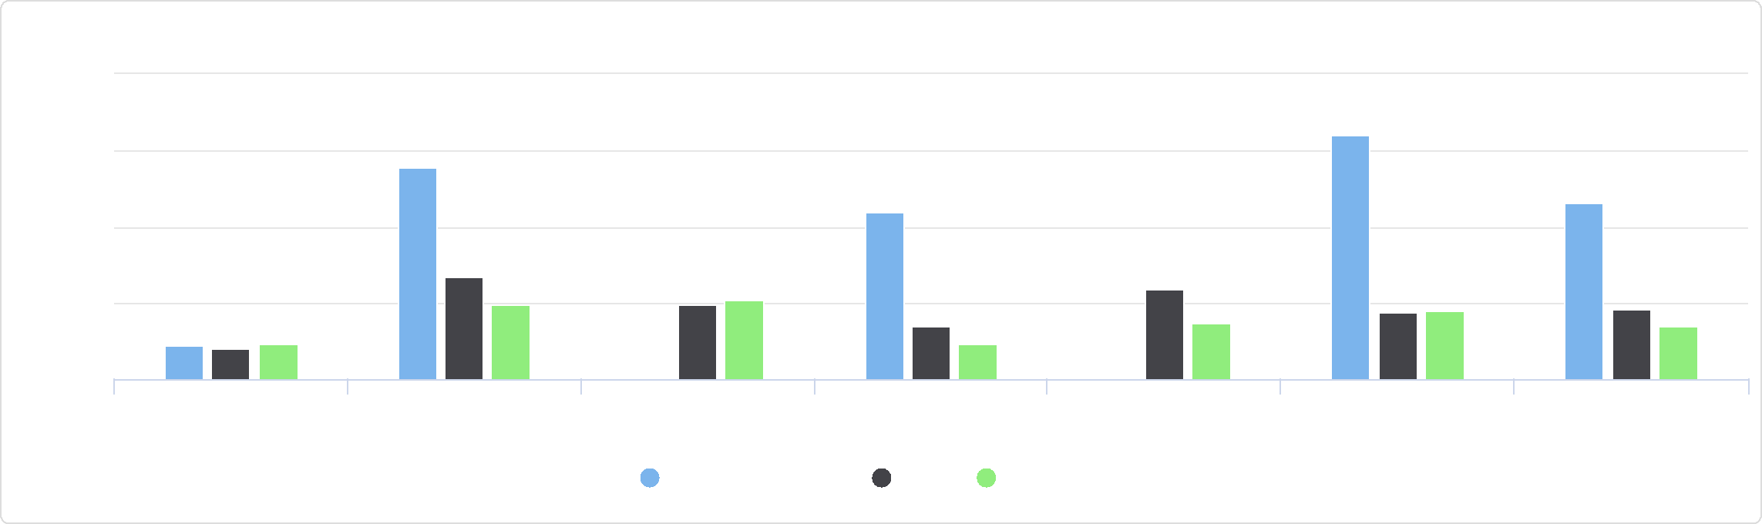

Some Other Race Multiple Race

Asian Native Hawaiian or Pacific

Islander

White Black or African American Native American or Alaska

Native

Population in Poverty by Race Alone, Percent

Jackson County, IA Iowa United States

100

75

%

50

25

0

Population in Poverty by Race Alone, Total

Jackson County, IA

## Poverty ‐ Population Below 185% FPL

In the report area 24.91% or 4,748 individuals are living in households with income below 185% of the Federal Poverty Level (FPL). This indicator is relevant because poverty creates barriers to access including health services, healthy food, and other necessities that contribute to poor health status.

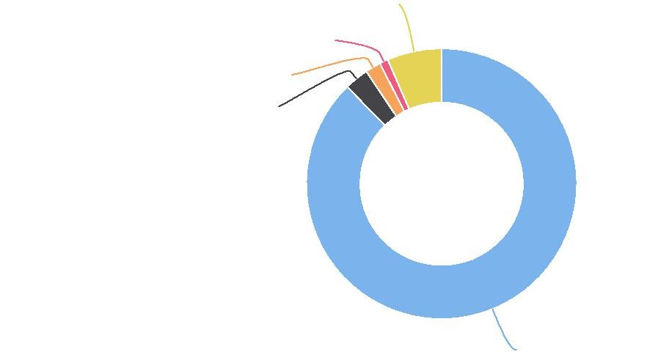

**Multiple Race: 6.5%**

**Some Other Race: 1.0%**

**Asian: 1.9%**

**Black or African American: 2.9%**

**White: 87.7%**

|  |  |  |  |
| --- | --- | --- | --- |
| **Report Area** | **Total  Population** | **Population with Income at or Below 185% FPL** | **Percent Population with Income at or Below 185% FPL** |
| Jackson  County, IA | 19,060 | 4,748 | **24.91%** |
| Iowa | 3,030,572 | 785,876 | 25.93% |
| United States | 314,943,184 | 92,202,319 | 29.28% |

*Note: This indicator is compared to the state average.*

*Data Source: US Census Bureau,* [*American Community Survey*](http://www.census.gov/acs/www/)*. 2014‐18. Source geography: Tract*

Percent Population with Income at or Below 185% FPL

|  |  |
| --- | --- |
|  | |
|  | 0% 100%  Jackson County (24.91%)  Iowa (25.93%)  United States (29.28%) |

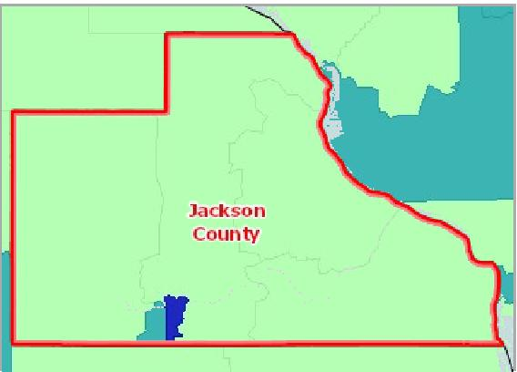

[](https://engagementnetwork.org/map-room/?ids=31163,t11&def=t11:FIPS%20In%20('19097')&bbox=-10120449.27515,5164829.551058,-10034264.57655,5219471.283242) View larger map

**Population Below 185% Poverty Level, Percent by Tract, ACS 2014‐18**

Over 43.0%

35.1 ‐ 43.0%

27.1 ‐ 35.0%

Under 27.1%

No Data or Data Suppressed

Jackson County, IA



## Poverty ‐ Population Below 200% FPL

In the report area 27.63% or 5,267 individuals are living in households with income below 200% of the Federal Poverty Level (FPL). This indicator is relevant because poverty creates barriers to access including health services, healthy food, and other necessities that contribute to poor health status.

|  |  |  |  |
| --- | --- | --- | --- |
| **Report Area** | **Total  Population** | **Population with Income at or Below 200% FPL** | **Percent Population with Income at or Below 200% FPL** |
| Jackson  County, IA | 19,060 | 5,267 | **27.63%** |
| Iowa | 3,030,572 | 869,006 | 28.67% |
| United States | 314,943,184 | 100,490,740 | 31.91% |

Percent Population with Income at or Below 200% FPL

|  |  |
| --- | --- |
|  | |
|  | 0% 100%  Jackson County (27.63%)  Iowa (28.67%)  United States (31.91%) |

*Note: This indicator is compared to the state average.*

*Data Source: US Census Bureau,* [*American Community Survey*](http://www.census.gov/acs/www/)*. 2014‐18. Source geography: Tract*

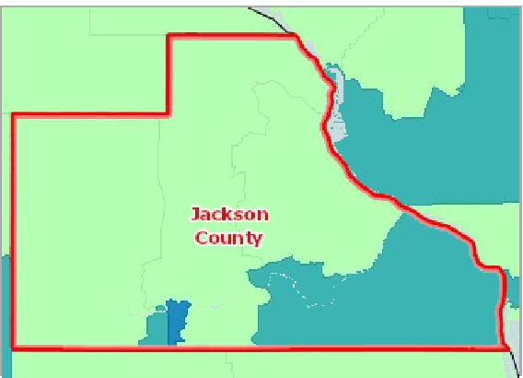

[](https://engagementnetwork.org/map-room/?ids=31167,t11&def=t11:FIPS%20In%20('19097')&bbox=-10120449.27515,5164829.551058,-10034264.57655,5219471.283242) View larger map

Over 50.0%

38.1 ‐ 50.0%

26.1 ‐ 38.0%

Under 26.1%

No Data or Data Suppressed

Jackson County, IA

**Population Below 200% Poverty Level, Percent by Tract, ACS 2014‐18**



## Poverty ‐ Population Below 50% FPL

In the report area 5.76% or 1,098 individuals are living in households with income below 50% of the Federal Poverty Level (FPL). This indicator is relevant because poverty creates barriers to access including health services, healthy food, and other necessities that contribute to poor health status.

|  |  |  |  |
| --- | --- | --- | --- |
| **Report Area** | **Total  Population** | **Population with Income at or Below 50% FPL** | **Percent Population with Income at or Below**  **50% FPL** |
| Jackson  County, IA | 19,060 | 1,098 | **5.76%** |
| Iowa | 3,030,572 | 160,431 | 5.29% |
| United States | 314,943,184 | 19,682,659 | 6.25% |

*Note: This indicator is compared to the state average.*

*Data Source: US Census Bureau,* [*American Community Survey*](http://www.census.gov/acs/www/)*. 2014‐18. Source geography: Tract*

Percent Population with Income at or Below 50% FPL

|  |  |
| --- | --- |
|  | |
| 0% 20% | |
|  | Jackson County (5.76%)  Iowa (5.29%)  United States (6.25%) |

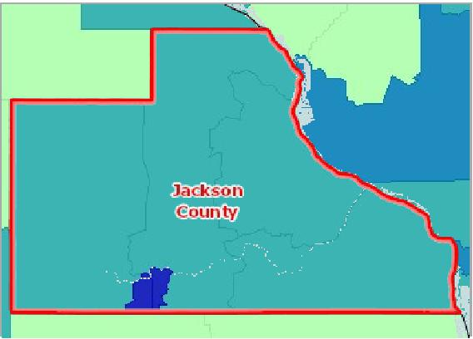

[](https://engagementnetwork.org/map-room/?ids=31171,t11&def=t11:FIPS%20In%20('19097')&bbox=-10120449.27515,5164829.551058,-10034264.57655,5219471.283242) View larger map

**Population Below 50% Poverty Level, Percent by Tract, ACS 2014‐18**

Over 9.0%

6.1 ‐ 9.0%

3.1 ‐ 6.0%

Under 3.1%

No Data or Data Suppressed

Jackson County, IA



## Student Reading Proficiency (4th Grade)

Information about student performance in the 4th grade English Language Arts portion of the state‐specific standardized tests are displayed in the table below. Of 638 students tested, 64.4% of 4th graders performed at or above the "proficient" level, and 35.6% tested below the "proficient" level, according to the latest data. Students in the report area tested worse than the statewide rate of 64.9%.

|  |  |  |  |
| --- | --- | --- | --- |
| **Report Area** | **Students with Valid  Test Scores** | **Students Scoring 'Proficient' or  Better, Percent** | **Students Scoring 'Not Proficient' or  Worse, Percent** |
| Jackson County, IA | 638 | 64.4% | **35.6%** |
| Iowa | 134,985 | 64.9% | 35.1% |
| United States | 13,445,671 | 46.2% | 53.8% |

*Note: This indicator is compared to the state average.*

*Data Source: US Department of Education,* [*EDFacts*](https://www2.ed.gov/about/inits/ed/edfacts/index.html)*. Additional data analysis by* [*CARES*](http://cares.missouri.edu)*. 2018‐19. Source geography: School District*

Students Scoring 'Not Proficient' or Worse, Percent

|  |  |
| --- | --- |
|  | |
| 0% 80% | |
|  | Jackson County (35.6%)  Iowa (35.1%)  United States (53.8%) |

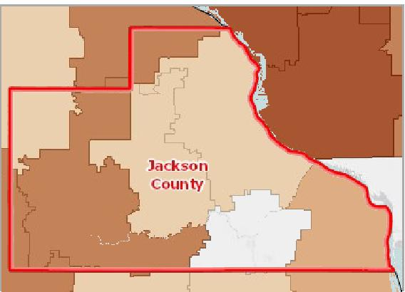

[](https://engagementnetwork.org/map-room/?ids=32350,t11&def=t11:FIPS%20In%20('19097')&bbox=-10120449.27515,5164829.551058,-10034264.57655,5219471.283242) View larger map

**Language Arts Test Scores, Grade 4, Percent Not Proficient by School District (Elementary), ED*Facts* 2017‐18**

Over 50.0%

30.1 ‐ 50.0%

20.1 ‐ 30.0%

Under 20.1%

No Data or Data Suppressed

Jackson County, IA



## Teen Births

|  |  |  |  |
| --- | --- | --- | --- |
| **Report Area** | **Female Population, Age 15 ‐ 19** | **Births to Mothers Age 15 ‐ 19** | **Teen Births, Rate (Per 1,000 Population)** |
| Jackson County, IA | 648 | 18 | **28.10** |
| Iowa | 105,598 | 3,157 | 29.90 |
| United States | 10,736,677 | 392,962 | 36.60 |

*Note: This indicator is compared to the state average.*

[*Data Source: Centers for Disease Control and Prevention,*](https://healthdata.gov/dataset/health-indicators-warehouse) *National Vital Statistics System. Accessed via CDC WONDER. US Department of Health & Human Services, Health Indicators*

[*Warehouse.*](https://healthdata.gov/dataset/health-indicators-warehouse) *2006‐12. Source geography: County*

Teen Births, Rate (Per 1,000 Population)

|  |  |
| --- | --- |
|  | |
|  | 0 100  Jackson County (28.10)  Iowa (29.90)  United States (36.60) |

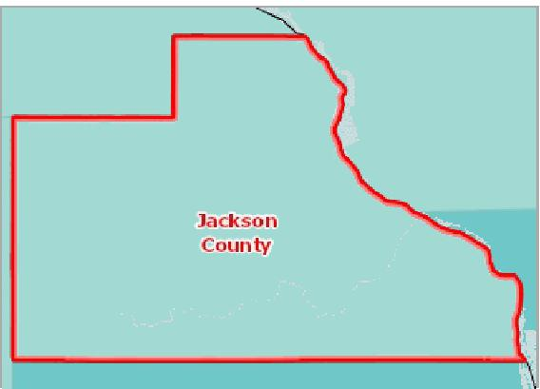

[](https://engagementnetwork.org/map-room/?ids=5709,t11&def=t11:FIPS%20In%20('19097')&bbox=-10120449.27515,5164829.551058,-10034264.57655,5219471.283242) View larger map

**Births to Females Age 15‐19, Rate (Per 1,000 Pop.) by County, NVSS 2006‐ 12**

Over 60.0

45.1 ‐ 60.0

30.1 ‐ 45.0

Under 30.1

No Data or Data Suppressed

Jackson County, IA



Births to Women Age 15‐19, Rate (per 1,000 Pop.) by Race / Ethnicity

|  |  |  |  |  |  |
| --- | --- | --- | --- | --- | --- |
| **Report Area** | **Non‐Hispanic White** |  | **Non‐Hispanic Black** |  | **Hispanic or Latino** |
| Jackson County, IA | 28.60 | No data |  | No data |  |
| Iowa | 25.00 |  | 68.20 |  | 73.60 |
| United States | 24.60 |  | 54.90 |  | 62.00 |

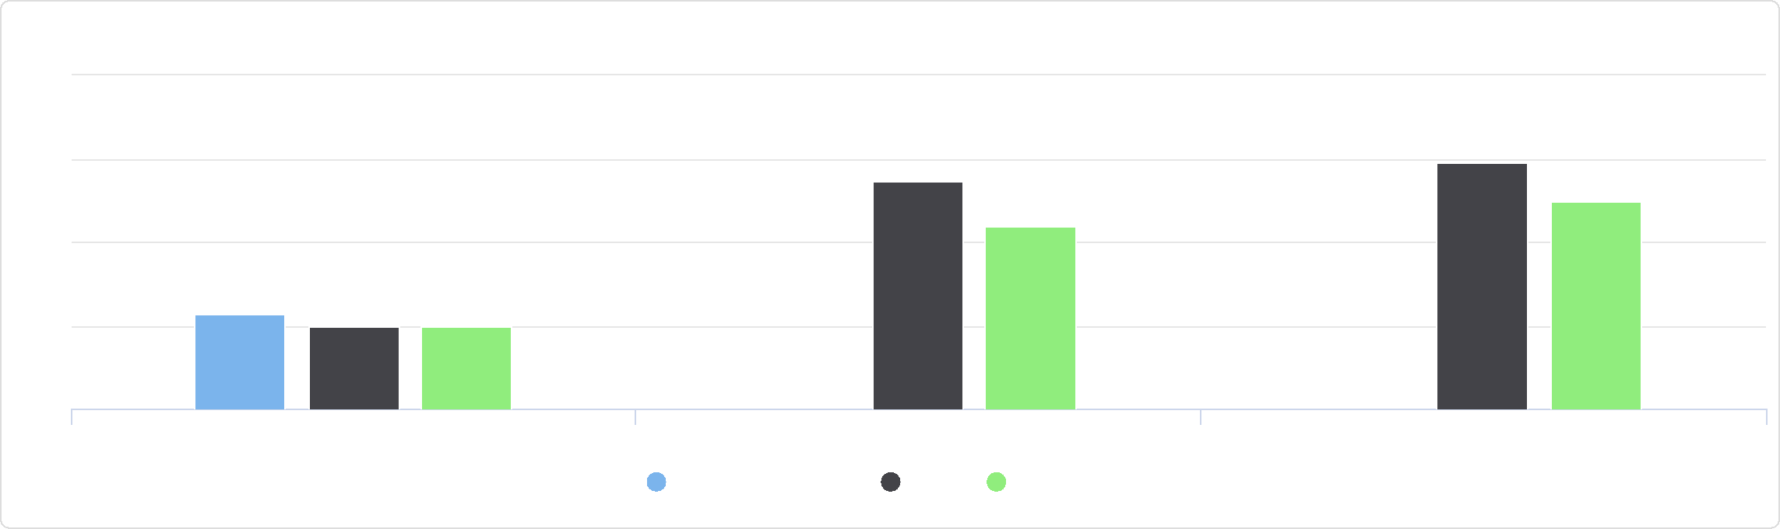

Births to Women Age 15-19, Rate (per 1,000 Pop.) by Race / Ethnicity

100

25

75

50

0

Non-Hispanic White Non-Hispanic Black Hispanic or Latino

Jackson County, IA Iowa United States

Births to Women Age 15‐19, Rate (per 1,000 Pop.) by Time Period,   
2002‐2008 through 2006‐2012

|  |  |  |  |  |  |
| --- | --- | --- | --- | --- | --- |
| **Report Area** | **2002‐2008** | **2003‐2009** | **2004‐2010** | **2005‐2011** | **2006‐2012** |
| Jackson County, IA | 26.30 | 27.20 | 27.60 | 27.40 | 28.10 |
| Iowa | 31.60 | 31.80 | 31.50 | 30.80 | 29.90 |
| United States | 41.00 | 40.30 | 39.30 | 38.00 | 36.60 |

## Unemployment Rate

Total unemployment in the report area for the current month equals 388, or 3.8% of the civilian non‐institutionalized population age 16 and older (non‐seasonally adjusted). This indicator is relevant because unemployment creates financial instability and barriers to access including insurance coverage, health services, healthy food, and other necessities that contribute to poor health status.

|  |  |  |  |  |
| --- | --- | --- | --- | --- |
| **Report Area** | **Labor Force** | **Number Employed** | **Number Unemployed** | **Unemployment Rate** |
| Jackson County, IA | 10,306 | 9,918 | 388 | **3.8%** |
| Iowa | 1,618,578 | 1,568,587 | 49,991 | 3.1% |
| United States | 161,489,601 | 151,129,451 | 10,360,151 | 6.4% |

*Note: This indicator is compared to the state average.*

*Data Source: US Department of Labor,* [*Bureau of Labor Statistics*](http://www.bls.gov/)*. 2020 ‐ November. Source geography: County*

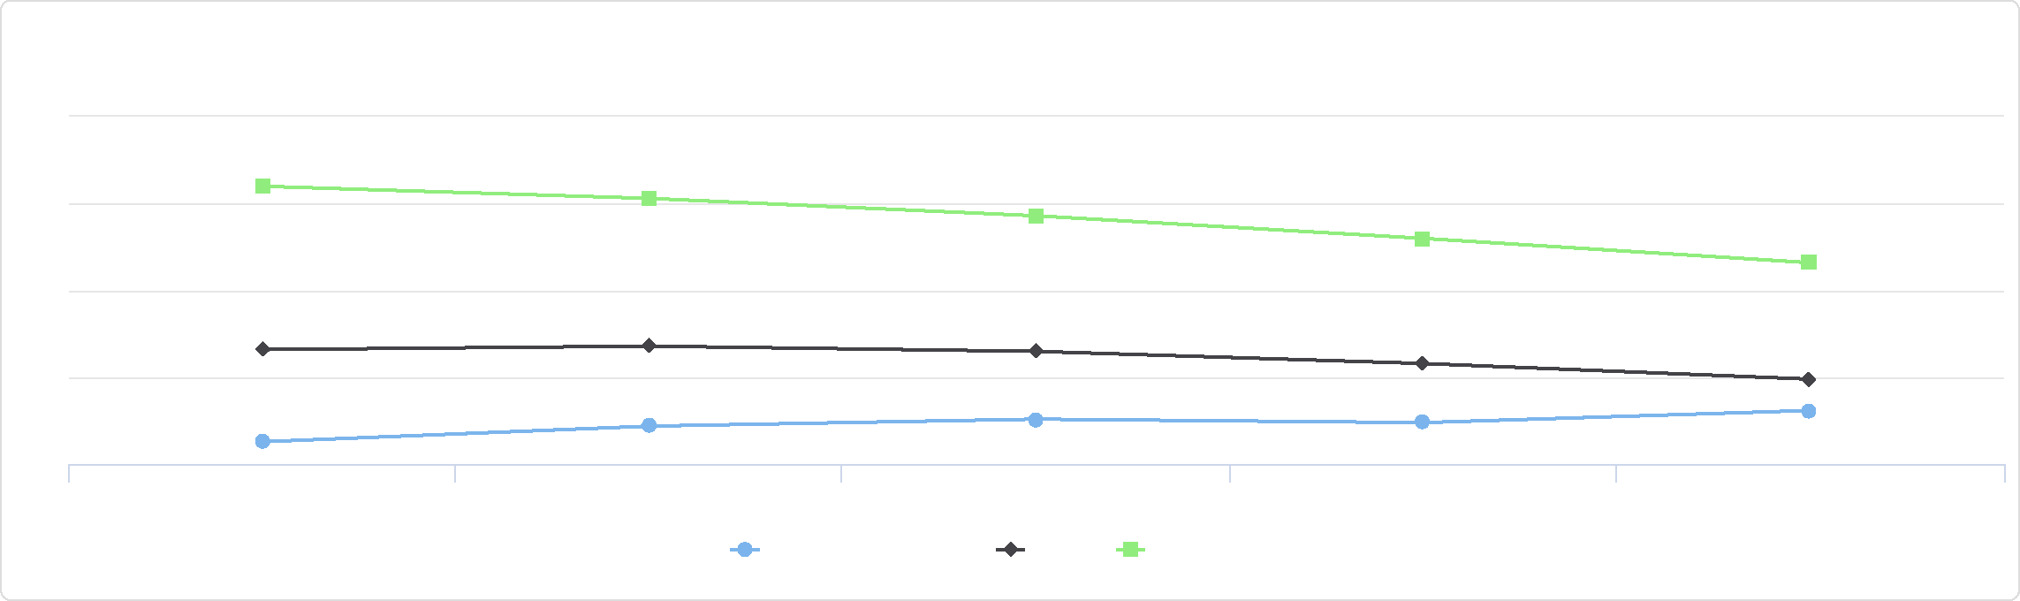

Births to Women Age 15-19, Rate (per 1,000 Pop.) by Time Period, 2002-2008 through 2006-2012

45

35

30

2002-2008 2003-2009 2004-2010 2005-2011 2006-2012

Jackson County, IA Iowa United States

40

25

Unemployment Rate

|  |  |
| --- | --- |
|  | |
| 0% 15% | |
|  | Jackson County (3.8%)  Iowa (3.1%)  United States (6.4%) |

Over 12.0% 9.1 ‐ 12.0% 6.1 ‐ 9.0% 3.1 ‐ 6.0% Under 3.1% Jackson County, IA



**Unemployment, Rate by County, BLS 2020 ‐ November**

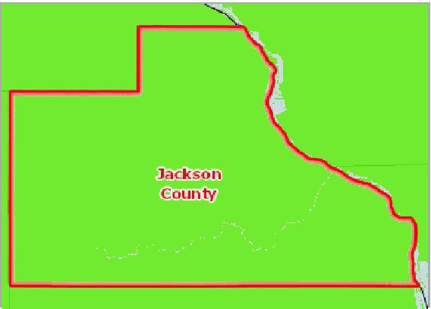

[](https://engagementnetwork.org/map-room/?ids=563,t11&def=t11:FIPS%20In%20('19097')&bbox=-10120449.27515,5164829.551058,-10034264.57655,5219471.283242) View larger map

Average Monthly Unemployment Rate, November 2019 ‐ November 2020

|  |  |  |  |  |  |  |  |  |  |  |  |  |  |
| --- | --- | --- | --- | --- | --- | --- | --- | --- | --- | --- | --- | --- | --- |
| **Report Area** | **Nov.**  **2019** | **Dec.**  **2019** | **Jan.**  **2020** | **Feb.**  **2020** | **Mar.**  **2020** | **Apr.**  **2020** | **May**  **2020** | **Jun.**  **2020** | **Jul.**  **2020** | **Aug.**  **2020** | **Sep.**  **2020** | **Oct.**  **2020** | **Nov.**  **2020** |
| Jackson County, IA | 2.7% | 3.5% | 5.0% | 4.5% | 4.8% | 11.2% | 11.2% | 9.5% | 7.7% | 7.0% | 4.7% | 3.5% | 3.8% |
| Iowa | 2.4% | 2.9% | 3.7% | 3.1% | 3.6% | 10.8% | 9.9% | 8.3% | 6.7% | 6.2% | 4.4% | 3.1% | 3.1% |
| United States | 3.3% | 3.4% | 4.0% | 3.8% | 4.5% | 14.4% | 13.0% | 11.2% | 10.4% | 8.5% | 7.7% | 6.6% | 6.4% |

Average Annual Unemployment Rate, 2009‐2019

|  |  |  |  |  |  |  |  |  |  |  |  |
| --- | --- | --- | --- | --- | --- | --- | --- | --- | --- | --- | --- |
| **Report Area** | **2009** | **2010** | **2011** | **2012** | **2013** | **2014** | **2015** | **2016** | **2017** | **2018** | **2019** |
| Jackson County, IA | 8.4% | 7.2% | 6.5% | 5.5% | 5.4% | 5.0% | 4.2% | 4.2% | 3.4% | 2.9% | 3.2% |
| Iowa | 6.4% | 6.0% | 5.5% | 5.0% | 4.7% | 4.2% | 3.8% | 3.6% | 3.1% | 2.6% | 2.7% |
| United States | 9.3% | 9.6% | 9.0% | 8.1% | 7.4% | 6.2% | 5.3% | 4.9% | 4.4% | 3.9% | 3.7% |

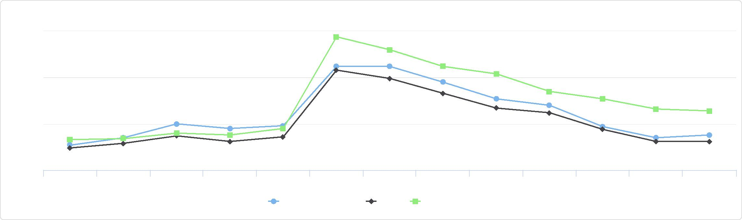

Average Monthly Unemployment Rate, November 2019 - November 2020

0

Nov. 2019 Dec. 2019 Jan. 2020 Feb. 2020 Mar. 2020 Apr. 2020 May 2020 Jun. 2020 Jul. 2020 Aug. 2020 Sep. 2020 Oct. 2020 Nov. 2020

Jackson County, IA Iowa United States

%

15

10

5

Average Annual Unemployment Rate, 2009-2019

## Violent Crime

This indicator reports information about violent crime offenses reported by law enforcement. In the report area, 16 violent crimes occurred during the 2014‐16 three year period. The violent crime rate of 82.3 which is lower than the statewide rate of 283.7. Violent crime includes homicide, rape, robbery, and aggravated assault.

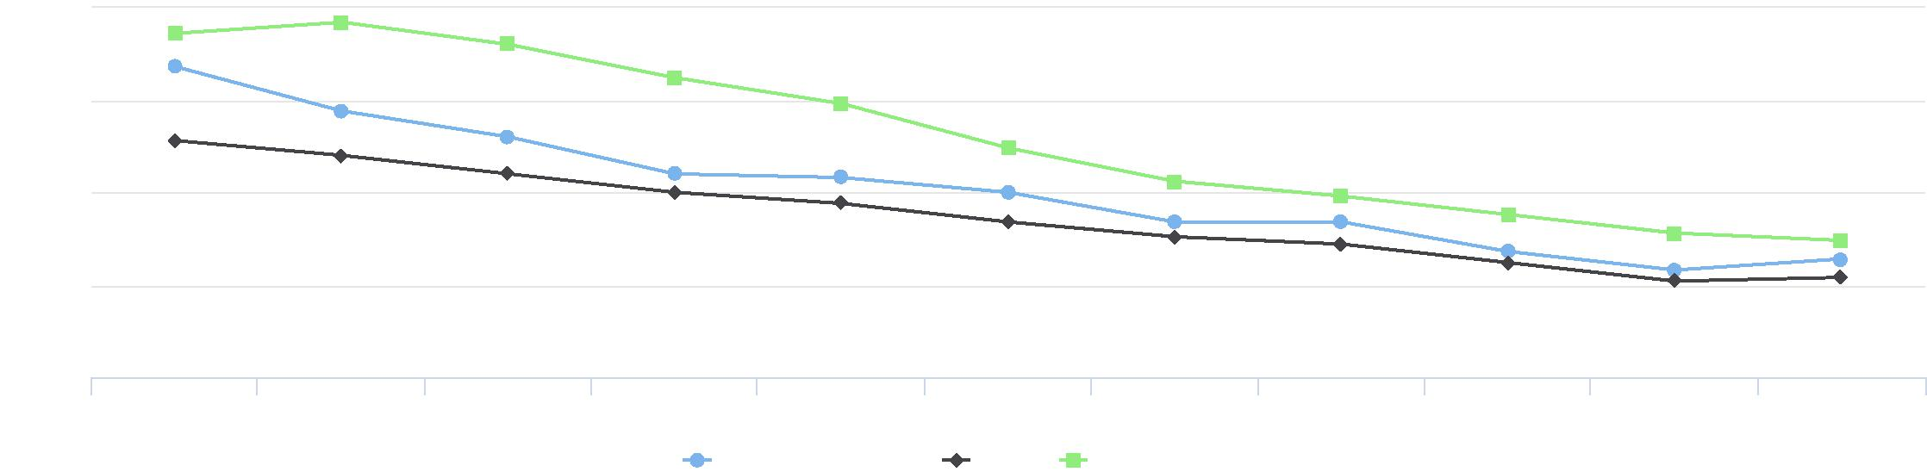

10

7.5

5

%

2.5

2009 2010 2011 2012 2013 2014 2015 2016 2017 2018 2019

Jackson County, IA Iowa United States

0

|  |  |  |
| --- | --- | --- |
| **Report Area** | **Violent Crimes** | **Violent Crime Rate (Per 100,000 Pop.)** |
| Jackson County, IA | 16 | **82.3** |
| Iowa | 17,412 | 283.7 |
| United States | 2,445,671 | 385.6 |

*Note: This indicator is compared to the state average.*

[*Data Source: Federal Bureau of Investigation,*](http://www.icpsr.umich.edu/icpsrweb/ICPSR/series/57) *FBI Uniform Crime Reports. Additional analysis by the National Archive of Criminal Justice Data. Accessed via the Inter‐university Consortium*

[*for Political and Social Research.*](http://www.icpsr.umich.edu/icpsrweb/ICPSR/series/57) *2020. Source geography: County*

Violent Crime Rate (Per 100,000

Pop.)

|  |  |
| --- | --- |
|  | |
| 0 1000 | |
|  | Jackson County (82.3)  Iowa (283.7)  United States (385.6) |

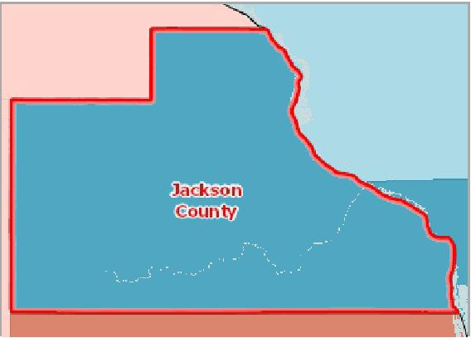

[](https://engagementnetwork.org/map-room/?ids=32148,t11&def=t11:FIPS%20In%20('19097')&bbox=-10120449.27515,5164829.551058,-10034264.57655,5219471.283242) View larger map

**Violent Crime, Rank by County, CHR 2020**

1st Quartile (Top 25%)

2nd Quartile

3rd Quartile

4th Quartile (Bottom 25%)

Bottom Quintile (Rhode Island Only)

No Data or Data Suppressed; ‐1

Jackson County, IA



# Physical Environment

## Air Quality ‐ Ozone

Within the report area, 0, or 0.00% of days exceeded the emission standard of 75 parts per billion (ppb). This indicator reports the percentage of days per year with Ozone (O3) levels above the National Ambient Air Quality Standard of 75 parts per billion (ppb). Figures are calculated using data collected by monitoring stations and modeled to include census tracts where no monitoring stations exist. This indicator is relevant because poor air quality contributes to respiratory issues and overall poor health.

|  |  |  |  |  |  |
| --- | --- | --- | --- | --- | --- |
| **Report Area** | **Total Population** | **Average Daily  Ambient Ozone  Concentration** | **Number of Days Exceeding Emissions Standards** | **Percentage of Days  Exceeding Standards,  Crude Average** | **Percentage of Days  Exceeding Standards, Pop.  Adjusted Average** |
| Jackson County, IA | 19,848 | 36.52 | 0 | 0.00% | **0.00%** |
| Iowa | 3,046,355 | 35.85 | 0 | 0.00% | 0.00% |
| United States | 306,675,006 | 37.87 | 1 | 0.27% | 0.39% |

*Note: This indicator is compared to the state average.*

*Data Source: Centers for Disease Control and Prevention,* [*National Environmental Public Health Tracking Network*](https://ephtracking.cdc.gov/showHome.action)*. 2015. Source geography: Tract*

Percentage of Days Exceeding Standards, Pop. Adjusted Average

|  |  |
| --- | --- |
|  | |
| 0% 10% | |
|  | Jackson County (0.00%)  Iowa (0.00%)  United States (0.39%) |

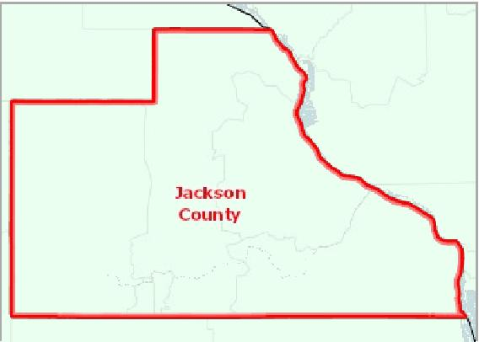

[](https://engagementnetwork.org/map-room/?ids=32558,t11&def=t11:FIPS%20In%20('19097')&bbox=-10120449.27515,5164829.551058,-10034264.57655,5219471.283242) View larger map

**Ozone Levels (O3), Percentage of Days Above NAAQ Standards by Tract, NEPHTN 2015**

Over 3.0%

1.1 ‐ 3.0%

0.51 ‐ 1.0%

Under ‐ 0.51%

No Days Above NAAQS Standards

No Data or Data Suppressed

Jackson County, IA



Percentage of (Pop. Adjusted) Days Exceeding NAAQ Standards:   
Ozone (O3), 2009 through 2015

|  |  |  |  |  |  |  |  |
| --- | --- | --- | --- | --- | --- | --- | --- |
| **Report Area** | **2009** | **2010** | **2011** | **2012** | **2013** | **2014** | **2015** |
| Jackson County, IA | 0.00 | 0.00 | 0.00 | 0.24 | 0.00 | 0.00 | 0.00 |
| Iowa | 0.00 | 0.00 | 0.00 | 0.05 | 0.00 | 0.00 | 0.00 |
| United States | 0.47 | 0.63 | 0.92 | 1.26 | 0.31 | 0.29 | 0.39 |

## Air Quality ‐ Particulate Matter 2.5

This indicator reports the percentage of days with particulate matter 2.5 levels above the National Ambient Air Quality Standard (35 micrograms per cubic meter) per year, calculated using data collected by monitoring stations and modeled to include counties where no monitoring stations occur. This indicator is relevant because poor air quality contributes to respiratory issues and overall poor health.

Percentage of (Pop. Adjusted) Days Exceeding NAAQ Standards:   
Ozone (O3), 2009 through 2015

|  |  |  |  |
| --- | --- | --- | --- |
| 1.5  1 |  |  |  |
|  |  |  |
|  |  |  |

0.5



2009 2010 2011 2012 2013 2014 2015

Jackson County, IA Iowa United States





0

|  |  |  |  |  |  |
| --- | --- | --- | --- | --- | --- |
| **Report Area** | **Total Population**  **(2010)** | **Average Daily Ambient Particulate Matter 2.5** | **Days Exceeding  Emissions  Standards** | **Days Exceeding  Standards, Percent  (Crude)** | **Days Exceeding  Standards, Percent  (Weighted)** |
| Jackson County, IA | 19,848 | 8.13 | 0 | 0.00 | **0.00%** |
| Iowa | 3,046,355 | 7.68 | 0 | 0.00 | 0.06% |
| United States | 306,675,006 | 8.26 | 0 | 0 | 0.11% |

*Note: This indicator is compared to the state average.*

*Data Source: Centers for Disease Control and Prevention,* [*National Environmental Public Health Tracking Network*](https://ephtracking.cdc.gov/showHome.action)*. 2016. Source geography: Tract*

Days Exceeding Standards, Percent (Weighted)

|  |  |
| --- | --- |
|  | |
| 0% 10% | |
|  | Jackson County (0.00%)  Iowa (0.06%)  United States (0.11%) |

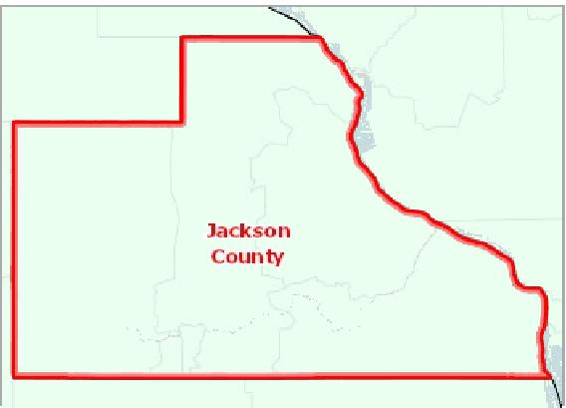

[](https://engagementnetwork.org/map-room/?ids=32559,t11&def=t11:FIPS%20In%20('19097')&bbox=-10120449.27515,5164829.551058,-10034264.57655,5219471.283242) View larger map

**Fine Particulate Matter Levels (PM 2.5), Percentage of Days Above NAAQ Standards by Tract, NEPHTN 2016**

Over 5.0%

1.1 ‐ 5.0%

0.51 ‐ 1.0%

Under 0.51%

No Days Above NAAQS Standards

No Data or Data Suppressed

Jackson County, IA



Days Exceeding NAAQ Standards (Pop. Adjusted), Percent:   
Particulate Matter (PM2.5), 2009 through 2016

|  |  |  |  |  |  |  |  |  |
| --- | --- | --- | --- | --- | --- | --- | --- | --- |
| **Report Area** | **2009** | **2010** | **2011** | **2012** | **2013** | **2014** | **2015** | **2016** |
| Jackson County, IA | 0.55% | 0.27% | 0.00% | 0.00% | 0.00% | 0.40% | 0.27% | 0.00% |
| Iowa | 0.36% | 0.43% | 0.00% | 0.00% | 0.17% | 0.19% | 0.24% | 0.06% |
| United States | 0.24% | 0.19% | 0.20% | 0.10% | 0.23% | 0.26% | 0.23% | 0.11% |

## Climate & Health ‐ Drought Severity

Drought is defined as a moisture deficit bad enough to have social, environmental or economic effects. The Drought Monitor map identifies areas of drought and labels them by intensity. D1 is the least intense level and D4 the most intense. In the

[1](https://droughtmonitor.unl.edu/About/AbouttheData/DroughtClassification.aspx)

report area, 1.25% of weeks during the 2017‐2019 period were spent in drought (any level). An additional 14.82% of weeks were categorized spent in "abnormally dry conditions" (D0) indicating that drought could occur, or that the area is recovering from drought but are not yet back to normal.

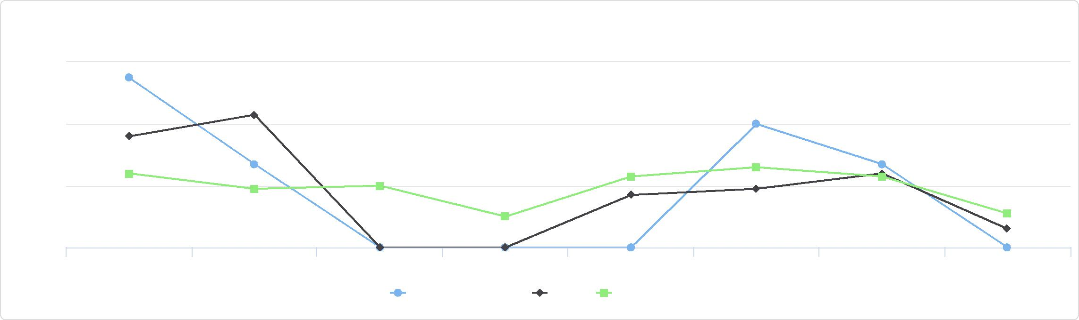

Days Exceeding NAAQ Standards (Pop. Adjusted), Percent: Particulate Matter (PM2.5), 2009 through 2016

0.6

2009 2010 2011 2012 2013 2014 2015 2016

Jackson County, IA Iowa United States

%

0.4

0.2

0

|  |  |  |  |  |  |  |  |
| --- | --- | --- | --- | --- | --- | --- | --- |
| **Report Area** | **Time Period** | **Weeks in D0  (Abnormally  Dry), Percent** | **Weeks in D1  (Moderate  Drought),  Percent** | **Weeks in D2 (Severe Drought), Percent** | **Weeks in D3  (Extreme  Drought),  Percent** | **Weeks in D4  (Exceptional**  **Drought),**  **Percent** | **Weeks in  Drought  (Any),  Percent** |
| Jackson County, IA | 2017‐  2019 | 14.82% | 1.24% | 0.00% | 0.00% | 0.00% | **1.25%** |
| Iowa | 2017‐  2019 | 15.37% | 5.45% | 0.58% | 0.13% | 0.00% | 6.17% |
| United States | 2017‐  2019 | 16.22% | 7.81% | 4.49% | 0.83% | 0.08% | 13.21% |

Weeks in Drought (Any), Percent

|  |  |
| --- | --- |
|  | |
| 0% 100% | |
|  | Jackson County (1.25%)  Iowa (6.17%)  United States (13.21%) |

*Note: This indicator is compared to the state average.*

*Data Source:* [*US Drought Monitor*](https://droughtmonitor.unl.edu/)*. 2017‐2019. Source geography: Tract*

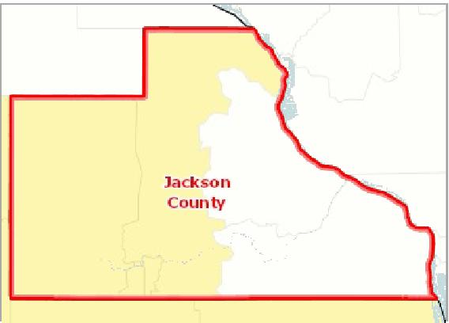

[](https://engagementnetwork.org/map-room/?ids=32473,t11&def=t11:FIPS%20In%20('19097')&bbox=-10120449.27515,5164829.551058,-10034264.57655,5219471.283242) View larger map

All Weeks in Drought

80.1 ‐ 99.9%

40.1 ‐ 8.00%

20.1 ‐ 40.0%

0.1 ‐ 20.0%

No Weeks in Drought

Jackson County, IA

**Drought ‐ Weeks in Drought (Any), Percent by Tract, US Drought Monitor 2017‐2019**



Annual Weeks in Drought, Percent

Data reported is the population‐weighted percentage of weeks in drought for each calendar year, beginning January 1, 2012.

|  |  |  |  |  |  |  |  |  |
| --- | --- | --- | --- | --- | --- | --- | --- | --- |
| **Report Area** | **2012** | **2013** | **2014** | **2015** | **2016** | **2017** | **2018** | **2019** |
| Jackson County, IA | 51.92% | 39.13% | 11.16% | 0.00% | 0.00% | 0.11% | 0.05% | 3.49% |
| Iowa | 56.52% | 53.77% | 20.36% | 0.48% | 1.11% | 11.46% | 6.09% | 1.52% |
| United States | 34.11% | 28.40% | 24.18% | 26.85% | 26.93% | 13.76% | 18.99% | 7.36% |

Annual Weeks in Drought, Percent

## Climate & Health ‐ High Heat Index Days

This indicator reports the percentage of recorded weather observations with heat index values over 103 degrees Fahrenheit. The "heat index" is a single value that takes both temperature and humidity into account. The higher the heat index, the

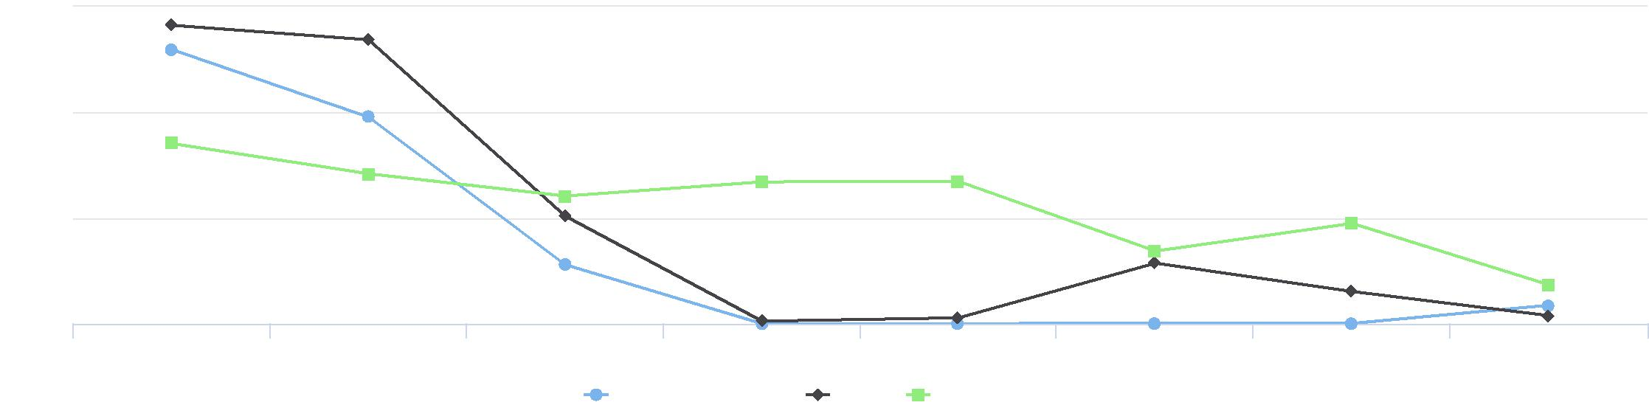

60

2012 2013 2014 2015 2016 2017 2018 2019

Jackson County, IA Iowa United States

%

40

20

0

hotter the weather feels, since sweat does not readily evaporate and cool the skin. The heat index is a better measure than air temperature alone for estimating the risk to workers from environmental heat sources.

Percentage of Weather   
Observations with High Heat   
Index Values

|  |  |
| --- | --- |
|  | |
| 0% 10% | |
|  | Jackson County (6.85%)  Iowa (6.50%)  United States (4.70%) |

|  |  |  |  |  |
| --- | --- | --- | --- | --- |
| **Report  Area** | **Total Weather  Observations** | **Average Heat  Index Value** | **Observations with High  Heat Index Values** | **Observations with High Heat Index Values, Percentage** |
| Jackson County, IA | 4,745 | 93.76 | 325.00 | **6.85%** |
| Iowa | 366,460 | 93.82 | 23,687.00 | 6.50% |
| United  States | 19,094,610 | 91.82 | 897,155.00 | 4.70% |

*Note: This indicator is compared to the state average.*

*Data Source: National Oceanic and Atmospheric Administration,* [*North America Land Data Assimilation System (NLDAS)*](http://www.emc.ncep.noaa.gov/mmb/nldas/) *. Accessed via* [*CDC WONDER*](http://wonder.cdc.gov)*. Additional data analysis by* [*CARES*](http://cares.missouri.edu)*.*

*2014. Source geography: County*

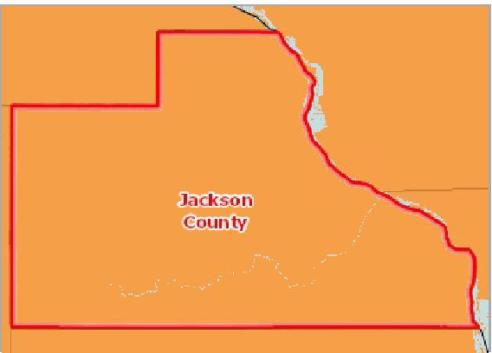

[](https://engagementnetwork.org/map-room/?ids=9815,t11&def=t11:FIPS%20In%20('19097')&bbox=-10120449.27515,5164829.551058,-10034264.57655,5219471.283242) View larger map

**High Heat Index Days, Percentage of Observations Over 103°F by County, NLDAS 2014**

Over 25.0%

15.1 ‐ 25.0%

5.1 ‐ 15.0%

0.1 ‐ 5.0%

None

Jackson County, IA



## Food Access ‐ Fast Food Restaurants

This indicator reports the number of fast food restaurants per 10,000 population. The prevalence of fast food restaurants provides a measure of both access to healthy food and environmental influences on dietary behaviors. Fast food restaurants are defined as limited‐service establishments primarily engaged in providing food services (except snack and nonalcoholic beverage bars) where patrons generally order or select items and pay before eating.

|  |  |  |  |  |  |  |
| --- | --- | --- | --- | --- | --- | --- |
| **Report Area** | **Total Population**  **(2010)** | | **Number of  Establishments** |  | **Establishments, Rate per 10,000 Population** |  |
| Jackson County, IA |  | 19,848 |  | 9 |  | **4.53** |
| Iowa | No data |  | No data |  | No data |  |
| United States | No data |  | No data |  | No data |  |

*Note: This indicator is compared to the state average.*

*Data Source: US Census Bureau,* [*County Business Patterns*](https://www.census.gov/programs-surveys/cbp.html)*. Additional data analysis by* [*CARES*](https://cares.missouri.edu)*. 2018. Source geography: County*

Fast Food Restaurants, Rate per 10,000 Population

|  |  |
| --- | --- |
|  | |
|  | 0 30  Jackson County (4.53)  Iowa (No data)  United States (No data) |

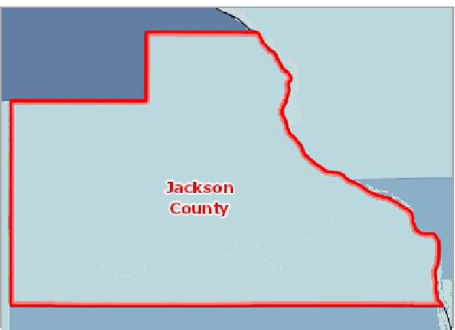

[](https://engagementnetwork.org/map-room/?ids=32656,t11&def=t11:FIPS%20In%20('19097')&bbox=-10120449.27515,5164829.551058,-10034264.57655,5219471.283242) View larger map

**Fast Food Restaurants, Rate (Per 100,000 Pop.) by County, CBP 2018**

Over 100.0

75.1 ‐ 100.0

50.1 ‐ 75.0

Under 50.1

No Fast Food Restaurants

Jackson County, IA



Fast Food Restaurants,

Rate per 10,000 Population by Year, 2010 through 2017

|  |  |  |  |  |  |  |  |  |
| --- | --- | --- | --- | --- | --- | --- | --- | --- |
| **Report Area** | **2010** | **2011** | **2012** | **2013** | **2014** | **2015** | **2016** | **2017** |
| Jackson County, IA | 4.03 | 3.53 | 2.52 | 3.02 | 2.52 | 2.52 | 3.02 | 3.53 |
| Iowa | 6.09 | 6.2 | 6.36 | 6.38 | 6.3 | 6.32 | 6.53 | 7 |
| United States | 6.91 | 7 | 7.28 | 7.37 | 7.41 | 7.56 | 7.71 | 8.13 |

## Food Access ‐ Food Desert Census Tracts

This indicator reports the number of neighborhoods in the report area that are within food deserts. The USDA Food Access Research Atlas defines a food desert as any neighborhood that lacks healthy food sources due to income level, distance to supermarkets, or vehicle access. The report area has a population of 9,748 living in food deserts and a total of 3 census tracts classified as food deserts by the USDA.

|  |  |  |  |  |  |
| --- | --- | --- | --- | --- | --- |
| **Report Area** | **Total Population (2010)** | **Food Desert Census Tracts** | **Other Census Tracts** | **Food Desert Population** | **Other Population** |
| Jackson County, IA | 19,848 | 3 | 3 | 9,748 | 10,100 |
| Iowa | 3,046,355 | 348 | 477 | 1,378,623 | 1,667,732 |
| United States | 308,745,538 | 27,527 | 45,337 | 129,885,212 | 178,860,326 |

*Data Source: US Department of Agriculture, Economic Research Service,* [*USDA ‐ Food Access Research Atlas*](http://www.ers.usda.gov/data-products/food-access-research-atlas)*. 2015. Source geography: Tract*

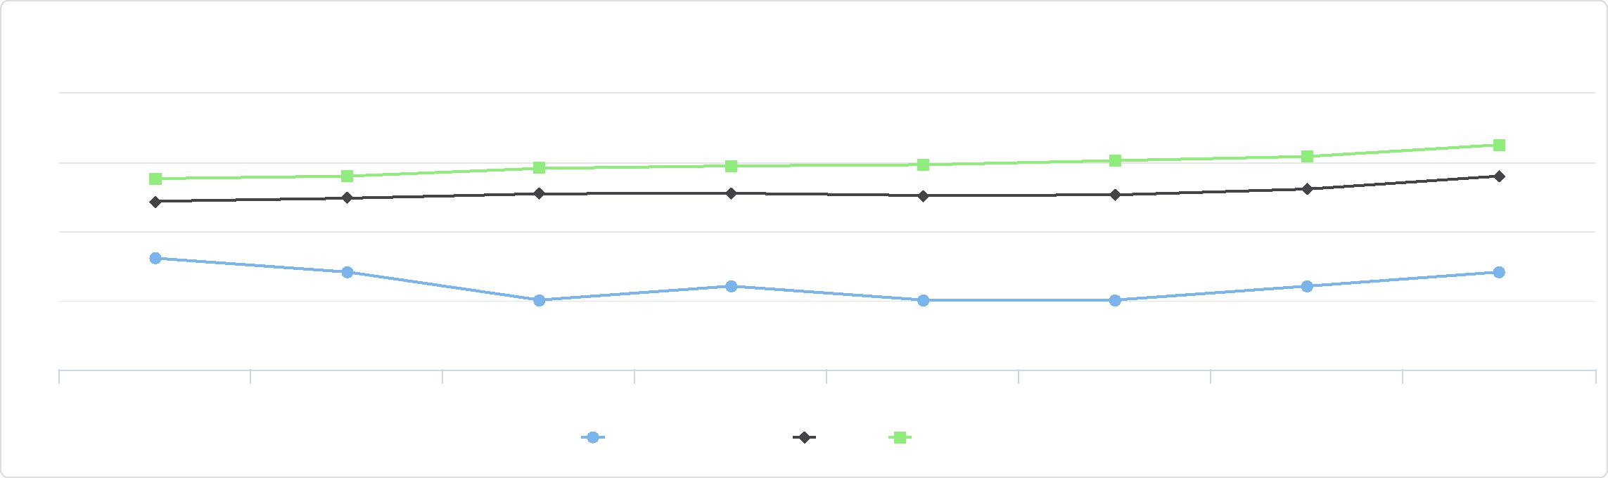

7.5

2.5

Fast Food Restaurants,

Rate per 10,000 Population by Year, 2010 through 2017

10

5

0

2010 2011 2012 2013 2014 2015 2016 2017

Jackson County, IA Iowa United States

**Food Desert Census Tracts, 1 Mi. / 10 Mi. by Tract, FARA 2015**

Food Desert

Not a Food Desert

No Data

Jackson County, IA



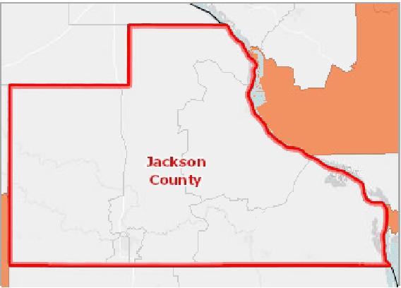

[](https://engagementnetwork.org/map-room/?ids=17548,t11&def=t11:FIPS%20In%20('19097')&bbox=-10120449.27515,5164829.551058,-10034264.57655,5219471.283242) View larger map

Food Access - Food Desert Census Tracts

Jackson County, IA



**Other Census Tracts: 50.0% Food Desert Census Tracts: 50.0%**

## Food Access ‐ Grocery Stores

Healthy dietary behaviors are supported by access to healthy foods, and Grocery Stores are a major provider of these foods. There are 0 grocery establishments in the report area, a rate of 0.00 per 10,000 population. Grocery stores are defined as supermarkets and smaller grocery stores primarily engaged in retailing a general line of food, such as canned and frozen foods; fresh fruits and vegetables; and fresh and prepared meats, fish, and poultry. Delicatessen‐type establishments are also included. Convenience stores and large general merchandise stores that also retail food, such as supercenters and warehouse club stores, are excluded.

|  |  |  |  |  |  |  |
| --- | --- | --- | --- | --- | --- | --- |
| **Report Area** | **Total Population**  **(2010)** | | **Number of  Establishments** |  | **Establishments, Rate per 100,000 Population** |  |
| Jackson County, IA |  | 19,848 |  | 0 |  | **0.00** |
| Iowa | No data |  | No data |  | No data |  |
| United States | No data |  | No data |  | No data |  |

*Note: This indicator is compared to the state average.*

*Data Source: US Census Bureau,* [*County Business Patterns*](https://www.census.gov/programs-surveys/cbp.html)*. Additional data analysis by* [*CARES*](https://cares.missouri.edu)*. 2018. Source geography: County*

Grocery Stores, Rate per 10,000 Population

|  |  |
| --- | --- |
|  | |
|  | 0 10  Jackson County (0.00)  Iowa (No data)  United States (No data) |

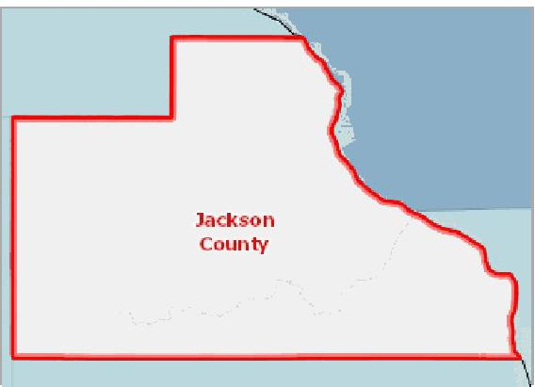

[](https://engagementnetwork.org/map-room/?ids=32665,t11&def=t11:FIPS%20In%20('19097')&bbox=-10120449.27515,5164829.551058,-10034264.57655,5219471.283242) View larger map

**All Retail Food Outlets, Rate (Per 100,000 Pop.) by County, CBP 2018**

Over 50.0

30.1 ‐ 50.0

20.1 ‐ 30.0

Under 20.1

No Retail Food Outlets

Jackson County, IA



Grocery Stores and Supermarkets,

Rate per 10,000 Population by Year, 2010 through 2017

|  |  |  |  |  |  |  |  |  |
| --- | --- | --- | --- | --- | --- | --- | --- | --- |
| **Report Area** | **2010** | **2011** | **2012** | **2013** | **2014** | **2015** | **2016** | **2017** |
| Jackson County, IA | 2.02 | 1.51 | 1.51 | 1.51 | 1.51 | 1.01 | 1.01 | 0 |
| Iowa | 1.95 | 1.95 | 1.95 | 1.97 | 1.99 | 2.01 | 1.97 | 1.98 |
| United States | 2.08 | 2.08 | 2.14 | 2.15 | 2.14 | 2.15 | 2.12 | 2.1 |

Grocery Stores and Supermarkets,

Rate per 10,000 Population by Year, 2010 through 2017

3

|  |  |  |  |  |
| --- | --- | --- | --- | --- |
|  |  |  |  |  |
| 2 |  |  |
|  |  |
| 1  0 |  |  |
|  |  |  |
|  |  |  |

2010 2011 2012 2013 2014 2015 2016 2017



Jackson County, IA Iowa United States



## Food Access ‐ Low Food Access

This indicator reports the percentage of the population with low food access. Low food access is defined as living more than 1/2 [mile from the nearest supermarket, supercenter, or large grocery store. Data are from the 2017 report,](https://www.ers.usda.gov/publications/pub-details/?pubid=82100) Low‐Income and Low‐ Supermarket‐Access Census Tracts, 2010‐2015. This indicator is relevant because it highlights populations and geographies facing food insecurity. 20.94% of the population in the report area have low food access. The total population in the report area with low food access is 4,156.

Percent Population with Low Food Access

|  |  |
| --- | --- |
|  | |
|  | 0% 30%  Jackson County (20.94%)  Iowa (21.41%)  United States (22.43%) |

|  |  |  |  |
| --- | --- | --- | --- |
| **Report Area** | **Total Population**  **(2010)** | **Population with Low Food  Access** | **Percent Population with Low Food**  **Access** |
| Jackson County, IA | 19,848 | 4,156 | **20.94%** |
| Iowa | 3,046,355 | 652,113 | 21.41% |
| United States | 308,745,538 | 69,266,771 | 22.43% |

*Note: This indicator is compared to the state average.*

*Data Source: US Department of Agriculture, Economic Research Service,* [*USDA ‐ Food Access Research Atlas*](http://www.ers.usda.gov/data-products/food-access-research-atlas)*. 2015. Source geography: Tract*

**Population with Limited Food Access, Percent by Tract, FARA 2015**

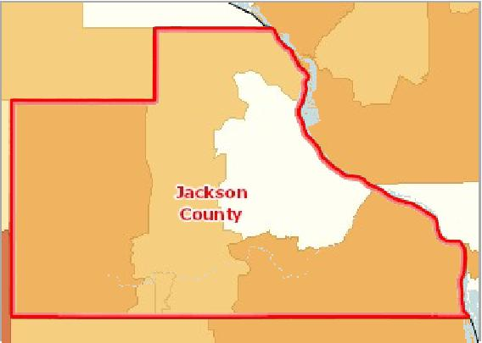

[](https://engagementnetwork.org/map-room/?ids=17543,t11&def=t11:FIPS%20In%20('19097')&bbox=-10120449.27515,5164829.551058,-10034264.57655,5219471.283242) View larger map

Over 50.0%

20.1 ‐ 50.0%

5.1 ‐ 20.0%

Under 5.1%

No Low Food Access

Jackson County, IA



## Food Access ‐ Low Income & Low Food Access

This indicator reports the percentage of the low income population with low food access. Low food access is defined as living [more than](https://www.ers.usda.gov/publications/pub-details/?pubid=82100) 1/2 mile from the nearest supermarket, supercenter, or large grocery store. Data are from the 2017 report, Low‐ Income and Low‐Supermarket‐Access Census Tracts, 2010‐2015. This indicator is relevant because it highlights populations and geographies facing food insecurity.

|  |  |  |  |  |
| --- | --- | --- | --- | --- |
| **Report Area** | **Total Population** | **Low Income  Population** | **Low Income Population with  Low Food Access** | **Percent Low Income Population with Low Food Access** |
| Jackson County, IA | 19,848 | 7,370 | 1,269 | **17.22%** |
| Iowa | 3,046,355 | 929,903 | 189,697 | 20.40% |
| United  States | 308,745,538 | 106,758,543 | 20,221,368 | 18.94% |

*Note: This indicator is compared to the state average.*

*Data Source: US Department of Agriculture, Economic Research Service,* [*USDA ‐ Food Access Research Atlas*](http://www.ers.usda.gov/data-products/food-access-research-atlas)*. 2015. Source geography: Tract*

Percent Low Income Population with Low Food Access

|  |  |
| --- | --- |
|  | |
|  | 0% 50%  Jackson County (17.22%)  Iowa (20.40%)  United States (18.94%) |

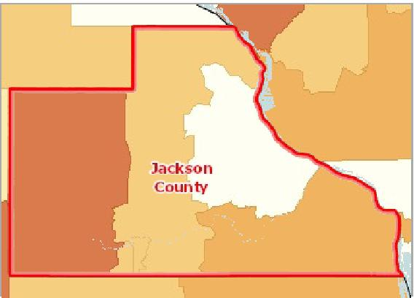

[](https://engagementnetwork.org/map-room/?ids=17544,t11&def=t11:FIPS%20In%20('19097')&bbox=-10120449.27515,5164829.551058,-10034264.57655,5219471.283242) View larger map

**Population with Limited Food Access, Low Income, Percent by Tract, FARA 2015**

Over 50.0%

20.1 ‐ 50.0%

5.1 ‐ 20.0%

Under 5.1%

No Low Food Access

Jackson County, IA



## Food Access ‐ Modified Retail Food Environment Index

This indicator reports the percentage of population living in census tracts with no or low access to healthy retail food stores. Figures are based on the CDC Modified Retail Food Environment Index. For this indicator, low food access tracts are considered those with index scores of 10.0 or less.

|  |  |  |  |  |  |  |
| --- | --- | --- | --- | --- | --- | --- |
| **Report Area** | **Total Population** | **Percent Population  in Tracts with No  Food Outlet** | **Percent Population in  Tracts with No Healthy  Food Outlet** | **Percent Population in  Tracts with Low  Healthy Food Access** | **Percent Population in  Tracts with Moderate  Healthy Food Access** | **Percent Population in  Tracts with High  Healthy Food Access** |
| Jackson County, IA | 19,848 | 0.00% | 49.11% | 0.00% | 32.70% | 18.19% |
| Iowa | 3,046,355 | 1.41% | 26.36% | 20.04% | 44.39% | 7.80% |
| United States | 308,741,655 | 1.00% | 18.86% | 31.27% | 43.81% | 5.08% |

*Data Source: Centers for Disease Control and Prevention,* [*Division of Nutrition, Physical Activity, and Obesity*](http://www.cdc.gov/nccdphp/dnpao/index.html)*. 2011. Source geography: Tract*

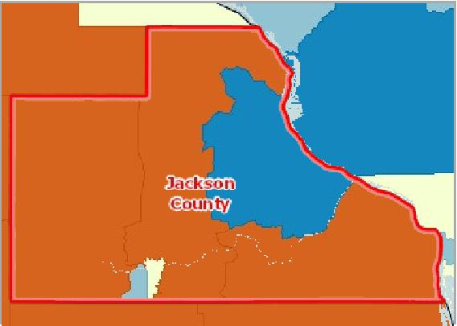

[](https://engagementnetwork.org/map-room/?ids=503,t11&def=t11:FIPS%20In%20('19097')&bbox=-10120449.27515,5164829.551058,-10034264.57655,5219471.283242) View larger map

**Modified Retail Food Environmental Index Score by Tract, DNPAO 2011**

Index Score Over 30 (High Access)

Index Score 15 ‐ 30 (Moderate Access)

Index Score 5 ‐ 15 (Low Access)

Index Score Under 5 (Poor Access)

No Healthy Retail Food Outlet (No Access)

No Retail Food Outlets Present (Food Desert)

Jackson County, IA



Population with Low or No Healthy Food Access, Racial Disparity Index

|  |  |
| --- | --- |
| **Report Area** | **Disparity Index Score**  ***(0 = No Disparity; 1 ‐ 15 = Some Disparity; Over 15 = High Disparity)*** |
| Jackson County, IA | 20.75 |
| Iowa | 24.13 |
| United States | 16.59 |

Population with Low or No Healthy Food Access by Race/Ethnicity, Percent

|  |  |  |  |  |  |  |  |  |
| --- | --- | --- | --- | --- | --- | --- | --- | --- |
| **Report Area** | **Total Population** | **Non‐Hispanic White** | **Non‐  Hispanic  Black** | **Non‐Hispanic Asian** | **Non‐Hispanic American Indian or Alaska Native** | **Non‐Hispanic Other** | **Multiple Race** | **Hispanic or Latino** |
| Jackson County, IA | 49.40 | 49.57% | 36.84% | 15.79% | 45.45% | 57.14% | 47.06% | 38.02% |
| Iowa | 48.91 | 48.46% | 62.15% | 53.28% | 54.59% | 57.44% | 52.53% | 49.86% |
| United  States | 52.02 | 49.33% | 64.15% | 51.26% | 54.56% | 57.92% | 53.64% | 54.98% |

Population with Low or No Healthy Food Access by Race/Ethnicity, Total

Population with Low or No Healthy Food Access, Racial Disparity Index

30

20

10

0

Disparity Index Score

*(0 = No Disparity; 1 - 15 = Some Disparity; Over 15 = High Disparity)*

Jackson County, IA Iowa United States



Population with Low or No Healthy Food Access by Race/Ethnicity, Percent

75

|  |  |  |  |  |  |  |  |  |  |  |  |  |  |  |  |  |  |  |  |  |  |  |  |  |  |  |  |  |  |  |  |  |  |  |
| --- | --- | --- | --- | --- | --- | --- | --- | --- | --- | --- | --- | --- | --- | --- | --- | --- | --- | --- | --- | --- | --- | --- | --- | --- | --- | --- | --- | --- | --- | --- | --- | --- | --- | --- |
|  |  |  |  |  |  |  |  |  |  |  |  |  |  |  |  |  |  |  |  |  |  |  |  |  |  |  |  |  |  |  |  |  |  |  |
|  |  |  |  |  |  |  |  |  |  |  |  |  |  |  |  |  |  |  |  |  |  |  |  |  |  |  |  |  |  |  |  |  |  |
|  |  |  |  |  |  |  |  |  |  |  |  |  |  |  |  |  |  |  |  |  |  |  |  |  |  |  |  |  |  |  |  |  |  |
|  |  |  |  |  |  |  |  |  |  |  |  |  |  |  |  |  |  |  |  |  |  |  |  |  |  |  |  |  |  |  |  |  |  |
| 50 |  |  |  |  |  |  |  |  |  |  |  |  |  |  |  |  |  |  |  |  |  |  |  |  |  |  |  |  |  |  |  |  |  |
|  |  |  |  |  |  |  |  |  |  |  |  |  |  |  |  |  |  |  |  |  |  |  |  |  |  |  |  |  |  |  |
|  |  |  |  |  |  |  |  |  |  |  |  |  |  |  |  |  |  |  |  |  |  |  |  |  |  |  |  | |  |  |
|  |  |  |  |  |  |  |  |  |  |  |  |  |  |  |  |  |  |  |  |  |  |  |  |  |  |  |
|  |  |  |  |  |  |  |  |  |  |  |  |  |  |  |  |  |  |  |  |  |  |  |  |  |  |  |  |
| 25 |  |  |  |  |  |  |  |  |  |  |  |  |  |  |  |  |  |  |  |  |  |  |  |  |  |  |  |
|  |  |  |  |  |  |  |  |  |  |  |  |  |  |  |  |  |  |  |  |  |  |  |  |  |  |  |
|  |  |  |  |  |  |  |  |  |  |  |  |  |  |  |  |  |  |  |  |  |  |  |  |  |  |  |  |
| 0 |  |  |  |  |  |  |  |  |  |  |  |  |  |  |  |  |  |  |  |  |  |  |  |  |  |  |  |
|  |  |  |  |  |  |  |  |  |  |  |  |  |  |  |  |  |  |  |  |  |  |  |  |  |  |  |  |  |  |  |  |  |  |

Total Population Non-Hispanic White Non-Hispanic Black Non-Hispanic Asian Non-Hispanic Non-Hispanic Other Multiple Race Hispanic or Latino

American Indian or   
Alaska Native

Jackson County, IA Iowa United States



|  |  |  |  |  |  |  |  |
| --- | --- | --- | --- | --- | --- | --- | --- |
| **Report Area** | **Non‐Hispanic White** | **Non‐Hispanic Black** | **Non‐Hispanic Asian** | **Non‐Hispanic American Indian or Alaska Native** | **Non‐Hispanic Other** | **Multiple  Race** | **Hispanic or  Latino** |
| Jackson County, IA | 9,914.00 | 7.00 | 3.00 | 10.00 | 4.00 | 40.00 | 46.00 |
| Iowa | 1,313,564.00 | 37,753.00 | 19,365.00 | 4,343.00 | 1,208.00 | 13,381.00 | 41,117.00 |
| United States | 95,978,903.00 | 21,776,320.00 | 5,189,224.00 | 1,128,698.00 | 270,921.00 | 2,468,453.00 | 19,410,660.00 |

Population with Low or No Healthy Food Access by Race/Ethnicity, Total

Jackson County, IA

## Food Access ‐ SNAP‐Authorized Food Stores

This indicator reports the number of SNAP‐authorized food stores as a rate per 10,000 population. SNAP‐authorized stores include grocery stores as well as supercenters, specialty food stores, and convenience stores that are authorized to accept SNAP (Supplemental Nutrition Assistance Program) benefits. The report area contains 18 total SNAP‐Authorized Retailers with a rate of 9.07.

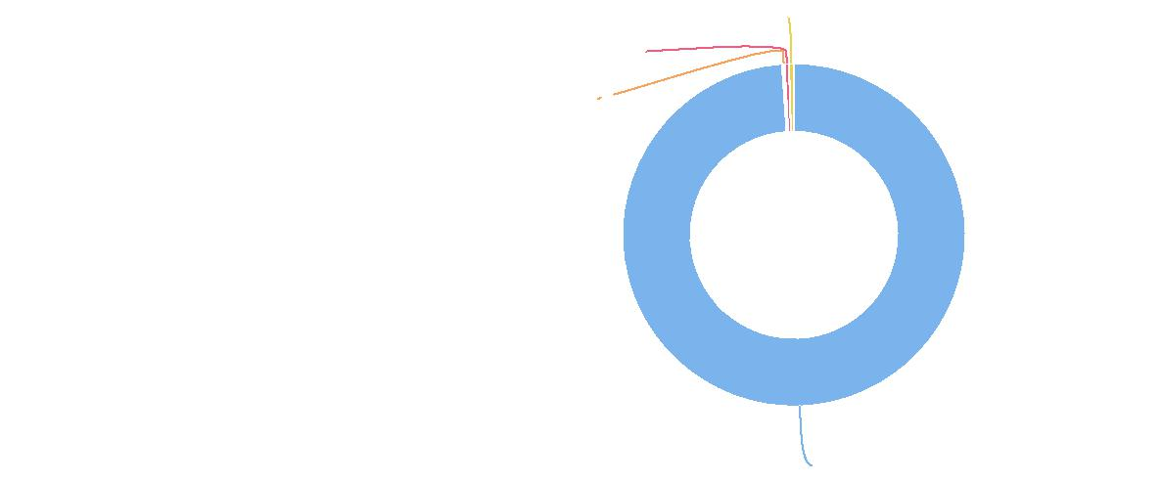

**Hispanic or Latino: 0.5%**

**Multiple Race: 0.4%**

**Non-Hispanic American Indian or Alaska Native: 0.1%**

**Non-Hispanic White: 98.9%**

|  |  |  |  |
| --- | --- | --- | --- |
| **Report Area** | **Total Population**  **(2010)** | **Total SNAP‐Authorized  Retailers** | **SNAP‐Authorized Retailers, Rate per 10,000  Population** |
| Jackson  County, IA | 19,848 | 18 | **9.07** |
| Iowa | 3,046,355 | 2,952 | 9.69 |
| United States | 312,383,875 | 250,022 | 8.00 |

*Note: This indicator is compared to the state average.*

*Data Source: US Department of Agriculture, Food and Nutrition Service,* [*USDA ‐ SNAP Retailer Locator*](http://www.snapretailerlocator.com/)*. Additional data analysis by* [*CARES*](http://cares.missouri.edu)*. 2020. Source geography: Tract*

SNAP-Authorized Retailers, Rate (Per 10,000 Population)

|  |  |
| --- | --- |
|  | |
| 0 60 | |
|  | Jackson County (9.07)  Iowa (9.69)  United States (8.00) |

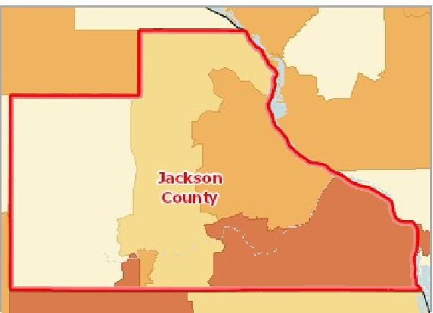

[](https://engagementnetwork.org/map-room/?ids=25540,t11&def=t11:FIPS%20In%20('19097')&bbox=-10120449.27515,5164829.551058,-10034264.57655,5219471.283242) View larger map

**SNAP‐Authorized Retailers Access, Rate per 10,000 Population by Tract, USDA 2020**

Over 12.0

6.1 ‐ 12.0

Under 6.0

No SNAP‐Authorized Retailers

No Population or No Data

Jackson County, IA



## Food Access ‐ WIC‐Authorized Food Stores

This indicator reports the number of food stores and other retail establishments per 100,000 population that are authorized to accept WIC Program (Special Supplemental Nutrition Program for Women, Infants, and Children) benefits and that carry

designated WIC foods and food categories. This indicator is relevant because it provides a measure of food security and healthy food access for women and children in poverty as well as environmental influences on dietary behaviors.

|  |  |  |  |
| --- | --- | --- | --- |
| **Report Area** | **Total  Population**  **(2011  Estimate)** | **Number WIC‐Authorized Food  Stores** | **WIC‐Authorized Food Store Rate (Per 100,000**  **Pop.)** |
| Jackson County, IA | 19,796.00 | 5.00 | **25.30** |
| Iowa | 3,069,845.00 | 681.00 | 22.10 |
| United States | 318,921,538.00 | 50,042.00 | 15.60 |

*Note: This indicator is compared to the state average.*

*Data Source: US Department of Agriculture, Economic Research Service,* [*USDA ‐ Food Environment Atlas*](http://www.ers.usda.gov/data-products/food-environment-atlas/about-the-atlas.aspx)*. 2011. Source geography: County*

WIC-Authorized Food Stores, Rate (Per 100,000 Population)

|  |  |
| --- | --- |
|  | |
|  | 0 30  Jackson County (25.30)  Iowa (22.10)  United States (15.60) |

|  |  |  |
| --- | --- | --- |
|  |  | Jackson County, IA |

[](https://engagementnetwork.org/map-room/?ids=251,t11&def=t11:FIPS%20In%20('19097')&bbox=-10120449.27515,5164829.551058,-10034264.57655,5219471.283242) View larger map

## Housing ‐ Assisted Housing

This indicator reports the total number of HUD‐funded assisted housing units available to eligible renters as well as the unit rate (per 10,000 total households).

|  |  |  |  |
| --- | --- | --- | --- |
| **Report Area** | **Total Housing Units**  **(2010)** | **Total HUD‐Assisted Housing**  **Units** | **HUD‐Assisted Units, Rate per 10,000  Housing Units** |
| Jackson  County, IA | 9,415 | 333 | **353.69** |
| Iowa | 1,336,417 | 40,386 | 302.20 |
| United States | 133,341,676 | 5,024,504 | 376.81 |

*Note: This indicator is compared to the state average.*

*Data Source:* [*US Department of Housing and Urban Development*](http://portal.hud.gov/hudportal/HUD)*. 2019. Source geography: County*

HUD-Assisted Units, Rate per 10,000 Housing Units

|  |  |
| --- | --- |
|  | |
|  | 0 1500  Jackson County (353.69)  Iowa (302.20)  United States (376.81) |

**Assisted Housing Units, All by Tract, HUD 2019**

Over 60

31 ‐ 60

11 ‐ 30

1 ‐ 10

No Units

Jackson County, IA



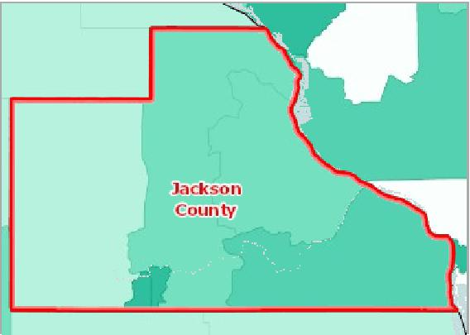

[](https://engagementnetwork.org/map-room/?ids=31847,31838,t11&def=t11:FIPS%20In%20('19097')&bbox=-10120449.27515,5164829.551058,-10034264.57655,5219471.283242) View larger map

Assisted Housing Units ‐ HUD Programs ‐ by Assistance Program

|  |  |  |  |  |  |  |  |
| --- | --- | --- | --- | --- | --- | --- | --- |
| **Report Area** | **Housing  Choice  Voucher Units** | **Project‐Based  Section 8  Units** | **Section 236 Units (Federal Housing**  **Authority**  **Projects)** | **Public Housing  Authority  Units** | **Section 202 Units  (Supportive  Housing for the  Elderly)** | **Section 811 Units  (Supportive Housing for  Persons with Disabilities)** | **Other Multi‐  Family Program  Units  (RAP, SUP,  Moderate  Rehab, Etc.)** |
| Jackson County, IA | 160 | 133 | 0 | 40 | 0 | 0 | 0 |
| Iowa | 23,215 | 11,852 | 5 | 4,048 | 998 | 255 | 14 |
| United States | 2,556,270 | 1,290,316 | 21,784 | 987,133 | 125,761 | 34,066 | 19,355 |

Assisted Housing Units ‐ HUD Programs ‐ by Assistance Program

This indicator reports the number of assisted units in each program type as a proportion of the total state share.

|  |  |  |  |  |  |  |  |  |
| --- | --- | --- | --- | --- | --- | --- | --- | --- |
| **Report Area** | **All Units** | **Housing  Choice  Voucher Units** | **Project‐Based  Section 8  Units** | **Section 236 Units (Federal Housing**  **Authority**  **Projects)** | **Public  Housing  Authority  Units** | **Section 202  Units  (Supportive  Housing for the  Elderly)** | **Section 811 Units  (Supportive Housing for  Persons with  Disabilities)** | **Other Multi‐  Family Program  Units  (RAP, SUP,  Moderate  Rehab, Etc.)** |
| Jackson County, IA | 0.83% | 0.73% | 1.11% | 0.00% | 0.91% | 0.00% | 0.00% | 0.00% |

Assisted Housing Units - HUD Programs - by Assistance Program

Jackson County, IA

**Housing Choice Voucher: 48.0%**

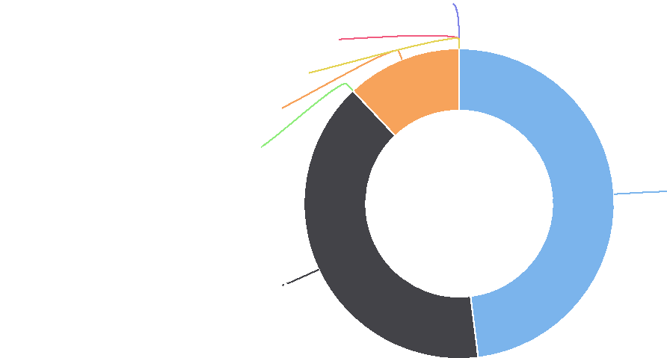

**Project-Based Section 8: 39.9%**

**Public Housing: 12.0%**

**Section 236: 0.0%**

**Section 202: 0.0%**

**Section 811: 0.0%**

**Other Programs: 0.0%**

Assisted Housing Units - HUD Programs - by Assistance Program

|  |  |
| --- | --- |
| All Units:% Housing Choice Voucher:% Project-Based Section 8:% Section 236:% Public Housing:% Section 202:% Section 811:% Other Programs:% |  |

0 0.1 0.2 0.3 0.4 0.5 0.6 0.7 0.8 0.9 1 1.1 1.2

%

Jackson County, IA



## Housing ‐ Housing Unit Age

This indicator reports, for a given geographic area, the median year in which all housing units (vacant and occupied) were first constructed. The year the structure was built provides information on the age of housing units. These data help identify new housing construction and measures the disappearance of old housing from the inventory, when used in combination with data from previous years. This data also serves to aid in the development of formulas to determine substandard housing and provide assistance in forecasting future services, such as energy consumption and fire protection. There are a total 9,518 housing units in the report area, and the median year built is 1967.

|  |  |  |
| --- | --- | --- |
| **Report Area** | **Total Housing Units** | **Median Year Structures Built** |
| Jackson County, IA | 9,518 | 1967 |
| Iowa | 1,386,722 | 1969 |
| United States | 136,384,292 | 1977 |

*Data Source: US Census Bureau,* [*American Community Survey*](http://www.census.gov/acs/www/)*. 2014‐18. Source geography: Tract*

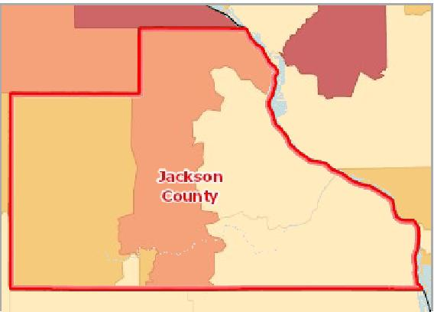

[](https://engagementnetwork.org/map-room/?ids=30539,t11&def=t11:FIPS%20In%20('19097')&bbox=-10120449.27515,5164829.551058,-10034264.57655,5219471.283242) View larger map

**Median Year Structure Built by Tract, ACS 2014‐18**

Newer than 1985

1976 ‐ 1985

1966 ‐ 1975

Older than 1966

No Data or Data Suppressed

Jackson County, IA



All Housing Units by Age (Time Period Constructed), Total

|  |  |  |  |  |  |
| --- | --- | --- | --- | --- | --- |
| **Report Area** | **Before 1960** | **1960‐1979** | **1980‐1999** | **2000‐2010** | **After 2010** |
| Jackson County, IA | 4,152 | 2,478 | 1,628 | 954 | 306 |
| Iowa | 569,169 | 345,824 | 250,243 | 158,500 | 62,986 |
| United States | 38,411,797 | 35,470,089 | 37,443,997 | 19,435,745 | 5,622,664 |

All Housing Units by Age (Time Period Constructed), Percentage

|  |  |  |  |  |  |
| --- | --- | --- | --- | --- | --- |
| **Report Area** | **Before 1960** | **1960‐1979** | **1980‐1999** | **2000‐2010** | **After 2010** |
| Jackson County, IA | 43.62% | 26.03% | 17.10% | 10.02% | 3.21% |
| Iowa | 41.04% | 24.94% | 18.05% | 11.43% | 4.54% |
| United States | 28.16% | 26.01% | 27.45% | 14.25% | 4.12% |

Owner‐Occupied Housing Units by Age, Total

|  |  |  |  |  |  |
| --- | --- | --- | --- | --- | --- |
| **Report Area** | **Before 1960** | **1960‐1979** | **1980‐1999** | **2000‐2010** | **After 2010** |
| Jackson County, IA | 2,768 | 1,715 | 1,082 | 681 | 256 |
| Iowa | 371,354 | 216,039 | 154,004 | 113,102 | 39,653 |
| United States | 20,824,214 | 18,946,634 | 21,376,804 | 12,195,336 | 3,101,822 |

Owner‐Occupied Housing Units by Age, Percentage

|  |  |  |  |  |  |
| --- | --- | --- | --- | --- | --- |
| **Report Area** | **Before 1960** | **1960‐1979** | **1980‐1999** | **2000‐2010** | **After 2010** |
| Jackson County, IA | 42.57% | 26.38% | 16.64% | 10.47% | 3.94% |
| Iowa | 41.53% | 24.16% | 17.22% | 12.65% | 4.43% |
| United States | 27.24% | 24.78% | 27.96% | 15.95% | 4.06% |

Renter‐Occupied Housing Units by Age, Total

All Housing Units by Age (Time Period Constructed), Percentage

Jackson County, IA

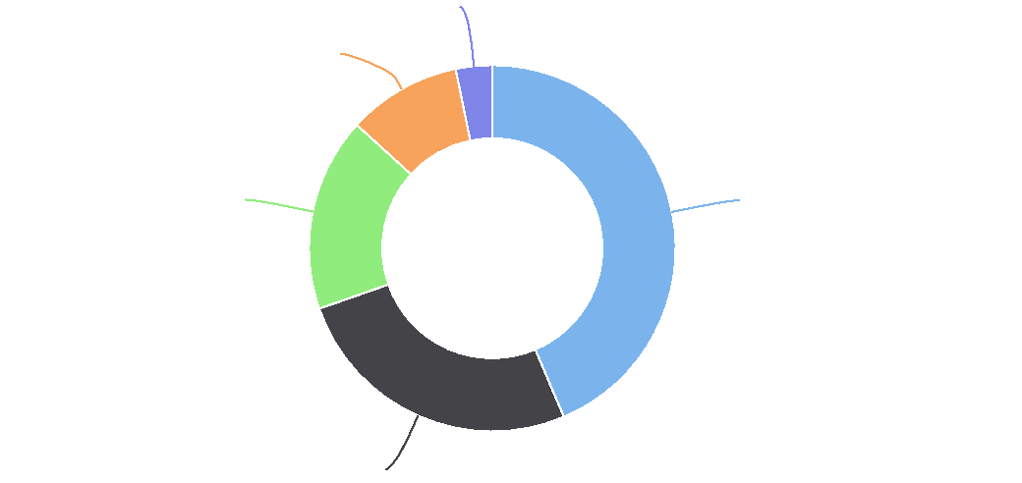

**After 2010:%: 3.2%**

**1960-1979:%: 26.0%**

**1980-1999:%: 17.1%**

**2000-2010:%: 10.0%**

**Before 1960:%: 43.6%**

Owner-Occupied Housing Units by Age, Percentage

Jackson County, IA

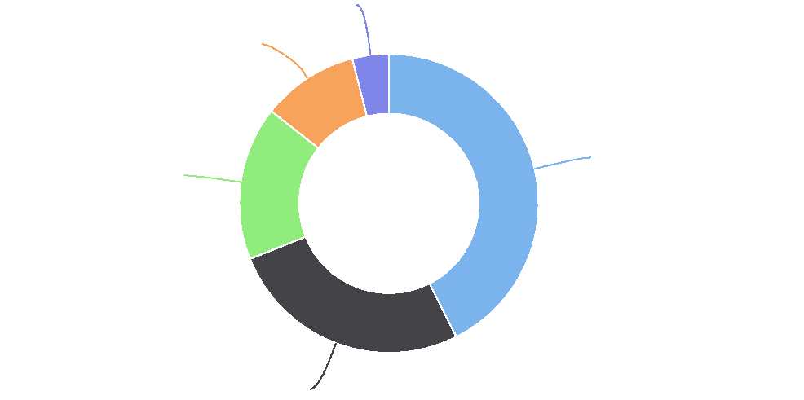

**After 2010: 3.9%**

**1980-1999: 16.6%**

**1960-1979: 26.4%**

**2000-2010: 10.5%**

**Before 1960: 42.6%**

|  |  |  |  |  |  |
| --- | --- | --- | --- | --- | --- |
| **Report Area** | **Before 1960** | **1960‐1979** | **1980‐1999** | **2000‐2010** | **After 2010** |
| Jackson County, IA | 902 | 2,478 | 352 | 104 | 0 |
| Iowa | 131,557 | 345,824 | 76,867 | 33,438 | 19,001 |
| United States | 12,503,162 | 35,470,089 | 11,645,910 | 4,959,712 | 1,946,815 |

Renter‐Occupied Housing Units by Age, Percentage

|  |  |  |  |  |  |
| --- | --- | --- | --- | --- | --- |
| **Report Area** | **Before 1960** | **1960‐1979** | **1980‐1999** | **2000‐2010** | **After 2010** |
| Jackson County, IA | 52.02% | 21.68% | 20.30% | 6.00% | 0.00% |
| Iowa | 36.27% | 28.08% | 21.19% | 9.22% | 5.24% |
| United States | 28.89% | 28.25% | 26.90% | 11.46% | 4.50% |

Renter-Occupied Housing Units by Age, Percentage

Jackson County, IA

## Housing ‐ LIHTC

The Low Income Housing Tax Credit (LIHTC) program gives State and local LIHTC‐allocating agencies the equivalent of nearly $8 billion in annual budget authority to issue tax credits for the acquisition, rehabilitation, or new construction of rental housing targeted to lower‐income households. This indicator reports the total number of housing units benefiting from Low Income Housing Tax Credits.

|  |  |  |
| --- | --- | --- |
| **Report Area** | **LIHTC Properties** | **LIHTC Units** |
| Jackson County, IA | 3 | 64 |
| Iowa | 652 | 25,865 |
| United States | 43,092 | 2,784,155 |

*Data Source:* [*US Department of Housing and Urban Development*](http://portal.hud.gov/hudportal/HUD)*. 2014. Source geography: County*

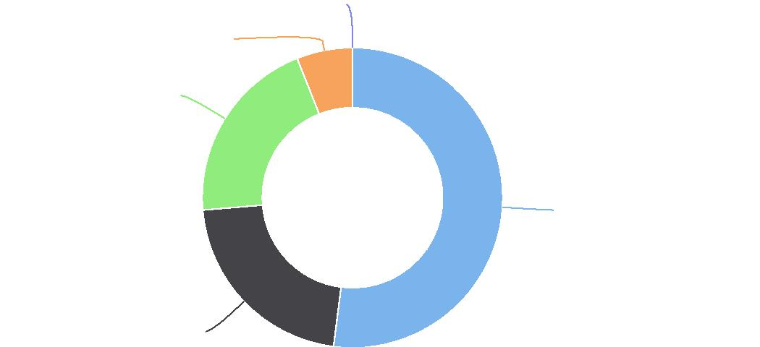

**After 2010:%: 0.0%**

**2000-2010:%: 6.0%**

**1980-1999:%: 20.3%**

**Before 1960:%: 52.0%**

**1960-1979:%: 21.7%**

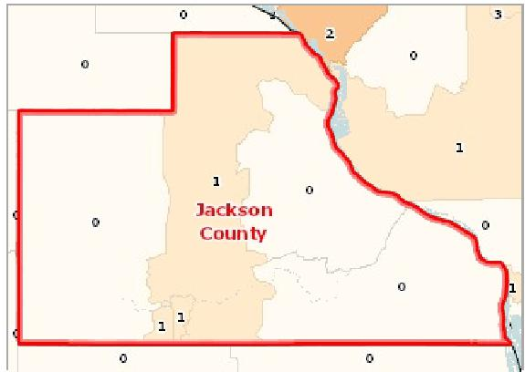

[](https://engagementnetwork.org/map-room/?ids=14551,14549,t11&def=t11:FIPS%20In%20('19097')&bbox=-10120449.27515,5164829.551058,-10034264.57655,5219471.283242) View larger map

**Low Income Housing Tax Credit (LIHTC) Units, Total by Tract, HUD 2014**

Low Income Housing Tax Credit (LIHTC) Units, Total by Tract, HUD 2014 Jackson County, IA



## Housing ‐ Mortgage Lending

Lending institutions must report all loans for home purchases, home improvements, and mortgage refinancing based on the Home Mortgage Disclosure Act (HMDA) of 1975. This indicator displays information derived from the 2014 HMDA loan‐level data files. Within the report area there are 267 home loan originations with an approval rate of 57.17% percent.

|  |  |  |  |  |
| --- | --- | --- | --- | --- |
| **Report Area** | **Total  Population**  **(2010)** | **Home Loan  Originations** | **Home Loans Originations,  Approval Rate** | **Home Loan Originations, Rate per  10,000 Population** |
| Jackson County, IA | 19,848 | 267 | 57.17% | **134.52** |
| Iowa | 3,046,355 | 70,792 | 62.17% | 232.38 |
| United  States | 312,470,869 | 5,959,108 | 51.57% | 190.71 |

*Note: This indicator is compared to the state average.*

*Data Source: Federal Financial Institutions Examination Council,* [*Home Mortgage Disclosure Act*](http://www.ffiec.gov/hmda/hmdaflat.htm)*. Additional data analysis by* [*CARES*](http://cares.missouri.edu)*. 2014. Source geography: Tract*

Home Loan Origination Rate per 10,000 Pop.

|  |  |
| --- | --- |
|  | |
|  | 0 500  Jackson County (134.52)  Iowa (232.38)  United States (190.71) |

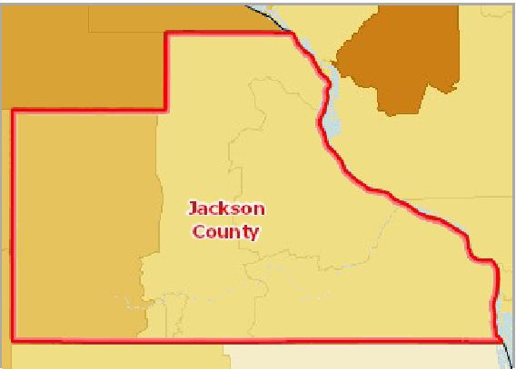

[](https://engagementnetwork.org/map-room/?ids=10229,t11&def=t11:FIPS%20In%20('19097')&bbox=-10120449.27515,5164829.551058,-10034264.57655,5219471.283242) View larger map

**All Home Loan Originations, Rate per 10,000 Population by Tract, HMDA 2014**

Over 360.0

240.1 ‐ 360.0 170.1 ‐ 240.0 100.1 ‐ 170.0 Under 100.0 No Originations Jackson County, IA



Home Purchase Loan Originations by Loan Type

This indicator reports the total number of home purchase loan originations by loan type. Types reported in the HMDA flat files include: Loans insured by the Federal Housing Administration (FHA loans); Loans insured by the Veterans Administration (VA loans); Farm Service Agency / Rural Housing Service loans (FHS/RHS); and Conventional loans (any loan other than FHA, VA, FSA, or RHS).

|  |  |  |  |  |
| --- | --- | --- | --- | --- |
| **Report Area** | **Total Conventional Loans** | **Total FHA Loans** | **Total VA Loans** | **Total FSA/RHA Loans** |
| Jackson County, IA | 211 | 25 | 9 | 22 |
| Iowa | 59,879 | 5,625 | 3,209 | 2,079 |
| United States | 4,544,119 | 787,974 | 491,987 | 135,028 |

Home Purchase Loan Originations by Loan Type

Jackson County, IA

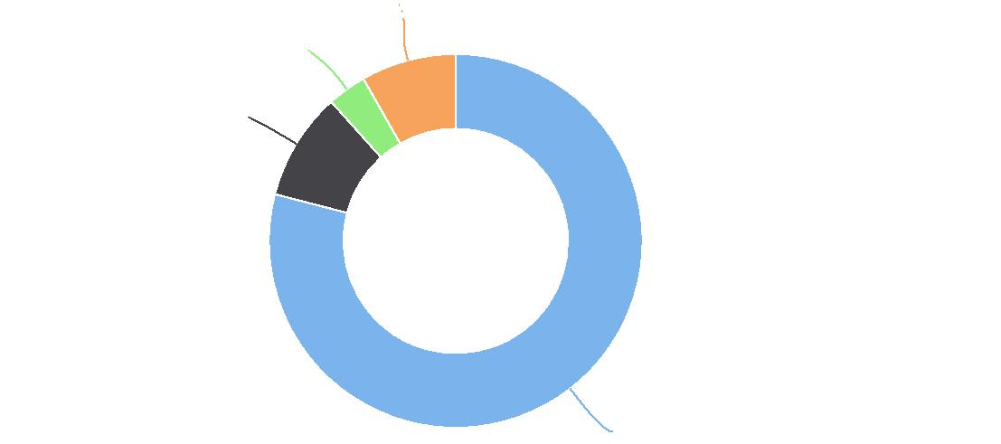

**Total FSA/RHA Loans: 8.2%**

**Total VA Loans: 3.4%**

**Total FHA Loans: 9.4%**

**Total Conventional Loans: 79.0%**

Home Purchase Loan Originations by Loan Amount

This indicator reports the total number and percentage of home purchase loan originations, grouped by loan amount.

|  |  |  |  |  |  |  |  |  |
| --- | --- | --- | --- | --- | --- | --- | --- | --- |
| **Report Area** | **Under**  **$60,000** | **Under**  **$60,000** | **$60,000 ‐**  **$119,999** | **$60,000 ‐**  **$119,999** | **$120,000 ‐**  **$199,999** | **$120,000 ‐**  **$199,999** | **$200,000 or  More** | **$200,000 or  More** |
| Jackson  County, IA | 23 | 19.49% | 57 | 48.31% | 34 | 28.81% | 4 | 3.39% |
| Iowa | 7,556 | 19.21% | 12,588 | 32.01% | 11,624 | 29.56% | 7,556 | 19.21% |
| United States | 203,473 | 6.28% | 618,748 | 19.10% | 966,072 | 29.82% | 1,451,453 | 44.80% |

Home Purchase Loan Originations by Race/Ethnicity

This indicator reports the total number and percentage of home purchase loan originations, grouped by the primary applicant's race and ethnicity. Co‐applicant race and ethnicity is not considered.

|  |  |  |  |  |  |  |  |  |
| --- | --- | --- | --- | --- | --- | --- | --- | --- |
| **Report Area** | **Non‐Hispanic White** | **Non‐Hispanic White** | **Non‐Hispanic Black** | **Non‐Hispanic Black** | **Non‐Hispanic Other** | **Non‐Hispanic  Other** | **Hispanic or  Latino** | **Hispanic or  Latino** |
| Jackson County, IA | 114 | 99.13% | 0 | 0.00% | 0 | 0.00% | 1 | 0.87% |
| Iowa | 33,328 | 93.63% | 378 | 1.06% | 829 | 2.33% | 975 | 2.74% |
| United States | 2,250,318 | 77.28% | 155,681 | 5.35% | 204,727 | 7.03% | 289,036 | 9.93% |

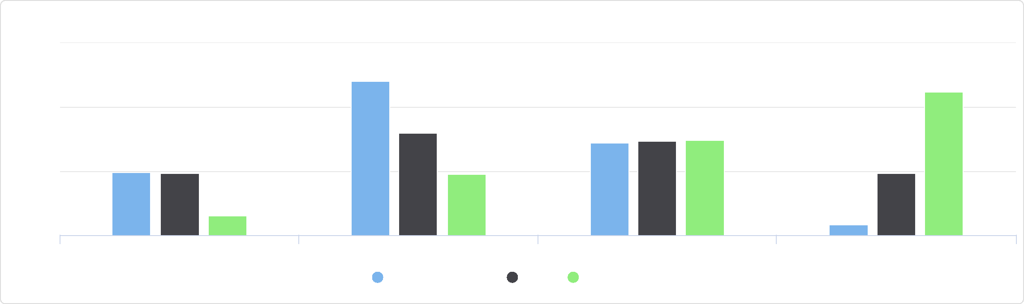

Home Purchase Loan Originations by Loan Amount

60

Under $60,000:% $60,000 - $119,999:% $120,000 - $199,999:% $200,000 or More:%

Jackson County, IA Iowa United States

%

40

20

0

Home Purchase Loan Originations by Race/Ethnicity

125

|  |  |  |  |  |  |  |  |  |  |  |  |
| --- | --- | --- | --- | --- | --- | --- | --- | --- | --- | --- | --- |
|  | 100  75  50  25 |  |  |  |  |  |  |  |  |  |  |
|  |  |  |  |  |  |  |  |  |  |  |
| % |  |  |  |  |  |  |  |  |  |
|  |  |  |  |  |  |  |  |  |  |
|  |  |  |  |  |  |  |  |  |  |
|  |  |  |  |  |  |  |  |  |  |  |
|  | 0 |  |  |  |  |  |  |  |  |  |
|  |  |  |  |  |  |  |  |  |  |  |

Non-Hispanic White:% Non-Hispanic Black:% Non-Hispanic Other:% Hispanic or Latino:%

Jackson County, IA Iowa United States



## Housing ‐ Overcrowded Housing

This indicator reports data on overcrowded housing from the latest 5‐year American Community Survey. The Census Bureau has no official definition of crowded units, but this report considers units with more than one occupant per room to be crowded.

Percentage of Housing Units Overcrowded

|  |  |
| --- | --- |
|  | |
| 0% 10% | |
|  | Jackson County (0.59%)  Iowa (1.77%)  United States (4.37%) |

|  |  |  |  |
| --- | --- | --- | --- |
| **Report Area** | **Total Occupied Housing  Units** | **Overcrowded Housing  Units** | **Percentage of Housing Units  Overcrowded** |
| Jackson County, IA | 8,130 | 48 | **0.59%** |
| Iowa | 1,168,235 | 20,664 | 1.77% |
| United States | 91,831,095 | 4,010,316 | 4.37% |

*Note: This indicator is compared to the state average.*

*Data Source: US Census Bureau,* [*American Community Survey*](http://www.census.gov/acs/www/)*. 2014‐18. Source geography: Tract*

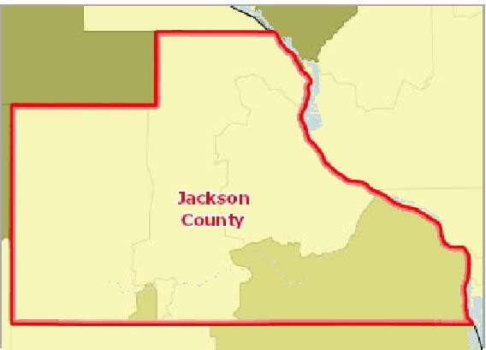

[](https://engagementnetwork.org/map-room/?ids=30589,t11&def=t11:FIPS%20In%20('19097')&bbox=-10120449.27515,5164829.551058,-10034264.57655,5219471.283242) View larger map

**Overcrowded Housing (Over 1 Person/Room), Percent by Tract, ACS 2014‐ 18**

Over 4.0%

2.1 ‐ 4.0%

1.1 ‐ 2.0%

Under 1.1%

No Data or Data Suppressed

Jackson County, IA



## Housing ‐ Substandard Housing

This indicator reports the number and percentage of owner‐ and renter‐occupied housing units having at least one of the following conditions: 1) lacking complete plumbing facilities, 2) lacking complete kitchen facilities, 3) with 1 or more occupants per room, 4) selected monthly owner costs as a percentage of household income greater than 30%, and 5) gross rent as a percentage of household income greater than 30%. Selected conditions provide information in assessing the quality of the housing inventory and its occupants. This data is used to easily identify homes where the quality of living and housing can be considered substandard. Of the 8,236 total occupied housing units in the report area, 1,624 or 19.72% have one or more substandard conditions.

Occupied Housing Units with One   
or More Substandard Conditions,   
Percent

|  |  |
| --- | --- |
|  | |
|  | 0% 50% Jackson County (19.72%) Iowa (23.55%)  United States (32.54%) |

|  |  |  |  |
| --- | --- | --- | --- |
| **Report  Area** | **Total Occupied  Housing Units** | **Occupied Housing Units with One or  More Substandard Conditions** | **Occupied Housing Units with One or More  Substandard Conditions, Percent** |
| Jackson County, IA | 8,236 | 1,624 | **19.72%** |
| Iowa | 1,256,855 | 295,992 | 23.55% |
| United States | 119,730,128 | 38,964,205 | 32.54% |

*Note: This indicator is compared to the state average.*

*Data Source: US Census Bureau,* [*American Community Survey*](http://www.census.gov/acs/www/)*. 2014‐18. Source geography: Tract*

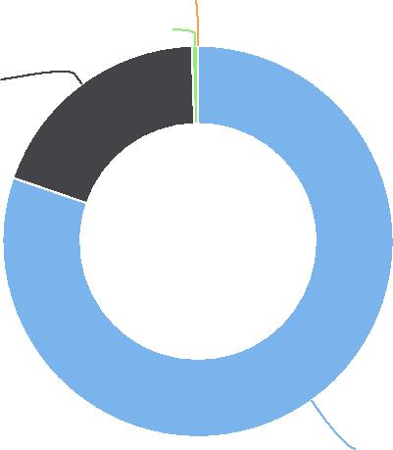

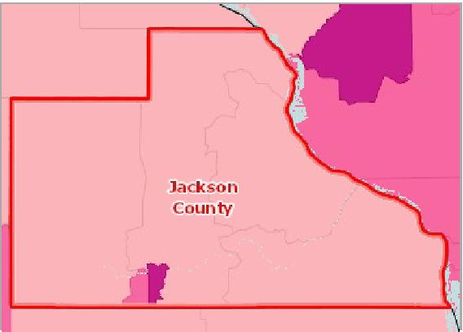

[](https://engagementnetwork.org/map-room/?ids=30481,t11&def=t11:FIPS%20In%20('19097')&bbox=-10120449.27515,5164829.551058,-10034264.57655,5219471.283242) View larger map

**Substandard Housing Units, Percent of Total by Tract, ACS 2014‐18**

Over 34.0%

28.1 ‐ 34.0%

22.1 ‐ 28.0%

Under 22.1%

No Data or Data Suppressed

Jackson County, IA



Substandard Housing: Number of Substandard Conditions Present

|  |  |  |  |  |
| --- | --- | --- | --- | --- |
| **Report Area** | **No Conditions** | **One Condition** | **Two or Three Conditions** | **Four Conditions** |
| Jackson County, IA | 80.28% | 19.22% | 0.50% | 0.00% |
| Iowa | 76.45% | 22.52% | 1.03% | 0.00% |
| United States | 67.46% | 30.62% | 1.91% | 0.01% |

Substandard Housing: Number of Substandard Conditions Present

Jackson County, IA

Substandard Housing: Households Lacking Complete Plumbing Facilities

Complete plumbing facilities include: (a) hot and cold running water, (b) a flush toilet, and (c) a bathtub or shower. All three facilities must be located inside the house, apartment, or mobile home, but not necessarily in the same room. Housing units are classified as lacking complete plumbing facilities when any of the three facilities is not present.

|  |  |  |  |
| --- | --- | --- | --- |
| **Report Area** | **Occupied Housing  Units** | **Housing Units Lacking Complete Plumbing  Facilities** | **Housing Units Lacking Complete Plumbing Facilities,**  **Percent** |
| Jackson County, IA | 8,236 | 13 | 0.16% |
| Iowa | 1,256,855 | 3,527 | 0.28% |
| United States | 119,730,128 | 472,098 | 0.39% |

**Four Conditions: 0.0%**

**Two or Three Conditions: 0.5%**

**One Condition: 19.2%**

**No Conditions: 80.3%**

Substandard Housing: Households Lacking Complete Plumbing Facilities

0.5

0.4

0.3

0.2

0.1

0

%

Housing Units Lacking Complete Plumbing Facilities, Percent

Jackson County, IA Iowa United States



Substandard Housing: Households Lacking Complete Kitchen Facilities

A unit has complete kitchen facilities when it has all three of the following facilities: (a) a sink with a faucet, (b) a stove or range, and (c) a refrigerator. All kitchen facilities must be located in the house, apartment, or mobile home, but they need not be in the same room. A housing unit having only a microwave or portable heating equipment such as a hot plate or camping stove should not be considered as having complete kitchen facilities. An icebox is not considered to be a refrigerator.

|  |  |  |  |
| --- | --- | --- | --- |
| **Report Area** | **Occupied Housing  Units** | **Housing Units Lacking Complete Kitchen  Facilities** | **Housing Units Lacking Complete Kitchen Facilities,**  **Percent** |
| Jackson County, IA | 9,518 | 240 | 2.52% |
| Iowa | 1,386,722 | 35,045 | 2.53% |
| United States | 136,384,292 | 3,867,311 | 2.84% |

Substandard Housing: Households Lacking Telephone Service

A telephone must be in working order and service available in the house, apartment, or mobile home that allows the respondent to both make and receive calls. Households that have cell‐phones (no land‐line) are counted as having telephone service available. Households whose service has been discontinued for nonpayment or other reasons are not counted as having telephone service available.

%

Substandard Housing: Households Lacking Complete Kitchen Facilities

3

2

1

0

Housing Units Lacking Complete Kitchen Facilities, Percent

Jackson County, IA Iowa United States



|  |  |  |  |  |  |  |
| --- | --- | --- | --- | --- | --- | --- |
| **Report Area** | **Housing Units  Lacking Telephone  Service** | **Housing Units  Lacking Telephone  Service** | **Owner‐Occupied  Units Lacking  Telephone Service** | **Owner‐Occupied  Units Lacking  Telephone Service** | **Renter‐Occupied  Units Lacking  Telephone Service** | **Renter‐Occupied Units  Lacking Telephone  Service** |
| Jackson County, IA | 173 | 2.10% | 130 | 2.00% | 43 | 2.48% |
| Iowa | 27,725 | 2.21% | 13,833 | 1.55% | 13,892 | 3.83% |
| United States | 2,607,717 | 2.18% | 1,108,891 | 1.45% | 1,498,826 | 3.46% |

## Housing ‐ Vacancy Rate

This indicator reports the number and percentage of housing units that are vacant. A housing unit is considered vacant by the American Community Survey if no one is living in it at the time of interview. Units occupied at the time of interview entirely by persons who are staying two months or less and who have a more permanent residence elsewhere are considered to be temporarily occupied, and are classified as “vacant.”

Substandard Housing: Households Lacking Telephone Service

5

4

|  |  |  |  |  |  |  |  |  |  |
| --- | --- | --- | --- | --- | --- | --- | --- | --- | --- |
|  | 3 |  |  |  |  |  |  |  |  |
| % |  |  |  |  |  |  |  |
| 2  1  0 |  |  |  |  |  |  |  |
|  |  |  |  |  | |  |
|  |  |  |  |  |
|  |  |  |  |  |  |  |  |  |

Total Units Renter-Occupied Units Owner-Occupied Units

Jackson County, IA Iowa United States



|  |  |  |  |
| --- | --- | --- | --- |
| **Report Area** | **Total Housing Units** | **Vacant Housing Units** | **Vacant Housing Units, Percent** |
| Jackson County, IA | 9,518 | 1,282 | **13.47%** |
| Iowa | 1,386,722 | 129,867 | 9.37% |
| United States | 136,384,292 | 16,654,164 | 12.21% |

*Note: This indicator is compared to the state average.*

*Data Source: US Census Bureau,* [*American Community Survey*](http://www.census.gov/acs/www/)*. 2014‐18. Source geography: Tract*

Vacant Housing Units, Percent

|  |  |
| --- | --- |
|  | |
|  | 0% 20%  Jackson County (13.47%)  Iowa (9.37%)  United States (12.21%) |

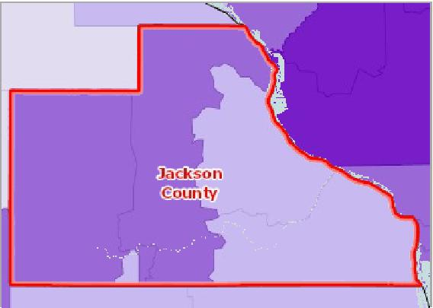

[](https://engagementnetwork.org/map-room/?ids=30594,t11&def=t11:FIPS%20In%20('19097')&bbox=-10120449.27515,5164829.551058,-10034264.57655,5219471.283242) View larger map

**Vacant Housing Units, Percent by Tract, ACS 2014‐18**

Over 20.0%

14.1 ‐ 20.0%

8.1 ‐ 14.0%

Under 8.1%

No Data or Data Suppressed

Jackson County, IA



Vacant Housing Units by Housing Market Classification, Total

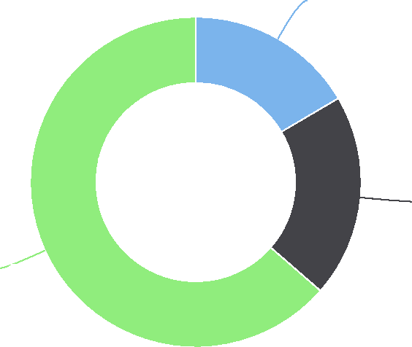

|  |  |  |  |
| --- | --- | --- | --- |
| **Report Area** | **Vacant Housing Units, for Sale** | **Vacant Housing Units, for Rent** | **Vacant Housing Units, for Other Use** |
| Jackson County, IA | 212 | 255 | 815 |
| Iowa | 20,757 | 31,208 | 77,902 |
| United States | 1,958,838 | 3,437,397 | 11,257,929 |

Vacant Housing Units by Housing Market Classification, Total

Jackson County, IA

Vacant Housing Units by Housing Market Classification, Percent

|  |  |  |  |
| --- | --- | --- | --- |
| **Report Area** | **Vacant Housing Units, for Sale** | **Vacant Housing Units, for Rent** | **Vacant Housing Units, for Other Use** |
| Jackson County, IA | 3.16% | 12.82% | 38.87% |
| Iowa | 2.27% | 7.92% | 37.49% |
| United States | 2.50% | 7.36% | 40.33% |

## Liquor Store Access

There are 0 establishments in the report area primarily engaged in retailing packaged alcoholic beverages, such as ale, beer, wine, and liquor. The number of liquor stores per 10,000 population provides a measure of environmental influences on dietary behaviors and the accessibility of healthy foods. Note this data excludes establishments preparing and serving alcohol for consumption on premises (including bars and restaurants) or which sell alcohol as a secondary retail product (including gas stations and grocery stores).

**Vacant Housing Units, for Sale: 16.5%**

**Vacant Housing Units, for Rent: 19.9%**

**Vacant Housing Units, for Other Use: 63.6%**

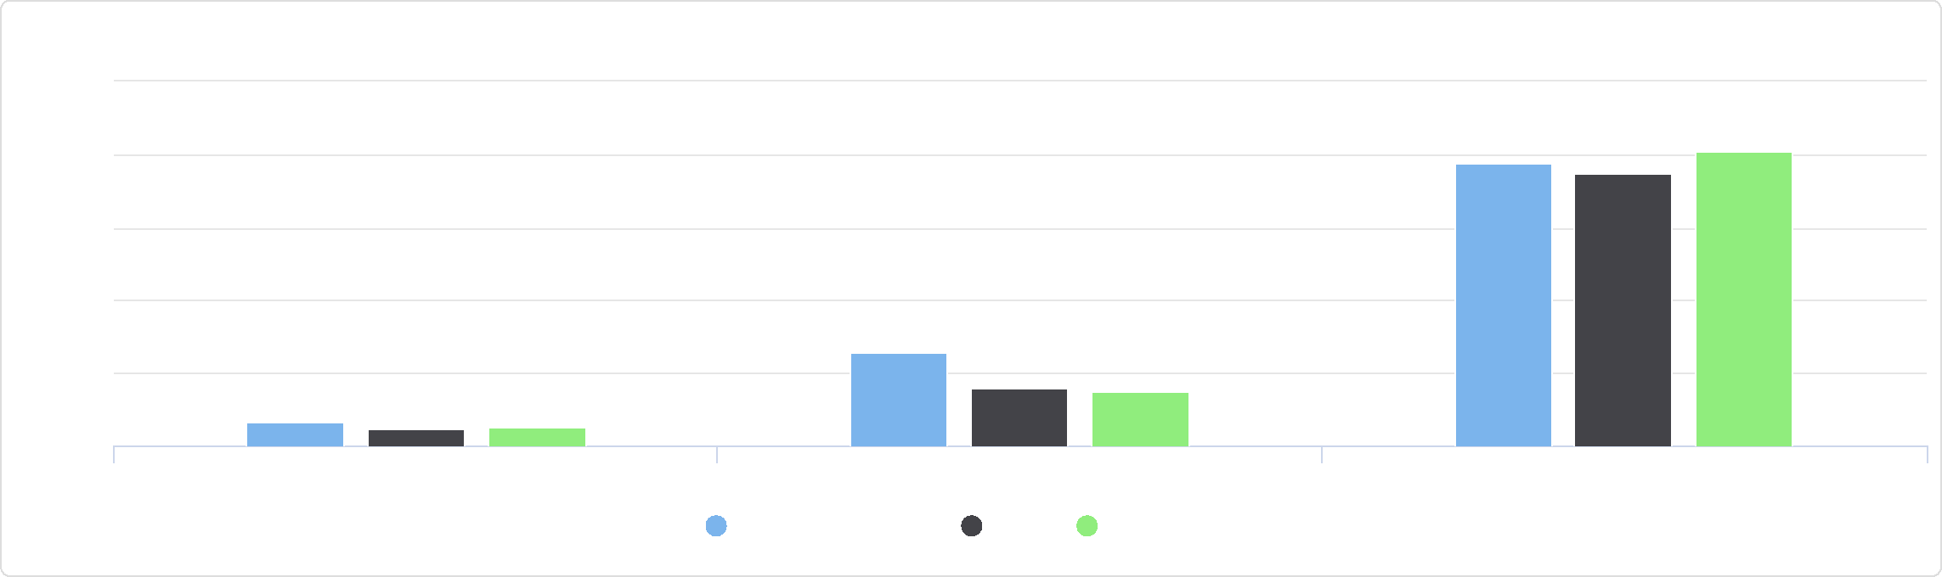

Vacant Housing Units by Housing Market Classification, Percent

50

Vacant Housing Units, for Sale Vacant Housing Units, for Rent Vacant Housing Units, for Other Use

Jackson County, IA Iowa United States

%

40

20

30

10

0

|  |  |  |  |  |  |  |
| --- | --- | --- | --- | --- | --- | --- |
| **Report Area** | **Total Population**  **(2010)** | | **Number of  Establishments** |  | **Establishments, Rate per 10,000 Population** |  |
| Jackson County, IA |  | 19,848 |  | 0 |  | **0.00** |
| Iowa | No data |  | No data |  | No data |  |
| United States | No data |  | No data |  | No data |  |

*Note: This indicator is compared to the state average.*

*Data Source: US Census Bureau,* [*County Business Patterns*](https://www.census.gov/programs-surveys/cbp.html)*. Additional data analysis by* [*CARES*](https://cares.missouri.edu)*. 2018. Source geography: County*

Liquor Stores, Rate per 10,000 Population

|  |  |
| --- | --- |
|  | |
|  | 0 4  Jackson County (0.00)  Iowa (No data)  United States (No data) |

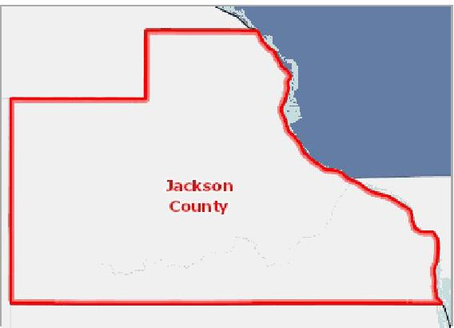

[](https://engagementnetwork.org/map-room/?ids=32659,t11&def=t11:FIPS%20In%20('19097')&bbox=-10120449.27515,5164829.551058,-10034264.57655,5219471.283242) View larger map

**Beer, Wine and Liquor Stores, Rate (Per 100,000 Pop.) by County, CBP 2018**

Over 18.0

12.1 ‐ 18.0

6.1 ‐ 12.0

Under 6.1

No Beer, Wine, or Liquor Stores

Jackson County, IA



Beer, Wine and Liquor Stores,

Rate per 10,000 Population by Year, 2010 through 2017

|  |  |  |  |  |  |  |  |  |
| --- | --- | --- | --- | --- | --- | --- | --- | --- |
| **Report Area** | **2010** | **2011** | **2012** | **2013** | **2014** | **2015** | **2016** | **2017** |
| Jackson County, IA | 1.01 | 1.01 | 0.5 | 0.5 | 0.5 | 0.5 | 0.5 | 0 |
| Iowa | 0.43 | 0.42 | 0.43 | 0.42 | 0.43 | 0.46 | 0.46 | 0.46 |
| United States | 1.02 | 1.03 | 1.05 | 1.06 | 1.08 | 1.09 | 1.1 | 1.12 |

## Recreation and Fitness Facility Access

Access to recreation and fitness facilities encourages physical activity and other healthy behaviors. The report area includes 0 establishments primarily engaged in operating fitness and recreational sports facilities featuring exercise and other active physical fitness conditioning or recreational sports activities, such as swimming, skating, or racquet sports.

Beer, Wine and Liquor Stores,

Rate per 10,000 Population by Year, 2010 through 2017

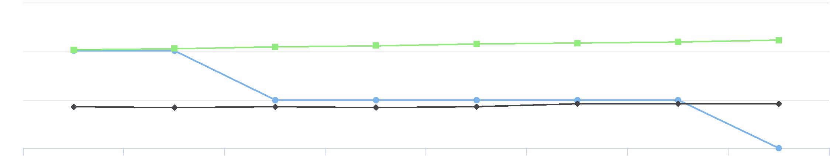

1

0.5

0

2010 2011 2012 2013 2014 2015 2016 2017

1.5



Jackson County, IA Iowa United States



|  |  |  |  |  |  |  |
| --- | --- | --- | --- | --- | --- | --- |
| **Report Area** | **Total Population**  **(2010)** | | **Number of  Establishments** |  | **Establishments, Rate per 10,000 Population** |  |
| Jackson County, IA |  | 19,848 |  | 0 |  | **0.00** |
| Iowa | No data |  | No data |  | No data |  |
| United States | No data |  | No data |  | No data |  |

*Note: This indicator is compared to the state average.*

*Data Source: US Census Bureau,* [*County Business Patterns*](https://www.census.gov/programs-surveys/cbp.html)*. Additional data analysis by* [*CARES*](https://cares.missouri.edu)*. 2018. Source geography: County*

Recreation and Fitness Facilities, Rate per 10,000 Population

|  |  |
| --- | --- |
|  | |
|  | 0 5  Jackson County (0.00) Iowa (No data)  United States (No data) |

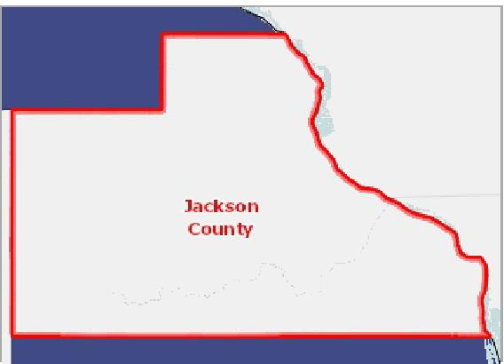

[](https://engagementnetwork.org/map-room/?ids=32658,t11&def=t11:FIPS%20In%20('19097')&bbox=-10120449.27515,5164829.551058,-10034264.57655,5219471.283242) View larger map

**Recreation and Fitness Facilities, Rate (Per 100,000 Pop.) by County, CBP 2018**

Over 12.0

8.1 ‐ 12.0

4.1 ‐ 8.0

Under 4.1

No Fitness and Recreation Centers

Jackson County, IA



Recreation and Fitness Facilities,

Rate per 10,000 Population by Year, 2010 through 2016

|  |  |  |  |  |  |  |  |  |
| --- | --- | --- | --- | --- | --- | --- | --- | --- |
| **Report Area** | **2010** | **2011** | **2012** | **2013** | **2014** | **2015** | **2016** | **2017** |
| Jackson County, IA | 1.01 | 1.01 | 0.5 | 0.5 | 0.5 | 0.5 | 0.5 | 0 |
| Iowa | 1.12 | 1.14 | 1.15 | 1.18 | 1.19 | 1.15 | 1.19 | 1.22 |
| United States | 0.97 | 0.96 | 0.96 | 0.98 | 1.03 | 1.06 | 1.1 | 1.18 |

## Use of Public Transportation

This indicator reports the percentage of population using public transportation as their primary means of commuting to work. Public transportation includes buses or trolley buses, streetcars or trolley cars, subway or elevated rails, and ferryboats.

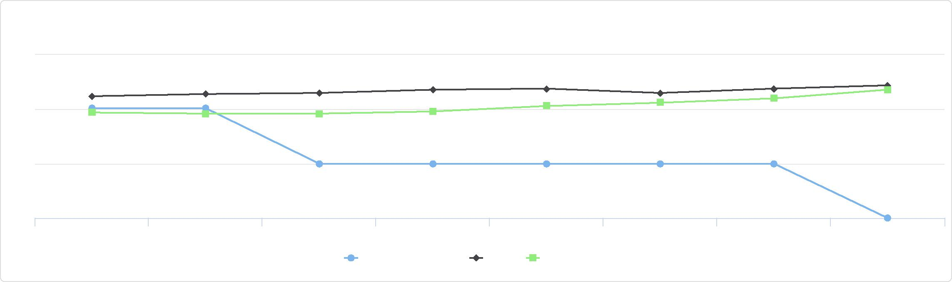

0.5

Recreation and Fitness Facilities,

Rate per 10,000 Population by Year, 2010 through 2016

1

0

2010 2011 2012 2013 2014 2015 2016 2017

Jackson County, IA Iowa United States

1.5

|  |  |  |  |
| --- | --- | --- | --- |
| **Report  Area** | **Total Population  Employed Age 16+** | **Population Using Public Transit for Commute to Work** | **Percent Population Using Public Transit for Commute to Work** |
| Jackson County, IA | 9,394 | 43 | **0.46%** |
| Iowa | 1,583,271 | 17,435 | 1.10% |
| United  States | 150,571,044 | 7,602,145 | 5.05% |

Percent Population Using Public Transit for Commute to Work

|  |  |
| --- | --- |
|  | |
| 0% 10% | |
|  | Jackson County (0.46%)  Iowa (1.10%)  United States (5.05%) |

*Note: This indicator is compared to the state average.*

*Data Source: US Census Bureau,* [*American Community Survey*](http://www.census.gov/acs/www/)*. 2014‐18. Source geography: Tract*

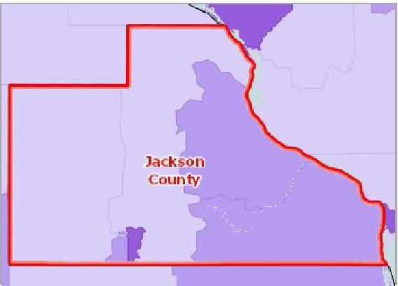

[](https://engagementnetwork.org/map-room/?ids=31446,t11&def=t11:FIPS%20In%20('19097')&bbox=-10120449.27515,5164829.551058,-10034264.57655,5219471.283242) View larger map

Over 4.0%

1.1 ‐ 4.0%

0.1 ‐ 1.0%

No Workers Using Public Transit

No Data or Data Suppressed

Jackson County, IA

**Workers Traveling to Work Using Public Transit, Percent by Tract, ACS 2014‐18**



# Clinical Care

## Access to Dentists

This indicator reports the number of dentists per 100,000 population. This indicator includes all dentists ‐ qualified as having a doctorate in dental surgery (D.D.S.) or dental medicine (D.M.D.), who are licensed by the state to practice dentistry and who are practicing within the scope of that license.

|  |  |  |  |
| --- | --- | --- | --- |
| **Report Area** | **Total Population, 2015** | **Dentists, 2015** | **Dentists, Rate per 100,000 Pop.** |
| Jackson County, IA | 19,444.00 | 10.00 | **51.43** |
| Iowa | 3,123,899.00 | 1,956.00 | 62.60 |
| United States | 321,418,820.00 | 210,832.00 | 65.60 |

*Note: This indicator is compared to the state average.*

*Data Source: US Department of Health & Human Services, Health Resources and Services Administration,* [*Area Health Resource File*](https://datawarehouse.hrsa.gov/topics/ahrf.aspx)*. 2015. Source geography: County*

Dentists, Rate per 100,000 Pop.

|  |  |
| --- | --- |
|  | |
|  | 0 300  Jackson County (51.43)  Iowa (62.60)  United States (65.60) |

**Access to Dentists, Rate per 100,000 Pop. by County, AHRF 2015**

Over 50.0   
35.1 ‐ 50.0   
20.1 ‐ 35.0   
Under 20.1   
No Dentists   
Jackson County, IA



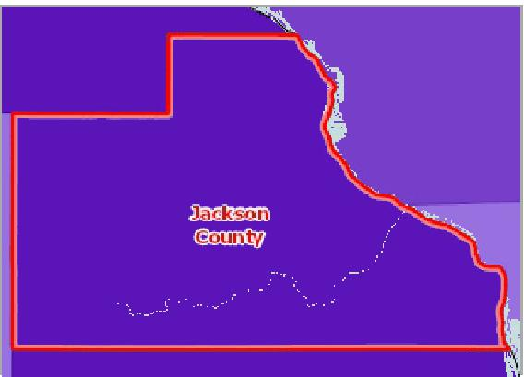

[](https://engagementnetwork.org/map-room/?ids=14792,t11&def=t11:FIPS%20In%20('19097')&bbox=-10120449.27515,5164829.551058,-10034264.57655,5219471.283242) View larger map

Access to Dentists, Rate (Per 100,000 Pop.) by Year, 2010 through 2015

This indicator reports the rate of dentists per 100,000 population by year.

|  |  |  |  |  |  |  |
| --- | --- | --- | --- | --- | --- | --- |
| **Report Area** | **2010** | **2011** | **2012** | **2013** | **2014** | **2015** |
| Jackson County, IA | 45.30 | 45.50 | 50.70 | 51.10 | 51.30 | 51.40 |
| Iowa | 56.70 | 57.90 | 59.40 | 59.90 | 61.40 | 62.60 |
| United States | 58.90 | 60.30 | 61.70 | 63.20 | 64.70 | 65.60 |

## Access to Mental Health Providers

This indicator reports the rate of the county population to the number of mental health providers including psychiatrists, psychologists, clinical social workers, and counsellors that specialize in mental health care.

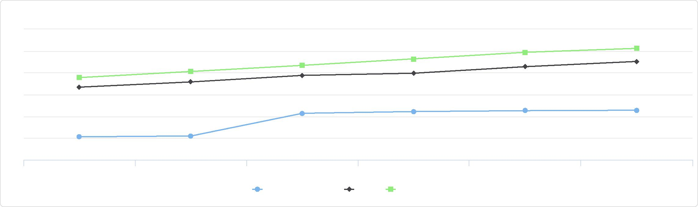

Access to Dentists, Rate (Per 100,000 Pop.) by Year, 2010 through 2015

70

65

60

55

40

2010 2011 2012 2013 2014 2015

Jackson County, IA Iowa United States

50

45

|  |  |  |  |  |
| --- | --- | --- | --- | --- |
| **Report  Area** | **Estimated  Population** | **Number of Mental  Health Providers** | **Ratio of Mental Health  Providers to Population  (1 Provider per x Persons)** | **Mental Health Care Provider Rate (Per 100,000 Population)** |
| Jackson County, IA | 19,432 | 16 | 1,214.5 | **82.3** |
| Iowa | 6,247,325 | 9,854 | 634 | 157.7 |
| United States | 317,105,555.00 | 643,219.00 | 493.00 | 202.80 |

*Note: This indicator is compared to the state average.*

*Data Source: University of Wisconsin Population Health Institute,* [*County Health Rankings*](http://www.countyhealthrankings.org/)*. 2019. Source geography: County*

Mental Health Care Provider Rate (Per 100,000 Population)

|  |  |
| --- | --- |
|  | |
| 0 250 | |
|  | Jackson County (82.3)  Iowa (157.7)  United States (202.80) |

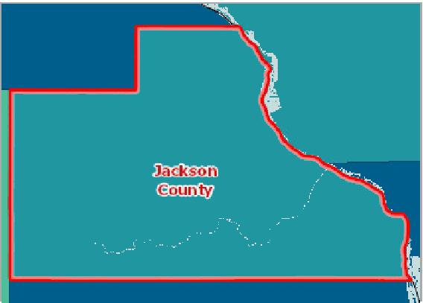

[](https://engagementnetwork.org/map-room/?ids=32167,t11&def=t11:FIPS%20In%20('19097')&bbox=-10120449.27515,5164829.551058,-10034264.57655,5219471.283242) View larger map

**Access to Mental Health Care Providers, Rate Per 100,000 Pop. by County, CHR 2019**

Over 120.0

55.1 ‐ 120.0

30.1 ‐ 55.0

Under 30.1

No Data or Data Suppressed

Jackson County, IA



## Access to Primary Care

This indicator reports the number of primary care physicians per 100,000 population. Doctors classified as "primary care physicians" by the AMA include: General Family Medicine MDs and DOs, General Practice MDs and DOs, General Internal Medicine MDs and General Pediatrics MDs. Physicians age 75 and over and physicians practicing sub‐specialties within the listed specialties are excluded. This indicator is relevant because a shortage of health professionals contributes to access and

health status issues.

Within the report area there are 7 primary care physicians serving a population of 19,368. This means there is a rate of 36.14 primary care physicians for every 100,000 people.

|  |  |  |  |
| --- | --- | --- | --- |
| **Report Area** | **Total Population**  **(2017)** | **Primary Care Physicians**  **(2017)** | **Primary Care Physicians, Rate per 100,000**  **Pop.** |
| Jackson County, IA | 19,368 | 7 | **36.14** |
| Iowa | 3,143,637 | 2,293 | 72.9 |
| United States | 325,147,121 | 249,103 | 76.6 |

*Note: This indicator is compared to the state average.*

*Data Source: US Department of Health & Human Services, Health Resources and Services Administration,* [*Area Health Resource File*](https://datawarehouse.hrsa.gov/topics/ahrf.aspx)*. 2017. Source geography: County*

Primary Care Providers, Rate per 100,000 Population

|  |  |
| --- | --- |
|  | |
|  | 0 300  Jackson County (36.14)  Iowa (72.9)  United States (76.6) |

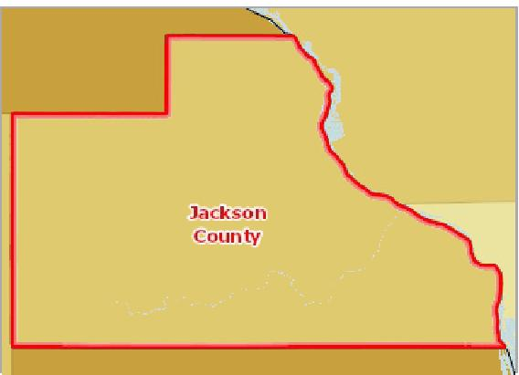

[](https://engagementnetwork.org/map-room/?ids=14785,t11&def=t11:FIPS%20In%20('19097')&bbox=-10120449.27515,5164829.551058,-10034264.57655,5219471.283242) View larger map

Over 80.0

60.1 ‐ 80.0

40.1 ‐ 60.0

Under 40.1

No Primary Care Physicians or No Data

Jackson County, IA

**Access to Primary Care Physicians, Rate per 100,000 Pop. by County, AHRF 2014**



Access to Primary Care, Rate (Per 100,000 Pop.) by Year, 2004 through 2014

This indicator reports the rate of primary care physicians per 100,000 population by year.

|  |  |  |  |  |  |  |  |  |  |  |  |
| --- | --- | --- | --- | --- | --- | --- | --- | --- | --- | --- | --- |
| **Report Area** | **2004** | **2005** | **2006** | **2007** | **2008** | **2009** | **2010** | **2011** | **2012** | **2013** | **2014** |
| Jackson County, IA | 39.48 | 39.34 | 44.36 | 39.93 | 30.05 | 40.55 | 50.38 | 50.52 | 50.73 | 51.05 | 46.20 |
| Iowa | 61.13 | 59.64 | 59.86 | 60.31 | 60.55 | 72.11 | 82.72 | 81.77 | 82.56 | 84.23 | 84.03 |
| United States | 80.76 | 80.94 | 80.54 | 80.38 | 80.16 | 82.22 | 84.57 | 85.83 | 86.66 | 87.76 | 87.77 |

## Cancer Screening ‐ Mammogram

This indicator reports the percentage of female Medicare beneficiaries age 35 and older who had a mammogram in most recent reporting year. The American Cancer Society recommends that women age 45 to 54 should get a mammogram every

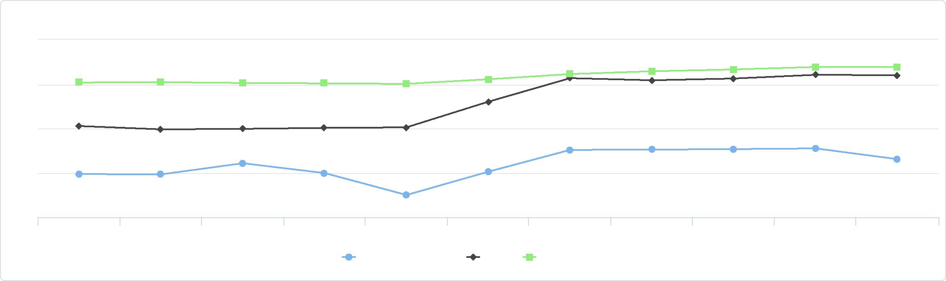

Access to Primary Care, Rate (Per 100,000 Pop.) by Year, 2004 through 2014

100

80

60

40

20

2004 2005 2006 2007 2008 2009 2010 2011 2012 2013 2014

Jackson County, IA Iowa United States

year, and women age 55 and older should get a mammogram every other year. In the latest reporting period there were 3,204 Medicare beneficiaries in the report area, and 36% of female beneficiaries age 35 or older had a mammogram in the past year. The rate in the report area was lower than the state rate of 39% during the same time period.

|  |  |  |
| --- | --- | --- |
| **Report Area** | **Medicare Beneficiaries** | **Female Beneficiaries with Recent Mammogram, Percent** |
| Jackson County, IA | 3,204 | **36%** |
| Iowa | 462,029 | 39% |
| United States | 33,648,235 | 32% |

*Note: This indicator is compared to the state average.*

*Data Source: Centers for Medicare and Medicaid Services,* [*Mapping Medicare Disparities Tool*](https://data.cms.gov/mapping-medicare-disparities)*. 2017. Source geography: County*

Percentage of Female Medicare   
Beneficiaries Age 35+ with Recent   
Mammogram

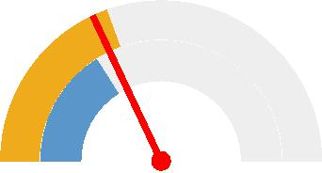

0% 100%

Jackson County, IA (36%) Iowa (39%)

United States (32%)



**Mammogram, Medicare Beneficiaries, Percent of Medicare Beneficiaries by County, CMS 2017**

Over 36%

31 ‐ 36%

25 ‐ 30%

Under 25%

No Data or Data Suppressed

Jackson County, IA

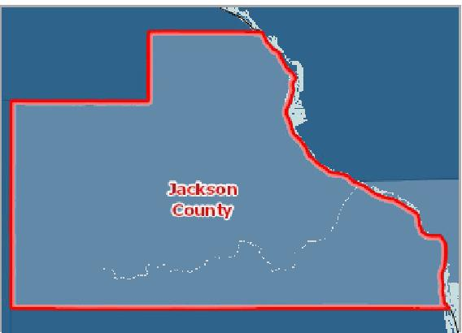

[](https://engagementnetwork.org/map-room/?ids=32584,t11&def=t11:FIPS%20In%20('19097')&bbox=-10120449.27515,5164829.551058,-10034264.57655,5219471.283242) View larger map



Breast Cancer Screening by Year

The table and chart below display local, state, and national trends in annual breast exam rates among female Medicare beneficiaries age 35 and older.

|  |  |  |  |  |  |  |
| --- | --- | --- | --- | --- | --- | --- |
| **Report Area** | **2012** | **2013** | **2014** | **2015** | **2016** | **2017** |
| Jackson County, IA | 36% | 39% | 36% | 35% | 37% | 36% |
| Iowa | 37% | 38% | 37% | 37% | 38% | 39% |
| United States | 32% | 32% | 31% | 32% | 32% | 32% |

## Cancer Screening ‐ Pap Test

This indicator reports the percentage of women aged 18 and older who self‐report that they have had a Pap test in the past three years. This indicator is relevant because engaging in preventive behaviors allows for early detection and treatment of health problems. This indicator can also highlight a lack of access to preventive care, a lack of health knowledge, insufficient

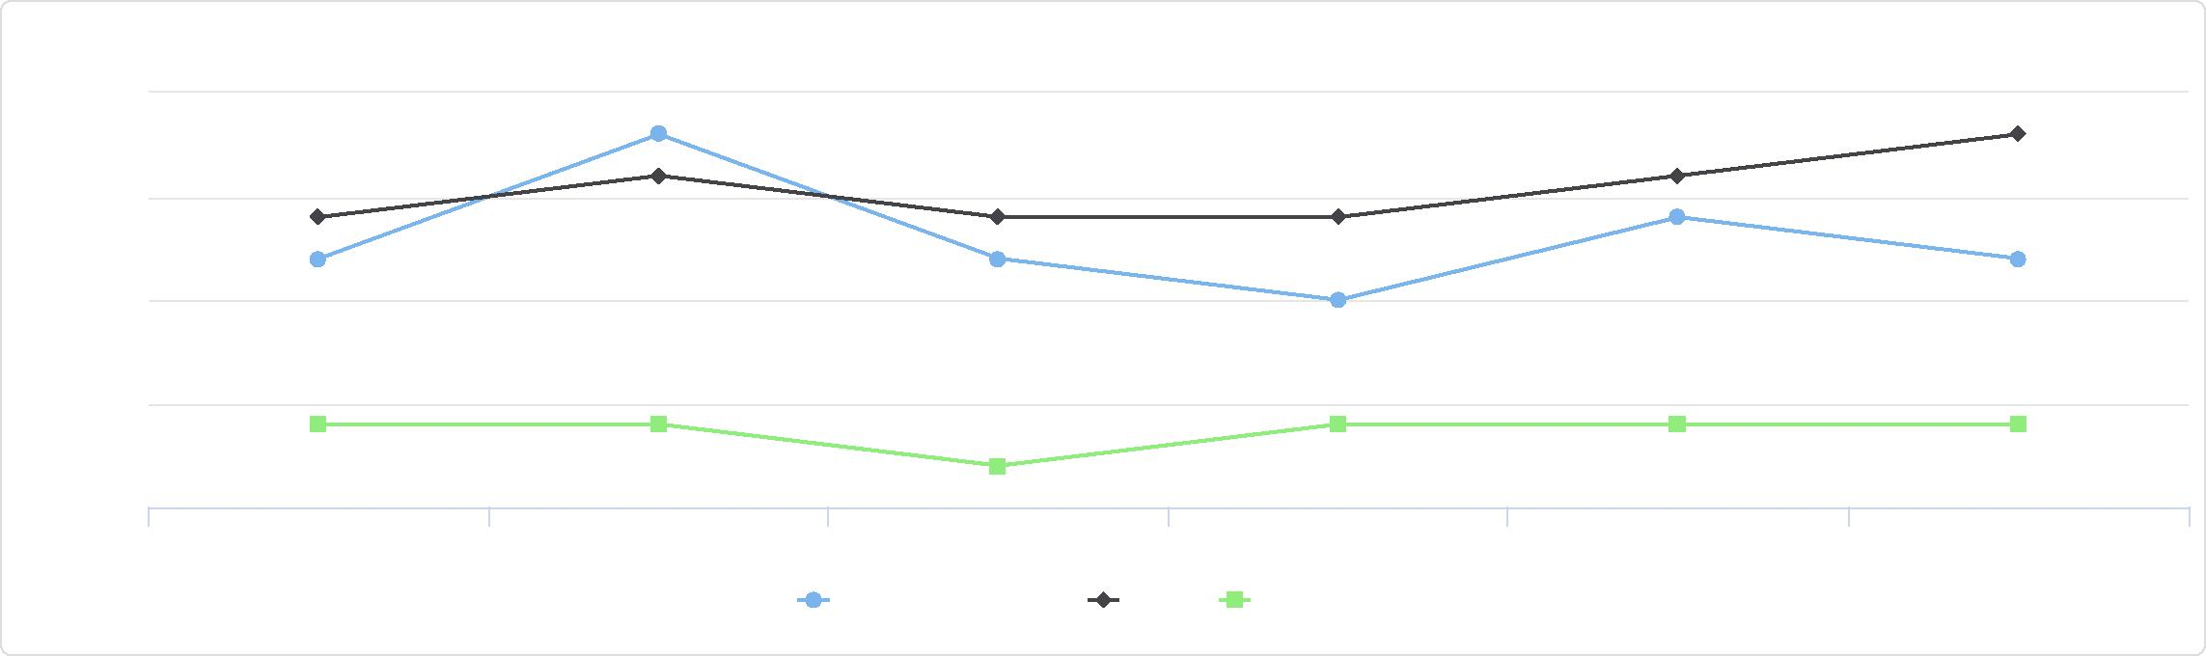

%

35

Breast Cancer Screening by Year

37.5

32.5

30

2012 2013 2014 2015 2016 2017

Jackson County, IA Iowa United States

40

## Dental Care Utilization

provider outreach, and/or social barriers preventing utilization of services.

|  |  |  |  |  |
| --- | --- | --- | --- | --- |
| **Report Area** | **Female Population  Age 18+** | **Estimated Number with Regular  Pap Test** | **Crude  Percentage** | **Age‐Adjusted  Percentage** |
| Jackson  County, IA | 14,980.00 | 11,684 | 78.00% | **79.80%** |
| Iowa | 2,151,841.00 | 1,665,525 | 77.40% | 79.50% |
| United States | 176,847,182.00 | 137,191,142 | 77.60% | 78.50% |

Percent Adults Females Age 18+   
with Regular Pap Test   
(Age-Adjusted)

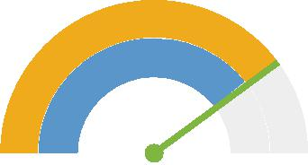

0% 100%

Jackson County (79.80%)

Iowa (79.50%)

United States (78.50%)



*Note: This indicator is compared to the state average.*

*Data Source: Centers for Disease Control and Prevention,* [*Behavioral Risk Factor Surveillance System*](http://www.cdc.gov/brfss/)*. Accessed via the* [*Health Indicators Warehouse*](http://healthindicators.gov)*. US Department of Health & Human*

*Services,* [*Health Indicators Warehouse*](https://healthdata.gov/dataset/health-indicators-warehouse)*. 2006‐12. Source geography: County*

**Cervical Cancer Screening (Past 3 Years), Percent of Women Age 18+ by County, BRFSS 2006‐12**

Over 84.0%

80.1 ‐ 84.0%

76.1 ‐ 80.0%

Under 76.1%

No Data or Data Suppressed

Jackson County, IA

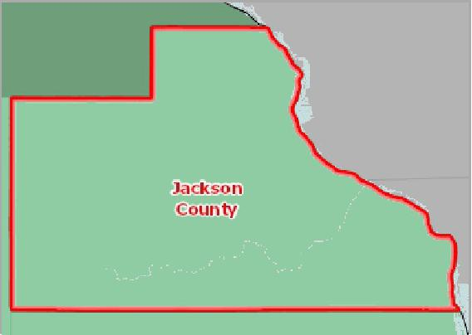

[](https://engagementnetwork.org/map-room/?ids=5449,t11&def=t11:FIPS%20In%20('19097')&bbox=-10120449.27515,5164829.551058,-10034264.57655,5219471.283242) View larger map



## Cancer Screening ‐ Sigmoidoscopy or Colonoscopy

This indicator reports the percentage of adults 50 and older who self‐report that they have ever had a sigmoidoscopy or colonoscopy. This indicator is relevant because engaging in preventive behaviors allows for early detection and treatment of health problems. This indicator can also highlight a lack of access to preventive care, a lack of health knowledge, insufficient provider outreach, and/or social barriers preventing utilization of services.

|  |  |  |  |  |
| --- | --- | --- | --- | --- |
| **Report Area** | **Total Population  Age 50+** | **Estimated Population Ever Screened for  Colon Cancer** | **Crude  Percentage** | **Age‐Adjusted  Percentage** |
| Jackson  County, IA | 6,306.00 | 3,796 | 60.20% | **54.10%** |
| Iowa | 812,983.00 | 517,870 | 63.70% | 60.00% |
| United States | 75,116,406.00 | 48,549,269 | 64.60% | 61.30% |

Percent Adults Screened for Colon

Cancer

(Age-Adjusted)

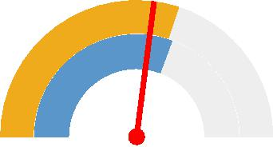

0% 100%

Jackson County (54.10%) Iowa (60.00%)

United States (61.30%)



*Note: This indicator is compared to the state average.*

*Data Source: Centers for Disease Control and Prevention,* [*Behavioral Risk Factor Surveillance System*](http://www.cdc.gov/brfss/)*. Accessed via the* [*Health Indicators Warehouse*](http://healthindicators.gov)*. US Department of Health & Human*

*Services,* [*Health Indicators Warehouse*](https://healthdata.gov/dataset/health-indicators-warehouse)*. 2006‐12. Source geography: County*

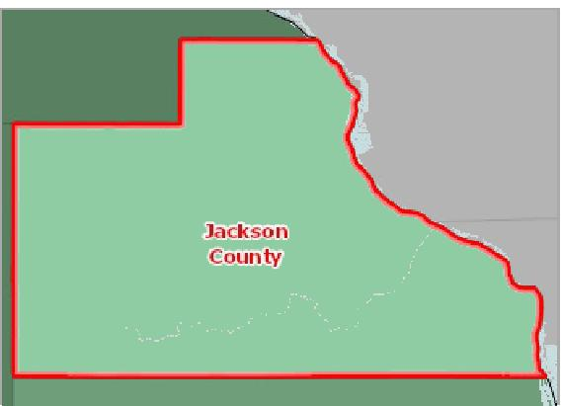

[](https://engagementnetwork.org/map-room/?ids=5447,t11&def=t11:FIPS%20In%20('19097')&bbox=-10120449.27515,5164829.551058,-10034264.57655,5219471.283242) View larger map

**Colon Cancer Screening (Ever), Percent of Adults Age 50+ by County, BRFSS 2006‐12**

Over 62.0%

55.1 ‐ 62.0%

48.1 ‐ 55.0%

Under 48.1%

No Data or Data Suppressed

Jackson County, IA



This indicator reports the percentage of adults aged 18 and older who self‐report that they have not visited a dentist, dental hygienist or dental clinic within the past year. This indicator is relevant because engaging in preventive behaviors decreases the likelihood of developing future health problems. This indicator can also highlight a lack of access to preventive care, a lack of health knowledge, insufficient provider outreach, and/or social barriers preventing utilization of services.

|  |  |  |  |
| --- | --- | --- | --- |
| **Report Area** | **Total  Population  (Age 18+)** | **Total Adults Without Recent Dental**  **Exam** | **Percent Adults with No Dental**  **Exam** |
| Jackson County, IA | 15,248.00 | 2,440.00 | **16.0%** |
| Iowa | 2,307,562.00 | 591,664.00 | 25.6% |
| United States | 235,375,690.00 | 70,965,788.00 | 30.2% |

*Note: This indicator is compared to the state average.*

*Data Source: Centers for Disease Control and Prevention,* [*Behavioral Risk Factor Surveillance System*](http://www.cdc.gov/brfss/)*. Additional data analysis by* [*CARES*](http://cares.missouri.edu)*. 2006‐10. Source geography: County*

Percent Adults Without Recent Dental Exam

|  |  |
| --- | --- |
|  | |
| 0% 50% | |
|  | Jackson County (16.0%)  Iowa (25.6%)  United States (30.2%) |

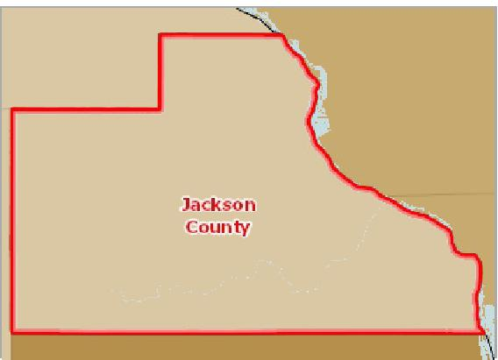

[](https://engagementnetwork.org/map-room/?ids=346,t11&def=t11:FIPS%20In%20('19097')&bbox=-10120449.27515,5164829.551058,-10034264.57655,5219471.283242) View larger map

**Adults Age 18+ Without Dental Exam in Past 12 Months, Percent by County, BRFSS 2006‐10**

Over 42.0%

34.1 ‐ 42.0%

26.1 ‐ 34.0%

Under 26.1%

No Data or Data Suppressed

Jackson County, IA



Adults Without Recent Dental Exam by Gender

|  |  |  |  |  |
| --- | --- | --- | --- | --- |
| **Report Area** | **Total Male** | **Total Female** | **Percent Male** | **Percent Female** |
| Iowa | 322,311 | 262,928 | 29.16% | 22.29% |
| United States | 36,311,042 | 34,083,921 | 32.30% | 28.12% |

*Note: No county data available. See data source and methodology for more details.*

Adults Without Recent Dental Exam by Race / Ethnicity, Percent

Adults Without Recent Dental Exam by Gender

40

30

20

10

0

%

Percent Male Percent Female

Iowa United States



|  |  |  |  |  |
| --- | --- | --- | --- | --- |
| **Report Area** | **Non‐Hispanic White** | **Non‐Hispanic Black** | **Non‐Hispanic Other Race** | **Hispanic or Latino** |
| Iowa | 24.65% | 43.24% | 33.13% | 41.12% |
| United States | 26.96% | 38.11% | 29.23% | 38.33% |

*Note: No county data available. See data source and methodology for more details.*

## Diabetes Management ‐ Hemoglobin A1c Test

This indicator reports the percentage of diabetic Medicare patients who have had a hemoglobin A1c (hA1c) test, a blood test which measures blood sugar levels, administered by a health care professional in the past year. In the report area, 263 Medicare enrollees with diabetes have had an annual exam out of 290 Medicare enrollees in the report area with diabetes, or 90.7%. This indicator is relevant because engaging in preventive behaviors allows for early detection and treatment of health problems. This indicator can also highlight a lack of access to preventive care, a lack of health knowledge, insufficient provider outreach, and/or social barriers preventing utilization of services.

Adults Without Recent Dental Exam by Race / Ethnicity, Percent

60

|  |  |  |  |  |  |
| --- | --- | --- | --- | --- | --- |
|  | 40  20  0 |  |  |  |  |
| % |  |  |  |
|  |  |  |
|  |  |  |  |  |

Non-Hispanic White Non-Hispanic Black Non-Hispanic Other Race Hispanic or Latino

Iowa United States



Medicare Enrollees with Diabetes with Annual Exam, Percent

|  |  |
| --- | --- |
|  | |
| 0% 100% | |
|  | Jackson County (90.7%)  Iowa (90.2%)  United States (85.7%) |

|  |  |  |  |  |
| --- | --- | --- | --- | --- |
| **Report  Area** | **Total  Medicare  Enrollees** | **Medicare Enrollees with Diabetes** | **Medicare Enrollees with  Diabetes with Annual Exam** | **Medicare Enrollees with Diabetes with Annual Exam, Percent** |
| Jackson County, IA | 2,858 | 290 | 263 | **90.7%** |
| Iowa | 385,061 | 37,861 | 34,152 | 90.2% |
| United States | 26,937,083 | 2,919,457 | 2,501,671 | 85.7% |

*Note: This indicator is compared to the state average.*

*Data Source: Dartmouth College Institute for Health Policy & Clinical Practice,* [*Dartmouth Atlas of Health Care*](http://www.dartmouthatlas.org/)*. 2015. Source geography: County*

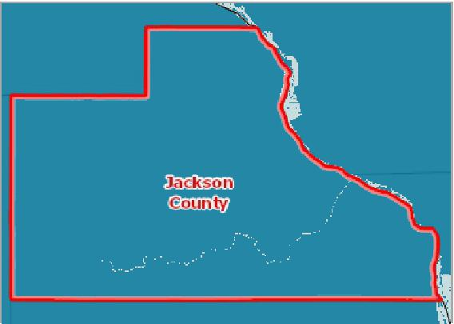

[](https://engagementnetwork.org/map-room/?ids=21676,t11&def=t11:FIPS%20In%20('19097')&bbox=-10120449.27515,5164829.551058,-10034264.57655,5219471.283242) View larger map

**Patients with Annual HA1C Test (Diabetes), Percent of Medicare Enrollees with Diabetes by County, Dartmouth Atlas 2015**

Over 88.0%

84.1 ‐ 88.0%

80.1 ‐ 84.0%

Under 80.1%

No Data or Data Suppressed

Jackson County, IA



Annual Hemoglobin A1c Test by Year, 2009 through 2015

Percent of Medicare Beneficiaries with Diabetes with Annual Hemoglobin A1c Test

|  |  |  |  |  |  |  |  |
| --- | --- | --- | --- | --- | --- | --- | --- |
| **Report Area** | **2009** | **2010** | **2011** | **2012** | **2013** | **2014** | **2015** |
| Jackson County, IA | 94.65 | 90.71 | 88.86 | 89.34 | 92.06 | 92.35 | 90.69 |
| Iowa | 89.26 | 89.22 | 89.45 | 89.43 | 82.07 | 90.17 | 90.21 |
| United States | 83.52 | 83.81 | 84.18 | 84.57 | 84.92 | 85.16 | 85.69 |

## Facilities Designated as Health Professional Shortage Areas

This indicator reports the number and location of health care facilities designated as "Health Professional Shortage Areas" (HPSAs), defined as having shortages of primary medical care, dental or mental health providers. This indicator is relevant because a shortage of health professionals contributes to access and health status issues.

|  |  |  |  |  |
| --- | --- | --- | --- | --- |
| **Report Area** | **Primary Care Facilities** | **Mental Health Care Facilities** | **Dental Health Care Facilities** | **Total HPSA Facility Designations** |
| Jackson County, IA | 0 | 0 | 0 | 0 |
| Iowa | 69 | 57 | 59 | 185 |
| United States | 3,979 | 3,617 | 3,432 | 11,028 |

*Data Source: US Department of Health & Human Services, Health Resources and Services Administration,* [*Health Resources and Services Administration*](http://hpsafind.hrsa.gov/)*. February 2019. Source geography: Address*

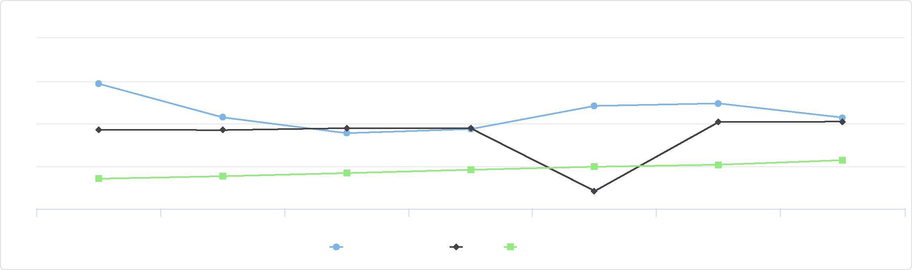

Annual Hemoglobin A1c Test by Year, 2009 through 2015

100

95

90

85

2009 2010 2011 2012 2013 2014 2015

Jackson County, IA Iowa United States

80

**Facilities Designated as HPSAs, HRSA HPSA Database February 2019**

Primary Care   
Mental Health   
Dental Health   
Jackson County, IA



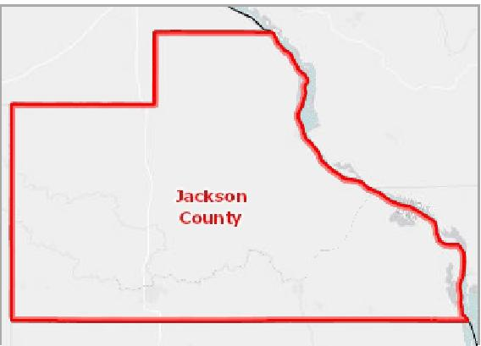

[](https://engagementnetwork.org/map-room/?ids=24885,t11&def=t11:FIPS%20In%20('19097')&bbox=-10120449.27515,5164829.551058,-10034264.57655,5219471.283242) View larger map

## Federally Qualified Health Centers

This indicator reports the number of Federally Qualified Health Centers (FQHCs) in the community. This indicator is relevant because FQHCs are community assets that provide health care to vulnerable populations; they receive extra funding from the federal government to promote access to ambulatory care in areas designated as medically underserved.

Within the report area, there are 0 Federally Qualified Heath Centers. When adjusted to a standard population, there is a rate of 0.00 Federally Qualified Health Centers for every 100,000 persons.

|  |  |  |  |
| --- | --- | --- | --- |
| **Report Area** | **Total Population**  **(2010)** | **Number of Federally Qualified  Health Centers** | **Rate of Federally Qualified Health Centers per  100,000 Population** |
| Jackson County, IA | 19,848 | 0 | **0.00** |
| Iowa | 3,046,355 | 78 | 2.56 |
| United States | 312,471,327 | 9,365 | 3.00 |

*Note: This indicator is compared to the state average.*

*Data Source: US Department of Health & Human Services, Center for Medicare & Medicaid Services,* [*Provider of Services File*](https://www.cms.gov/Research-Statistics-Data-and-Systems/Downloadable-Public-Use-Files/Provider-of-Services/index.html)*. September 2020. Source geography: Address*

Federally Qualified Health   
Centers, Rate per 100,000   
Population

|  |  |
| --- | --- |
|  | |
| 0 3 | |
|  | Jackson County (0.00)  Iowa (2.56)  United States (3.00) |

**Federally Qualified Health Centers, POS September 2020**

Federally Qualified Health Centers, POS September 2020 Jackson County, IA



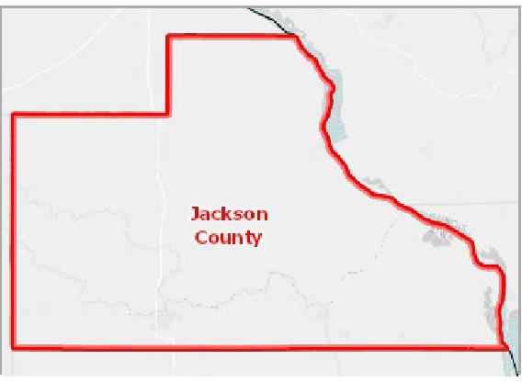

[](https://engagementnetwork.org/map-room/?ids=17723,t11&def=t11:FIPS%20In%20('19097')&bbox=-10120449.27515,5164829.551058,-10034264.57655,5219471.283242) View larger map

## High Blood Pressure Management

This indicator is relevant because engaging in preventive behaviors decreases the likelihood of developing future health problems. When considered with other indicators of poor health, this indicator can also highlight a lack of access to preventive care, a lack of health knowledge, insufficient provider outreach, and/or social barriers preventing utilization of services.

|  |  |  |  |  |  |
| --- | --- | --- | --- | --- | --- |
| **Report Area** | **Total  Population  (Age 18+)** | **Total Adults Not Taking Blood Pressure Medication (When Needed)** | | **Percent Adults Not Taking  Medication** | |
| Jackson  County, IA | 15,248.00 | No data |  | No data |  |
| Iowa | 2,307,562.00 |  | 441,847.00 |  | 19.1% |
| United States | 235,375,690.00 |  | 51,175,402.00 |  | 21.7% |

*Note: This indicator is compared to the state average.*

*Data Source: Centers for Disease Control and Prevention,* [*Behavioral Risk Factor Surveillance System*](http://www.cdc.gov/brfss/)*. Additional data analysis by* [*CARES*](http://cares.missouri.edu)*. 2006‐10. Source geography: County*

Percent Adults with High Blood Pressure Not Taking Medication

|  |  |
| --- | --- |
|  | |
| 0% 50% | |
|  | Iowa (19.1%)  United States (21.7%) |

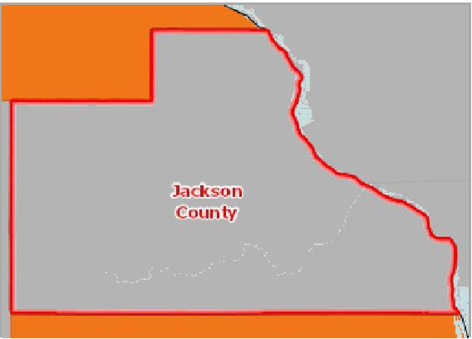

[](https://engagementnetwork.org/map-room/?ids=339,t11&def=t11:FIPS%20In%20('19097')&bbox=-10120449.27515,5164829.551058,-10034264.57655,5219471.283242) View larger map

**Adults Age 18+ with High Blood Pressure, Not Taking Medication, Percent by County, BRFSS 2006‐10**

Over 25.0%

20.0 ‐ 25.0%

15.0 ‐ 19.9%

Under 15.0%

No Data or Data Suppressed

Jackson County, IA



Adults Not Taking Medicine for High Blood Pressure, Percent by Race / Ethnicity

|  |  |  |  |  |
| --- | --- | --- | --- | --- |
| **Report Area** | **Non‐Hispanic White** | **Non‐Hispanic Black** | **Non‐Hispanic Other Race** | **Hispanic or Latino** |
| Iowa | 18.54% | 26.74% | 22.01% | 41.41% |
| United States | 19.66% | 18.65% | 28.31% | 34.86% |

*Note: No county data available. See data source and methodology for more details.*

## HIV Screenings

This indicator reports the percentage of adults age 18‐70 who self‐report that they have never been screened for HIV. This indicator is relevant because engaging in preventive behaviors allows for early detection and treatment of health problems. This indicator can also highlight a lack of access to preventive care, a lack of health knowledge, insufficient provider outreach, and/or social barriers preventing utilization of services.

Adults Not Taking Medicine for High Blood Pressure, Percent by Race / Ethnicity

50

|  |  |  |  |  |  |  |  |
| --- | --- | --- | --- | --- | --- | --- | --- |
|  | 40 30 20 10  0 |  |  |  |  |  |  |
|  |  |  |  |  |  |
| % |  |  |  |  |  |
|  |  |  |  |  |
|  |  |  |  |
|  |  |  |  |  |  |  |

Non-Hispanic White Non-Hispanic Black Non-Hispanic Other Race Hispanic or Latino

Iowa United States



Percent Adults Never Screened for HIV / AIDS

|  |  |
| --- | --- |
|  | |
|  | 0% 100%  Jackson County (79.02%)  Iowa (73.82%)  United States (62.79%) |

|  |  |  |  |
| --- | --- | --- | --- |
| **Report Area** | **Survey  Population  (Adults Age  18+)** | **Total Adults Never Screened for HIV /**  **AIDS** | **Percent Adults Never Screened for HIV /**  **AIDS** |
| Jackson County, IA | 20,146 | 15,920 | **79.02%** |
| Iowa | 2,165,379 | 1,598,389 | 73.82% |
| United States | 214,984,421 | 134,999,025 | 62.79% |

*Note: This indicator is compared to the state average.*

*Data Source: Centers for Disease Control and Prevention,* [*Behavioral Risk Factor Surveillance System*](http://www.cdc.gov/brfss/)*. Additional data analysis by* [*CARES*](http://cares.missouri.edu)*. 2011‐12. Source geography: County*

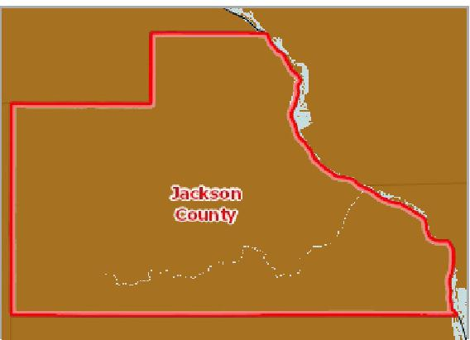

[](https://engagementnetwork.org/map-room/?ids=6341,t11&def=t11:FIPS%20In%20('19097')&bbox=-10120449.27515,5164829.551058,-10034264.57655,5219471.283242) View larger map

**Adults Age 18+ Never Screened for HIV / AIDS, Percent by County, BRFSS 2011‐12**

Over 76.1%

68.1 ‐ 76.0%

60.1 ‐ 68.0%

Under 60.1%

No Data or Data Suppressed

Jackson County, IA



Adults Never Screened for HIV / AIDS, Percent by Race / Ethnicity

|  |  |  |  |  |
| --- | --- | --- | --- | --- |
| **Report Area** | **Non‐Hispanic White** | **Non‐Hispanic Black** | **Non‐Hispanic Other Race** | **Hispanic or Latino** |
| Iowa | 75.42% | 37.62% | 71.90% | 59.79% |
| United States | 68.19% | 38.56% | 67.84% | 56.71% |

*Note: No county data available. See data source and methodology for more details.*

## Lack of a Consistent Source of Primary Care

This indicator reports the percentage of adults aged 18 and older who self‐report that they do not have at least one person who they think of as their personal doctor or health care provider. This indicator is relevant because access to regular primary care is important to preventing major health issues and emergency department visits.

Adults Never Screened for HIV / AIDS, Percent by Race / Ethnicity

100

|  |  |  |  |  |  |  |  |  |  |  |  |
| --- | --- | --- | --- | --- | --- | --- | --- | --- | --- | --- | --- |
|  | 75  50  25  0 |  |  |  |  |  |  |  |  |  |  |
| % |  |  | |  |  |  |  |  |  |  |
|  |  |  |  |  |  |
|  |  |  |  |  |  |
|  |  |  |  |  |  |  |  |  |  |  |

Non-Hispanic White Non-Hispanic Black Non-Hispanic Other Race Hispanic or Latino

Iowa United States



Percent Adults Without Any Regular Doctor

|  |  |
| --- | --- |
|  | |
|  | 0% 40%  Jackson County (25.73%)  Iowa (17.93%)  United States (22.07%) |

|  |  |  |  |
| --- | --- | --- | --- |
| **Report Area** | **Survey  Population  (Adults Age 18+)** | **Total Adults Without Any Regular**  **Doctor** | **Percent Adults Without Any Regular**  **Doctor** |
| Jackson County, IA | 21,881 | 5,629 | **25.73%** |
| Iowa | 2,312,665 | 414,647 | 17.93% |
| United States | 236,884,668 | 52,290,932 | 22.07% |

*Note: This indicator is compared to the state average.*

*Data Source: Centers for Disease Control and Prevention,* [*Behavioral Risk Factor Surveillance System*](http://www.cdc.gov/brfss/)*. Additional data analysis by* [*CARES*](http://cares.missouri.edu)*. 2011‐12. Source geography: County*

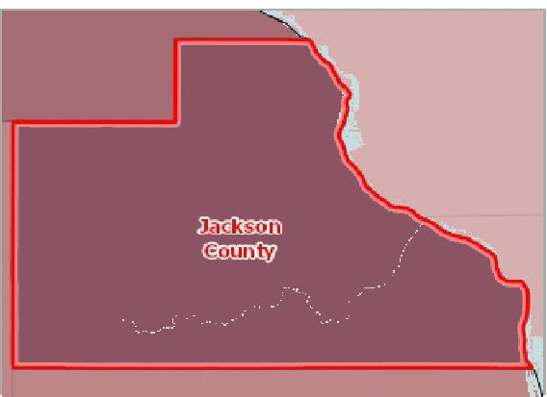

[](https://engagementnetwork.org/map-room/?ids=6372,t11&def=t11:FIPS%20In%20('19097')&bbox=-10120449.27515,5164829.551058,-10034264.57655,5219471.283242) View larger map

**No Consistent Source of Primary Care, Percentage of Adults Age 18+ by County, BRFSS 2011‐12**

Over 25.0%

19.1 ‐ 25.0%

13.1 ‐ 19.0%

Under 13.1%

No Data or Data Suppressed

Jackson County, IA



Adults Without a Consistent Source of Primary Care, Percent by Race / Ethnicity

|  |  |  |  |  |
| --- | --- | --- | --- | --- |
| **Report Area** | **Non‐Hispanic White** | **Non‐Hispanic Black** | **Non‐Hispanic Other Race** | **Hispanic or Latino** |
| Iowa | 15.94% | 35.94% | 35.31% | 42.31% |
| United States | 17.15% | 25.28% | 25.47% | 38.58% |

*Note: No county data available. See data source and methodology for more details.*

Adults Without a Consistent Source of Primary Care, Percent by Race / Ethnicity

## Lack of Prenatal Care

This indicator reports the percentage of women who do not obtain prenatal care during their first trimester of pregnancy. This indicator is relevant because engaging in prenatal care decreases the likelihood of maternal and infant health risks. This indicator can also highlight a lack of access to preventive care, a lack of health knowledge, insufficient provider outreach, and/or social barriers preventing utilization of services.

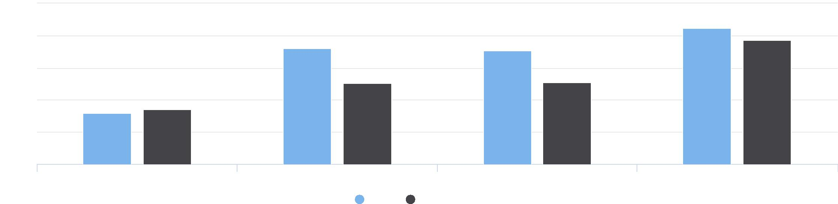

50

Non-Hispanic White Non-Hispanic Black Non-Hispanic Other Race Hispanic or Latino

Iowa United States

40

30

%

20

10

0

Percentage Mothers with Late or No Prenatal Care

|  |  |
| --- | --- |
|  | |
| 0% 50% | |
|  | Iowa (25.40%)  United States (17.30%) |

|  |  |  |  |  |  |  |  |  |
| --- | --- | --- | --- | --- | --- | --- | --- | --- |
| **Report  Area** | **Total  Births** | **Mothers Starting  Prenatal Care in First  Semester** | | **Mothers with Late or No Prenatal Care** | | **Prenatal Care Not Reported** | **Percentage Mothers with Late or No Prenatal Care** | |
| Jackson County, IA | No data | No data |  | No data |  | No data | Suppressed |  |
| Iowa | 159,530 |  | 116,207 |  | 40,489 | 2,834 |  | 25.40% |
| United States | 16,693,978 |  | 7,349,554 |  | 2,880,098 | 6,464,326 |  | 17.30% |

*Note: This indicator is compared to the state average.*

[*Data Source: Centers for Disease Control and Prevention,*](http://wonder.cdc.gov/) *National Vital Statistics System. Accessed via CDC WONDER. Centers for Disease Control and Prevention, Wide‐Ranging Online Data*

[*for Epidemiologic Research.*](http://wonder.cdc.gov/) *2007‐10. Source geography: County*

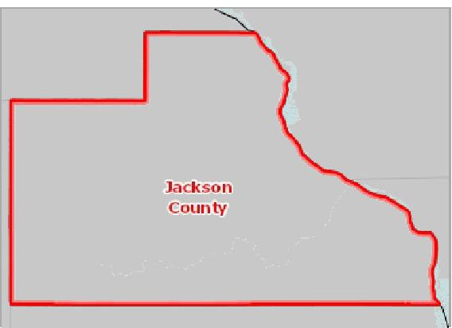

[](https://engagementnetwork.org/map-room/?ids=1112,t11&def=t11:FIPS%20In%20('19097')&bbox=-10120449.27515,5164829.551058,-10034264.57655,5219471.283242) View larger map

**Mothers with Late or No Pre‐Natal Care, Percent by County, NVSS 2007‐10**

Over 35.0%

25.1 ‐ 35.0%

15.1 ‐ 25.0%

Under 15.1%

No Data or Data Suppressed

Jackson County, IA



## Pneumonia Vaccination

This indicator reports the percentage of adults aged 65 and older who self‐report that they have ever received a pneumonia vaccine. This indicator is relevant because engaging in preventive behaviors decreases the likelihood of developing future health problems. This indicator can also highlight a lack of access to preventive care, a lack of health knowledge, insufficient provider outreach, and/or social barriers preventing utilization of services.

|  |  |  |  |  |
| --- | --- | --- | --- | --- |
| **Report Area** | **Total Population  Age 65+** | **Estimated Population with Annual  Pneumonia Vaccination** | **Crude  Percentage** | **Age‐Adjusted  Percentage** |
| Jackson County, IA | 3,676.00 | 2,481 | 67.50% | **65.40%** |
| Iowa | 450,318.00 | 316,574 | 70.30% | 69.90% |
| United States | 39,608,820.00 | 26,680,462 | 67.40% | 67.50% |

Percent Population Age 65+ with   
Pneumonia Vaccination   
(Age-Adjusted)

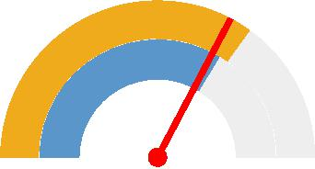

0% 100%

Jackson County (65.40%)

Iowa (69.90%)

United States (67.50%)



*Note: This indicator is compared to the state average.*

*Data Source: Centers for Disease Control and Prevention,* [*Behavioral Risk Factor Surveillance System*](http://www.cdc.gov/brfss/)*. Accessed via the* [*Health Indicators Warehouse*](http://healthindicators.gov)*. US Department of Health & Human*

*Services,* [*Health Indicators Warehouse*](https://healthdata.gov/dataset/health-indicators-warehouse)*. 2006‐12. Source geography: County*

**Annual Pneumonia Vaccination, Percent of Adults Age 65+ by County, BRFSS 2006‐12**

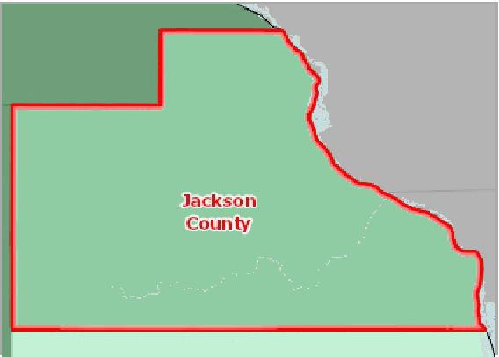

[](https://engagementnetwork.org/map-room/?ids=5443,t11&def=t11:FIPS%20In%20('19097')&bbox=-10120449.27515,5164829.551058,-10034264.57655,5219471.283242) View larger map

Over 72.0%

68.1 ‐ 72.0%

64.1 ‐ 68.0%

Under 64.1%

No Data or Data Suppressed

Jackson County, IA



## Population Living in a Health Professional Shortage Area

This indicator reports the percentage of the population that is living in a geographic area designated as a "Health Professional Shortage Area" (HPSA), defined as having a shortage of primary medical care, dental or mental health professionals. This indicator is relevant because a shortage of health professionals contributes to access and health status issues.

|  |  |  |  |  |
| --- | --- | --- | --- | --- |
| **Report Area** | **Total Population (ACS  2017 5‐Year  Estimates)** | **Population Living in an  Area Affected by a  HPSA** | **Percentage of Population Living in an Area Affected by a**  **HPSA** | **Percentage of HPSA  Population  Underserved** |
| Jackson County, IA | 19,395 | 19,236 | **99.2%** | 14.5% |
| Iowa | 3,132,499 | 639,502 | 20.4% | 43.5% |
| United States | 322,903,030 | 74,701,828 | 23.1% | 53.7% |

*Note: This indicator is compared to the state average.*

*Data Source: US Department of Health & Human Services, Health Resources and Services Administration,* [*Health Resources and Services Administration*](http://hpsafind.hrsa.gov/)*. February 2019. Source geography:*

*HPSA*

Percentage of Population Living in an Area Affected by a HPSA

|  |  |
| --- | --- |
|  | |
| 0% 100% | |
|  | Jackson County (99.2%)  Iowa (20.4%)  United States (23.1%) |

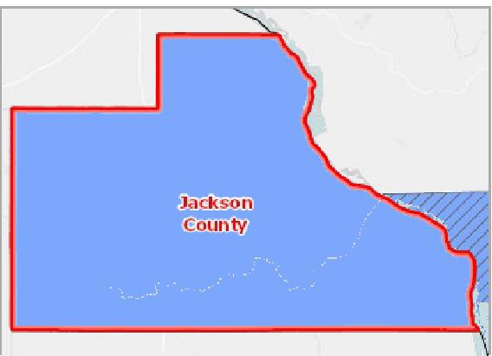

[](https://engagementnetwork.org/map-room/?ids=24884,t11&def=t11:FIPS%20In%20('19097')&bbox=-10120449.27515,5164829.551058,-10034264.57655,5219471.283242) View larger map

Population Group; Over 20.0 FTE Needed Population Group; 1.1 ‐ 20.0 FTE Needed Population Group; Under 1.1 FTE Needed Geographic Area; Over 20.0 FTE Needed Geographic Area; 1.1 ‐ 20.0 FTE Needed Geographic Area; Under 1.1 FTE Needed Jackson County, IA

**Primary Care HPSA Components, Type and Degree of Shortage by Tract / County, HRSA HPSA Database February 2019**



## Preventable Hospital Events

This indicator reports the preventable hospitalization rate among Medicare beneficiaries for the latest reporting period.

Preventable hospitalizations include hospital admissions for one or more of the following conditions: diabetes with short‐term complications, diabetes with long‐term complications, uncontrolled diabetes without complications, diabetes with lower‐ extremity amputation, chronic obstructive pulmonary disease, asthma, hypertension, heart failure, bacterial pneumonia, or urinary tract infection. Rates are presented per 100,000 beneficiaries. In the latest reporting period there were 3,204 Medicare beneficiaries in the report area. The preventable hospitalization rate was 5,494. The rate in the report area was higher than the state rate of 3,711 during the same time period.

|  |  |  |
| --- | --- | --- |
| **Report Area** | **Medicare Beneficiaries** | **Preventable Hospitalizations, Rate per 100,000 Beneficiaries** |
| Jackson County, IA | 3,204 | **5,494** |
| Iowa | 462,029 | 3,711 |
| United States | 33,648,235 | 4,624 |

*Note: This indicator is compared to the state average.*

*Data Source: Centers for Medicare and Medicaid Services,* [*Mapping Medicare Disparities Tool*](https://data.cms.gov/mapping-medicare-disparities)*. 2017. Source geography: County*

Preventable Hospital Events, Rate per 100,000 Beneficiaries

|  |  |
| --- | --- |
|  | |
|  | 0 6000  Jackson County (5,494)  Iowa (3,711)  United States (4,624) |

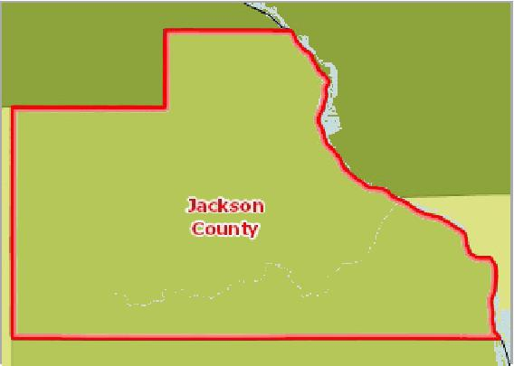

[](https://engagementnetwork.org/map-room/?ids=32588,t11&def=t11:FIPS%20In%20('19097')&bbox=-10120449.27515,5164829.551058,-10034264.57655,5219471.283242) View larger map

**Preventable Hospitalization, Medicare Beneficiaries, Rate by County, CMS 2017**

Over 6000

4801 ‐ 6000

3601 ‐ 4800

Under 3601

No Data or Data Suppressed

Jackson County, IA



Preventable Hospitalization Rate by Year

The table and chart below display local, state, and national trends in preventable hospitalization rates among Medicare beneficiaries.

|  |  |  |  |  |  |  |
| --- | --- | --- | --- | --- | --- | --- |
| **Report Area** | **2012** | **2013** | **2014** | **2015** | **2016** | **2017** |
| Jackson County, IA | 4,618 | 4,484 | 3,833 | 4,682 | 5,068 | 5,494 |
| Iowa | 4,304 | 4,039 | 3,823 | 3,618 | 3,679 | 3,711 |
| United States | 5,060 | 4,758 | 4,523 | 4,192 | 4,598 | 4,624 |

Preventable Hospitalization Rate by Race and Ethnicity

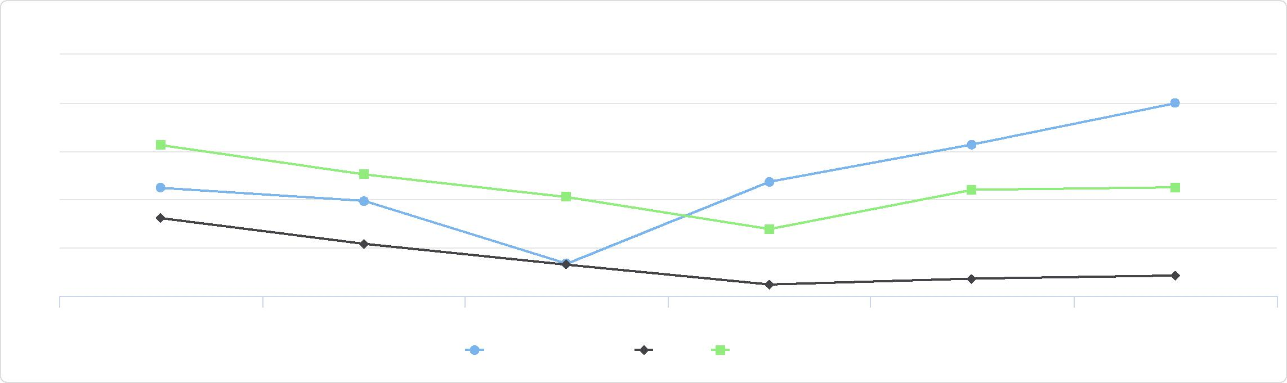

Preventable Hospitalization Rate by Year

6000

5500

5000

4500

4000

3500

2012 2013 2014 2015 2016 2017

Jackson County, IA Iowa United States

The table and chart below display local, state, and national trends in preventable hospitalization rates among Medicare beneficiaries for the latest report year (2017) by patient race and ethnicity.

|  |  |  |  |  |
| --- | --- | --- | --- | --- |
| **Report Area** | **Non‐Hispanic White** |  | **Black or African American** | **Hispanic or Latino** |
| Jackson County, IA | 5,529 | No data |  | 26,829 |
| Iowa | 3,675 |  | 6,840 | 5,525 |
| United States | 4,447 |  | 6,961 | 4,699 |

## Recent Primary Care Visit

This indicator reports the number and percentage of adults age 18 and older with one or more visits to a doctor for routine checkup within the past one year. Data for this indicator is only available for the population within the top 500 most populous cities across the United States. County, State, and National values represent the population within those cities, and not the total US population.

Preventable Hospitalization Rate by Race and Ethnicity

30k

20k

10k

0

Non-Hispanic White Black or African American Hispanic or Latino

Jackson County, IA Iowa United States



Percentage of Adults with Routine Checkup in Past 1 Year

|  |  |
| --- | --- |
|  | |
| 0% 70% | |
|  | Iowa (68.1%)  United States (68.5%) |

|  |  |  |  |  |
| --- | --- | --- | --- | --- |
| **Report Area** | **Total Population**  **(2010)** | **Total Population in the 500  Cities (2010)** | **Percentage of Adults with Routine Checkup in Past 1 Year** | |
| Jackson  County, IA | 19,848 | 0 | No data |  |
| Iowa | 3,046,355.00 | 648,396 |  | 68.1% |
| United States | 308,745,538 | 103,020,808 |  | 68.5% |

*Note: This indicator is compared to the state average.*

*Data Source: Centers for Disease Control and Prevention,* [*Behavioral Risk Factor Surveillance System*](http://www.cdc.gov/brfss/)*. Accessed via the* [*500 Cities Data Portal*](https://chronicdata.cdc.gov/health-area/500-cities)*. 2017. Source geography: Tract*



[](https://engagementnetwork.org/map-room/?ids=32636,t11&def=t11:FIPS%20In%20('19097')&bbox=-10120449.27515,5164829.551058,-10034264.57655,5219471.283242) View larger map

**Primary Care Physician Visit, Percent of Adults Seen in Past 1 Year by Tract, BRFSS 500 Cities Project 2017**

Over 73.0%

67.1% ‐ 73.0%

61.1% ‐ 67.0%

Under 61.1%

No Data or Data Suppressed

Jackson County, IA



# Health Behaviors

## Alcohol Consumption

This indicator reports the percentage of adults aged 18 and older who self‐report heavy alcohol consumption (defined as more than two drinks per day on average for men and one drink per day on average for women). This indicator is relevant because current behaviors are determinants of future health and this indicator may illustrate a cause of significant health issues, such as cirrhosis, cancers, and untreated mental and behavioral health needs. Within the report area, 25.00% adults drink excessively.

Excessive Drinking, Age-Adjusted Percentage

|  |  |
| --- | --- |
|  | |
|  | 0% 50%  Jackson County (25.00%)  Iowa (21.40%)  United States (16.90%) |

|  |  |  |  |  |
| --- | --- | --- | --- | --- |
| **Report Area** | **Population Age**  **18+** | **Estimated Adults  Drinking Excessively** | **Excessive Drinking,  Crude Percentage** | **Excessive Drinking, Age‐  Adjusted Percentage** |
| Jackson County, IA | 15,242.00 | 3,856 | 25.30% | **25.00%** |
| Iowa | 2,307,562.00 | 463,820 | 20.10% | 21.40% |
| United  States | 232,556,016.00 | 38,248,349 | 16.40% | 16.90% |

*Note: This indicator is compared to the state average.*

*Data Source: Centers for Disease Control and Prevention,* [*Behavioral Risk Factor Surveillance System*](http://www.cdc.gov/brfss/)*. Accessed via the* [*Health Indicators Warehouse*](http://healthindicators.gov)*. US Department of Health & Human*

*Services,* [*Health Indicators Warehouse*](https://healthdata.gov/dataset/health-indicators-warehouse)*. 2006‐12. Source geography: County*

**Excessive Drinking, Percent of Adults Age 18+ by County, BRFSS 2006‐12**

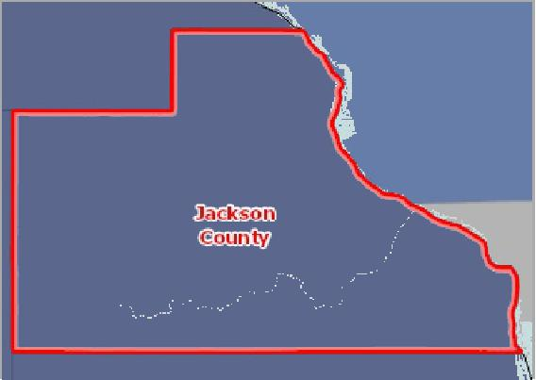

[](https://engagementnetwork.org/map-room/?ids=5453,t11&def=t11:FIPS%20In%20('19097')&bbox=-10120449.27515,5164829.551058,-10034264.57655,5219471.283242) View larger map

Over 22.0%

18.1 ‐ 22.0%

14.1 ‐ 18.0%

Under 14.1%

No Data or Data Suppressed

Jackson County, IA



## Alcohol Expenditures

This indicator reports estimated annual expenditures for alcoholic beverages purchased at home, as a percentage of total household expenditures. This indicator is relevant because current behaviors are determinants of future health and this indicator may illustrate a cause of significant health issues, such as cirrhosis, cancers, and untreated mental and behavioral health needs. Expenditures data are suppressed for single counties and single‐geography custom areas. Rank data are not available custom report areas or multi‐county areas.

Alcoholic Beverage Expenditures,   
Percentage of Total Food-At-   
Home Expenditures

|  |  |
| --- | --- |
|  | |
| 0% 25% | |
|  | Iowa (14.89%)  United States (14.29%) |

|  |  |  |  |  |  |  |  |  |
| --- | --- | --- | --- | --- | --- | --- | --- | --- |
| **Report Area** | **State  Rank** | **Z‐Score  (US)** | **Z‐Score (Within‐ State)** | | **Average Expenditures (USD)** | | **Percentage of Food‐At‐Home  Expenditures** | |
| Jackson  County, IA | 42.00 | 0.65 |  | 0.37 | Suppressed |  | Suppressed |  |
| Iowa | No data | 0.32 | No data |  |  | $847.00 |  | 14.89% |
| United States | No data | No data | No data |  |  | $839.54 |  | 14.29% |

*Note: This indicator is compared to the state average.*

*Data Source: Nielsen,* [*Nielsen SiteReports*](https://claritas360.claritas.com/knowledgecenter/help/content/reports/standard_reports/consumer_demand_reports/cbp_rpt_home.htm)*. 2014. Source geography: Tract*

**Alcoholic Beverage Expenditures, Percent of Food‐At‐Home Expenditures, National Rank by Tract, Nielsen 2014**



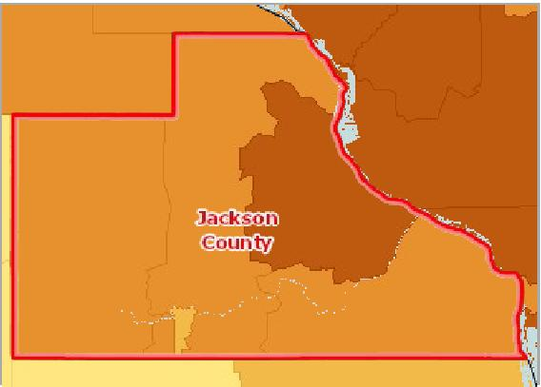

[](https://engagementnetwork.org/map-room/?ids=9305,t11&def=t11:FIPS%20In%20('19097')&bbox=-10120449.27515,5164829.551058,-10034264.57655,5219471.283242) View larger map

1st Quintile (Highest Expenditures)

2nd Quintile

3rd Quintile

4th Quintile

5th Quintile (Lowest Expenditures)

No Data or Data Suppressed

Jackson County, IA

## Fruit/Vegetable Consumption

In the report area an estimated 12,377, or 81.30% of adults over the age of 18 are consuming less than 5 servings of fruits and vegetables each day. This indicator is relevant because current behaviors are determinants of future health, and because unhealthy eating habits may cause of significant health issues, such as obesity and diabetes.

|  |  |  |  |
| --- | --- | --- | --- |
| **Report Area** | **Total  Population  (Age 18+)** | **Total Adults with Inadequate Fruit /  Vegetable Consumption** | **Percent Adults with Inadequate Fruit /  Vegetable Consumption** |
| Jackson County, IA | 15,224.00 | 12,377 | **81.30%** |
| Iowa | 2,268,969.00 | 1,831,058 | 80.70% |
| United  States | 227,279,010.00 | 171,972,118 | 75.70% |

*Note: This indicator is compared to the state average.*

*Data Source: Centers for Disease Control and Prevention,* [*Behavioral Risk Factor Surveillance System*](http://www.cdc.gov/brfss/)*. Accessed via the* [*Health Indicators Warehouse*](http://healthindicators.gov)*. US Department of Health & Human*

*Services,* [*Health Indicators Warehouse*](https://healthdata.gov/dataset/health-indicators-warehouse)*. 2005‐09. Source geography: County*

Percent Adults with Inadequate Fruit / Vegetable Consumption

|  |  |
| --- | --- |
|  | |
| 50% 100% | |
|  | Jackson County (81.30%)  Iowa (80.70%)  United States (75.70%) |

**Inadequate Fruit/Vegetable Consumption, Percent of Adults Age 18+ by County, BRFSS 2005‐09**

Over 85.0%

80.1 ‐ 85.0%

75.1 ‐ 80.0%

Under 75.1%

No Data or Data Suppressed

Jackson County, IA

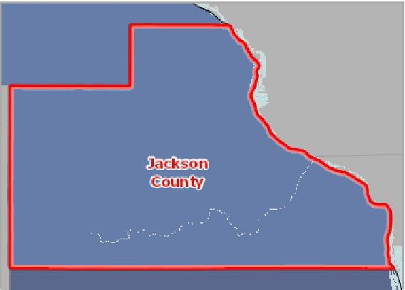

[](https://engagementnetwork.org/map-room/?ids=5440,t11&def=t11:FIPS%20In%20('19097')&bbox=-10120449.27515,5164829.551058,-10034264.57655,5219471.283242) View larger map



Adult with Inadequate Fruit Consumption Trend over Time, 2011 through 2019

The table and chart below display trends in the percentage of adult population over time who consumed fruit less than one time per day.

|  |  |  |  |  |
| --- | --- | --- | --- | --- |
| **Report Area** | **2013** | **2015** | **2017** | **2019** |
| Iowa | 39.9% | 42.4% | 35.9% | 41.3% |
| United States | 40.3% | 41.6% | 37.2% | 40.4% |

*Note: No county data available. See data source and methodology for more details.*

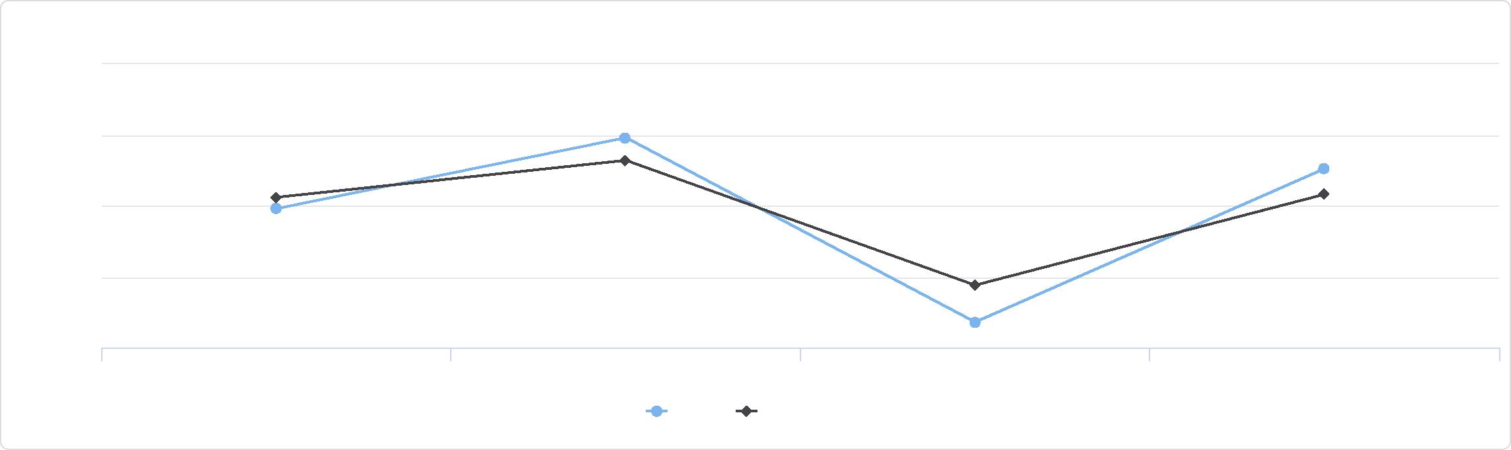

Adult with Inadequate Fruit Consumption Trend over Time, 2011 through 2019

45

42.5

40

37.5

35

%

2013 2015 2017 2019

Iowa United States

Adult with Inadequate Vegetable Consumption Trend over Time, 2011 through 2019

The table and chart below display trends in the percentage of adult population over time who consumed vegetable less than one time per day.

|  |  |  |  |  |
| --- | --- | --- | --- | --- |
| **Report Area** | **2013** | **2015** | **2017** | **2019** |
| Iowa | 27.3% | 27.2% | 19.6% | 23.1% |
| United States | 23.4% | 22.8% | 19.4% | 21.5% |

*Note: No county data available. See data source and methodology for more details.*

Adult with Inadequate Vegetable Consumption Trend over Time, 2011 through 2019

## Fruit/Vegetable Expenditures

This indicator reports estimated expenditures for fruits and vegetables purchased for in‐home consumption, as a percentage of total food‐at‐home expenditures. This indicator is relevant because current behaviors are determinants of future health, and because unhealthy eating habits may illustrate a cause of significant health issues, such as obesity and diabetes. Expenditures data are suppressed for single counties and single‐geography custom areas. Rank data are not available custom report areas or multi‐county areas.

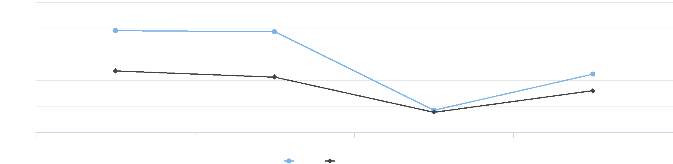

30

27.5

25

2013 2015 2017 2019

Iowa United States

%

17.5

22.5

20

|  |  |  |  |  |  |  |  |  |
| --- | --- | --- | --- | --- | --- | --- | --- | --- |
| **Report Area** | **State  Rank** | **Z‐Score  (US)** | **Z‐Score (Within‐ State)** | | **Average Expenditures (USD)** | | **Percentage of Food‐At‐Home  Expenditures** | |
| Jackson  County, IA | 30.00 | ‐1.02 |  | 1.40 | Suppressed |  | Suppressed |  |
| Iowa | No data | ‐0.68 | No data |  |  | $663.93 |  | 11.68% |
| United States | No data | No data | No data |  |  | $744.71 |  | 12.68% |

Fruit / Vegetable Expenditures,   
Percentage of Total Food-At-   
Home Expenditures

|  |  |
| --- | --- |
|  | |
| 0% 25% | |
|  | Iowa (11.68%)  United States (12.68%) |

*Note: This indicator is compared to the state average.*

*Data Source: Nielsen,* [*Nielsen SiteReports*](https://claritas360.claritas.com/knowledgecenter/help/content/reports/standard_reports/consumer_demand_reports/cbp_rpt_home.htm)*. 2014. Source geography: Tract*

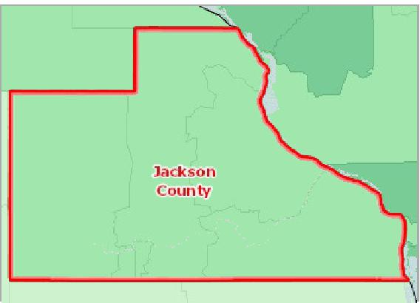

[](https://engagementnetwork.org/map-room/?ids=9303,t11&def=t11:FIPS%20In%20('19097')&bbox=-10120449.27515,5164829.551058,-10034264.57655,5219471.283242) View larger map

1st Quintile (Highest Expenditures)

2nd Quintile

3rd Quintile

4th Quintile

5th Quintile (Lowest Expenditures)

No Data or Data Suppressed

Jackson County, IA

**Fruit and Vegetable Expenditures, Percent of Food‐At‐Home Expenditures, National Rank by Tract, Nielsen 2014**



## Physical Inactivity

Within the report area, 4,113 or 26.0% of adults aged 20 and older self‐report no leisure time for activity, based on the question: "During the past month, other than your regular job, did you participate in any physical activities or exercises such as running, calisthenics, golf, gardening, or walking for exercise?" This indicator is relevant because current behaviors are determinants of future health and this indicator may illustrate a cause of significant health issues, such as obesity and poor cardiovascular health.

|  |  |  |  |
| --- | --- | --- | --- |
| **Report Area** | **Population Age**  **20+** | **Adults with no Leisure Time Physical Activity** | **Adults with no Leisure Time Physical  Activity, Percent** |
| Jackson  County, IA | 14,637 | 4,113 | **26.0%** |
| Iowa | 2,319,510 | 525,218 | 21.7% |
| United States | 243,068,284 | 55,261,407 | 22.1% |

Percentage of Adults with No Leisure-Time Physical Acitvity,

2016

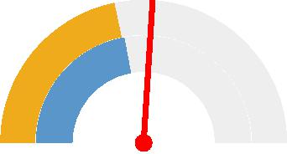

0% 50%

Jackson County (26.0%)

Iowa (21.7%)

United States (22.1%)



*Note: This indicator is compared to the state average.*

*Data Source: Centers for Disease Control and Prevention,* [*National Center for Chronic Disease Prevention and Health Promotion*](http://www.cdc.gov/nccdphp/dnpao/index.html)*. 2017. Source geography: County*

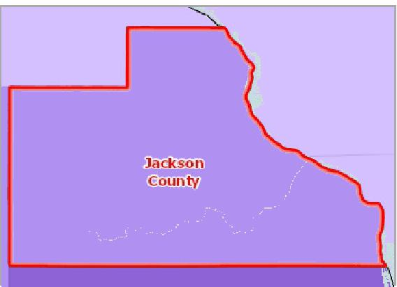

[](https://engagementnetwork.org/map-room/?ids=32688,t11&def=t11:FIPS%20In%20('19097')&bbox=-10120449.27515,5164829.551058,-10034264.57655,5219471.283242) View larger map

**No Leisure‐Time Physical Activity, Adults Age 20+, Percent by County, CDC NCCDPHP 2017**

Over 29.0%

26.1 ‐ 29.0%

23.1 ‐ 26.0%

Under 23.1%

No Data or Data Suppressed

Jackson County, IA



Adults with No Leisure‐Time Physical Activity by Gender, 2017

The table below displays national, state, and local variation in the percentage of adults reporting no leisure‐time physical by gender.

|  |  |  |  |  |
| --- | --- | --- | --- | --- |
| **Report Area** | **Male** | **Male, Percent** | **Female** | **Female, Percent** |
| Jackson County, IA | 1,923 | 25.1% | 2,189 | 26.8% |
| Iowa | 245,707 | 20.9% | 279,511 | 22.4% |
| United States | 24,806,207 | 20.6% | 30,455,202 | 23.5% |

Percentage of Adults Physically Inactive by Year

The table below displays trends in the percentage of adults reporting no leisure‐time physical activity for years 2004 through 2017.

|  |  |  |  |  |  |  |  |  |  |  |  |  |  |  |
| --- | --- | --- | --- | --- | --- | --- | --- | --- | --- | --- | --- | --- | --- | --- |
| **Report Area** | **2004** | **2005** | **2006** | **2007** | **2008** | **2009** | **2010** | **2011** | **2012** | **2013** | **2014** | **2015** | **2016** | **2017** |
| Jackson County, IA | 25.4% | 23.9% | 23.5% | 22.1% | 23.1% | 23.5% | 22.9% | 22.6% | 25.4% | 25.2% | 29.3% | 28.8% | 33.3% | 26.0% |
| Iowa | 22.7% | 22.3% | 22.4% | 22.9% | 23.5% | 24.5% | 24.5% | 23.5% | 24.2% | 22.7% | 23.8% | 22.0% | 22.9% | 21.7% |
| United States | 23.0% | 22.8% | 22.9% | 23.2% | 23.5% | 23.7% | 23.4% | 22.5% | 22.6% | 21.8% | 22.6% | 21.6% | 22.8% | 22.1% |

## Soda Expenditures

This indicator reports soft drink consumption by census tract by estimating expenditures for carbonated beverages, as a percentage of total food‐at‐home expenditures. This indicator is relevant because current behaviors are determinants of future health and this indicator may illustrate a cause of significant health issues such as diabetes and obesity. Expenditures data are suppressed for single counties and single‐geography custom areas. Rank data are not available custom report areas or multi‐county areas.

Adults with No Leisure-Time Physical Activity by Gender, 2017

30

|  |  |  |  |  |  |  |
| --- | --- | --- | --- | --- | --- | --- |
|  | 20  10  0 |  |  |  |  |  |
| % |  |  |  |
|  |  |  |  |
|  |  |  |  |  |  |

Male, Percent Female, Percent

Jackson County, IA Iowa United States



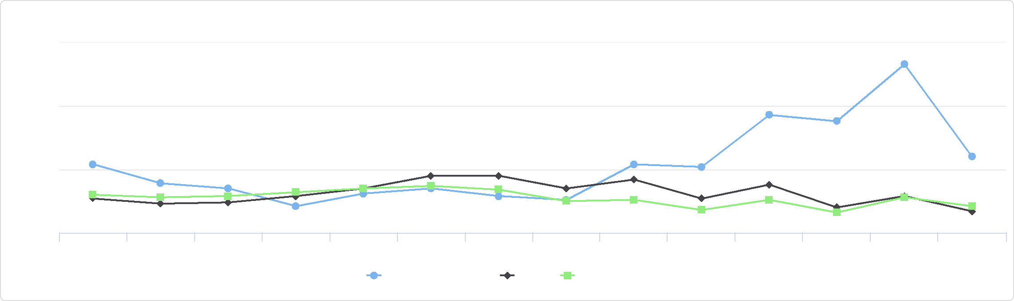

%

Percentage of Adults Physically Inactive by Year

35

30

20

2004 2005 2006 2007 2008 2009 2010 2011 2012 2013 2014 2015 2016 2017

Jackson County, IA Iowa United States

25

|  |  |  |  |  |  |  |  |  |
| --- | --- | --- | --- | --- | --- | --- | --- | --- |
| **Report Area** | **State  Rank** | **Z‐Score  (US)** | **Z‐Score (Within‐ State)** | | **Average Expenditures (USD)** | | **Percentage of Food‐At‐Home  Expenditures** | |
| Jackson  County, IA | 32.00 | 1.08 |  | ‐1.24 | Suppressed |  | Suppressed |  |
| Iowa | No data | 0.84 | No data |  |  | $259.53 |  | 4.56% |
| United States | No data | No data | No data |  |  | $236.04 |  | 4.02% |

Soda Expenditures, Percentage of   
Total Food-At-Home   
Expenditures

|  |  |
| --- | --- |
|  | |
| 0% 5% | |
|  | Iowa (4.56%)  United States (4.02%) |

*Note: This indicator is compared to the state average.*

*Data Source: Nielsen,* [*Nielsen SiteReports*](https://claritas360.claritas.com/knowledgecenter/help/content/reports/standard_reports/consumer_demand_reports/cbp_rpt_home.htm)*. 2014. Source geography: Tract*

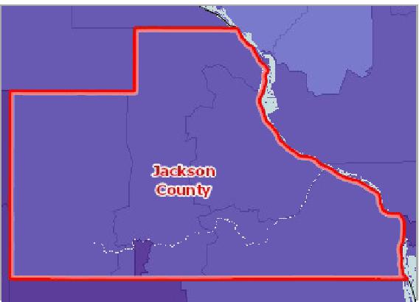

[](https://engagementnetwork.org/map-room/?ids=9302,t11&def=t11:FIPS%20In%20('19097')&bbox=-10120449.27515,5164829.551058,-10034264.57655,5219471.283242) View larger map

1st Quintile (Highest Expenditures)

2nd Quintile

3rd Quintile

4th Quintile

5th Quintile (Lowest Expenditures)

No Data or Data Suppressed

Jackson County, IA

**Soda Expenditures, Percent of Food‐At‐Home Expenditures, National Rank by Tract, Nielsen 2014**



## Tobacco Expenditures

This indicator reports estimated expenditures for cigarettes, as a percentage of total household expenditures. This indicator is relevant because tobacco use is linked to leading causes of death such as cancer and cardiovascular disease. Expenditures data are suppressed for single counties and single‐geography custom areas. Rank data are not available custom report areas or multi‐county areas. Expenditures data are suppressed for single counties and single‐geography custom areas. Rank data are not available custom report areas or multi‐county areas.

Cigarette Expenditures,   
Percentage of Total Household   
Expenditures

|  |  |
| --- | --- |
|  | |
| -5% 5% | |
|  | Iowa (1.86%)  United States (1.56%) |

|  |  |  |  |  |  |  |  |  |
| --- | --- | --- | --- | --- | --- | --- | --- | --- |
| **Report Area** | **State  Rank** | **Z‐Score  (US)** | **Z‐Score (Within‐ State)** | | **Average Expenditures (USD)** | | **Percentage of Food‐At‐Home  Expenditures** | |
| Jackson  County, IA | 80.00 | 1.39 |  | 1.54 | Suppressed |  | Suppressed |  |
| Iowa | No data | 0.26 | No data |  |  | $967.17 |  | 1.86% |
| United States | No data | No data | No data |  |  | $822.70 |  | 1.56% |

*Note: This indicator is compared to the state average.*

*Data Source: Nielsen,* [*Nielsen SiteReports*](https://claritas360.claritas.com/knowledgecenter/help/content/reports/standard_reports/consumer_demand_reports/cbp_rpt_home.htm)*. 2014. Source geography: Tract*

**Cigarette Expenditures, Percent of Total Expenditures, National Rank by Tract, Nielsen 2014**



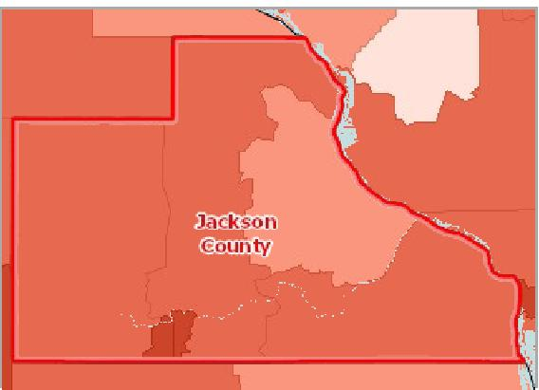

[](https://engagementnetwork.org/map-room/?ids=9304,t11&def=t11:FIPS%20In%20('19097')&bbox=-10120449.27515,5164829.551058,-10034264.57655,5219471.283242) View larger map

1st Quintile (Highest Expenditures)

2nd Quintile

3rd Quintile

4th Quintile

5th Quintile (Lowest Expenditures)

No Data or Data Suppressed

Jackson County, IA

## Tobacco Usage ‐ Current Smokers

In the report area an estimated 1,600, or 10.50% of adults age 18 or older self‐report currently smoking cigarettes some days or every day. This indicator is relevant because tobacco use is linked to leading causes of death such as cancer and cardiovascular disease.

|  |  |  |  |  |
| --- | --- | --- | --- | --- |
| **Report  Area** | **Total Population Age 18+** | **Total Adults Regularly  Smoking Cigarettes** | **Percent Population  Smoking Cigarettes  (Crude)** | **Percent Population  Smoking Cigarettes  (Age‐Adjusted)** |
| Jackson County, IA | 15,242.00 | 1,600 | 10.50% | **11.00%** |
| Iowa | 2,307,562.00 | 403,823 | 17.50% | 18.10% |
| United  States | 232,556,016.00 | 41,491,223 | 17.80% | 18.10% |

*Note: This indicator is compared to the state average.*

*Data Source: Centers for Disease Control and Prevention,* [*Behavioral Risk Factor Surveillance System*](http://www.cdc.gov/brfss/)*. Accessed via the* [*Health Indicators Warehouse*](http://healthindicators.gov)*. US Department of Health & Human*

*Services,* [*Health Indicators Warehouse*](https://healthdata.gov/dataset/health-indicators-warehouse)*. 2006‐12. Source geography: County*

Percentage of Adults Smoking Cigarettes

|  |  |
| --- | --- |
|  | |
|  | 0% 30%  Jackson County (11.00%)  Iowa (18.10%)  United States (18.10%) |

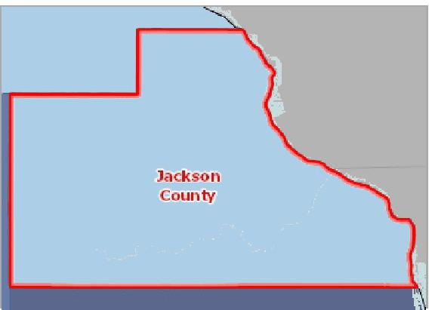

[](https://engagementnetwork.org/map-room/?ids=5448,t11&def=t11:FIPS%20In%20('19097')&bbox=-10120449.27515,5164829.551058,-10034264.57655,5219471.283242) View larger map

**Current Smokers, Adult, Percent of Adults Age 18+ by County, BRFSS 2006‐12**

Over 26.0%

22.1 ‐ 26.0%

18.1 ‐ 22.0%

Under 18.1%

No Data or Data Suppressed

Jackson County, IA



## Tobacco Usage ‐ Former or Current Smokers

In the report area, an estimated 7,079 adults, or 33.01%, report ever smoking 100 or more cigarettes. This indicator is relevant because tobacco use is linked to leading causes of death such as cancer and cardiovascular disease.

|  |  |  |  |
| --- | --- | --- | --- |
| **Report Area** | **Survey  Population  (Adults Age  18+)** | **Total Adults Ever Smoking 100 or More Cigarettes** | **Percent Adults Ever Smoking 100 or More Cigarettes** |
| Jackson  County, IA | 21,444 | 7,079 | **33.01%** |
| Iowa | 2,296,543 | 1,017,920 | 44.32% |
| United States | 235,151,778 | 103,842,020 | 44.16% |

*Note: This indicator is compared to the state average.*

*Data Source: Centers for Disease Control and Prevention,* [*Behavioral Risk Factor Surveillance System*](http://www.cdc.gov/brfss/)*. Additional data analysis by* [*CARES*](http://cares.missouri.edu)*. 2011‐12. Source geography: County*

Percent Adults Ever Smoking 100 or More Cigarettes

|  |  |
| --- | --- |
|  | |
|  | 0% 50%  Jackson County (33.01%)  Iowa (44.32%)  United States (44.16%) |

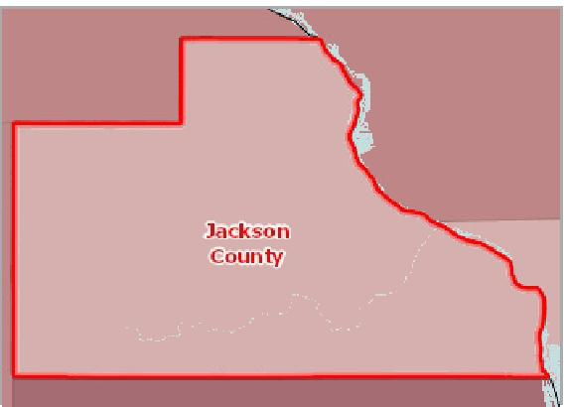

[](https://engagementnetwork.org/map-room/?ids=6342,t11&def=t11:FIPS%20In%20('19097')&bbox=-10120449.27515,5164829.551058,-10034264.57655,5219471.283242) View larger map

**Adults Age 18+ Smoking > 99 Cigarettes (Ever), Percent by County, BRFSS 2011‐12**

Over 56.0%

48.1 ‐ 56.0%

40.1 ‐ 48.0%

Under 40.1%

No Data or Data Suppressed

Jackson County, IA



Adults Ever Smoking 100 or More Cigarettes by Race / Ethnicity, Percent

|  |  |  |  |  |
| --- | --- | --- | --- | --- |
| **Report Area** | **White**  **(Non‐Hispanic)** | **Black**  **(Non‐Hispanic)** | **Other Race  (Non‐Hispanic)** | **Hispanic / Latino** |
| Iowa | 45.02% | 45.65% | 28.06% | 31.03% |
| United States | 48.52% | 38.34% | 31.30% | 34.17% |

*Note: No county data available. See data source and methodology for more details.*

## Tobacco Usage ‐ Quit Attempt

An estimated 49.37% of adult smokers in the report area attempted to quit smoking for at least 1 day in the past year. This indicator is relevant because tobacco use is linked to leading causes of death such as cancer and cardiovascular disease and supporting efforts to quit smoking may increase positive health outcomes.

Adults Ever Smoking 100 or More Cigarettes by Race / Ethnicity, Percent

60

|  |  |  |  |  |  |  |  |  |  |  |
| --- | --- | --- | --- | --- | --- | --- | --- | --- | --- | --- |
|  | 40  20  0 |  |  |  |  |  |  |  |  |  |
| % |  |  |  |  |  |  |  |
|  |  |  |  |  |  |
|  |  |  |  |  |  |  |  |  |  |

White Black Other Race Hispanic / Latino

(Non-Hispanic) (Non-Hispanic) (Non-Hispanic)

Iowa United States



|  |  |  |  |
| --- | --- | --- | --- |
| **Report Area** | **Survey  Population  (Smokers Age  18+)** | **Total Smokers with Quit Attempt in  Past 12 Months** | **Percent Smokers with Quit Attempt in  Past 12 Months** |
| Jackson County, IA | 2,398 | 1,184 | **49.37%** |
| Iowa | 441,750 | 247,931 | 56.12% |
| United States | 45,526,654 | 27,323,073 | 60.02% |

*Note: This indicator is compared to the state average.*

*Data Source: Centers for Disease Control and Prevention,* [*Behavioral Risk Factor Surveillance System*](http://www.cdc.gov/brfss/)*. Additional data analysis by* [*CARES*](http://cares.missouri.edu)*. 2011‐12. Source geography: County*

Percent Smokers with Quit Attempt in Past 12 Months

|  |  |
| --- | --- |
|  | |
|  | 0% 80%  Jackson County (49.37%)  Iowa (56.12%)  United States (60.02%) |

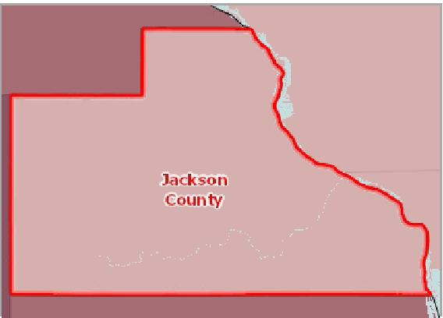

[](https://engagementnetwork.org/map-room/?ids=6343,t11&def=t11:FIPS%20In%20('19097')&bbox=-10120449.27515,5164829.551058,-10034264.57655,5219471.283242) View larger map

**Smokers Who Quit / Attempted to Quit in Past 12 Months, Percent by County, BRFSS 2011‐12**

Over 64.0%

58.1 ‐ 64.0%

52.1 ‐ 58.0%

Under 52.1%

No Data or Data Suppressed

Jackson County, IA



Adult Smokers with Quit Attempt in Past 1 Year by Race / Ethnicity, Percent

|  |  |  |  |  |
| --- | --- | --- | --- | --- |
| **Report Area** | **White**  **(Non‐Hispanic)** | **Black**  **(Non‐Hispanic)** | **Other Race  (Non‐Hispanic)** | **Hispanic / Latino** |
| Iowa | 55.20% | 66.85% | 69.43% | 64.12% |
| United States | 56.63% | 70.87% | 62.26% | 65.83% |

*Note: No county data available. See data source and methodology for more details.*

## Walking or Biking to Work

This indicator reports the percentage of the population that commutes to work by either walking or riding a bicycle.

Adult Smokers with Quit Attempt in Past 1 Year by Race / Ethnicity, Percent

75

|  |  |  |  |  |  |  |  |  |  |  |
| --- | --- | --- | --- | --- | --- | --- | --- | --- | --- | --- |
|  | 50  25  0 |  |  |  |  |  |  |  |  |  |
| % |  |  |  |  |  |
|  |  |  |  |  |  |
|  |  |  |  |  |  |  |  |  |  |

White Black Other Race Hispanic / Latino

(Non-Hispanic) (Non-Hispanic) (Non-Hispanic)

Iowa United States



Percentage Walking or Biking to

Work

|  |  |
| --- | --- |
|  | |
| 0% 10% | |
|  | Jackson County (3.26%)  Iowa (3.76%)  United States (3.26%) |

|  |  |  |  |
| --- | --- | --- | --- |
| **Report Area** | **Population Age**  **16+** | **Population Walking or Biking to**  **Work** | **Percentage Walking or Biking to**  **Work** |
| Jackson County, IA | 9,394 | 306 | **3.26%** |
| Iowa | 1,583,271 | 59,567 | 3.76% |
| United States | 150,571,044 | 4,908,631 | 3.26% |

*Note: This indicator is compared to the state average.*

*Data Source: US Census Bureau,* [*American Community Survey*](http://www.census.gov/acs/www/)*. 2014‐18. Source geography: Tract*

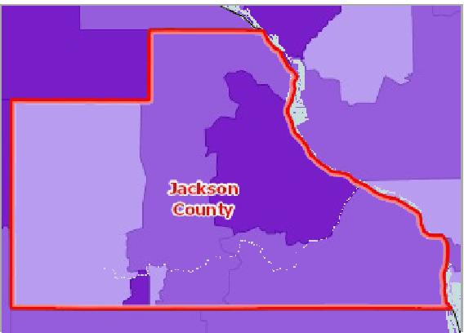

[](https://engagementnetwork.org/map-room/?ids=31445,t11&def=t11:FIPS%20In%20('19097')&bbox=-10120449.27515,5164829.551058,-10034264.57655,5219471.283242) View larger map

**Workers Traveling to Work by Walking/Biking, Percent by Tract, ACS 2014‐ 18**

Over 4.0%

1.1 ‐ 4.0%

0.1 ‐ 1.0%

No Workers Walking or Biking

No Data or Data Suppressed

Jackson County, IA



# Health Outcomes

## Asthma Prevalence

This indicator reports the percentage of adults aged 18 and older who self‐report that they have ever been told by a doctor, nurse, or other health professional that they had asthma. This indicator is relevant because asthma is a prevalent problem in the U.S. that is often exacerbated by poor environmental conditions.

|  |  |  |  |
| --- | --- | --- | --- |
| **Report Area** | **Survey Population  (Adults Age 18+)** | **Total Adults with Asthma** | **Percent Adults with Asthma** |
| Jackson County, IA | 21,943 | 740 | **3.4%** |
| Iowa | 2,314,076 | 273,507 | 11.8% |
| United States | 237,197,465 | 31,697,608 | 13.4% |

*Note: This indicator is compared to the state average.*

*Data Source: Centers for Disease Control and Prevention,* [*Behavioral Risk Factor Surveillance System*](http://www.cdc.gov/brfss/)*. Additional data analysis by* [*CARES*](http://cares.missouri.edu)*. 2011‐12. Source geography: County*

Percent Adults with Asthma

|  |  |
| --- | --- |
|  | |
| 0% 25% | |
|  | Jackson County (3.4%)  Iowa (11.8%)  United States (13.4%) |

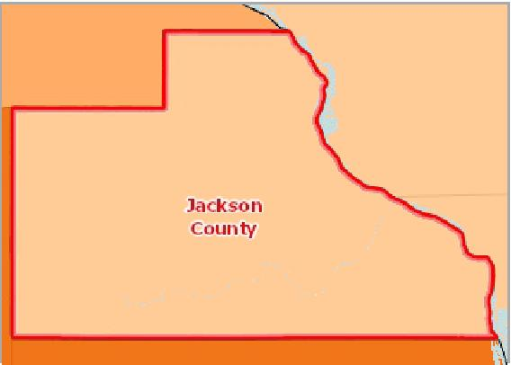

[](https://engagementnetwork.org/map-room/?ids=6336,t11&def=t11:FIPS%20In%20('19097')&bbox=-10120449.27515,5164829.551058,-10034264.57655,5219471.283242) View larger map

**Asthma (Diagnosed), Percentage of Adults Age 18+ by County, BRFSS 2011‐12**

Over 16.0%

13.1 ‐ 16.0%

10.1 ‐ 13.0%

Under 10.1%

No Data or Data Suppressed

Jackson County, IA



Adults Ever Diagnosed with Asthma, Percentage by Race / Ethnicity

The table below displays the prevalence of asthma among the adult population by race/ethnicity

|  |  |  |  |  |
| --- | --- | --- | --- | --- |
| **Report Area** | **Non‐Hispanic White** | **Non‐Hispanic Black** | **Non‐Hispanic Other Race** | **Hispanic or Latino** |
| Iowa | 11.6% | 20.6% | 8.0% | 7.4% |
| United States | 13.2% | 15.8% | 11.9% | 12.0% |

*Note: No county data available. See data source and methodology for more details.*

## Cancer Incidence ‐ Breast

This indicator reports the age adjusted incidence rate (cases per 100,000 population per year) of females with breast cancer adjusted to 2000 U.S. standard population age groups (Under Age 1, 1‐4, 5‐9, ..., 80‐84, 85 and older).

Adults Ever Diagnosed with Asthma, Percentage by Race / Ethnicity

25

|  |  |  |  |  |  |  |  |  |
| --- | --- | --- | --- | --- | --- | --- | --- | --- |
|  | 20 15 10 5  0 |  |  |  |  |  |  |  |
|  |  |  |  |  |  |  |
| % |  |  |  |  |  |  |
|  |  |  |  |  |
|  |  |  |  |  |
|  |  |  |  |  |  |  |  |

Non-Hispanic White Non-Hispanic Black Non-Hispanic Other Race Hispanic or Latino

Iowa United States



|  |  |  |  |
| --- | --- | --- | --- |
| **Report Area** | **Estimated Total Population (Female)** | **New Cases (Annual Average)** | **Cancer Incidence Rate (Per 100,000 Pop.)** |
| Jackson County, IA | 13,171 | 13 | **98.7** |
| Iowa | 1,912,335 | 2,465 | 128.9 |
| United States | 194,131,056 | 244,411 | 125.9 |

*Note: This indicator is compared to the state average.*

*Data Source:* [*State Cancer Profiles*](http://statecancerprofiles.cancer.gov/)*. 2013‐17. Source geography: County*

Breast Cancer Incidence Rate (Per 100,000 Pop.)

|  |  |
| --- | --- |
|  | |
| 0 150 | |
|  | Jackson County (98.7)  Iowa (128.9)  United States (125.9) |

**Breast Cancer, Incidence Rate (Per 100,000 Pop.) by County, State Cancer Profiles 2013‐17**

Over 130.0

115.1 ‐ 130.0

100.1 ‐ 115.0

0.1 ‐ 100.0

Data Suppressed (<16 Cases)

No Data

Jackson County, IA

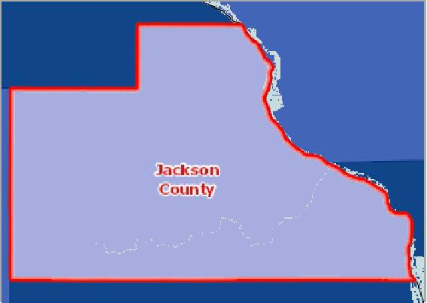

[](https://engagementnetwork.org/map-room/?ids=32793,t11&def=t11:FIPS%20In%20('19097')&bbox=-10120449.27515,5164829.551058,-10034264.57655,5219471.283242) View larger map



Breast Cancer Incidence, Rate Per 100,000 Population by Race / Ethnicity

This table reports the age‐adjusted breast cancer incidence rate for the 5‐year period 2012‐2016 by race and by Hispanic origin.

|  |  |  |  |  |  |  |  |  |
| --- | --- | --- | --- | --- | --- | --- | --- | --- |
| **Report Area** | **White** | **Black** | **Asian or Pacific Islander** | | **American Indian or Alaskan Native** | | **Hispanic or Latino** | |
| Jackson County, IA | 100.1 | Suppressed | Suppressed |  | Suppressed |  | Suppressed |  |
| Iowa | 129.8 | 111.9 |  | 89.8 |  | 98.8 |  | 70.3 |
| United States | 126.9 | 124.4 |  | 95.5 |  | 74.4 |  | 94.2 |

Breast Cancer Incidence (Average Annual New Cases) by Race / Ethnicity

|  |  |  |  |  |  |  |  |  |
| --- | --- | --- | --- | --- | --- | --- | --- | --- |
| **Report Area** | **White** | **Black** | **Asian or Pacific Islander** | | **American Indian or Alaskan Native** | | **Hispanic or Latino** | |
| Jackson County, IA | 13 | Suppressed | Suppressed |  | Suppressed |  | Suppressed |  |
| Iowa | 2,390 | 40 |  | 25 |  | 6 |  | 34 |
| United States | 201,468 | 28,664 |  | 10,273 |  | 1,426 |  | 20,216 |

## Cancer Incidence ‐ Cervical

Breast Cancer Incidence, Rate Per 100,000 Population by Race / Ethnicity

150

|  |  |  |  |  |  |  |  |  |  |  |  |
| --- | --- | --- | --- | --- | --- | --- | --- | --- | --- | --- | --- |
| 100  50  0 |  |  |  |  |  |  |  |  |  |  |  |
|  |  |  |  |  |  |  |  |  |
|  |  |  |  |  |  |
|  |  |  |  |  |  |  |  |  |  |  |

White Black Asian or Pacific Islander American Indian or Alaskan Native Hispanic or Latino

Jackson County, IA Iowa United States



This indicator reports the age adjusted incidence rate (cases per 100,000 population per year) of females with cervical cancer adjusted to 2000 U.S. standard population age groups (Under age 1, 1‐4, 5‐9, ..., 80‐84, 85 and older).

|  |  |  |  |  |  |  |
| --- | --- | --- | --- | --- | --- | --- |
| **Report Area** | **Estimated Total Population (Female)** | | **New Cases (Annual Average)** | | **Cancer Incidence Rate (Per 100,000 Pop.)** | |
| Jackson County, IA | No data |  | Suppressed |  | Suppressed |  |
| Iowa |  | 1,546,666 |  | 116 |  | 7.5 |
| United States |  | 168,855,263 |  | 12,833 |  | 7.6 |

*Note: This indicator is compared to the state average.*

*Data Source:* [*State Cancer Profiles*](http://statecancerprofiles.cancer.gov/)*. 2012‐16. Source geography: County*

Annual Cervical Cancer Incidence

Rate

(Per 100,000 Pop.)

|  |  |
| --- | --- |
|  | |
| 0 10 | |
|  | Iowa (7.5)  United States (7.6) |

Cervical Cancer Incidence, Rate Per 100,000 Population by Race / Ethnicity

This table reports the age‐adjusted cervical cancer incidence rate for the 5‐year period 2012‐2016 by race and by Hispanic origin.

|  |  |  |  |  |  |  |  |  |
| --- | --- | --- | --- | --- | --- | --- | --- | --- |
| **Report Area** | **White** | **Black** | **Asian or Pacific Islander** | | **American Indian or Alaskan Native** |  | **Hispanic or Latino** | |
| Jackson County, IA | No data | No data | No data |  | No data |  | No data |  |
| Iowa | 7.4 | Suppressed | Suppressed |  | Suppressed |  |  | 10.9 |
| United States | 7.5 | 8.8 |  | 6.1 |  | 6.3 |  | 9.5 |

Cervical Cancer Incidence (Average Annual New Cases) by Race / Ethnicity

|  |  |  |  |  |  |  |  |  |
| --- | --- | --- | --- | --- | --- | --- | --- | --- |
| **Report Area** | **White** | **Black** | **Asian or Pacific Islander** | | **American Indian or Alaskan Native** | | **Hispanic or Latino** | |
| Jackson County, IA | Suppressed | Suppressed | Suppressed |  | Suppressed |  | Suppressed |  |
| Iowa | 108 | Suppressed | Suppressed |  | Suppressed |  |  | 6 |
| United States | 9,816 | 1,978 |  | 659 |  | 128 |  | 2,238 |

## Cancer Incidence ‐ Colon and Rectum

This indicator reports the age adjusted incidence rate (cases per 100,000 population per year) of colon and rectum cancer adjusted to 2000 U.S. standard population age groups (Under age 1, 1‐4, 5‐9, ..., 80‐84, 85 and older).

Cervical Cancer Incidence, Rate Per 100,000 Population by Race / Ethnicity

15

|  |  |  |  |  |  |  |  |  |  |  |
| --- | --- | --- | --- | --- | --- | --- | --- | --- | --- | --- |
| 10 |  |  |  |  |  |  |  |  |  |  |
|  |  |  |  |  |  |  |  |  |
|  |  |  |  |  |  |  |  |  |  |
|  |  |  |  |  |  |  |  |  |  |
|  |  |  |  |  |  |  |  |  |
| 5  0 |  |  |  |  |  |  |  |  |
|  |  |  |  |  |  |  |  |
|  |  |  |  |  |  |  |  |  |  |

White Black Asian or Pacific Islander American Indian or Alaskan Native Hispanic or Latino

Iowa United States



|  |  |  |  |
| --- | --- | --- | --- |
| **Report Area** | **Estimated Total Population** | **New Cases (Annual Average)** | **Cancer Incidence Rate  (Per 100,000 Pop.)** |
| Jackson County, IA | 28,248 | 15 | **53.1** |
| Iowa | 3,798,627 | 1,660 | 43.7 |
| United States | 370,377,604 | 142,225 | 38.4 |

*Note: This indicator is compared to the state average.*

*Data Source:* [*State Cancer Profiles*](http://statecancerprofiles.cancer.gov/)*. 2013‐17. Source geography: County*

Colon and Rectum Cancer

Incidence Rate

(Per 100,000 Pop.)

|  |  |
| --- | --- |
|  | |
| 0 100 | |
|  | Jackson County (53.1)  Iowa (43.7)  United States (38.4) |

**Colon‐Rectal Cancer, Incidence Rate (Per 100,000 Pop.) by County, State Cancer Profiles 2013‐17**

Over 50.0

44.1 ‐ 50.0

38.1 ‐ 44.0

0.1 ‐ 38.0

Data Suppressed (<16 Cases)

No Data

Jackson County, IA

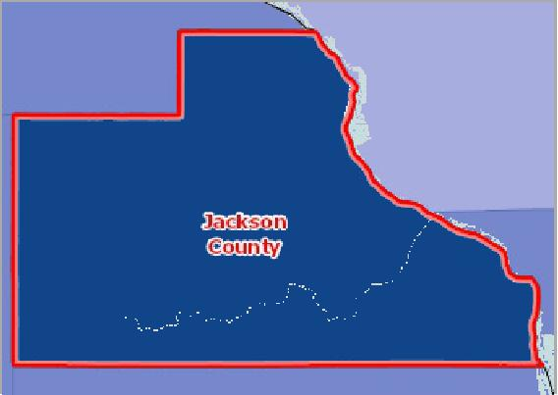

[](https://engagementnetwork.org/map-room/?ids=32795,t11&def=t11:FIPS%20In%20('19097')&bbox=-10120449.27515,5164829.551058,-10034264.57655,5219471.283242) View larger map



Colon and Rectum Cancer Incidence, Rate Per 100,000 Population by Race / Ethnicity

This table reports the age‐adjusted colon and rectum cancer incidence rate for the 5‐year period 2012‐2016 by race and by Hispanic origin.

|  |  |  |  |  |  |  |  |  |
| --- | --- | --- | --- | --- | --- | --- | --- | --- |
| **Report Area** | **White** | **Black** | **Asian or Pacific Islander** | | **American Indian or Alaskan Native** | | **Hispanic or Latino** | |
| Jackson County, IA | 52.1 | Suppressed | Suppressed |  | Suppressed |  | Suppressed |  |
| Iowa | 43.7 | 45.7 |  | 35.3 |  | 60.4 |  | 29.4 |
| United States | 37.7 | 43.7 |  | 29.8 |  | 30.8 |  | 33.7 |

Colon and Rectum Cancer Incidence (Average Annual New Cases) by Race / Ethnicity

|  |  |  |  |  |  |  |  |  |
| --- | --- | --- | --- | --- | --- | --- | --- | --- |
| **Report Area** | **White** | **Black** | **Asian or Pacific Islander** | | **American Indian or Alaskan Native** | | **Hispanic or Latino** | |
| Jackson County, IA | 14 | Suppressed | Suppressed |  | Suppressed |  | Suppressed |  |
| Iowa | 1,606 | 31 |  | 15 |  | 5 |  | 22 |
| United States | 116,285 | 17,567 |  | 5,561 |  | 1,051 |  | 12,517 |

## Cancer Incidence ‐ Lung

Colon and Rectum Cancer Incidence, Rate Per 100,000 Population by Race / Ethnicity

80

|  |  |  |  |  |  |  |  |  |  |  |
| --- | --- | --- | --- | --- | --- | --- | --- | --- | --- | --- |
| 60  40  20  0 |  |  |  |  |  |  |  |  |  |  |
|  |  |  |  |  |  | |  |  |  |
|  |  |  |  |  |  |  |  |
|  |  |  |  |  |  |  |
|  |  |  |  |  |
|  |  |  |  |  |  |  |  |  |  |

White Black Asian or Pacific Islander American Indian or Alaskan Native Hispanic or Latino

Jackson County, IA Iowa United States



This indicator reports the age adjusted incidence rate (cases per 100,000 population per year) of lung cancer adjusted to 2000 U.S. standard population age groups (Under age 1, 1‐4, 5‐9, ..., 80‐84, 85 and older).

In the report area, there were 17 new cases of lung cancer reported, for an incidence rate of 56.8 per 100,000 people. Statewide, the incidence rate is 63.3 per 100,000 people.

|  |  |  |  |
| --- | --- | --- | --- |
| **Report Area** | **Estimated Total Population** | **New Cases (Annual Average)** | **Cancer Incidence Rate  (Per 100,000 Pop.)** |
| Jackson County, IA | 29,929 | 17 | **56.8** |
| Iowa | 3,930,489 | 2,488 | 63.3 |
| United States | 380,048,027 | 221,568 | 58.3 |

*Note: This indicator is compared to the state average.*

*Data Source:* [*State Cancer Profiles*](http://statecancerprofiles.cancer.gov/)*. 2013‐17. Source geography: County*

Lung Cancer Incidence Rate (Per 100,000 Pop.)

|  |  |
| --- | --- |
|  | |
| 0 100 | |
|  | Jackson County (56.8)  Iowa (63.3)  United States (58.3) |

**Lung Cancer, Incidence Rate (Per 100,000 Pop.) by County, State Cancer Profiles 2013‐17**

Over 84.0

72.1 ‐ 84.0

60.1 ‐ 72.0

0.1 ‐ 60.0

Data Suppressed (<16 Cases)

No Data

Jackson County, IA

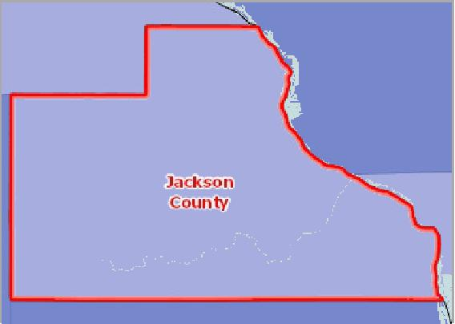

[](https://engagementnetwork.org/map-room/?ids=32796,t11&def=t11:FIPS%20In%20('19097')&bbox=-10120449.27515,5164829.551058,-10034264.57655,5219471.283242) View larger map



Lung Cancer Incidence, Rate Per 100,000 Population by Race / Ethnicity

This table reports the age‐adjusted lung and bronchus cancer incidence rate for the 5‐year period 2012‐2016 by race and by Hispanic origin.

|  |  |  |  |  |  |  |  |  |
| --- | --- | --- | --- | --- | --- | --- | --- | --- |
| **Report Area** | **White** | **Black** | **Asian or Pacific Islander** | | **American Indian or Alaskan Native** | | **Hispanic or Latino** | |
| Jackson County, IA | 57.2 | Suppressed | Suppressed |  | Suppressed |  | Suppressed |  |
| Iowa | 63.2 | 78.2 |  | 39.6 |  | 56.6 |  | 23.7 |
| United States | 59.3 | 59.4 |  | 34.4 |  | 42.1 |  | 29.5 |

Lung Cancer Incidence (Average Annual New Cases) by Race / Ethnicity

This table reports the age‐adjusted lung and bronchus cancer incidence for the 5‐year period 2012‐2016 by race and by

Lung Cancer Incidence, Rate Per 100,000 Population by Race / Ethnicity

100

|  |  |  |  |  |  |  |  |  |  |  |  |  |  |
| --- | --- | --- | --- | --- | --- | --- | --- | --- | --- | --- | --- | --- | --- |
| 75  50 |  |  |  |  |  |  |  |  |  |  |  |  |  |
|  |  |  |  |  |  |  |  |  |  |  |  |
|  |  |  |  |  |  |  |  |  |  |
| 25 |  |  |  |  |  |  |  |  |  |
|  |  |  |  |  |  |  |  |  |
|  |  |  |  |  |  |  |  |  |
| 0 |  |  |  |  |  |  |  |  |  |
|  |  |  |  |  |  |  |  |  |  |  |  |  |

White Black Asian or Pacific Islander American Indian or Alaskan Native Hispanic or Latino

Jackson County, IA Iowa United States



Hispanic origin.

|  |  |  |  |  |  |  |  |  |
| --- | --- | --- | --- | --- | --- | --- | --- | --- |
| **Report Area** | **White** | **Black** | **Asian or Pacific Islander** | | **American Indian or Alaskan Native** | | **Hispanic or Latino** | |
| Jackson County, IA | 17 | Suppressed | Suppressed |  | Suppressed |  | Suppressed |  |
| Iowa | 2,417 | 49 |  | 15 |  | 5 |  | 14 |
| United States | 189,612 | 23,470 |  | 6,096 |  | 1,339 |  | 9,646 |

## Cancer Incidence ‐ Prostate

This indicator reports the age adjusted incidence rate (cases per 100,000 population per year) of males with prostate cancer adjusted to 2000 U.S. standard population age groups (Under age 1, 1‐4, 5‐9, ..., 80‐84, 85 and older).

Prostate Cancer Incidence Rate (Per 100,000 Pop.)

|  |  |
| --- | --- |
|  | |
|  | 0 200  Jackson County (128.5)  Iowa (107.7)  United States (104.5) |

|  |  |  |  |
| --- | --- | --- | --- |
| **Report Area** | **Estimated Total Population (Male)** | **New Cases (Annual Average)** | **Cancer Incidence Rate (Per 100,000 Pop.)** |
| Jackson County, IA | 14,785 | 19 | **128.5** |
| Iowa | 1,913,649 | 2,061 | 107.7 |
| United States | 184,610,526 | 192,918 | 104.5 |

*Note: This indicator is compared to the state average.*

*Data Source:* [*State Cancer Profiles*](http://statecancerprofiles.cancer.gov/)*. 2013‐17. Source geography: County*

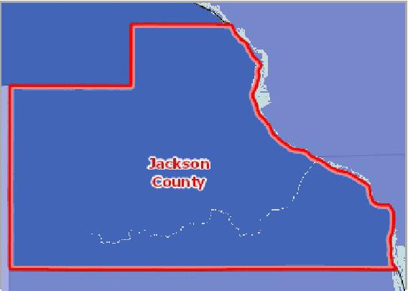

[](https://engagementnetwork.org/map-room/?ids=32797,t11&def=t11:FIPS%20In%20('19097')&bbox=-10120449.27515,5164829.551058,-10034264.57655,5219471.283242) View larger map

**Prostate Cancer, Incidence Rate (Per 100,000 Pop.) by County, State Cancer Profiles 2013‐17**

Over 130.0

115.1 ‐ 130.0

100.1 ‐ 115.0

0.1 ‐ 100.0

Data Suppressed (<16 Cases)

No Data

Jackson County, IA



Prostate Cancer Incidence, Rate Per 100,000 Population by Race / Ethnicity

This table reports the age‐adjusted prostate cancer incidence rate for the 5‐year period 2012‐2016 by race and by Hispanic origin.

|  |  |  |  |  |  |  |  |  |
| --- | --- | --- | --- | --- | --- | --- | --- | --- |
| **Report Area** | **White** | **Black** | **Asian or Pacific Islander** | | **American Indian or Alaskan Native** | | **Hispanic or Latino** | |
| Jackson County, IA | 129.4 | Suppressed | Suppressed |  | Suppressed |  | Suppressed |  |
| Iowa | 106.1 | 174.6 |  | 33 |  | 85.7 |  | 68 |
| United States | 95.8 | 167.8 |  | 53.7 |  | 54.8 |  | 84.7 |

Prostate Cancer Incidence, Rate Per 100,000 Population by Race / Ethnicity

200

|  |  |  |  |  |  |  |  |  |  |  |  |
| --- | --- | --- | --- | --- | --- | --- | --- | --- | --- | --- | --- |
| 150  100  50 |  |  |  |  |  |  |  |  |  |  |  |
|  |  |  |  |  |  |  |  |  |  |
|  |  |  |  |  |  |  |  |  |  |
|  |  |  |  |  |  |  |  |
|  |  |  |  |  |  |  |  |
|  |  |  |  |  |  |  |  |  |
| 0 |  |  |  |  |  |  |  |  |
|  |  |  |  |  |  |  |  |  |  |  |

White Black Asian or Pacific Islander American Indian or Alaskan Native Hispanic or Latino

Jackson County, IA Iowa United States



Prostate Cancer Incidence (Average Annual New Cases) by Race / Ethnicity

|  |  |  |  |  |  |  |  |  |
| --- | --- | --- | --- | --- | --- | --- | --- | --- |
| **Report Area** | **White** | **Black** | **Asian or Pacific Islander** | | **American Indian or Alaskan Native** | | **Hispanic or Latino** | |
| Jackson County, IA | 19 | Suppressed | Suppressed |  | Suppressed |  | Suppressed |  |
| Iowa | 1,971 | 59 |  | 6 |  | 4 |  | 23 |
| United States | 149,439 | 31,251 |  | 4,431 |  | 860 |  | 13,590 |

## Depression (Medicare Population)

This indicator reports the percentage of the Medicare fee‐for‐service population with depression.

|  |  |  |  |
| --- | --- | --- | --- |
| **Report Area** | **Total Medicare Fee‐for‐Service  Beneficiaries** | **Beneficiaries with  Depression** | **Beneficiaries with Depression,  Percent** |
| Jackson  County, IA | 3,204 | 603 | **18.8%** |
| Iowa | 462,029 | 87,262 | 18.9% |
| United States | 33,725,823 | 6,047,681 | 17.9% |

*Note: This indicator is compared to the state average.*

*Data Source: Centers for Medicare and Medicaid Services,* [*CMS Geographic Variation Public Use File*](https://www.cms.gov/Research-Statistics-Data-and-Systems/Statistics-Trends-and-Reports/Medicare-Geographic-Variation/GV_PUF) *. 2017. Source geography: County*

Percentage of Medicare Beneficiaries with Depression

|  |  |
| --- | --- |
|  | |
| 0% 60% | |
|  | Jackson County (18.8%)  Iowa (18.9%)  United States (17.9%) |

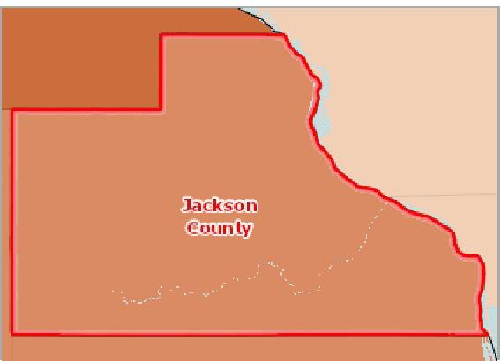

[](https://engagementnetwork.org/map-room/?ids=25613,t11&def=t11:FIPS%20In%20('19097')&bbox=-10120449.27515,5164829.551058,-10034264.57655,5219471.283242) View larger map

**Beneficiaries with Depression, Percent by County, CMS 2017**

Over 20.0%

17.1 ‐ 20.0%

15.1 ‐ 17.0%

Under 15.1%

No Data or Data Suppressed

Jackson County, IA



Medicare Population with Depression by Year, 2011 through 2017

This indicator reports the percentage of the Medicare fee‐for‐service population with depression over time.

|  |  |  |  |  |  |  |  |
| --- | --- | --- | --- | --- | --- | --- | --- |
| **Report Area** | **2011** | **2012** | **2013** | **2014** | **2015** | **2016** | **2017** |
| Jackson County, IA | 13.0% | 13.9% | 14.3% | 14.3% | 16.2% | 16.9% | 18.8% |
| Iowa | 14.9% | 15.2% | 15.5% | 16.1% | 17.1% | 17.8% | 18.9% |
| United States | 15.3% | 15.8% | 16.2% | 16.7% | 17.4% | 17.4% | 17.9% |

Medicare Population with Depression, Percentage by Age

This indicator reports the prevalence of depression among Medicare beneficiaries by age.

|  |  |  |
| --- | --- | --- |
| **Report Area** | **65 Years and Older** | **Less than 65 Years** |
| Jackson County, IA | 15.6% | 33.6% |
| Iowa | 15.9% | 38.7% |
| United States | 15.4% | 31.2% |

## Diabetes (Adult)

Within the report area, 1,571 or 8.8% of adults aged 20 and older self‐report that they have ever been diagnosed with diabetes.

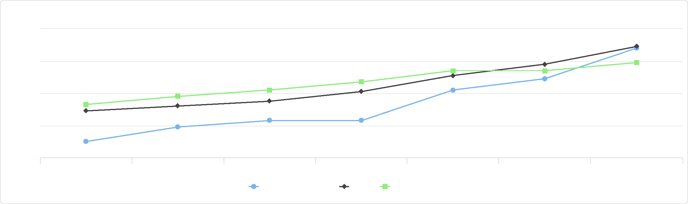

Medicare Population with Depression by Year, 2011 through 2017

20

12

2011 2012 2013 2014 2015 2016 2017

Jackson County, IA Iowa United States

%

18

16

14

Medicare Population with Depression, Percentage by Age

50

40

|  |  |  |  |  |  |  |  |  |  |  |
| --- | --- | --- | --- | --- | --- | --- | --- | --- | --- | --- |
|  | 30  20 |  |  |  |  |  |  |  |  |  |
| % |  |  |  |  |  |  |  |  |
|  |  |  |  |  |  |  |  |  |
|  |  |  |  |  |  |  |  |  |  |
|  | 10  0 |  |  |  |  |  |  |  |  |
|  |  |  |  |  |  |  |  |  |
|  |  |  |  |  |  |  |  |  |  |

65 Years and Older Less than 65 Years

Jackson County, IA Iowa United States



|  |  |  |  |
| --- | --- | --- | --- |
| **Report Area** | **Population Age**  **20+** | **Adults with Diagnosed  Diabetes** | **Adults with Diagnosed Diabetes, Age‐Adjusted**  **Rate** |
| Jackson County, IA | 14,682 | 1,571 | **8.8%** |
| Iowa | 2,322,854 | 230,654 | 8.6% |
| United States | 245,628,960 | 25,942,874 | 9.5% |

*Note: This indicator is compared to the state average.*

*Data Source: Centers for Disease Control and Prevention,* [*National Center for Chronic Disease Prevention and Health Promotion*](http://www.cdc.gov/nccdphp/dnpao/index.html)*. 2017. Source geography: County*

Percentage of Adults with   
Diagnosed Diabetes   
(Age-Adjusted), 2016

|  |  |
| --- | --- |
|  | |
| 0% 15% | |
|  | Jackson County (8.8%)  Iowa (8.6%)  United States (9.5%) |

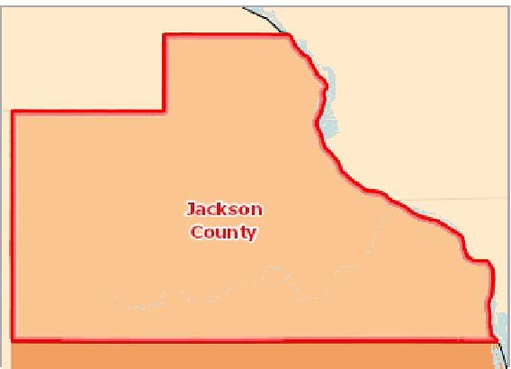

[](https://engagementnetwork.org/map-room/?ids=32689,t11&def=t11:FIPS%20In%20('19097')&bbox=-10120449.27515,5164829.551058,-10034264.57655,5219471.283242) View larger map

**Diabetes Prevalence, Percent of Adults Age 20+ by County, CDC NCCDPHP 2017**

Over 11.0%

9.6 ‐ 11.0%

8.1 ‐ 9.5%

Under 8.1%

No Data or Data Suppressed

Jackson County, IA



Adults with Diagnosed Diabetes by Gender, 2017

The table below displays national, state, and local variation in the prevalence of diabetes among the adult population by gender.

|  |  |  |  |  |
| --- | --- | --- | --- | --- |
| **Report Area** | **Male** | **Male, Percent** | **Female** | **Female, Percent** |
| Jackson County, IA | 868 | 10.0% | 703 | 7.7% |
| Iowa | 118,175 | 9.3% | 112,472 | 8.1% |
| United States | 12,926,433 | 10.1% | 12,576,507 | 8.9% |

Adults with Diagnosed Diabetes by Year, 2004 through 2017

The table below displays trends in the percentage of adults with diabetes for years 2004 through 2017.

|  |  |  |  |  |  |  |  |  |  |  |  |  |  |  |
| --- | --- | --- | --- | --- | --- | --- | --- | --- | --- | --- | --- | --- | --- | --- |
| **Report Area** | **2004** | **2005** | **2006** | **2007** | **2008** | **2009** | **2010** | **2011** | **2012** | **2013** | **2014** | **2015** | **2016** | **2017** |
| Jackson County, IA | 6.1% | 6.5% | 6.7% | 6.7% | 6.7% | 6.6% | 7.5% | 9.0% | 9.4% | 9.4% | 8.0% | 8.0% | 4.9% | 8.8% |
| Iowa | 21.0% | 20.6% | 20.9% | 21.3% | 21.7% | 22.7% | 22.5% | 21.7% | 22.2% | 21.0% | 21.6% | 20.1% | 20.7% | 19.6% |
| United States | 22.5% | 22.3% | 22.2% | 22.4% | 22.6% | 22.6% | 22.1% | 21.2% | 21.2% | 20.4% | 21.0% | 20.1% | 21.1% | 20.4% |

Adults with Diagnosed Diabetes by Gender, 2017

12.5

|  |  |  |  |  |  |  |
| --- | --- | --- | --- | --- | --- | --- |
|  | 10 7.5 5 2.5  0 |  |  |  |  |  |
|  |  |  |  |  |
| % |  |  |  |
|  |  |  |  |
|  |  |  |  |
|  |  |  |  |  |  |

% %

Jackson County, IA Iowa United States



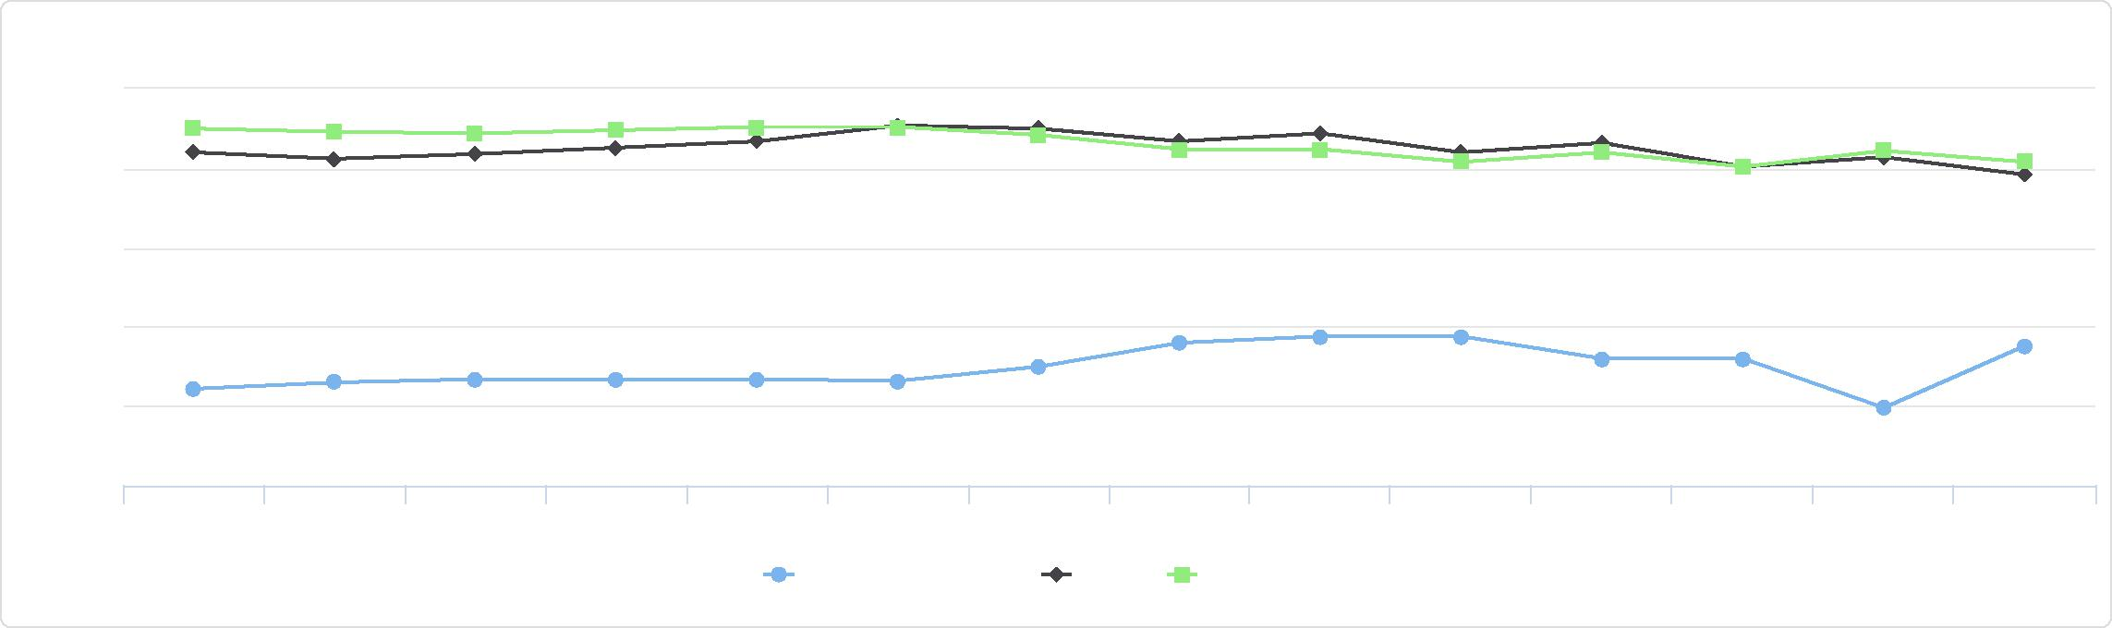

Adults with Diagnosed Diabetes by Year, 2004 through 2017

5

0

2004 2005 2006 2007 2008 2009 2010 2011 2012 2013 2014 2015 2016 2017

Jackson County, IA Iowa United States

25

20

15

%

10

## Diabetes (Medicare Population)

In the report area, there were 816 cases with Diabetes out of the 3,204 total Medicare Fee‐for‐Service beneficiaries. This 25.5% is greater than the state's reported 24.2%.

|  |  |  |  |
| --- | --- | --- | --- |
| **Report Area** | **Total Medicare Fee‐for‐Service  Beneficiaries** | **Beneficiaries with  Diabetes** | **Beneficiaries with Diabetes,  Percent** |
| Jackson County, IA | 3,204 | 816 | **25.5%** |
| Iowa | 462,029 | 111,590 | 24.2% |
| United States | 33,725,823 | 9,188,128 | 27.2% |

*Note: This indicator is compared to the state average.*

*Data Source: Centers for Medicare and Medicaid Services,* [*CMS Geographic Variation Public Use File*](https://www.cms.gov/Research-Statistics-Data-and-Systems/Statistics-Trends-and-Reports/Medicare-Geographic-Variation/GV_PUF) *. 2017. Source geography: County*

Percentage of Medicare Beneficiaries with Diabetes

|  |  |
| --- | --- |
|  | |
| 0% 60% | |
|  | Jackson County (25.5%)  Iowa (24.2%)  United States (27.2%) |

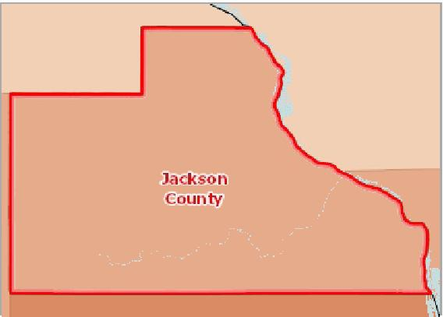

[](https://engagementnetwork.org/map-room/?ids=25603,t11&def=t11:FIPS%20In%20('19097')&bbox=-10120449.27515,5164829.551058,-10034264.57655,5219471.283242) View larger map

**Beneficiaries with Diabetes, Percent by County, CMS 2017**

Over 30.0%

27.1 ‐ 30.0%

24.1 ‐ 27.0%

Under 24.1%

No Data or Data Suppressed

Jackson County, IA



Medicare Population with Diabetes by Year, 2011 through 2017

|  |  |  |  |  |  |  |  |
| --- | --- | --- | --- | --- | --- | --- | --- |
| **Report Area** | **2011** | **2012** | **2013** | **2014** | **2015** | **2016** | **2017** |
| Jackson County, IA | 24.7% | 25.2% | 24.3% | 24.2% | 25.1% | 25.0% | 25.5% |
| Iowa | 24.1% | 24.2% | 24.1% | 24.1% | 24.2% | 24.0% | 24.2% |
| United States | 27.5% | 27.6% | 27.5% | 27.4% | 27.4% | 27.3% | 27.2% |

Medicare Population with Diabetes by Year, 2011 through 2017

28





27

26

|  |  |  |  |  |  |  |
| --- | --- | --- | --- | --- | --- | --- |
| 25 |  |  |  |  |  |  |
|  |  |  |  |  |

%

|  |  |  |  |  |  |
| --- | --- | --- | --- | --- | --- |
| 24 |  |  |  |  |  |
|  |  |  |
|  |  |  |  |

23

2011 2012 2013 2014 2015 2016 2017

Jackson County, IA Iowa United States



Medicare Population with Diabetes, Percentage by Age

|  |  |  |
| --- | --- | --- |
| **Report Area** | **65 Years and Older** | **Less than 65 Years** |
| Jackson County, IA | 25.8% | 23.8% |
| Iowa | 24.0% | 25.0% |
| United States | 27.4% | 26.6% |

## Heart Disease (Adult)

1,182, or 5.40% of adults aged 18 and older have ever been told by a doctor that they have coronary heart disease or angina. This indicator is relevant because coronary heart disease is a leading cause of death in the U.S. and is also related to high blood pressure, high cholesterol, and heart attacks.

Medicare Population with Diabetes, Percentage by Age

30

|  |  |  |  |  |  |  |
| --- | --- | --- | --- | --- | --- | --- |
|  | 20  10  0 |  |  |  |  |  |
| % |  |  |  |
|  |  |  |  |
|  |  |  |  |  |  |

65 Years and Older Less than 65 Years

Jackson County, IA Iowa United States



|  |  |  |  |
| --- | --- | --- | --- |
| **Report Area** | **Survey Population (Adults Age 18+)** | **Total Adults with Heart Disease** | **Percent Adults with Heart Disease** |
| Jackson County, IA | 21,943 | 1,182 | **5.40%** |
| Iowa | 2,307,278 | 96,325 | 4.20% |
| United States | 236,406,904 | 10,407,185 | 4.40% |

*Note: This indicator is compared to the state average.*

*Data Source: Centers for Disease Control and Prevention,* [*Behavioral Risk Factor Surveillance System*](http://www.cdc.gov/brfss/)*. Additional data analysis by* [*CARES*](http://cares.missouri.edu)*. 2011‐12. Source geography: County*

Percent Adults with Heart Disease

|  |  |
| --- | --- |
|  | |
| 0% 15% | |
|  | Jackson County (5.40%)  Iowa (4.20%)  United States (4.40%) |

**Heart Disease (Diagnosed), Percentage of Adults Age 18+ by County, BRFSS 2011‐12**

Over 7.0%

5.1 ‐ 7.0%

3.1 ‐ 5.0%

Under 3.1%

No Data or Data Suppressed

Jackson County, IA

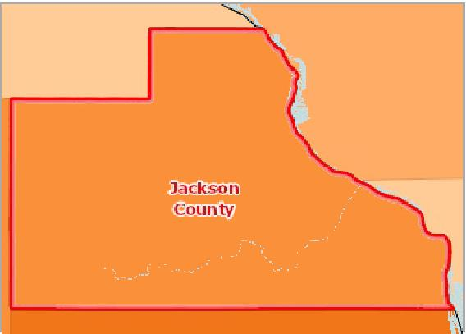

[](https://engagementnetwork.org/map-room/?ids=6335,t11&def=t11:FIPS%20In%20('19097')&bbox=-10120449.27515,5164829.551058,-10034264.57655,5219471.283242) View larger map



Heart Disease Prevalence by Year, 2011 through 2019

The table and chart below display trends in the percentage of population who had angina ir coronary heart disease for years 2011 through 2019.

|  |  |  |  |  |  |  |  |  |  |
| --- | --- | --- | --- | --- | --- | --- | --- | --- | --- |
| **Report Area** | **2011** | **2012** | **2013** | **2014** | **2015** | **2016** | **2017** | **2018** | **2019** |
| Iowa | 3.3% | 4.0% | 4.0% | 3.6% | 3.2% | 3.3% | 3.5% | 3.6% | 3.1% |
| United States | 4.1% | 4.3% | 4.0% | 4.1% | 3.7% | 4.0% | 3.7% | 3.9% | 3.6% |

*Note: No county data available. See data source and methodology for more details.*

Adults Ever Diagnosed with Heart Disease, Percentage by Race / Ethnicity

|  |  |  |  |  |
| --- | --- | --- | --- | --- |
| **Report Area** | **Non‐Hispanic White** | **Non‐Hispanic Black** | **Non‐Hispanic Other Race** | **Hispanic or Latino** |
| Iowa | 4.3% | 2.4% | 4.2% | 2.3% |
| United States | 5.0% | 3.6% | 3.2% | 2.9% |

*Note: No county data available. See data source and methodology for more details.*

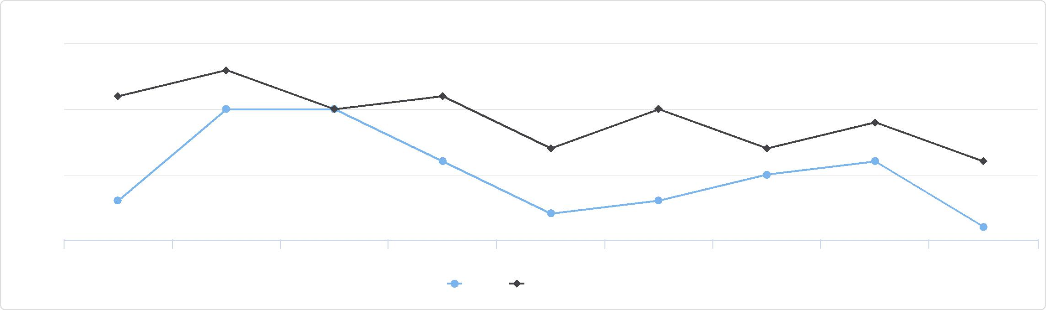

Heart Disease Prevalence by Year, 2011 through 2019

4.5

3

2011 2012 2013 2014 2015 2016 2017 2018 2019

Iowa United States

%

3.5

4

Adults Ever Diagnosed with Heart Disease, Percentage by Race / Ethnicity

6

|  |  |  |  |  |  |  |  |  |  |  |
| --- | --- | --- | --- | --- | --- | --- | --- | --- | --- | --- |
|  | 4  2  0 |  |  |  |  |  |  |  |  |  |
| % |  |  |  |  |  |  |  |
|  |  |  |  |  |  |
|  |  |  |  |  |  |  |  |  |  |

Non-Hispanic White Non-Hispanic Black Non-Hispanic Other Race Hispanic or Latino

Iowa United States



## Heart Disease (Medicare Population)

In the report area, there were 733 cases with Heart Disease out of the 3,204 total Medicare Fee‐for‐Service beneficiaries. This 22.9% is less than the state's reported 24.0%.

|  |  |  |  |
| --- | --- | --- | --- |
| **Report Area** | **Total Medicare Fee‐for‐Service  Beneficiaries** | **Beneficiaries with Heart Disease** | **Beneficiaries with Heart Disease, Percent** |
| Jackson  County, IA | 3,204 | 733 | **22.9%** |
| Iowa | 462,029 | 110,821 | 24.0% |
| United States | 33,725,823 | 9,076,698 | 26.9% |

*Note: This indicator is compared to the state average.*

*Data Source: Centers for Medicare and Medicaid Services,* [*CMS Geographic Variation Public Use File*](https://www.cms.gov/Research-Statistics-Data-and-Systems/Statistics-Trends-and-Reports/Medicare-Geographic-Variation/GV_PUF) *. 2017. Source geography: County*

Percentage of Medicare Beneficiaries with Heart Disease

|  |  |
| --- | --- |
|  | |
| 0% 60% | |
|  | Jackson County (22.9%)  Iowa (24.0%)  United States (26.9%) |

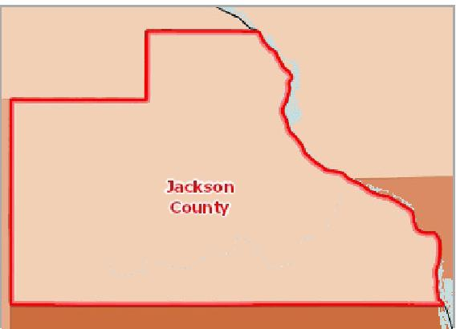

[](https://engagementnetwork.org/map-room/?ids=25608,t11&def=t11:FIPS%20In%20('19097')&bbox=-10120449.27515,5164829.551058,-10034264.57655,5219471.283242) View larger map

**Beneficiaries with Ischemic Heart Disease, Percent by County, CMS 2017**

Over 31.0%

27.1 ‐ 31.0%

23.1 ‐ 27.0%

Under 23.1%

No Data or Data Suppressed

Jackson County, IA



Medicare Population with Heart Disease by Year, 2011 through 2017

|  |  |  |  |  |  |  |  |
| --- | --- | --- | --- | --- | --- | --- | --- |
| **Report Area** | **2011** | **2012** | **2013** | **2014** | **2015** | **2016** | **2017** |
| Jackson County, IA | 25.9% | 26.0% | 25.5% | 24.8% | 24.7% | 23.7% | 22.9% |
| Iowa | 26.0% | 25.7% | 25.1% | 24.5% | 24.2% | 23.9% | 24.0% |
| United States | 29.8% | 29.2% | 28.4% | 27.7% | 27.2% | 27.0% | 26.9% |

Medicare Population with Heart Disease by Year, 2011 through 2017

32.5

|  |  |  |  |  |  |
| --- | --- | --- | --- | --- | --- |
|  | 30 |  |  |  |  |
|  |  |  | |  |
| % | 27.5 |  |  |
|  |  |
|  | 25 |  |  |
|  |  |  |

22.5



2011 2012 2013 2014 2015 2016 2017

Jackson County, IA Iowa United States



Medicare Population with Heart Disease, Percentage by Age

|  |  |  |
| --- | --- | --- |
| **Report Area** | **65 Years and Older** | **Less than 65 Years** |
| Jackson County, IA | 14.3% | 6.2% |
| Iowa | 13.4% | 8.8% |
| United States | 14.5% | 10.3% |

Medicare Population with Heart Disease, Percentage by Age

## High Blood Pressure (Adult)

2,850, or 18.70% of adults aged 18 and older have ever been told by a doctor that they have high blood pressure or hypertension.

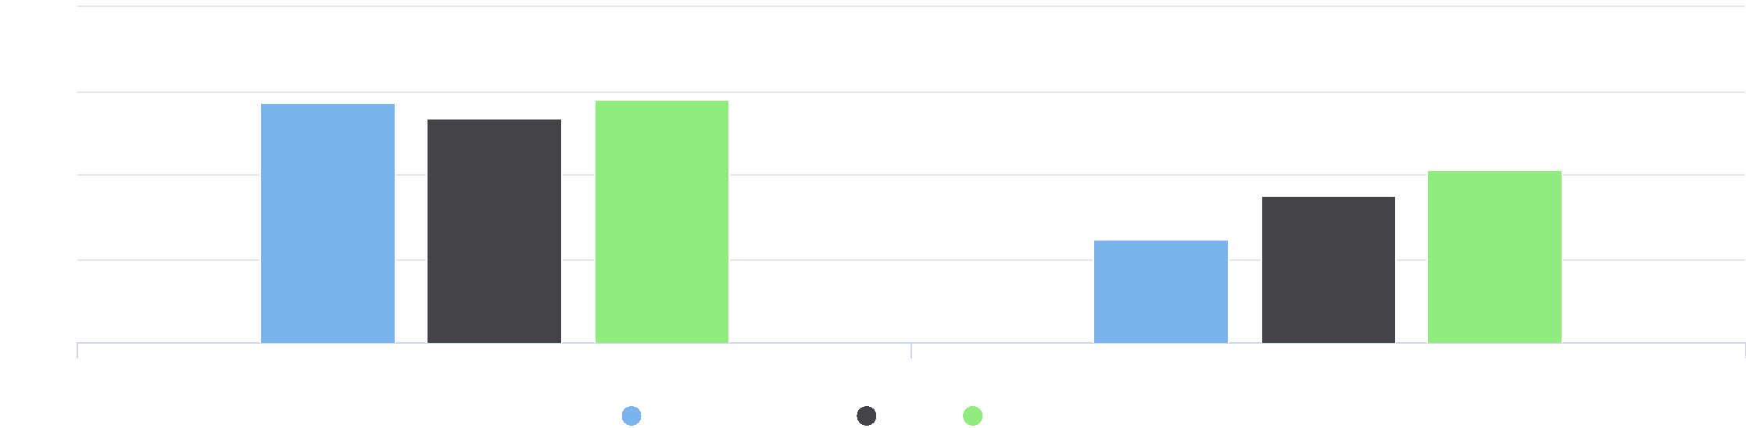

20

15

5

0

65 Years and Older Less than 65 Years

Jackson County, IA Iowa United States

%

10

|  |  |  |  |
| --- | --- | --- | --- |
| **Report Area** | **Total  Population  (Age 18+)** | **Total Adults with High Blood  Pressure** | **Percent Adults with High Blood  Pressure** |
| Jackson County, IA | 15,242.00 | 2,850 | **18.70%** |
| Iowa | 2,307,562.00 | 581,506 | 25.20% |
| United States | 232,556,016.00 | 65,476,522 | 28.20% |

*Note: This indicator is compared to the state average.*

*Data Source: Centers for Disease Control and Prevention,* [*Behavioral Risk Factor Surveillance System*](http://www.cdc.gov/brfss/)*. Accessed via the* [*Health Indicators Warehouse*](http://healthindicators.gov)*. US Department of Health & Human*

*Services,* [*Health Indicators Warehouse*](https://healthdata.gov/dataset/health-indicators-warehouse)*. 2006‐12. Source geography: County*

Percent Adults with High Blood Pressure

|  |  |
| --- | --- |
|  | |
|  | 0% 40%  Jackson County (18.70%)  Iowa (25.20%)  United States (28.20%) |

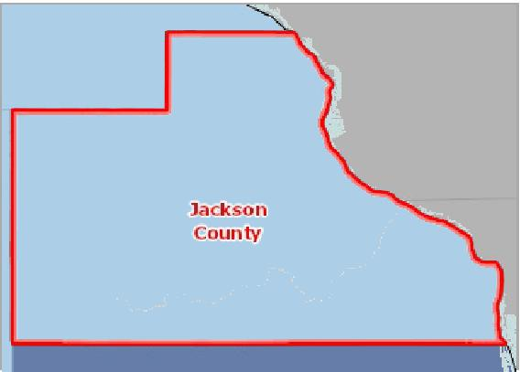

[](https://engagementnetwork.org/map-room/?ids=5441,t11&def=t11:FIPS%20In%20('19097')&bbox=-10120449.27515,5164829.551058,-10034264.57655,5219471.283242) View larger map

**High Blood Pressure, Percent of Adults Age 18+ by County, BRFSS 2006‐12**

Over 35.0%

30.1 ‐ 35.0%

25.1 ‐ 30.0%

Under 25.1%

No Data or Data Suppressed

Jackson County, IA



High Blood Pressure Prevalence Trend over Time, 2011 through 2019

The table and chart below display trends in the percentage of population with high blood pressure over time.

|  |  |  |  |  |  |
| --- | --- | --- | --- | --- | --- |
| **Report Area** | **2011** | **2013** | **2015** | **2017** | **2019** |
| Iowa | 27.5% | 28.6% | 27.6% | 28.3% | 28.7% |
| United States | 30.2% | 30.6% | 30.0% | 30.3% | 30.5% |

*Note: No county data available. See data source and methodology for more details.*

## High Blood Pressure (Medicare Population)

In the report area, there were 1,731 cases with High Blood Pressure out of the 3,204 total Medicare Fee‐for‐Service beneficiaries. This 54.0% is greater than the state's reported 53.6%.



High Blood Pressure Prevalence Trend over Time, 2011 through 2019



31



30

29

%

|  |  |  |  |  |  |
| --- | --- | --- | --- | --- | --- |
| 28 |  |  |  |  |  |
|  |  |  |  |

27

2011 2013 2015 2017 2019

Iowa United States



|  |  |  |  |
| --- | --- | --- | --- |
| **Report Area** | **Total Medicare Fee‐for‐Service Beneficiaries** | **Beneficiaries with High  Blood Pressure** | **Beneficiaries with High Blood  Pressure, Percent** |
| Jackson County, IA | 3,204 | 1,731 | **54.0%** |
| Iowa | 462,029 | 247,751 | 53.6% |
| United States | 33,725,823 | 19,269,721 | 57.1% |

Percentage of Medicare   
Beneficiaries with High Blood   
Pressure

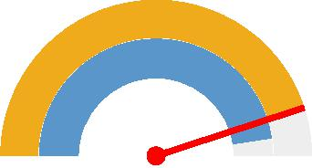

0% 60%

Jackson County (54.0%)

Iowa (53.6%)

United States (57.1%)



*Note: This indicator is compared to the state average.*

*Data Source: Centers for Medicare and Medicaid Services,* [*CMS Geographic Variation Public Use File*](https://www.cms.gov/Research-Statistics-Data-and-Systems/Statistics-Trends-and-Reports/Medicare-Geographic-Variation/GV_PUF) *. 2017. Source geography: County*

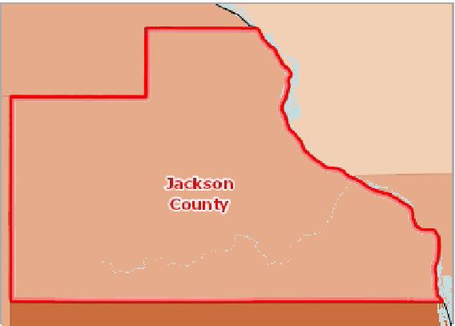

[](https://engagementnetwork.org/map-room/?ids=25607,t11&def=t11:FIPS%20In%20('19097')&bbox=-10120449.27515,5164829.551058,-10034264.57655,5219471.283242) View larger map

**Beneficiaries with High Blood Pressure, Percent by County, CMS 2017**

Over 62.0%

56.1 ‐ 62.0%

48.1 ‐ 56.0%

Under 48.1%

No Data or Data Suppressed

Jackson County, IA



Medicare Population with High Blood Pressure by Year, 2011 through 2017

|  |  |  |  |  |  |  |  |
| --- | --- | --- | --- | --- | --- | --- | --- |
| **Report Area** | **2011** | **2012** | **2013** | **2014** | **2015** | **2016** | **2017** |
| Jackson County, IA | 52.0% | 53.0% | 52.9% | 52.0% | 53.8% | 53.7% | 54.0% |
| Iowa | 52.1% | 52.0% | 52.1% | 51.7% | 52.0% | 52.8% | 53.6% |
| United States | 56.7% | 56.7% | 56.8% | 56.5% | 56.6% | 56.9% | 57.1% |

Medicare Population with High Blood Pressure, Percentage by Age

|  |  |  |
| --- | --- | --- |
| **Report Area** | **65 Years and Older** | **Less than 65 Years** |
| Jackson County, IA | 58.5% | 33.9% |
| Iowa | 56.1% | 37.3% |
| United States | 59.9% | 42.6% |

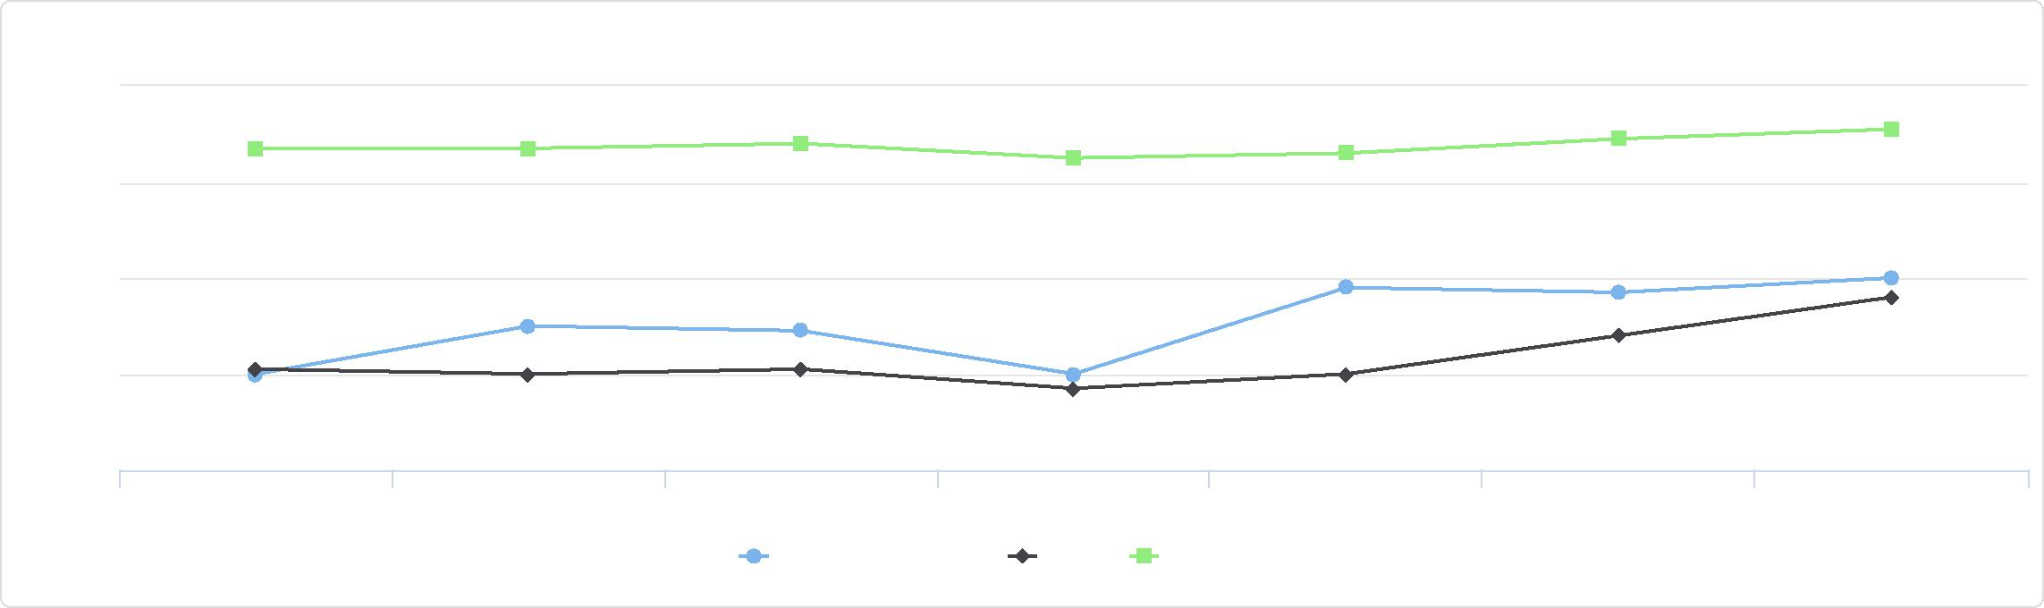

%

54

Medicare Population with High Blood Pressure by Year, 2011 through 2017

52

50

2011 2012 2013 2014 2015 2016 2017

Jackson County, IA Iowa United States

56

58

Medicare Population with High Blood Pressure, Percentage by Age

80

|  |  |  |  |  |  |  |
| --- | --- | --- | --- | --- | --- | --- |
|  | 60  40  20  0 |  |  |  |  |  |
| % |  |  | | |  |
|  |  |
|  |  |  |
|  |  |  |  |  |  |

65 Years and Older Less than 65 Years

Jackson County, IA Iowa United States



## High Cholesterol (Adult)

This indicator reports the percentage of adults aged 18 and older who self‐report that they have ever been told by a doctor, nurse, or other health professional that they had high blood cholesterol.

Percent Adults with High   
Cholesterol

|  |  |
| --- | --- |
|  | |
|  | 0% 40%  Jackson County (35.00%)  Iowa (37.91%)  United States (38.52%) |

|  |  |  |  |
| --- | --- | --- | --- |
| **Report Area** | **Survey Population (Adults Age 18+)** | **Total Adults with High Cholesterol** | **Percent Adults with High Cholesterol** |
| Jackson County, IA | 17,356 | 6,074 | **35.00%** |
| Iowa | 1,741,545 | 660,181 | 37.91% |
| United States | 180,861,326 | 69,662,357 | 38.52% |

*Note: This indicator is compared to the state average.*

*Data Source: Centers for Disease Control and Prevention,* [*Behavioral Risk Factor Surveillance System*](http://www.cdc.gov/brfss/)*. Additional data analysis by* [*CARES*](http://cares.missouri.edu)*. 2011‐12. Source geography: County*

**High Cholesterol (Diagnosed), Percentage of Adults Age 18+ by County, BRFSS 2011‐12**

Over 48.0%

42.1 ‐ 48.0%

36.1 ‐ 42.0%

Under 36.1%

No Data or Data Suppressed

Jackson County, IA

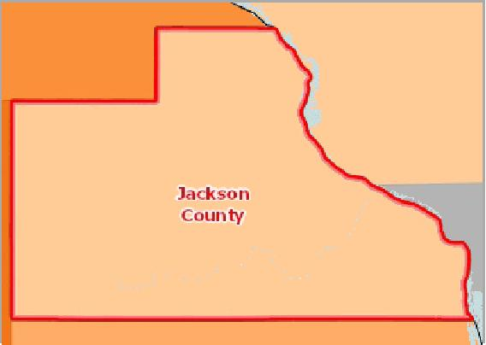

[](https://engagementnetwork.org/map-room/?ids=6340,t11&def=t11:FIPS%20In%20('19097')&bbox=-10120449.27515,5164829.551058,-10034264.57655,5219471.283242) View larger map



High Cholesterol Trend over Time, 2011 through 2019

The table and chart below display trends in the percentage of population with high cholesterol over time.

|  |  |  |  |  |  |
| --- | --- | --- | --- | --- | --- |
| **Report Area** | **2011** | **2013** | **2015** | **2017** | **2019** |
| Iowa | 32.7% | 35.2% | 30.6% | 28.3% | 28.0% |
| United States | 33.9% | 33.6% | 31.7% | 29.4% | 29.0% |

*Note: No county data available. See data source and methodology for more details.*

Adults Ever Diagnosed with High Cholesterol, Percentage by Race / Ethnicity

High Cholesterol Trend over Time, 2011 through 2019

37.5

|  |  |  |  |  |
| --- | --- | --- | --- | --- |
|  | 35 |  |  |  |
|  |  |  |
| % | 32.5 |  |  |
|  |  |
|  | 30 |  |  |
|  |  |  |

27.5

2011 2013 2015 2017 2019

Iowa United States



|  |  |  |  |  |
| --- | --- | --- | --- | --- |
| **Report Area** | **White**  **(Non‐Hispanic)** | **Black**  **(Non‐Hispanic)** | **Other Race  (Non‐Hispanic)** | **Hispanic / Latino** |
| Iowa | 38.3% | 24.7% | 45.8% | 23.9% |
| United States | 40.0% | 34.3% | 35.4% | 36.0% |

*Note: No county data available. See data source and methodology for more details.*

## High Cholesterol (Medicare Population)

This indicator reports the percentage of the Medicare fee‐for‐service population with hyperlipidemia, which is typically associated with high cholesterol.

Adults Ever Diagnosed with High Cholesterol, Percentage by Race / Ethnicity

60

|  |  |  |  |  |  |  |  |  |  |  |  |
| --- | --- | --- | --- | --- | --- | --- | --- | --- | --- | --- | --- |
|  | 40  20  0 |  |  |  |  |  |  |  |  |  |  |
| % |  |  | |  |  |  |  |  |  |
|  |  |  |  |  |  |
|  |  |  |  |  |  |  |  |  |  |  |

White Black Other Race Hispanic / Latino

(Non-Hispanic) (Non-Hispanic) (Non-Hispanic)

Iowa United States



|  |  |  |  |
| --- | --- | --- | --- |
| **Report Area** | **Total Medicare Fee‐for‐Service  Beneficiaries** | **Beneficiaries with High  Cholesterol** | **Percent with High  Cholesterol** |
| Jackson County, IA | 3,204 | 1,416 | **44.2%** |
| Iowa | 462,029 | 179,615 | 38.9% |
| United States | 33,725,823 | 13,714,033 | 40.7% |

*Note: This indicator is compared to the state average.*

*Data Source: Centers for Medicare and Medicaid Services,* [*CMS Geographic Variation Public Use File*](https://www.cms.gov/Research-Statistics-Data-and-Systems/Statistics-Trends-and-Reports/Medicare-Geographic-Variation/GV_PUF) *. 2017. Source geography: County*

Percentage of Medicare   
Beneficiaries with High   
Cholesterol

|  |  |
| --- | --- |
|  | |
| 0% 60% | |
|  | Jackson County (44.2%)  Iowa (38.9%)  United States (40.7%) |

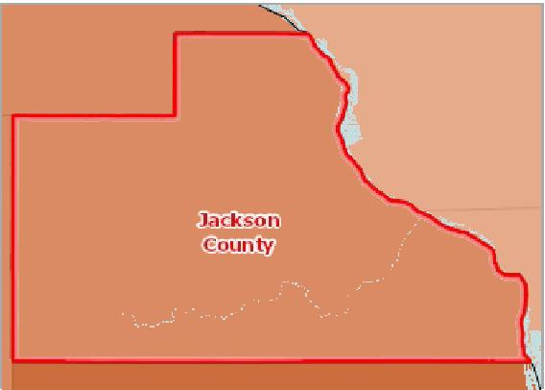

[](https://engagementnetwork.org/map-room/?ids=25604,t11&def=t11:FIPS%20In%20('19097')&bbox=-10120449.27515,5164829.551058,-10034264.57655,5219471.283242) View larger map

**Beneficiaries with High Cholesterol, Percent by County, CMS 2017**

Over 48.0%

42.1 ‐ 48.0%

36.1 ‐ 42.0%

Under 36.1%

No Data or Data Suppressed

Jackson County, IA



Medicare Population with High Cholesterol by Year, 2011 through 2017

This indicator reports the percentage of the Medicare fee‐for‐service population with high cholesterol over time.

|  |  |  |  |  |  |  |  |
| --- | --- | --- | --- | --- | --- | --- | --- |
| **Report Area** | **2011** | **2012** | **2013** | **2014** | **2015** | **2016** | **2017** |
| Jackson County, IA | 44.9% | 45.6% | 45.2% | 45.1% | 47.0% | 46.4% | 44.2% |
| Iowa | 40.8% | 40.9% | 40.8% | 40.3% | 41.0% | 40.6% | 38.9% |
| United States | 45.5% | 45.8% | 46.0% | 45.9% | 45.9% | 45.1% | 40.7% |

Medicare Population with High Cholesterol, Percentage by Age

This indicator reports the prevalence of high cholesterol among Medicare beneficiaries by age.

|  |  |  |
| --- | --- | --- |
| **Report Area** | **65 Years and Older** | **Less than 65 Years** |
| Jackson County, IA | 47.8% | 28.1% |
| Iowa | 40.6% | 27.2% |
| United States | 43.0% | 28.4% |

## Infant Mortality

This indicator reports the rate of deaths to infants less than one year of age per 1,000 births. This indicator is relevant because high rates of infant mortality indicate the existence of broader issues pertaining to access to care and maternal and child health.

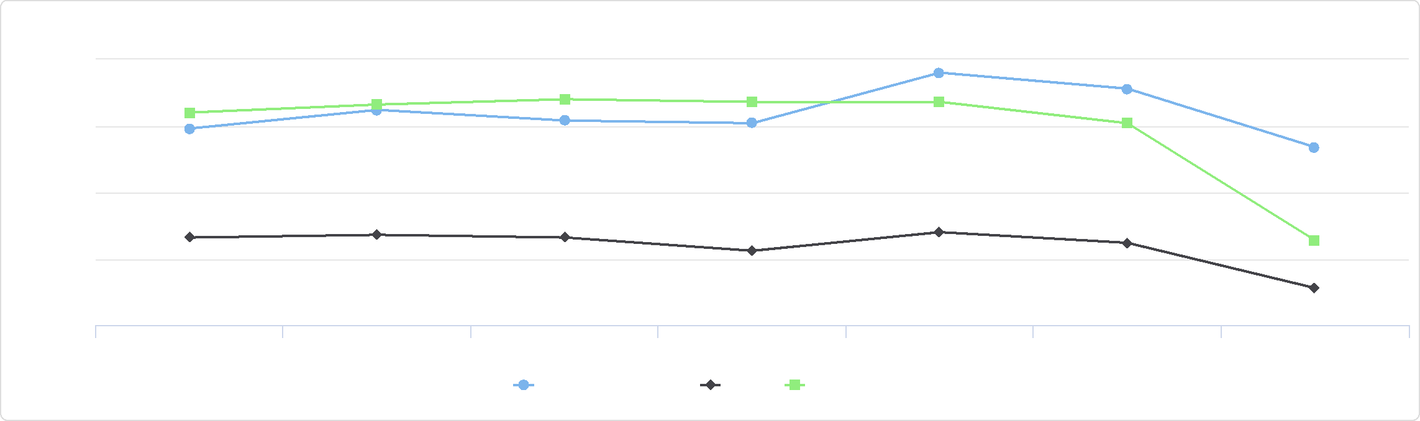

Medicare Population with High Cholesterol by Year, 2011 through 2017

47.5

37.5

2011 2012 2013 2014 2015 2016 2017

Jackson County, IA Iowa United States

%

42.5

45

40

Medicare Population with High Cholesterol, Percentage by Age

60

|  |  |  |  |  |  |  |
| --- | --- | --- | --- | --- | --- | --- |
|  | 40  20  0 |  |  |  |  |  |
| % |  |  |  |  |
|  |  |  |  |
|  |  |  |  |  |  |

65 Years and Older Less than 65 Years

Jackson County, IA Iowa United States



|  |  |  |  |
| --- | --- | --- | --- |
| **Report Area** | **Total Births** | **Infant Deaths** | **Infant Mortality Rate (Per 1,000 Births)** |
| Jackson County, IA | 1,015 | 4 | **3.90** |
| Iowa | 199,795 | 1,039 | 5.20 |
| United States | 20,913,535 | 136,369 | 6.50 |

*Note: This indicator is compared to the state average.*

*Data Source: US Department of Health & Human Services, Health Resources and Services Administration,* [*Area Health Resource File*](https://datawarehouse.hrsa.gov/topics/ahrf.aspx)*. 2006‐10. Source geography: County*

Infant Mortality Rate (Per 1,000

Births)

|  |  |
| --- | --- |
|  | |
| 0 10 | |
|  | Jackson County (3.90)  Iowa (5.20)  United States (6.50) |

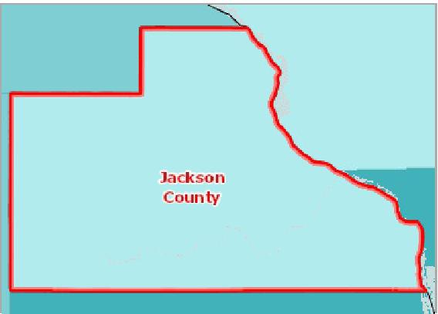

[](https://engagementnetwork.org/map-room/?ids=5716,t11&def=t11:FIPS%20In%20('19097')&bbox=-10120449.27515,5164829.551058,-10034264.57655,5219471.283242) View larger map

**Infant Mortality, Rate (Per 1,000 Live Births) by County, AHRF 2006‐10**

Over 10.0

8.1 ‐ 10.0

5.1 ‐ 8.0

Under 5.1

No Data or Data Suppressed

Jackson County, IA



Infant Mortality Rate (Per 1,000 Live Births) by Race / Ethnicity

|  |  |  |  |  |  |
| --- | --- | --- | --- | --- | --- |
| **Report Area** | **Non‐Hispanic White** | **Non‐Hispanic Black** | **Asian or Pacific Islander** | **American Indian or Alaska Native** | **Hispanic or Latino** |
| Jackson County, IA | No data | No data | No data | No data | No data |
| Iowa | 4.80 | 11.40 | 4.10 | No data | 6.30 |
| United States | 5.50 | 12.70 | 4.50 | 8.50 | 5.40 |

## Low Birth Weight

This indicator reports the percentage of total births that are low birth weight (Under 2500g). This indicator is relevant because low birth weight infants are at high risk for health problems. This indicator can also highlight the existence of health disparities. Out of a total 1,470 live births in the report area, 97 or 6.60% were considered low birth weight.

Infant Mortality Rate (Per 1,000 Live Births) by Race / Ethnicity

15

|  |  |  |  |  |  |  |  |  |  |  |  |  |  |  |  |
| --- | --- | --- | --- | --- | --- | --- | --- | --- | --- | --- | --- | --- | --- | --- | --- |
| 10 |  |  |  |  |  |  |  |  |  |  |  |  |  |  |  |
|  |  |  |  |  |  |  |  |  |  |  |  |  |  |
|  |  |  |  |  |  |  |  |  |  |  |  |  |  |  |
|  |  |  |  |  |  |  |  |  |  |  |  |  |  |  |
| 5 |  |  |  |  |  |  |  |  |  |  |  |  |  |
|  |  |  |  |  |  |  |  |  |  |  |  |  |
|  |  |  |  |  |  |  |  |  |  |  |  |  |
|  |  |  |  |  |  |  |  |  |  |  |  |  |  |
|  |  |  |  |  |  |  |  |  |  |  |  |  |  |
| 0 |  |  |  |  |  |  |  |  |  |  |  |  |  |
|  |  |  |  |  |  |  |  |  |  |  |  |  |  |  |

Non-Hispanic White Non-Hispanic Black Asian or Pacific Islander American Indian or Alaska Native Hispanic or Latino

Iowa United States



|  |  |  |  |
| --- | --- | --- | --- |
| **Report Area** | **Total Live Births** | **Low Weight Births  (Under 2500g)** | **Low Weight Births, Percent** |
| Jackson County, IA | 1,470 | 97 | **6.60%** |
| Iowa | 277,340 | 18,859 | 6.80% |
| United States | 29,300,495 | 2,402,641 | 8.20% |

*Note: This indicator is compared to the state average.*

[*Data Source: Centers for Disease Control and Prevention,*](https://healthdata.gov/dataset/health-indicators-warehouse) *National Vital Statistics System. Accessed via CDC WONDER. US Department of Health & Human Services, Health Indicators*

[*Warehouse.*](https://healthdata.gov/dataset/health-indicators-warehouse) *2006‐12. Source geography: County*

Percent Low Birth Weight Births

|  |  |
| --- | --- |
|  | |
| 0% 15% | |
|  | Jackson County (6.60%)  Iowa (6.80%)  United States (8.20%) |

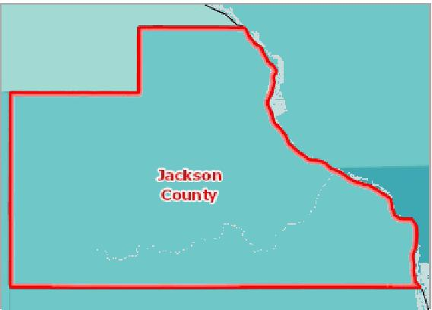

[](https://engagementnetwork.org/map-room/?ids=5707,t11&def=t11:FIPS%20In%20('19097')&bbox=-10120449.27515,5164829.551058,-10034264.57655,5219471.283242) View larger map

**Low Birth Weight, Percent of Live Births by County, NVSS 2006‐12**

Over 10.0%

8.1 ‐ 10.0%

6.1 ‐ 8.0%

Under 6.1%

No Data or Data Suppressed

Jackson County, IA



Babies Born with Low Birth Weight, Percent by Race / Ethnicity

|  |  |  |  |  |  |  |  |
| --- | --- | --- | --- | --- | --- | --- | --- |
| **Report Area** | **Non‐Hispanic White** | **Non‐Hispanic Black** | | **Non‐Hispanic Asian or Pacific Islander** | | **Hispanic or Latino** | |
| Jackson County, IA | 6.40% | No data |  | No data |  | No data |  |
| Iowa | 6.50% |  | 11.60% |  | 7.80% |  | 6.10% |
| United States | 7.20% |  | 13.60% |  | 8.20% |  | 7.00% |

Babies Born with Low Birth Weight, Percent by Time Period,   
2002‐2008 through 2006‐2012

|  |  |  |  |  |  |
| --- | --- | --- | --- | --- | --- |
| **Report Area** | **2002‐2008** | **2003‐2009** | **2004‐2010** | **2005‐2011** | **2006‐2012** |
| Jackson County, IA | 6.40% | 6.50% | 6.80% | 6.60% | 6.60% |
| Iowa | 6.80% | 6.80% | 6.90% | 6.80% | 6.80% |
| United States | 8.10% | 8.10% | 8.20% | 8.20% | 8.20% |

Babies Born with Low Birth Weight, Percent by Race / Ethnicity

15

|  |  |  |  |  |  |  |  |  |  |  |
| --- | --- | --- | --- | --- | --- | --- | --- | --- | --- | --- |
|  | 10  5  0 |  |  |  |  |  |  |  |  |  |
| % |  |  |  |  |  |  |  |  |
|  |  |  |  |  |  |
|  |  |  |  |  |  |  |  |  |  |

Non-Hispanic White Non-Hispanic Black Non-Hispanic Asian or Pacific Islander Hispanic or Latino

Jackson County, IA Iowa United States



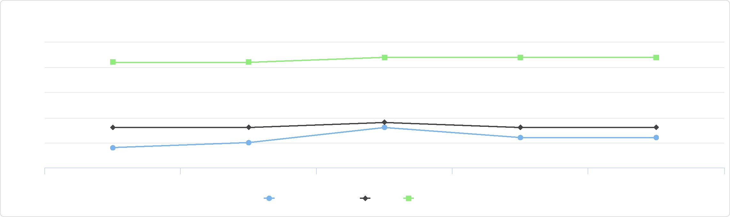

%

8

7

6.5

Babies Born with Low Birth Weight, Percent by Time Period, 2002-2008 through 2006-2012

8.5

7.5

6

2002-2008 2003-2009 2004-2010 2005-2011 2006-2012

Jackson County, IA Iowa United States

## Mortality ‐ Cancer

This indicator reports the rate of death due to malignant neoplasm (cancer) per 100,000 population. Figures are reported as crude rates, and as rates age‐adjusted to year 2000 standard. Rates are resummarized for report areas from county level data, only where data is available. This indicator is relevant because cancer is a leading cause of death in the United States.

In the report area, there were 45 average annual deaths due to cancer among the total population of 19,439. The age adjusted death rate of 153.8 per every 100,000 people is less than the state's reported rate of 160.57.

|  |  |  |  |  |
| --- | --- | --- | --- | --- |
| **Report Area** | **Total Population** | **Average Annual Deaths,**  **2013‐2017** | **Crude Death Rate (Per 100,000 Pop.)** | **Age‐Adjusted Death Rate (Per 100,000 Pop.)** |
| Jackson County, IA | 19,439 | 45 | 231.5 | **153.8** |
| Iowa | 3,133,515 | 6,465 | 206.32 | 160.57 |
| United States | 323,258,000 | 596,810 | 184.6 | 155.3 |

*Note: This indicator is compared to the state average.*

*Data Source: Centers for Disease Control and Prevention,* [*National Vital Statistics System*](http://www.cdc.gov/nchs/nvss.htm/)*. Accessed via* [*CDC WONDER*](http://wonder.cdc.gov)*. 2014‐18. Source geography: County*

Cancer Mortality, Age-Adjusted

Death Rate

(Per 100,000 Pop.)

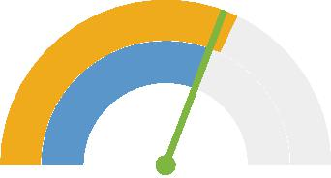

0 250

Jackson County (153.8)

Iowa (160.57)

United States (155.3)



**Cancer Mortality, Age Adj. Rate (Per 100,000 Pop.) by County, NVSS 2014‐ 18**

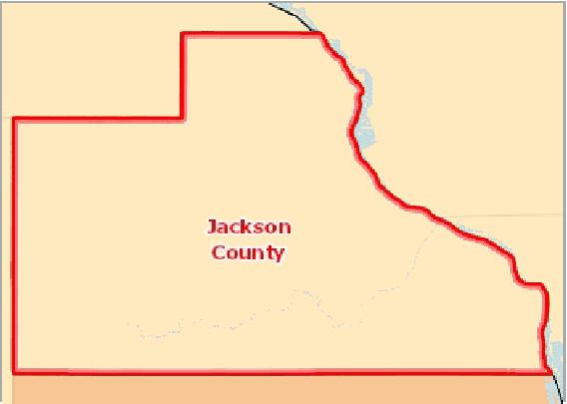

[](https://engagementnetwork.org/map-room/?ids=32706,t11&def=t11:FIPS%20In%20('19097')&bbox=-10120449.27515,5164829.551058,-10034264.57655,5219471.283242) View larger map

Over 200.0

180.1 ‐ 200.0

160.1 ‐ 180.0

Under 160.1

Data Suppressed (<20 Deaths)

Jackson County, IA



Cancer Mortality, Age‐Adjusted Rate (Per 100,000 Pop.) by Gender

|  |  |  |
| --- | --- | --- |
| **Report Area** | **Male** | **Female** |
| Jackson County, IA | 176.50 | 138.29 |
| Iowa | 192.73 | 136.79 |
| United States | 184.91 | 133.50 |

Cancer Mortality, Age-Adjusted Rate (Per 100,000 Pop.) by Gender

250

200

|  |  |  |  |  |  |
| --- | --- | --- | --- | --- | --- |
| 150  100  50  0 |  |  |  |  |  |
|  |  |  |  |
|  |  |  |
|  |  |  |
|  |  |  |  |  |

Male Female

Jackson County, IA Iowa United States



Cancer Mortality, Age‐Adjusted Rate (Per 100,000 Pop.) by Race / Ethnicity

|  |  |  |  |  |  |
| --- | --- | --- | --- | --- | --- |
| **Report Area** | **Non‐Hispanic White** | **Non‐Hispanic Black** | **Asian or Pacific Islander** | **American Indian or Alaskan Native** | **Hispanic or Latino** |
| Jackson County, IA | 149.74 | Suppressed | No data | No data | No data |
| Iowa | 162.22 | 194.62 | 110.03 | 125.77 | 75.97 |
| United States | 160.49 | 181.81 | 96.19 | 102.56 | 109.49 |

Cancer Mortality, Age‐Adjusted Rate (Per 100,000 Pop.), Yearly Trend

|  |  |  |  |  |  |  |  |  |  |  |  |  |  |  |  |
| --- | --- | --- | --- | --- | --- | --- | --- | --- | --- | --- | --- | --- | --- | --- | --- |
| **Report Area** | **2004** | **2005** | **2006** | **2007** | **2008** | **2009** | **2010** | **2011** | **2012** | **2013** | **2014** | **2015** | **2016** | **2017** | **2018** |
| Iowa | 182.25 | 183.72 | 178.96 | 176.84 | 177.10 | 170.41 | 171.94 | 173.12 | 168.60 | 168.40 | 166.00 | 164.05 | 159.81 | 157.98 | 155.30 |
| United States | 186.79 | 185.09 | 181.78 | 179.26 | 176.37 | 173.53 | 172.79 | 168.96 | 166.50 | 163.20 | 161.20 | 158.52 | 155.76 | 152.49 | 149.11 |

*Note: No county data available. See data source and methodology for more details.*

Cancer Mortality, Age-Adjusted Rate (Per 100,000 Pop.) by Race / Ethnicity

250

200

|  |  |  |  |  |  |  |  |  |  |
| --- | --- | --- | --- | --- | --- | --- | --- | --- | --- |
| 150  100  50  0 |  |  |  |  |  |  |  |  |  |
|  |  |  |  |  |  |  |
|  |  |  |  |  |
|  |  |  |  |  |
|  |  |  |  |  |  |  |  |  |

Non-Hispanic White Non-Hispanic Black Asian or Pacific Islander American Indian or Alaskan Native Hispanic or Latino

Jackson County, IA Iowa United States



Cancer Mortality, Age-Adjusted Rate (Per 100,000 Pop.), Yearly Trend

## Mortality ‐ Coronary Heart Disease

Within the report area the rate of death due to coronary heart disease (ICD10 Codes I20‐I25) per 100,000 population is 119.4. This rate is greater than than the Healthy People 2020 target of less than or equal to 103.4.

Figures are reported as crude rates, and as rates age‐adjusted to year 2000 standard. Rates are resummarized for report areas from county level data, only where data is available. This indicator is relevant because heart disease is a leading cause of death in the United States.

190

|  |  |
| --- | --- |
| 180 170 160 150  140 |  |

2004 2005 2006 2007 2008 2009 2010 2011 2012 2013 2014 2015 2016 2017 2018

Iowa United States



|  |  |  |  |  |
| --- | --- | --- | --- | --- |
| **Report Area** | **Total Population** | **Average Annual Deaths,**  **2013‐2017** | **Crude Death Rate (Per 100,000 Pop.)** | **Age‐Adjusted Death Rate (Per 100,000 Pop.)** |
| Jackson County, IA | 19,439 | 39 | 198.6 | **119.4** |
| Iowa | 3,133,515 | 4,406 | 140.62 | 103.86 |
| United States | 323,258,000 | 365,301 | 113.0 | 94.7 |

*Note: This indicator is compared to the state average.*

*Data Source: Centers for Disease Control and Prevention,* [*National Vital Statistics System*](http://www.cdc.gov/nchs/nvss.htm/)*. Accessed via* [*CDC WONDER*](http://wonder.cdc.gov)*. 2014‐18. Source geography: County*

Coronary Heart Disease Mortality,   
Age-Adjusted Death Rate   
(Per 100,000 Pop.)

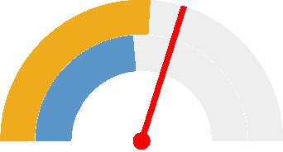

0 200

Jackson County (119.4) Iowa (103.86)

United States (94.7)



**Coronary Heart Disease Mortality, Age Adj. Rate (Per 100,000 Pop.) by County, NVSS 2014‐18**

Over 150.0

120.1 ‐ 150.0

100.1 ‐ 120.0

Under 100.1

Data Suppressed (<20 Deaths)

Jackson County, IA

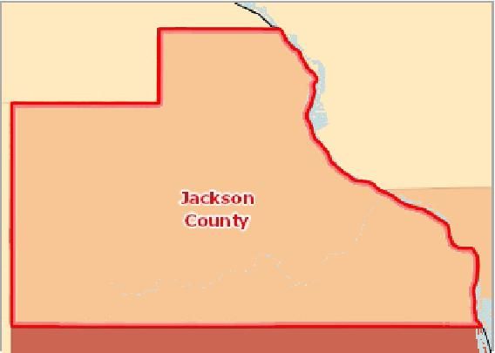

[](https://engagementnetwork.org/map-room/?ids=32710,t11&def=t11:FIPS%20In%20('19097')&bbox=-10120449.27515,5164829.551058,-10034264.57655,5219471.283242) View larger map



Coronary Heart Disease Mortality, Age‐Adjusted Rate (Per 100,000 Pop.) by Gender

|  |  |  |
| --- | --- | --- |
| **Report Area** | **Male** | **Female** |
| Jackson County, IA | 158.68 | 86.93 |
| Iowa | 145.73 | 71.57 |
| United States | 128.75 | 67.88 |

Coronary Heart Disease Mortality, Age-Adjusted Rate (Per 100,000 Pop.) by Gender

200

|  |  |  |  |  |  |
| --- | --- | --- | --- | --- | --- |
| 150  100  50  0 |  |  |  |  |  |
|  |  |  |  |
|  |  |  |  |
|  |  |  |
|  |  |  |  |  |

Male Female

Jackson County, IA Iowa United States



Coronary Heart Disease Mortality, Age‐Adjusted Rate (Per 100,000 Pop.) by Race / Ethnicity

|  |  |  |  |  |  |
| --- | --- | --- | --- | --- | --- |
| **Report Area** | **Non‐Hispanic White** | **Non‐Hispanic Black** | **Asian or Pacific Islander** | **American Indian or Alaskan Native** | **Hispanic or Latino** |
| Jackson County, IA | 121.09 | Suppressed | Suppressed | Suppressed | Suppressed |
| Iowa | 104.88 | 123.48 | 48.47 | 61.88 | 48.71 |
| United States | 97.24 | 109.81 | 53.91 | 70.41 | 72.28 |

Coronary Heart Disease Mortality, Age‐Adjusted Rate (Per 100,000 Pop.), Yearly Trend

|  |  |  |  |  |  |  |  |  |  |  |  |  |  |  |  |
| --- | --- | --- | --- | --- | --- | --- | --- | --- | --- | --- | --- | --- | --- | --- | --- |
| **Report Area** | **2004** | **2005** | **2006** | **2007** | **2008** | **2009** | **2010** | **2011** | **2012** | **2013** | **2014** | **2015** | **2016** | **2017** | **2018** |
| Iowa | 149.93 | 150.09 | 143.04 | 134.29 | 139.31 | 132.02 | 126.49 | 118.66 | 119.30 | 117.00 | 107.40 | 104.97 | 102.81 | 103.02 | 101.13 |
| United States | 153.24 | 148.15 | 138.33 | 129.24 | 126.14 | 117.72 | 113.65 | 109.18 | 105.40 | 102.60 | 98.80 | 97.24 | 94.33 | 92.88 | 90.85 |

*Note: No county data available. See data source and methodology for more details.*

Coronary Heart Disease Mortality, Age-Adjusted Rate (Per 100,000 Pop.) by Race / Ethnicity

150

|  |  |  |  |  |  |  |  |  |  |  |  |  |  |
| --- | --- | --- | --- | --- | --- | --- | --- | --- | --- | --- | --- | --- | --- |
| 100 |  |  |  |  |  |  |  |  |  |  |  |  |  |
|  |  |  |  |  |  |  |  |  |  |  |  |
|  |  |  |  |  |  |  |  |  |  |  |  |  |
| 50 |  |  |  |  |  |  |  |  |  |  |  |
|  |  |  |  |  |  |  |  |  |  |  |
|  |  |  |  |  |  |  |  |  |  |  |
| 0 |  |  |  |  |  |  |  |  |  |  |  |
|  |  |  |  |  |  |  |  |  |  |  |  |  |

Non-Hispanic White Non-Hispanic Black Asian or Pacific Islander American Indian or Alaskan Native Hispanic or Latino

Jackson County, IA Iowa United States



Coronary Heart Disease Mortality, Age-Adjusted Rate (Per 100,000 Pop.), Yearly Trend

## Mortality ‐ Drug Poisoning

This indicator reports the rate of death due to drug overdose per 100,000 population. Figures are reported as crude rates, and as rates age‐adjusted to year 2000 standard. Rates are resummarized for report areas from county level data, only where data is available.52:greater|less] than the state's reported rate of 9.52.

175

|  |  |
| --- | --- |
| 150  125  100  75 |  |

2004 2005 2006 2007 2008 2009 2010 2011 2012 2013 2014 2015 2016 2017 2018

Iowa United States



|  |  |  |  |  |  |  |  |
| --- | --- | --- | --- | --- | --- | --- | --- |
| **Report Area** | **Total Population** | **Average Annual Deaths,**  **2013‐2017** | | **Crude Death Rate (Per 100,000 Pop.)** | | **Age‐Adjusted Death Rate (Per 100,000 Pop.)** | |
| Jackson County, IA | 19,539 | No data |  | Suppressed |  | Suppressed |  |
| Iowa | 3,106,064 |  | 284 |  | 9.15 |  | 9.52 |
| United States | 318,689,254 |  | 49,715 |  | 15.6 |  | 15.6 |

*Note: This indicator is compared to the state average.*

*Data Source: Centers for Disease Control and Prevention,* [*National Vital Statistics System*](http://www.cdc.gov/nchs/nvss.htm/)*. Accessed via* [*CDC WONDER*](http://wonder.cdc.gov)*. 2014‐18. Source geography: County*

Drug Overdose Deaths, Age-   
Adjusted Death Rate   
(Per 100,000 Pop.)

|  |  |
| --- | --- |
|  | |
| 0 50 | |
|  | Iowa (9.52)  United States (15.6) |

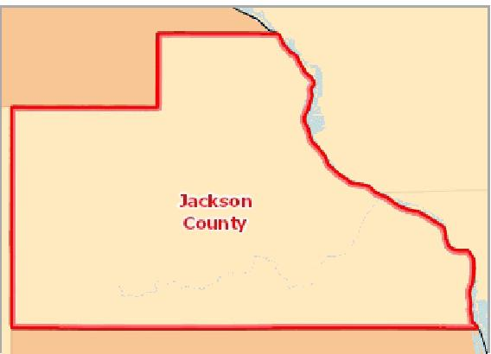

[](https://engagementnetwork.org/map-room/?ids=32714,t11&def=t11:FIPS%20In%20('19097')&bbox=-10120449.27515,5164829.551058,-10034264.57655,5219471.283242) View larger map

**Drug Poisoning Mortality, Age Adj. Rate (Per 100,000 Pop.) by County, NVSS 2014‐18**

Over 25.0

20.1 ‐ 25.0

10.1 ‐ 20.0

Under 10.1

Data Suppressed (<20 Deaths)

Jackson County, IA



Drug Overdose Mortality, Age‐Adjusted Rate (Per 100,000 Pop.), Yearly Trend

|  |  |  |  |  |  |  |  |  |  |  |  |  |  |  |
| --- | --- | --- | --- | --- | --- | --- | --- | --- | --- | --- | --- | --- | --- | --- |
| **Report Area** | **2004** | **2005** | **2006** | **2007** | **2008** | **2009** | **2010** | **2011** | **2012** | **2013** | **2014** | **2015** | **2016** | **2017** |
| Jackson County, IA | 6.91 | 7.10 | 8.41 | 8.33 | 8.85 | 9.72 | 9.28 | 9.86 | 9.39 | 9.79 | 12.05 | 11.17 | 14.27 | 13.53 |
| Iowa | 4.23 | 4.85 | 6.55 | 6.88 | 7.18 | 7.13 | 8.57 | 8.44 | 8.66 | 9.29 | 8.80 | 10.28 | 10.62 | 11.50 |
| United States | 9.38 | 10.07 | 11.49 | 11.88 | 11.89 | 11.94 | 12.30 | 13.19 | 13.14 | 13.80 | 14.68 | 16.29 | 19.79 | 21.70 |

Drug Overdose Mortality, Age-Adjusted Rate (Per 100,000 Pop.), Yearly Trend

## Mortality ‐ Heart Disease

Within the report area the rate of death due to heart disease (ICD10 Codes I00‐I09, I11, I13, I20‐I151) per 100,000 population is 187.1. Figures are reported as crude rates, and as rates age‐adjusted to year 2000 standard. Rates are resummarized for report areas from county level data, only where data is available. This indicator is relevant because heart disease is a leading cause of death in the United States.

25

|  |  |
| --- | --- |
| 20 15 10 5  0 |  |

2004 2005 2006 2007 2008 2009 2010 2011 2012 2013 2014 2015 2016 2017

Jackson County, IA Iowa United States



Heart Disease Mortality, Age-   
Adjusted Death Rate   
(Per 100,000 Pop.)

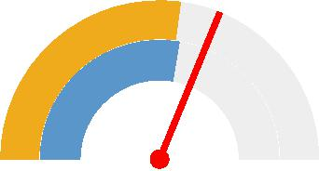

0 300

Jackson County (187.1)

Iowa (162.71)

United States (165.9)



|  |  |  |  |  |
| --- | --- | --- | --- | --- |
| **Report Area** | **Total Population** | **Average Annual Deaths,**  **2013‐2017** | **Crude Death Rate (Per 100,000 Pop.)** | **Age‐Adjusted Death Rate (Per 100,000 Pop.)** |
| Jackson County, IA | 19,439 | 59 | 305.6 | **187.1** |
| Iowa | 3,133,515 | 6,946 | 221.67 | 162.71 |
| United States | 323,258,000 | 637,258 | 197.1 | 165.9 |

*Note: This indicator is compared to the state average.*

*Data Source: Centers for Disease Control and Prevention,* [*National Vital Statistics System*](http://www.cdc.gov/nchs/nvss.htm/)*. Accessed via* [*CDC WONDER*](http://wonder.cdc.gov)*. 2014‐18. Source geography: County*

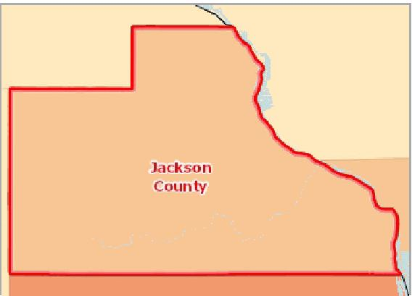

[](https://engagementnetwork.org/map-room/?ids=32711,t11&def=t11:FIPS%20In%20('19097')&bbox=-10120449.27515,5164829.551058,-10034264.57655,5219471.283242) View larger map

**Heart Disease Mortality, Age Adj. Rate (Per 100,000 Pop.) by County, NVSS 2014‐18**

Over 240.0

200.1 ‐ 240.0

160.1 ‐ 200.0

Under 160.1

Data Suppressed (<20 Deaths)

Jackson County, IA



Heart Disease Mortality, Age‐Adjusted Rate (Per 100,000 Pop.) by Gender

|  |  |  |
| --- | --- | --- |
| **Report Area** | **Male** | **Female** |
| Jackson County, IA | 246.30 | 137.67 |
| Iowa | 208.96 | 126.15 |
| United States | 209.60 | 130.61 |

Heart Disease Mortality, Age-Adjusted Rate (Per 100,000 Pop.) by Gender

300

|  |  |  |  |  |  |
| --- | --- | --- | --- | --- | --- |
| 200  100  0 |  |  |  |  |  |
|  |  |  |  |
|  |  |  |
|  |  |  |  |  |

Male Female

Jackson County, IA Iowa United States



Heart Disease Mortality, Age‐Adjusted Rate (Per 100,000 Pop.) by Race / Ethnicity

|  |  |  |  |  |  |
| --- | --- | --- | --- | --- | --- |
| **Report Area** | **Non‐Hispanic White** | **Non‐Hispanic Black** | **Asian or Pacific Islander** | **American Indian or Alaskan Native** | **Hispanic or Latino** |
| Jackson County, IA | 188.14 | Suppressed | No data | No data | No data |
| Iowa | 163.84 | 208.30 | 79.66 | 96.69 | 73.97 |
| United States | 169.36 | 209.73 | 85.58 | 115.68 | 114.90 |

Heart Disease Mortality, Age‐Adjusted Rate (Per 100,000 Pop.)   
by Year, 2004 through 2016

|  |  |  |  |  |  |  |  |  |  |  |  |  |  |  |  |
| --- | --- | --- | --- | --- | --- | --- | --- | --- | --- | --- | --- | --- | --- | --- | --- |
| **Report Area** | **2004** | **2005** | **2006** | **2007** | **2008** | **2009** | **2010** | **2011** | **2012** | **2013** | **2014** | **2015** | **2016** | **2017** | **2018** |
| Iowa | 194.98 | 196.62 | 187.05 | 177.21 | 185.52 | 176.08 | 173.31 | 166.02 | 170.40 | 168.80 | 157.30 | 160.90 | 162.82 | 167.37 | 165.12 |
| United States | 221.63 | 216.85 | 205.47 | 196.09 | 192.12 | 182.82 | 179.14 | 173.74 | 170.50 | 169.80 | 167.00 | 168.49 | 165.53 | 165.04 | 163.61 |

*Note: No county data available. See data source and methodology for more details.*

Heart Disease Mortality, Age-Adjusted Rate (Per 100,000 Pop.) by Race / Ethnicity

250

|  |  |  |  |  |  |  |  |  |  |  |  |
| --- | --- | --- | --- | --- | --- | --- | --- | --- | --- | --- | --- |
| 200 150 100 50  0 |  |  |  |  |  |  |  |  |  |  |  |
|  |  |  |  |  |  |  |  |  |  |
|  |  |  |  |  |  |  |  |  |
|  |  |  |  |  |  |  |
|  |  |  |  |  |  |
|  |  |  |  |  |  |  |  |  |  |  |

Non-Hispanic White Non-Hispanic Black Asian or Pacific Islander American Indian or Alaskan Native Hispanic or Latino

Jackson County, IA Iowa United States



Heart Disease Mortality, Age-Adjusted Rate (Per 100,000 Pop.)   
by Year, 2004 through 2016

## Mortality ‐ Homicide

This indicator reports the rate of death due to assault (homicide) per 100,000 population. Figures are reported as crude rates, and as rates age‐adjusted to year 2000 standard. Rates are resummarized for report areas from county level data, only where data is available. This indicator is relevant because homicide rate is a measure of poor community safety and is a leading cause of premature death.80:greater|less] than the state's reported rate of 2.80.

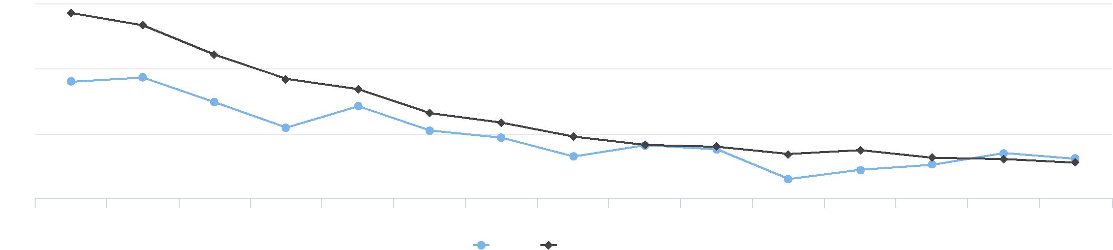

2004 2005 2006 2007 2008 2009 2010 2011 2012 2013 2014 2015 2016 2017 2018

Iowa United States

225

200

175

150

|  |  |  |  |  |  |  |  |
| --- | --- | --- | --- | --- | --- | --- | --- |
| **Report Area** | **Total Population** | **Average Annual Deaths,**  **2013‐2017** | | **Crude Death Rate (Per 100,000 Pop.)** | | **Age‐Adjusted Death Rate (Per 100,000 Pop.)** | |
| Jackson County, IA | 19,439 | No data |  | Suppressed |  | Suppressed |  |
| Iowa | 3,133,515 |  | 84 |  | 2.69 |  | 2.80 |
| United States | 323,258,000 |  | 18,273 |  | 5.7 |  | 5.8 |

*Note: This indicator is compared to the state average.*

*Data Source: Centers for Disease Control and Prevention,* [*National Vital Statistics System*](http://www.cdc.gov/nchs/nvss.htm/)*. Accessed via* [*CDC WONDER*](http://wonder.cdc.gov)*. 2014‐18. Source geography: County*

Homicide, Age-Adjusted Death

Rate

(Per 100,000 Pop.)

|  |  |
| --- | --- |
|  | |
| 0 25 | |
|  | Iowa (2.80)  United States (5.8) |

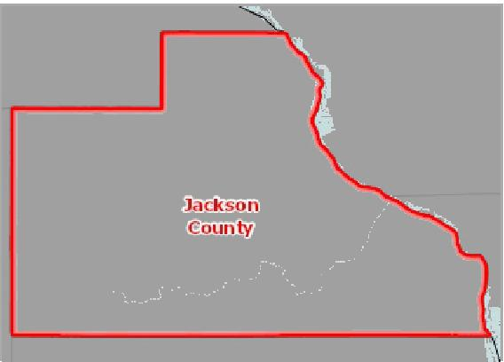

[](https://engagementnetwork.org/map-room/?ids=32701,t11&def=t11:FIPS%20In%20('19097')&bbox=-10120449.27515,5164829.551058,-10034264.57655,5219471.283242) View larger map

**Homicide Mortality, Age Adj. Rate (Per 100,000 Pop.) by County, NVSS 2014‐18**

Over 9.0

6.1 ‐ 9.0

3.1 ‐ 6.0

Under 3.1

Data Suppressed (<20 Deaths)

Jackson County, IA



Homicide Mortality, Age‐Adjusted Rate (Per 100,000 Pop.) by Gender

|  |  |  |  |  |
| --- | --- | --- | --- | --- |
| **Report Area** |  | **Male** |  | **Female** |
| Jackson County, IA | Suppressed |  | Suppressed |  |
| Iowa |  | 3.83 |  | 1.72 |
| United States |  | 9.23 |  | 2.35 |

Homicide Mortality, Age-Adjusted Rate (Per 100,000 Pop.) by Gender

10

7.5

5

2.5

0

Male Female

Iowa United States



Homicide Mortality, Age‐Adjusted Rate (Per 100,000 Pop.) by Race / Ethnicity

|  |  |  |  |  |  |
| --- | --- | --- | --- | --- | --- |
| **Report Area** | **Non‐Hispanic White** | **Non‐Hispanic Black** | **Asian or Pacific Islander** | **American Indian or Alaskan Native** | **Hispanic or Latino** |
| Jackson County, IA | Suppressed | Suppressed | No data | No data | No data |
| Iowa | 2.02 | 17.10 | Suppressed | Suppressed | 4.10 |
| United States | 2.75 | 21.29 | 1.64 | 6.44 | 4.96 |

Homicide Mortality, Age‐Adjusted Rate (Per 100,000 Pop.), Yearly Trend

|  |  |  |  |  |  |  |  |  |  |  |  |  |  |  |  |
| --- | --- | --- | --- | --- | --- | --- | --- | --- | --- | --- | --- | --- | --- | --- | --- |
| **Report Area** | **2004** | **2005** | **2006** | **2007** | **2008** | **2009** | **2010** | **2011** | **2012** | **2013** | **2014** | **2015** | **2016** | **2017** | **2018** |
| Iowa | 1.98 | 1.57 | 2.51 | 1.78 | 2.83 | 1.49 | 1.88 | 1.86 | 2.10 | 2.10 | 2.50 | 2.83 | 2.48 | 3.44 | 2.74 |
| United States | 5.94 | 6.16 | 6.26 | 6.15 | 5.93 | 5.54 | 5.33 | 5.30 | 5.40 | 5.20 | 5.10 | 5.66 | 6.16 | 6.16 | 5.93 |

*Note: No county data available. See data source and methodology for more details.*

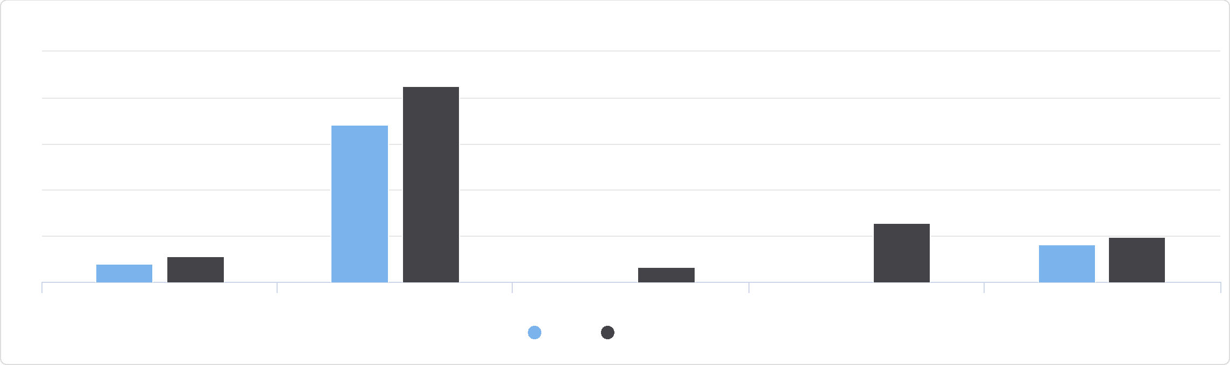

Homicide Mortality, Age-Adjusted Rate (Per 100,000 Pop.) by Race / Ethnicity

25

Non-Hispanic White Non-Hispanic Black Asian or Pacific Islander American Indian or Alaskan Native Hispanic or Latino

Iowa United States

20

15

10

5

0

Homicide Mortality, Age-Adjusted Rate (Per 100,000 Pop.), Yearly Trend

## Mortality ‐ Lung Disease

This indicator reports the rate of death due to chronic lower respiratory disease per 100,000 population. Figures are reported as crude rates, and as rates age‐adjusted to year 2000 standard. Rates are resummarized for report areas from county level data, only where data is available. This indicator is relevant because lung disease is a leading cause of death in the United States.

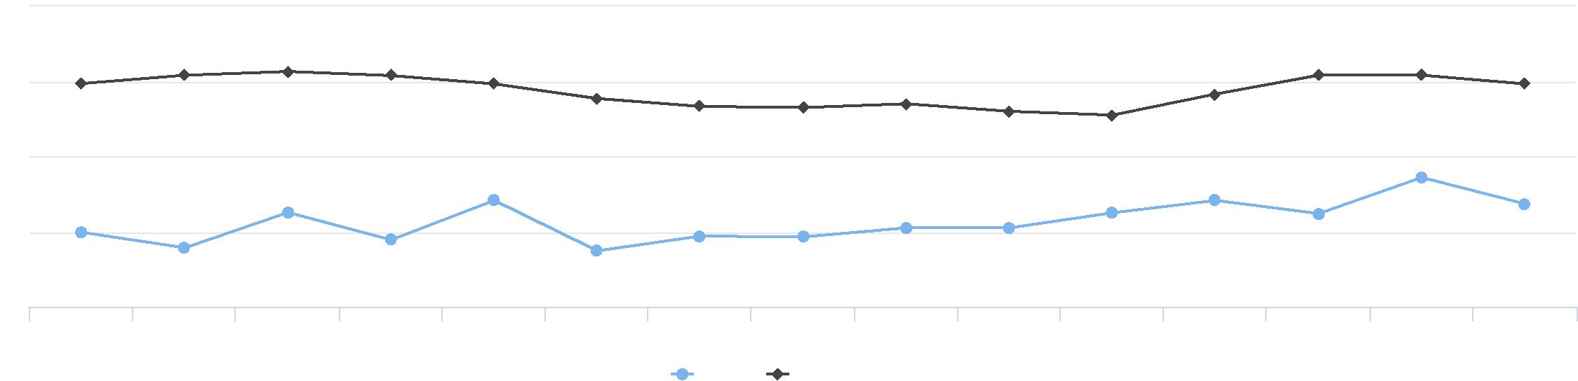

2004 2005 2006 2007 2008 2009 2010 2011 2012 2013 2014 2015 2016 2017 2018

Iowa United States

6

8

4

2

0

|  |  |  |  |  |
| --- | --- | --- | --- | --- |
| **Report Area** | **Total Population** | **Average Annual Deaths,**  **2013‐2017** | **Crude Death Rate (Per 100,000 Pop.)** | **Age‐Adjusted Death Rate (Per 100,000 Pop.)** |
| Jackson County, IA | 19,439 | 13 | 68.9 | **44.7** |
| Iowa | 3,133,515 | 1,947 | 62.12 | 47.12 |
| United States | 323,258,000 | 155,285 | 48.0 | 40.6 |

*Note: This indicator is compared to the state average.*

*Data Source: Centers for Disease Control and Prevention,* [*National Vital Statistics System*](http://www.cdc.gov/nchs/nvss.htm/)*. Accessed via* [*CDC WONDER*](http://wonder.cdc.gov)*. 2014‐18. Source geography: County*

Lung Disease Mortality, Age-   
Adjusted Death Rate   
(Per 100,000 Pop.)

|  |  |
| --- | --- |
|  | |
| 0 100 | |
|  | Jackson County (44.7)  Iowa (47.12)  United States (40.6) |

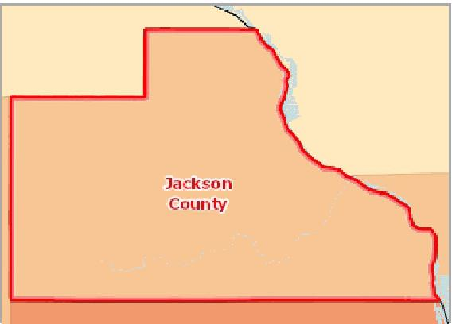

[](https://engagementnetwork.org/map-room/?ids=32704,t11&def=t11:FIPS%20In%20('19097')&bbox=-10120449.27515,5164829.551058,-10034264.57655,5219471.283242) View larger map

**Lung Disease Mortality, Age Adj. Rate (Per 100,000 Pop.) by County, NVSS 2014‐18**

Over 60.0

50.1 ‐ 60.0

40.1 ‐ 50.0

Under 40.1

Data Suppressed (<10 Deaths)

Jackson County, IA



Lung Disease Mortality, Age‐Adjusted Rate (Per 100,000 Pop.) by Gender

|  |  |  |
| --- | --- | --- |
| **Report Area** | **Male** | **Female** |
| Jackson County, IA | 48.47 | 41.80 |
| Iowa | 55.52 | 41.62 |
| United States | 44.99 | 37.59 |

Lung Disease Mortality, Age-Adjusted Rate (Per 100,000 Pop.) by Gender

60

|  |  |  |  |  |
| --- | --- | --- | --- | --- |
| 40  20  0 |  |  |  |  |
|  |  |
|  |  |
|  |  |  |  |

Male Female

Jackson County, IA Iowa United States



Lung Disease Mortality, Age‐Adjusted Rate (Per 100,000 Pop.) by Race / Ethnicity

|  |  |  |  |  |  |
| --- | --- | --- | --- | --- | --- |
| **Report Area** | **Non‐Hispanic White** | **Non‐Hispanic Black** | **Asian or Pacific Islander** | **American Indian or Alaskan Native** | **Hispanic or Latino** |
| Jackson County, IA | 45.19 | Suppressed | No data | No data | No data |
| Iowa | 47.84 | 49.12 | 13.67 | Suppressed | 11.34 |
| United States | 45.92 | 29.87 | 11.95 | 29.98 | 17.29 |

Lung Disease Mortality, Age‐Adjusted Rate (Per 100,000 Pop.)   
by Year, 2004 through 2016

|  |  |  |  |  |  |  |  |  |  |  |  |  |  |  |  |
| --- | --- | --- | --- | --- | --- | --- | --- | --- | --- | --- | --- | --- | --- | --- | --- |
| **Report Area** | **2004** | **2005** | **2006** | **2007** | **2008** | **2009** | **2010** | **2011** | **2012** | **2013** | **2014** | **2015** | **2016** | **2017** | **2018** |
| Iowa | 42.69 | 46.97 | 45.23 | 44.59 | 49.35 | 48.68 | 44.69 | 47.61 | 46.80 | 47.80 | 47.70 | 49.10 | 48.59 | 46.46 | 43.80 |
| United States | 41.61 | 43.89 | 41.01 | 41.35 | 44.67 | 42.65 | 42.18 | 42.51 | 41.50 | 42.10 | 40.50 | 41.62 | 40.56 | 40.92 | 39.71 |

*Note: No county data available. See data source and methodology for more details.*

Lung Disease Mortality, Age-Adjusted Rate (Per 100,000 Pop.) by Race / Ethnicity

60

|  |  |  |  |  |  |  |  |  |  |  |  |  |  |  |  |
| --- | --- | --- | --- | --- | --- | --- | --- | --- | --- | --- | --- | --- | --- | --- | --- |
| 40 |  |  |  |  |  |  |  |  |  |  |  |  |  |  |  |
|  |  |  |  |  |  |  |  |  |  |  |  |  |
| 20 |  |  |  |  |  |  |  |  |  |  |  |  |  |
|  |  |  |  |  |  |  |  |  |  |  |  |  |
|  |  |  |  |  |  |  |  |  |  |  |  |  |  |
|  |  |  |  |  |  |  |  |  |  |  |  |  |  |
|  |  |  |  |  |  |  |  |  |  |  |  |  |  |
|  |  |  |  |  |  |  |  |  |  |  |  |  |  |
| 0 |  |  |  |  |  |  |  |  |  |  |  |  |  |
|  |  |  |  |  |  |  |  |  |  |  |  |  |  |  |

Non-Hispanic White Non-Hispanic Black Asian or Pacific Islander American Indian or Alaskan Native Hispanic or Latino

Jackson County, IA Iowa United States



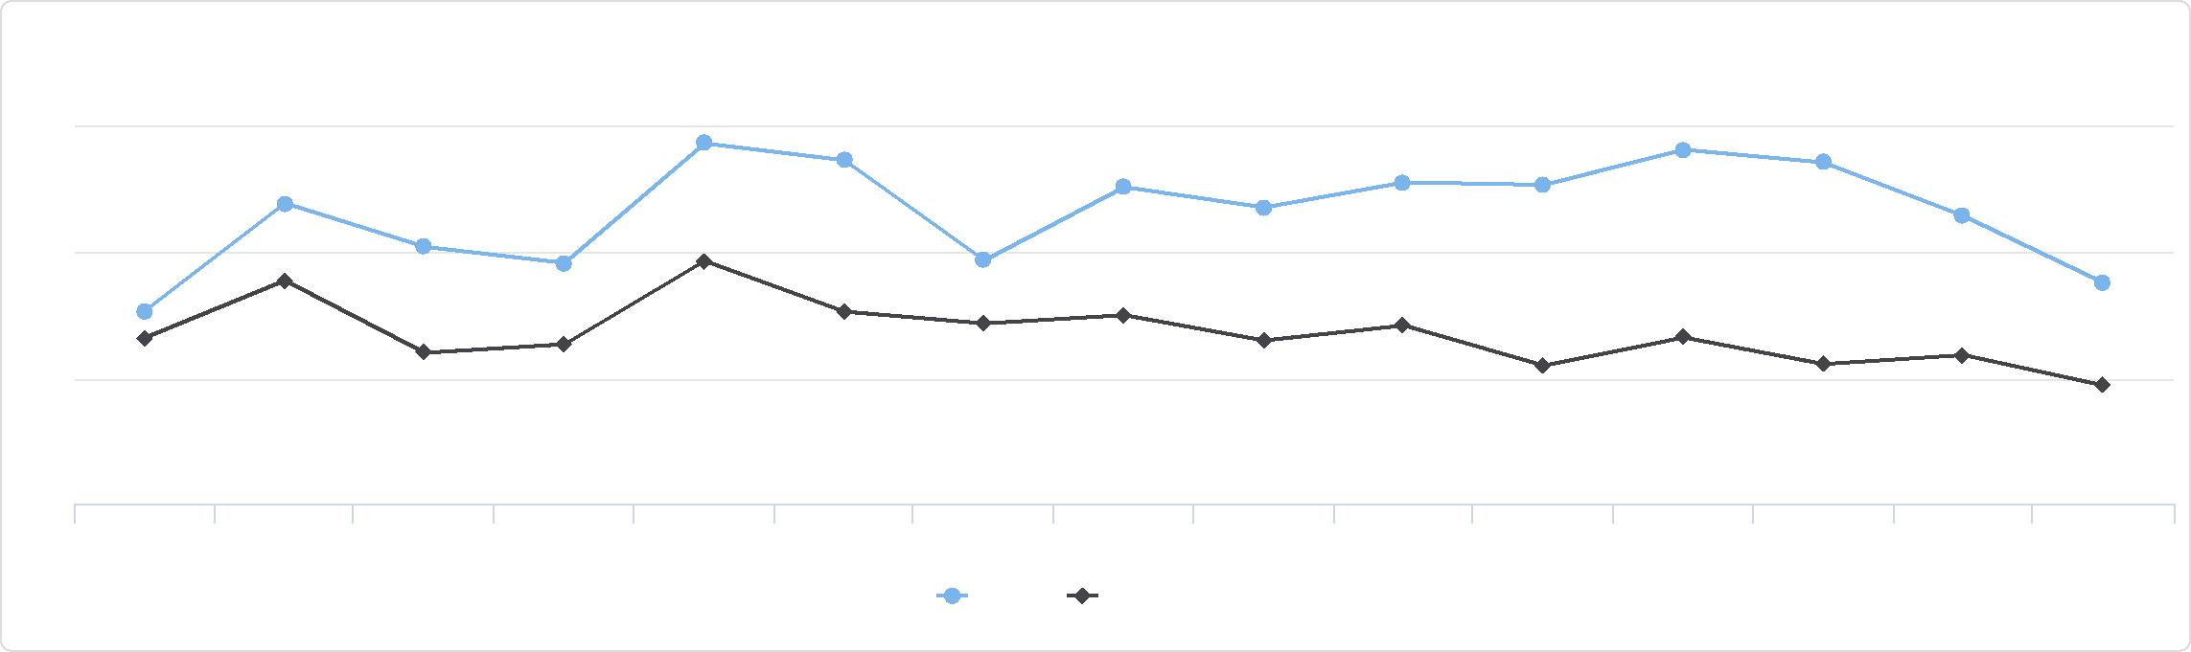

Lung Disease Mortality, Age-Adjusted Rate (Per 100,000 Pop.) by Year, 2004 through 2016

50

45

40

35

2004 2005 2006 2007 2008 2009 2010 2011 2012 2013 2014 2015 2016 2017 2018

Iowa United States

## Mortality ‐ Motor Vehicle Crash

This indicator reports the rate of death due to motor vehicle crashes per 100,000 population, which include collisions with another motor vehicle, a nonmotorist, a fixed object, and a non‐fixed object, an overturn, and any other non‐collision. This indicator is relevant because motor vehicle crash deaths are preventable and they are a cause of premature death.

In the report area, there were 4 average annual deaths due to motor vehicle crashes among the total population of 19,439. The age adjusted death rate of ‐1 per every 100,000 people is less than the state's reported rate of 10.82.

|  |  |  |  |  |  |
| --- | --- | --- | --- | --- | --- |
| **Report Area** | **Total Population** | **Average Annual Deaths,**  **2013‐2017** | **Crude Death Rate (Per 100,000 Pop.)** | **Age‐Adjusted Death Rate (Per 100,000 Pop.)** | |
| Jackson County, IA | 19,439 | 4 | 18.5 | Suppressed |  |
| Iowa | 3,133,515 | 353 | 11.25 |  | 10.82 |
| United States | 323,258,000 | 37,059 | 11.5 |  | 11.1 |

*Note: This indicator is compared to the state average.*

*Data Source: Centers for Disease Control and Prevention,* [*National Vital Statistics System*](http://www.cdc.gov/nchs/nvss.htm/)*. Accessed via* [*CDC WONDER*](http://wonder.cdc.gov)*. 2014‐18. Source geography: County*

Motor Vehicle Crash Death, Age-

Adjusted Death Rate

(Per 100,000 Pop.)

|  |  |
| --- | --- |
|  | |
| 0 50 | |
|  | Iowa (10.82)  United States (11.1) |

**Motor Vehicle Crash Mortality, Age Adj. Rate (Per 100,000 Pop.) by County, NVSS 2014‐18**

Over 25.0

20.1 ‐ 25.0

10.1 ‐ 20.0

Under 10.1

Data Suppressed (<20 Deaths)

Jackson County, IA

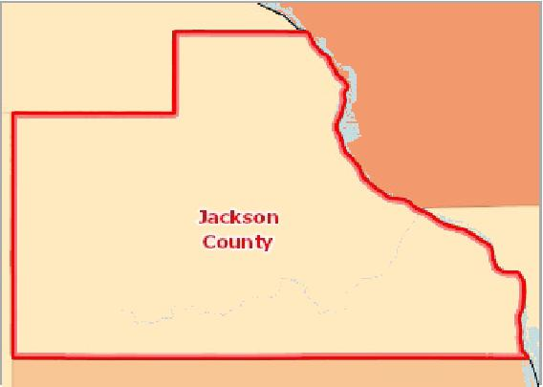

[](https://engagementnetwork.org/map-room/?ids=32700,t11&def=t11:FIPS%20In%20('19097')&bbox=-10120449.27515,5164829.551058,-10034264.57655,5219471.283242) View larger map



Motor Vehicle Crash Mortality, Age‐Adjusted Rate (Per 100,000 Pop.) by Gender

|  |  |  |  |  |
| --- | --- | --- | --- | --- |
| **Report Area** |  | **Male** |  | **Female** |
| Jackson County, IA | Suppressed |  | Suppressed |  |
| Iowa |  | 15.32 |  | 6.48 |
| United States |  | 16.19 |  | 6.32 |

Motor Vehicle Crash Mortality, Age-Adjusted Rate (Per 100,000 Pop.) by Gender

20

15

10

5

0

Male Female

Iowa United States



Motor Vehicle Crash Mortality, Age‐Adjusted Rate (Per 100,000 Pop.) by Race / Ethnicity

|  |  |  |  |  |  |
| --- | --- | --- | --- | --- | --- |
| **Report Area** | **Non‐Hispanic White** | **Non‐Hispanic Black** | **Asian or Pacific Islander** | **American Indian or Alaskan Native** | **Hispanic or Latino** |
| Jackson County, IA | Suppressed | Suppressed | Suppressed | Suppressed | Suppressed |
| Iowa | 10.83 | 12.01 | 7.35 | Suppressed | 9.36 |
| United States | 11.36 | 13.15 | 4.66 | 16.59 | 10.16 |

Motor Vehicle Accident Mortality, Age‐Adjusted Rate (Per 100,000 Pop.), Yearly Trend

|  |  |  |  |  |  |  |  |  |  |  |  |  |  |  |  |
| --- | --- | --- | --- | --- | --- | --- | --- | --- | --- | --- | --- | --- | --- | --- | --- |
| **Report Area** | **2004** | **2005** | **2006** | **2007** | **2008** | **2009** | **2010** | **2011** | **2012** | **2013** | **2014** | **2015** | **2016** | **2017** | **2018** |
| Iowa | 12.91 | 14.01 | 13.57 | 13.60 | 13.26 | 11.21 | 11.63 | 10.96 | 11.00 | 10.10 | 9.80 | 10.60 | 13.50 | 11.30 | 10.26 |
| United States | 10.34 | 10.15 | 9.93 | 9.24 | 8.12 | 7.21 | 6.54 | 6.76 | 10.90 | 10.50 | 10.30 | 11.41 | 12.15 | 11.53 | 11.24 |

*Note: No county data available. See data source and methodology for more details.*

Motor Vehicle Crash Mortality, Age-Adjusted Rate (Per 100,000 Pop.) by Race / Ethnicity

20

|  |  |  |  |  |  |  |  |  |  |  |  |
| --- | --- | --- | --- | --- | --- | --- | --- | --- | --- | --- | --- |
| 15  10 |  |  |  |  |  |  |  |  |  |  |  |
|  |  |  |  |  |  |  |  |  |  |
|  |  |  |  |  |  |  |  |
| 5 |  |  |  |  |  |  |  |  |
|  |  |  |  |  |  |  |  |
|  |  |  |  |  |  |  |  |
| 0 |  |  |  |  |  |  |  |  |
|  |  |  |  |  |  |  |  |  |  |  |

Non-Hispanic White Non-Hispanic Black Asian or Pacific Islander American Indian or Alaskan Native Hispanic or Latino

Iowa United States



Motor Vehicle Accident Mortality, Age-Adjusted Rate (Per 100,000 Pop.), Yearly Trend

## Mortality ‐ Pedestrian Motor Vehicle Crash

Motor vehicle crash deaths are preventable and are a leading cause of death among young persons. In the report area, there were 1 pedestrians killed by motor vehicles during the multi‐year report period. The annual (crude) mortality rate for the report area is 1.7, which is higher than the state average of 1.6.

Note: Fatality counts are based on the location of the crash and not the decedent's residence.

15

|  |  |
| --- | --- |
| 12.5  10  7.5  5 |  |

2004 2005 2006 2007 2008 2009 2010 2011 2012 2013 2014 2015 2016 2017 2018

Iowa United States



|  |  |  |  |
| --- | --- | --- | --- |
| **Report Area** | **Total Population (2010)** | **Pedestrian Deaths (2014‐2018)** | **Pedestrian Deaths,  Annual Rate per 100,000 Pop.** |
| Jackson County, IA | 19,848 | 1 | **1.7** |
| Iowa | 3,046,355 | 142 | 1.6 |
| United States | 312,443,997 | 31,951 | 3.4 |

*Note: This indicator is compared to the state average.*

*Data Source: US Department of Transportation, National Highway Traffic Safety Administration,* [*Fatality Analysis Reporting System*](http://www.nhtsa.gov/FARS)*. 2014‐2018. Source geography: Address*

Pedestrian Motor Vehicle   
Mortality, Crude Death Rate   
(Per 100,000 Pop.)

|  |  |
| --- | --- |
|  | |
|  | 0 10  Jackson County, IA (1.7)  Iowa (1.6)  United States (3.4) |

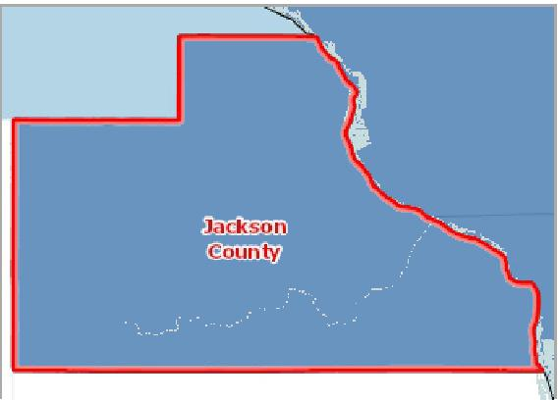

[](https://engagementnetwork.org/map-room/?ids=28502,t11&def=t11:FIPS%20In%20('19097')&bbox=-10120449.27515,5164829.551058,-10034264.57655,5219471.283242) View larger map

**Pedestrian Motor Vehicle Crash Mortality, Rate (Per 100,000 Pop.) by County, NHTSA 2014‐2018**

Over 3.0

2.1 ‐ 3.0

1.1 ‐ 2.0

0.1 ‐ 1.0

No Deaths

Jackson County, IA



## Mortality ‐ Premature Death

This indicator reports Years of Potential Life Lost (YPLL) before age 75 per 100,000 population for all causes of death, age‐ adjusted to the 2000 standard. YPLL measures premature death and is calculated by subtracting the age of death from the 75 year benchmark. This indicator is relevant because a measure of premature death can provide a unique and comprehensive look at overall health status.

In the report area, there were 244 premature deaths, leading to the loss of 3,379 potential years of life. The rate of years lost is 6,398 per every 100,000 people, which is greater than the state's loss rate of 6,257.

|  |  |  |  |
| --- | --- | --- | --- |
| **Report Area** | **Premature Deaths,**  **2016‐2018** | **Years of Potential Life Lost,  2016‐2018 Average** | **Years of Potential Life Lost,  Rate per 100,000 Population** |
| Jackson County, IA | 244 | 3,379 | **6,398** |
| Iowa | 69,816 | 1,091,004 | 6,257 |
| United States | 7,616,614 | 127,141,260 | 6,977 |

*Note: This indicator is compared to the state average.*

*Data Source: University of Wisconsin Population Health Institute,* [*County Health Rankings*](http://www.countyhealthrankings.org/)*. 2016‐2018. Source geography: County*

Years of Potential Life Lost, Rate per 100,000 Population

|  |  |
| --- | --- |
|  | |
| 5000 10000 | |
|  | Jackson County (6,398)  Iowa (6,257)  United States (6,977) |

**Premature Death (YPLL), Years Lost Rate (Per 100,000 Pop.) by County, NVSS 2016‐2018**

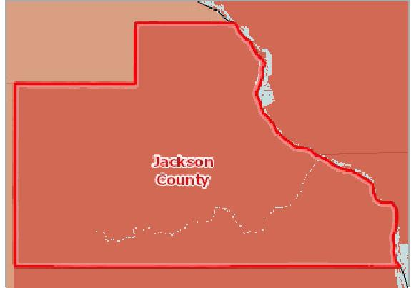

[](https://engagementnetwork.org/map-room/?ids=32157,t11&def=t11:FIPS%20In%20('19097')&bbox=-10120449.27515,5164829.551058,-10034264.57655,5219471.283242) View larger map

Over 10,000

8,001 ‐ 10,000

6,001 ‐ 8,000

Under 6,001

No Data or Data Suppressed

Jackson County, IA



Premature Death ‐ Years of Potential Life Lost,

Rate per 100,000 Population by Time Period, Yearly Trend

|  |  |  |  |  |  |  |  |  |
| --- | --- | --- | --- | --- | --- | --- | --- | --- |
| **Report Area** | **1997‐1999** | **2000‐2002** | **2003‐2005** | **2006‐2008** | **2009‐2011** | **2012‐2014** | **2015‐2017** | **2016‐2018** |
| Jackson County, IA | 6,966.1 | 5,559.3 | 6,851.1 | 6,402.0 | 6,473.5 | 7,890.0 | 6,160.9 | 6,397.6 |
| Iowa | 6,356.4 | 6,139.2 | 6,062.3 | 5,996.35 | 5,885.5 | 5,905.5 | 6,165.9 | 6,244.28 |
| United States | 7,705.2 | 7,535 | 7,345 | 7,090.49 | 6,703.7 | 6,601.2 | 6,900.63 | 6,940.11 |

Premature Death Rate per 100,000 Population by Race / Ethnicity

|  |  |  |  |  |  |
| --- | --- | --- | --- | --- | --- |
| **Report Area** |  | **Non‐Hispanic White** |  | **Non‐Hispanic Black** | **Hispanic or Latino** |
| Jackson County, IA | No data |  | No data |  | No data |

## Mortality ‐ Stroke

Within the report area there are an estimated 38.7 deaths due to cerebrovascular disease (stroke) per 100,000 population. This is greater than than the Healthy People 2020 target of less than or equal to 33.8. Figures are reported as crude rates, and as rates age‐adjusted to year 2000 standard. Rates are resummarized for report areas from county level data, only where data

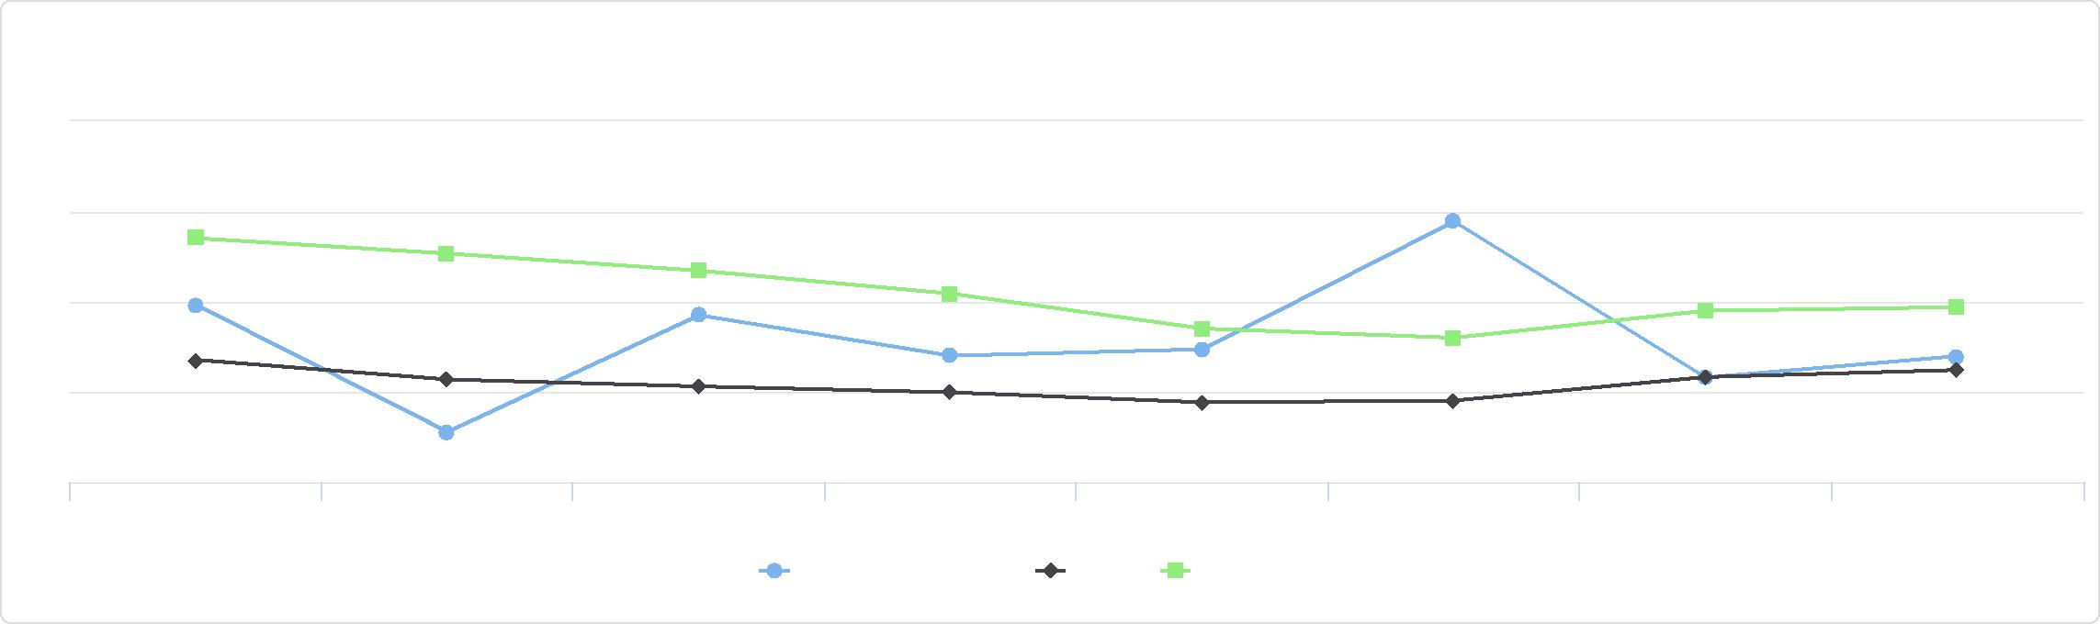

Premature Death - Years of Potential Life Lost,

Rate per 100,000 Population by Time Period, Yearly Trend

9k

8k

7k

6k

5k

1997-1999 2000-2002 2003-2005 2006-2008 2009-2011 2012-2014 2015-2017 2016-2018

Jackson County, IA Iowa United States

is available. This indicator is relevant because stroke is a leading cause of death in the United States.

|  |  |  |  |  |
| --- | --- | --- | --- | --- |
| **Report Area** | **Total Population** | **Average Annual Deaths,**  **2013‐2017** | **Crude Death Rate (Per 100,000 Pop.)** | **Age‐Adjusted Death Rate (Per 100,000 Pop.)** |
| Jackson County, IA | 19,439 | 13 | 66.9 | **38.7** |
| Iowa | 3,133,515 | 1,419 | 45.28 | 33.09 |
| United States | 323,258,000 | 141,952 | 43.9 | 37.2 |

*Note: This indicator is compared to the state average.*

*Data Source: Centers for Disease Control and Prevention,* [*National Vital Statistics System*](http://www.cdc.gov/nchs/nvss.htm/)*. Accessed via* [*CDC WONDER*](http://wonder.cdc.gov)*. 2014‐18. Source geography: County*

Stroke Mortality, Age-Adjusted

Death Rate

(Per 100,000 Pop.)

|  |  |
| --- | --- |
|  | |
| 0 100 | |
|  | Jackson County (38.7)  Iowa (33.09)  United States (37.2) |

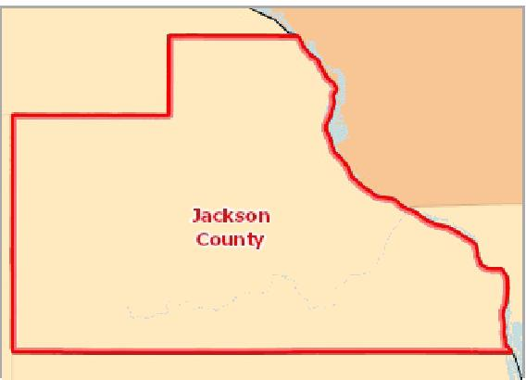

[](https://engagementnetwork.org/map-room/?ids=32708,t11&def=t11:FIPS%20In%20('19097')&bbox=-10120449.27515,5164829.551058,-10034264.57655,5219471.283242) View larger map

**Stroke Mortality, Age Adj. Rate (Per 100,000 Pop.) by County, NVSS 2014‐ 18**

Over 70.0

55.1 ‐ 70.0

40.1 ‐ 55.0

Under 40.1

Data Suppressed (<20 Deaths)

Jackson County, IA



Stroke Mortality, Age‐Adjusted Rate (Per 100,000 Pop.) by Gender

|  |  |  |
| --- | --- | --- |
| **Report Area** | **Male** | **Female** |
| Jackson County, IA | 39.25 | 36.62 |
| Iowa | 32.97 | 32.65 |
| United States | 37.56 | 36.32 |

Stroke Mortality, Age‐Adjusted Rate (Per 100,000 Pop.) by Race / Ethnicity

|  |  |  |  |  |  |
| --- | --- | --- | --- | --- | --- |
| **Report Area** | **Non‐Hispanic White** | **Non‐Hispanic Black** | **Asian or Pacific Islander** | **American Indian or Alaskan Native** | **Hispanic or Latino** |
| Iowa | 32.97 | 49.16 | 35.65 | Suppressed | 17.76 |
| United States | 36.01 | 52.01 | 29.70 | 24.84 | 31.72 |

Stroke Mortality, Age-Adjusted Rate (Per 100,000 Pop.) by Gender

50

|  |  |  |  |  |  |
| --- | --- | --- | --- | --- | --- |
| 40 30 20 10  0 |  |  |  |  |  |
|  |  |  |  |  |
|  |  |  |
|  |  |  |
|  |  |  |
|  |  |  |  |  |

Male Female

Jackson County, IA Iowa United States



Stroke Mortality, Age-Adjusted Rate (Per 100,000 Pop.) by Race / Ethnicity

60

|  |  |  |  |  |  |  |  |  |  |  |  |  |  |
| --- | --- | --- | --- | --- | --- | --- | --- | --- | --- | --- | --- | --- | --- |
| 40 |  |  |  |  |  |  |  |  |  |  |  |  |  |
|  |  |  |  |  |  |  |  |  |  |  |  |
|  |  |  |  |  |  |  |  |  |  |  |
|  |  |  |  |  |  |  |  |  |  |  |
| 20 |  |  |  |  |  |  |  |  |  |  |
|  |  |  |  |  |  |  |  |  |  |
|  |  |  |  |  |  |  |  |  |  |  |
| 0 |  |  |  |  |  |  |  |  |  |  |
|  |  |  |  |  |  |  |  |  |  |  |  |  |

Non-Hispanic White Non-Hispanic Black Asian or Pacific Islander American Indian or Alaskan Native Hispanic or Latino

Iowa United States



Stroke Mortality, Age‐Adjusted Rate (Per 100,000 Pop.), Yearly Trend

|  |  |  |  |  |  |  |  |  |  |  |  |  |  |  |  |
| --- | --- | --- | --- | --- | --- | --- | --- | --- | --- | --- | --- | --- | --- | --- | --- |
| **Report Area** | **2004** | **2005** | **2006** | **2007** | **2008** | **2009** | **2010** | **2011** | **2012** | **2013** | **2014** | **2015** | **2016** | **2017** | **2018** |
| Iowa | 50.48 | 49.16 | 43.62 | 42.80 | 43.62 | 41.15 | 38.01 | 34.89 | 34.10 | 33.90 | 34.10 | 33.22 | 32.30 | 32.80 | 33.00 |
| United States | 51.18 | 47.96 | 44.80 | 43.52 | 42.05 | 39.59 | 39.13 | 37.90 | 36.90 | 36.20 | 36.50 | 37.62 | 37.34 | 37.59 | 37.07 |

*Note: No county data available. See data source and methodology for more details.*

Stroke Mortality, Age-Adjusted Rate (Per 100,000 Pop.), Yearly Trend

## Mortality ‐ Suicide

This indicator reports the rate of death due to intentional self‐harm (suicide) per 100,000 population. Figures are reported as crude rates, and as rates age‐adjusted to year 2000 standard. Rates are resummarized for report areas from county level data, only where data is available. This indicator is relevant because suicide is an indicator of poor mental health.

In the report area, there were 4 average annual deaths due to suicide among the total population of 19,439. The age adjusted death rate of ‐1 per every 100,000 people is less than the state's reported rate of 14.4.

55

|  |  |
| --- | --- |
| 50 45 40 35  30 |  |

2004 2005 2006 2007 2008 2009 2010 2011 2012 2013 2014 2015 2016 2017 2018

Iowa United States



Suicide, Age-Adjusted Death Rate (Per 100,000 Pop.)

|  |  |
| --- | --- |
|  | |
| 0 50 | |
|  | Iowa (14.4)  United States (13.6) |

|  |  |  |  |  |  |
| --- | --- | --- | --- | --- | --- |
| **Report Area** | **Total Population** | **Average Annual Deaths,**  **2013‐2017** | **Crude Death Rate (Per 100,000 Pop.)** | **Age‐Adjusted Death Rate (Per 100,000 Pop.)** | |
| Jackson County, IA | 19,439 | 4 | 19.6 | Suppressed |  |
| Iowa | 3,133,515 | 452 | 14.4 |  | 14.4 |
| United States | 323,258,000 | 45,500 | 14.1 |  | 13.6 |

*Note: This indicator is compared to the state average.*

*Data Source: Centers for Disease Control and Prevention,* [*National Vital Statistics System*](http://www.cdc.gov/nchs/nvss.htm/)*. Accessed via* [*CDC WONDER*](http://wonder.cdc.gov)*. 2014‐18. Source geography: County*

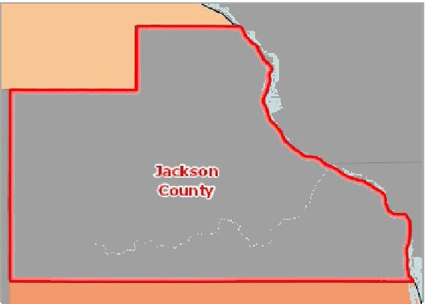

[](https://engagementnetwork.org/map-room/?ids=32702,t11&def=t11:FIPS%20In%20('19097')&bbox=-10120449.27515,5164829.551058,-10034264.57655,5219471.283242) View larger map

**Suicide Mortality, Age Adj. Rate (Per 100,000 Pop.) by County, NVSS 2014‐ 18**

Over 20.0

16.1 ‐ 20.0

12.1 ‐ 16.0

Under 12.1

Data Suppressed (<20 Deaths)

Jackson County, IA



Suicide Mortality, Age‐Adjusted Rate (Per 100,000 Pop.) by Gender

|  |  |  |  |  |
| --- | --- | --- | --- | --- |
| **Report Area** |  | **Male** |  | **Female** |
| Jackson County, IA | Suppressed |  | Suppressed |  |
| Iowa |  | 23.22 |  | 5.79 |
| United States |  | 21.66 |  | 6.03 |

Suicide Mortality, Age‐Adjusted Rate (Per 100,000 Pop.) by Race / Ethnicity

|  |  |  |  |  |  |
| --- | --- | --- | --- | --- | --- |
| **Report Area** | **Non‐Hispanic White** | **Non‐Hispanic Black** | **Asian or Pacific Islander** | **American Indian or Alaskan Native** | **Hispanic or Latino** |
| Jackson County, IA | Suppressed | Suppressed | No data | No data | No data |
| Iowa | 15.54 | 5.58 | 7.09 | Suppressed | 4.94 |
| United States | 17.24 | 6.37 | 6.53 | 12.87 | 6.71 |

Suicide Mortality, Age-Adjusted Rate (Per 100,000 Pop.) by Gender

30

20

10

0

Male Female

Iowa United States



Suicide Mortality, Age-Adjusted Rate (Per 100,000 Pop.) by Race / Ethnicity

20

|  |  |  |  |  |  |  |  |  |  |  |  |
| --- | --- | --- | --- | --- | --- | --- | --- | --- | --- | --- | --- |
| 15 |  |  |  |  |  |  |  |  |  |  |  |
|  |  |  |  |  |  |  |  |  |  |
|  |  |  |  |  |  |  |  |  |  |  |
| 10  5  0 |  |  |  |  |  |  |  |  |  |  |
|  |  |  |  |  |  |  |  |  |  |
|  |  |  |  |  |  |  |
|  |  |  |  |  |  |  |  |  |  |  |

Non-Hispanic White Non-Hispanic Black Asian or Pacific Islander American Indian or Alaskan Native Hispanic or Latino

Iowa United States



Suicide Mortality, Age‐Adjusted Rate (Per 100,000 Pop.), Yearly Trend

|  |  |  |  |  |  |  |  |  |  |  |  |  |  |  |  |
| --- | --- | --- | --- | --- | --- | --- | --- | --- | --- | --- | --- | --- | --- | --- | --- |
| **Report Area** | **2004** | **2005** | **2006** | **2007** | **2008** | **2009** | **2010** | **2011** | **2012** | **2013** | **2014** | **2015** | **2016** | **2017** | **2018** |
| Iowa | 11.54 | 11.18 | 11.16 | 10.66 | 12.63 | 11.87 | 12.09 | 13.91 | 12.70 | 14.40 | 12.90 | 13.89 | 14.57 | 15.04 | 15.48 |
| United States | 10.99 | 10.93 | 11.00 | 11.29 | 11.60 | 11.76 | 12.11 | 12.34 | 12.60 | 12.60 | 13.00 | 13.28 | 13.47 | 14.01 | 14.24 |

*Note: No county data available. See data source and methodology for more details.*

Suicide Mortality, Age-Adjusted Rate (Per 100,000 Pop.), Yearly Trend

## Mortality ‐ Unintentional Injury

This indicator reports the rate of death due to unintentional injury (accident) per 100,000 population. Figures are reported as crude rates, and as rates age‐adjusted to year 2000 standard. Rates are resummarized for report areas from county level data, only where data is available. This indicator is relevant because accidents are a leading cause of death in the U.S.

In the report area, there were 10 average annual deaths due to accidents among the total population of 19,439. The age adjusted death rate of 44.8 per every 100,000 people is greater than the state's reported rate of 42.67.

16

|  |  |
| --- | --- |
| 14  12  10 |  |

2004 2005 2006 2007 2008 2009 2010 2011 2012 2013 2014 2015 2016 2017 2018

Iowa United States



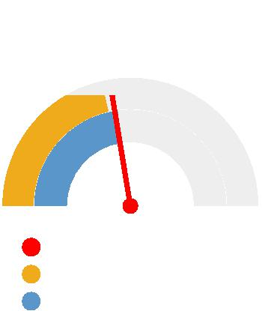

Unintentional Injury (Accident)   
Mortality, Age-Adjusted Death   
Rate   
(Per 100,000 Pop.)

0 100

Jackson County (44.8)

Iowa (42.67)

United States (45.7)

|  |  |  |  |  |
| --- | --- | --- | --- | --- |
| **Report Area** | **Total Population** | **Average Annual Deaths,**  **2013‐2017** | **Crude Death Rate (Per 100,000 Pop.)** | **Age‐Adjusted Death Rate (Per 100,000 Pop.)** |
| Jackson County, IA | 19,439 | 10 | 49.4 | **44.8** |
| Iowa | 3,133,515 | 1,536 | 49.01 | 42.67 |
| United States | 323,258,000 | 156,187 | 48.3 | 45.7 |

*Note: This indicator is compared to the state average.*

*Data Source: Centers for Disease Control and Prevention,* [*National Vital Statistics System*](http://www.cdc.gov/nchs/nvss.htm/)*. Accessed via* [*CDC WONDER*](http://wonder.cdc.gov)*. 2014‐18. Source geography: County*

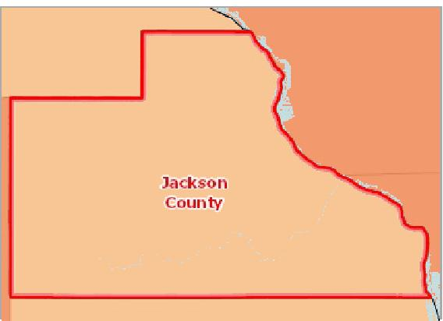

[](https://engagementnetwork.org/map-room/?ids=32709,t11&def=t11:FIPS%20In%20('19097')&bbox=-10120449.27515,5164829.551058,-10034264.57655,5219471.283242) View larger map

**Unintentional Injury (Accident) Mortality, Age Adj. Rate (Per 100,000 Pop.) by County, NVSS 2014‐18**

Over 70.0

50.1 ‐ 70.0

40.1 ‐ 50.0

Under 40.1

Data Suppressed (<20 Deaths)

Jackson County, IA



Unintentional Injury (Accident) Mortality, Age‐Adjusted Rate (Per 100,000 Pop.) by Gender

|  |  |  |
| --- | --- | --- |
| **Report Area** | **Male** | **Female** |
| Jackson County, IA | 53.55 | 35.35 |
| Iowa | 57.01 | 29.37 |
| United States | 62.48 | 29.96 |

Unintentional Injury (Accident) Mortality,

Age‐Adjusted Rate (Per 100,000 Pop.) by Race / Ethnicity

|  |  |  |  |  |  |
| --- | --- | --- | --- | --- | --- |
| **Report Area** | **Non‐Hispanic White** | **Non‐Hispanic Black** | **Asian or Pacific Islander** | **American Indian or Alaskan Native** | **Hispanic or Latino** |
| Jackson County, IA | 46.45 | Suppressed | No data | No data | No data |
| Iowa | 43.10 | 47.88 | 26.15 | 38.12 | 29.88 |
| United States | 51.76 | 42.75 | 16.46 | 52.70 | 30.49 |

Unintentional Injury (Accident) Mortality,

Age‐Adjusted Rate (Per 100,000 Pop.), Yearly Trend

|  |  |  |  |  |  |  |  |  |  |  |  |  |  |  |  |
| --- | --- | --- | --- | --- | --- | --- | --- | --- | --- | --- | --- | --- | --- | --- | --- |
| **Report Area** | **2004** | **2005** | **2006** | **2007** | **2008** | **2009** | **2010** | **2011** | **2012** | **2013** | **2014** | **2015** | **2016** | **2017** | **2018** |
| Iowa | 33.42 | 36.70 | 35.68 | 37.46 | 37.81 | 37.00 | 37.23 | 39.57 | 39.70 | 40.00 | 42.10 | 42.11 | 45.77 | 42.75 | 40.81 |
| United States | 38.06 | 39.51 | 40.24 | 40.36 | 39.25 | 37.49 | 37.99 | 39.13 | 39.10 | 39.40 | 40.50 | 43.22 | 47.41 | 49.39 | 47.99 |

*Note: No county data available. See data source and methodology for more details.*

Unintentional Injury (Accident) Mortality, Age-Adjusted Rate (Per 100,000 Pop.) by Gender

80

|  |  |  |  |  |
| --- | --- | --- | --- | --- |
| 60  40  20  0 |  |  |  |  |
|  |  |  |
|  |  |  |
|  |  |
|  |  |  |  |

Male Female

Jackson County, IA Iowa United States



Unintentional Injury (Accident) Mortality,

Age-Adjusted Rate (Per 100,000 Pop.) by Race / Ethnicity

60

|  |  |  |  |  |  |  |  |  |  |  |  |  |  |
| --- | --- | --- | --- | --- | --- | --- | --- | --- | --- | --- | --- | --- | --- |
| 40 |  |  |  |  |  |  |  |  |  |  |  |  |  |
|  |  |  |  |  |  |  |  |  |  |
| 20 |  |  |  |  |  |  |  |  |  |
|  |  |  |  |  |  |  |  |  |
|  |  |  |  |  |  |  |  |  |  |
| 0 |  |  |  |  |  |  |  |  |  |
|  |  |  |  |  |  |  |  |  |  |  |  |  |

Non-Hispanic White Non-Hispanic Black Asian or Pacific Islander American Indian or Alaskan Native Hispanic or Latino

Jackson County, IA Iowa United States



Unintentional Injury (Accident) Mortality,

Age-Adjusted Rate (Per 100,000 Pop.), Yearly Trend

## Obesity

34.7% of adults aged 20 and older self‐report that they have a Body Mass Index (BMI) greater than 30.0 (obese) in the report area. Excess weight may indicate an unhealthy lifestyle and puts individuals at risk for further health issues.

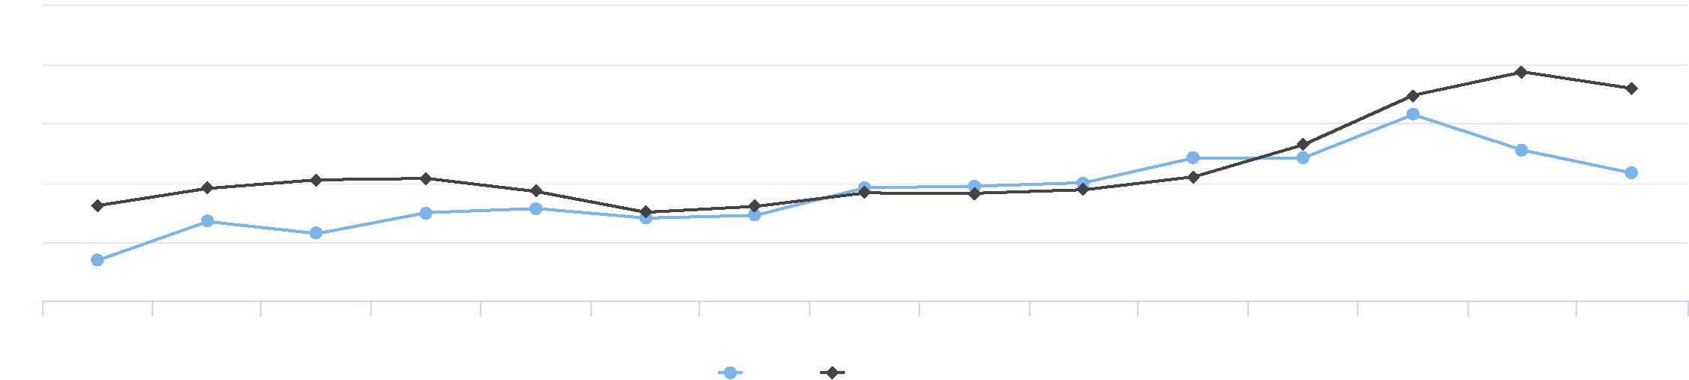

55

50

45

40

35

30

2004 2005 2006 2007 2008 2009 2010 2011 2012 2013 2014 2015 2016 2017 2018

Iowa United States

Percentage of Adults Obese (BMI > 30.0 ), 2016

|  |  |
| --- | --- |
|  | |
| 0% 50% | |
|  | Jackson County (34.7%)  Iowa (34.4%)  United States (29.5%) |

|  |  |  |  |
| --- | --- | --- | --- |
| **Report Area** | **Population Age 20+** | **Adults with BMI > 30.0 (Obese)** | **Adults with BMI > 30.0 (Obese), Percent** |
| Jackson County, IA | 14,637 | 5,035 | **34.7%** |
| Iowa | 2,321,552 | 796,904 | 34.4% |
| United States | 243,101,202 | 72,159,365 | 29.5% |

*Note: This indicator is compared to the state average.*

*Data Source: Centers for Disease Control and Prevention,* [*National Center for Chronic Disease Prevention and Health Promotion*](http://www.cdc.gov/nccdphp/dnpao/index.html)*. 2017. Source geography: County*

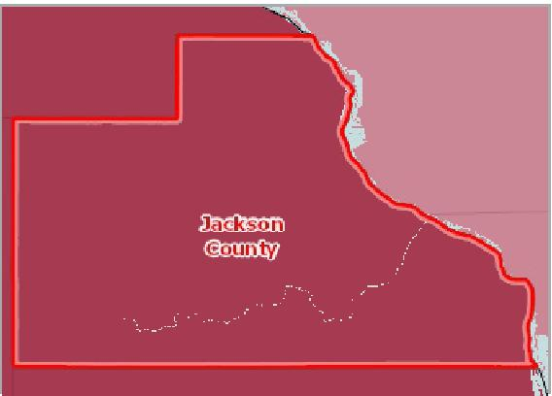

[](https://engagementnetwork.org/map-room/?ids=32691,t11&def=t11:FIPS%20In%20('19097')&bbox=-10120449.27515,5164829.551058,-10034264.57655,5219471.283242) View larger map

**Obese (BMI >= 30), Adults Age 20+, Percent by County, CDC NCCDPHP 2017**

Over 34.0%

30.1 ‐ 34.0%

26.1 ‐ 30.0%

Under 26.1%

No Data or Data Suppressed

Jackson County, IA



Adults Obese (BMI > 30.0) by Gender, 2017

The table below displays national, state, and local variation in the prevalence of obesity among the adult population by gender.

|  |  |  |  |  |
| --- | --- | --- | --- | --- |
| **Report Area** | **Male** | **Male, Percent** | **Female** | **Female, Percent** |
| Jackson County, IA | 2,603 | 35.8% | 2,432 | 33.7% |
| Iowa | 401,557 | 34.9% | 395,353 | 33.9% |
| United States | 35,502,906 | 29.8% | 36,656,416 | 29.3% |

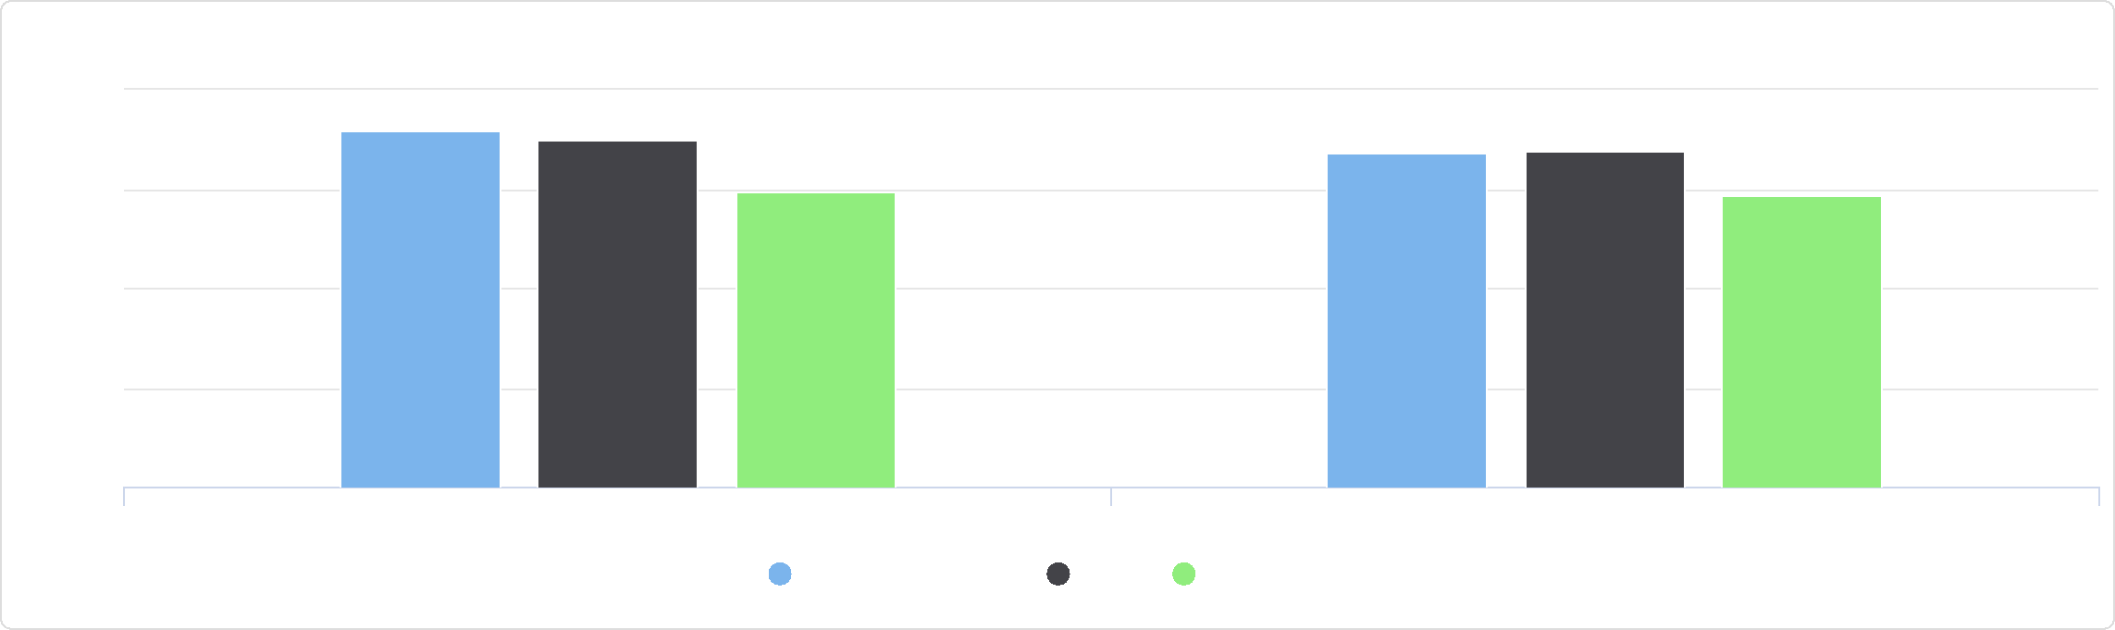

Adults Obese (BMI > 30.0) by Gender, 2017

40

Male, Percent Female, Percent

Jackson County, IA Iowa United States

%

20

30

10

0

Percentage of Adults Obese (BMI > 30.0) by Year

The table below displays trends in the percentage of adults that are obese for years 2004 through 2017.

|  |  |  |  |  |  |  |  |  |  |  |  |  |  |  |
| --- | --- | --- | --- | --- | --- | --- | --- | --- | --- | --- | --- | --- | --- | --- |
| **Report Area** | **2004** | **2005** | **2006** | **2007** | **2008** | **2009** | **2010** | **2011** | **2012** | **2013** | **2014** | **2015** | **2016** | **2017** |
| Jackson County, IA | 24.2% | 25.6% | 27.4% | 27.8% | 29.1% | 31.2% | 30.3% | 30.3% | 32.1% | 32.7% | 32.6% | 30.9% | 30.1% | 34.7% |
| Iowa | 24.6% | 25.4% | 26.7% | 27.1% | 28.1% | 29.0% | 29.3% | 29.6% | 30.4% | 31.1% | 31.7% | 32.1% | 33.2% | 34.4% |
| United States | 23.1% | 23.8% | 24.8% | 25.6% | 26.4% | 27.4% | 27.3% | 27.2% | 27.1% | 27.5% | 27.8% | 28.3% | 28.8% | 29.5% |

## Overweight

32.60% of adults aged 18 and older self‐report that they have a Body Mass Index (BMI) between 25.0 and 30.0 (overweight) in the report area. Excess weight may indicate an unhealthy lifestyle and puts individuals at rist for further health issues.

|  |  |  |  |
| --- | --- | --- | --- |
| **Report Area** | **Survey Population  (Adults Age 18+)** | **Total Adults Overweight** | **Percent Adults Overweight** |
| Jackson County, IA | 21,380 | 6,966 | **32.60%** |
| Iowa | 2,193,149 | 767,907 | 35.00% |
| United States | 224,991,207 | 80,499,532 | 35.80% |

*Note: This indicator is compared to the state average.*

*Data Source: Centers for Disease Control and Prevention,* [*Behavioral Risk Factor Surveillance System*](http://www.cdc.gov/brfss/)*. Additional data analysis by* [*CARES*](http://cares.missouri.edu)*. 2011‐12. Source geography: County*

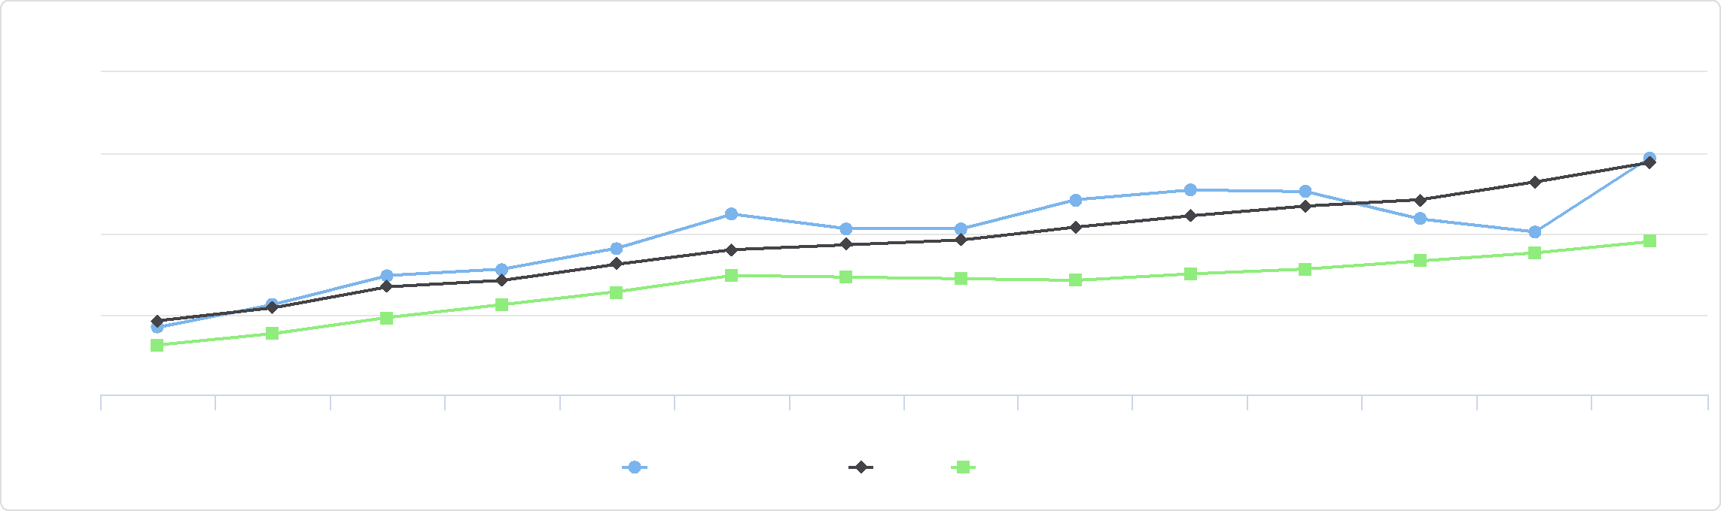

Percentage of Adults Obese (BMI > 30.0) by Year

40

35

30

25

20

%

2004 2005 2006 2007 2008 2009 2010 2011 2012 2013 2014 2015 2016 2017

Jackson County, IA Iowa United States

Percent Adults Overweight

|  |  |
| --- | --- |
|  | |
|  | 0% 50%  Jackson County (32.60%)  Iowa (35.00%)  United States (35.80%) |

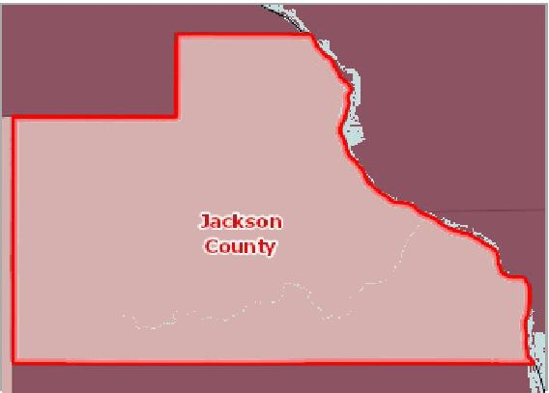

[](https://engagementnetwork.org/map-room/?ids=6337,t11&def=t11:FIPS%20In%20('19097')&bbox=-10120449.27515,5164829.551058,-10034264.57655,5219471.283242) View larger map

**Overweight (BMI 25.0‐29.9), Adults Age 18+, Percent by County, BRFSS 2011‐12**

Over 39.0%

36.1 ‐ 39.0%

33.1 ‐ 36.0%

Under 33.1%

No Data or Data Suppressed

Jackson County, IA



Adult Overweight by Year, 2011 through 2019

The table and chart below display trends in the percentage of adult population who were overweight (BMI 25.0‐29.9) for years 2011 through 2019.

|  |  |  |  |  |  |  |  |  |  |
| --- | --- | --- | --- | --- | --- | --- | --- | --- | --- |
| **Report Area** | **2011** | **2012** | **2013** | **2014** | **2015** | **2016** | **2017** | **2018** | **2019** |
| Iowa | 35.4% | 33.6% | 35.3% | 35.6% | 34.0% | 36.2% | 33.2% | 33.6% | 34.0% |
| United States | 35.3% | 35.3% | 35.1% | 34.9% | 35.1% | 34.9% | 34.8% | 34.4% | 34.5% |

*Note: No county data available. See data source and methodology for more details.*

Adults Overweight, Percent by Race / Ethnicity

|  |  |  |  |  |
| --- | --- | --- | --- | --- |
| **Report Area** | **Non‐Hispanic White** | **Non‐Hispanic Black** | **Non‐Hispanic Other Race** | **Hispanic or Latino** |
| Iowa | 35.42% | 33.06% | 27.42% | 32.38% |
| United States | 35.85% | 34.31% | 31.61% | 38.43% |

*Note: No county data available. See data source and methodology for more details.*

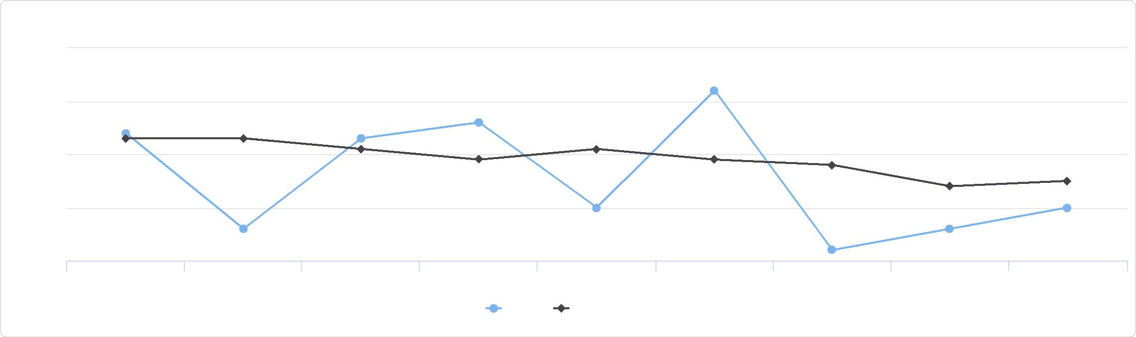

Adult Overweight by Year, 2011 through 2019

37

36

35

34

33

%

2011 2012 2013 2014 2015 2016 2017 2018 2019

Iowa United States

Adults Overweight, Percent by Race / Ethnicity

50

40

|  |  |  |  |  |  |  |  |  |
| --- | --- | --- | --- | --- | --- | --- | --- | --- |
|  | 30  20  10  0 |  |  |  |  |  |  |  |
| % |  |  |  |  |
|  |  |  |  |  |
|  |  |  |  |  |
|  |  |  |  |  |  |  |  |

Non-Hispanic White Non-Hispanic Black Non-Hispanic Other Race Hispanic or Latino

Iowa United States



## Poor Dental Health

This indicator reports the percentage of adults age 18 and older who self‐report that six or more of their permanent teeth have been removed due to tooth decay, gum disease, or infection. This indicator is relevant because it indicates lack of access to dental care and/or social barriers to utilization of dental services.

|  |  |  |  |
| --- | --- | --- | --- |
| **Report Area** | **Population Age 18** | **Adults with Poor Dental Health** | **Adults with Poor Dental Health, Percent** |
| Jackson County, IA | 15,248.00 | 4,631.00 | **30.4%** |
| Iowa | 2,307,562.00 | 341,535.00 | 14.8% |
| United States | 235,375,690.00 | 36,842,620.00 | 15.7% |

*Note: This indicator is compared to the state average.*

*Data Source: Centers for Disease Control and Prevention,* [*Behavioral Risk Factor Surveillance System*](http://www.cdc.gov/brfss/)*. Additional data analysis by* [*CARES*](http://cares.missouri.edu)*. 2006‐10. Source geography: County*

Adults with Poor Dental Health, Percent

|  |  |
| --- | --- |
|  | |
| 0% 40% | |
|  | Jackson County (30.4%)  Iowa (14.8%)  United States (15.7%) |

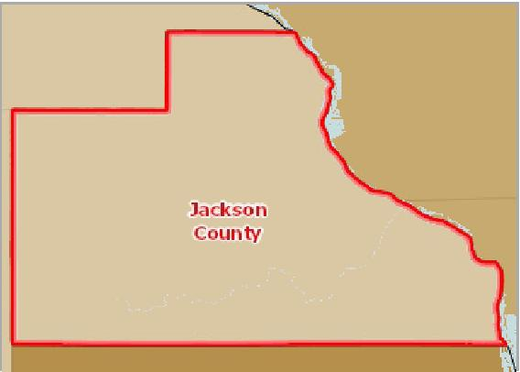

[](https://engagementnetwork.org/map-room/?ids=346,t11&def=t11:FIPS%20In%20('19097')&bbox=-10120449.27515,5164829.551058,-10034264.57655,5219471.283242) View larger map

**Adults Age 18+ Without Dental Exam in Past 12 Months, Percent by County, BRFSS 2006‐10**

Over 42.0%

34.1 ‐ 42.0%

26.1 ‐ 34.0%

Under 26.1%

No Data or Data Suppressed

Jackson County, IA



Adults with Poor Dental Health (6+ Teeth Removed), Percent by Race / Ethnicity

|  |  |  |  |  |
| --- | --- | --- | --- | --- |
| **Report Area** | **Non‐Hispanic White** | **Non‐Hispanic Black** | **Non‐Hispanic Other Race** | **Hispanic or Latino** |
| Iowa | 14.87% | 17.35% | 10.98% | 9.90% |
| United States | 16.04% | 21.60% | 12.11% | 10.31% |

*Note: No county data available. See data source and methodology for more details.*

Adults with Poor Dental Health (6+ Teeth Removed), Percent by Race / Ethnicity

30

|  |  |  |  |  |  |  |  |  |  |  |
| --- | --- | --- | --- | --- | --- | --- | --- | --- | --- | --- |
|  | 20  10  0 |  |  |  |  |  |  |  |  |  |
| % |  |  |  |  |  |  |  |  |
|  |  |  |  |  |  |
|  |  |  |  |  |  |  |  |  |  |

Non-Hispanic White Non-Hispanic Black Non-Hispanic Other Race Hispanic or Latino

Iowa United States



## Poor General Health

Within the report area 9.60% of adults age 18 and older self‐report having poor or fair health in response to the question "would you say that in general your health is excellent, very good, good, fair, or poor?". This indicator is relevant because it is a measure of general poor health status.

Percent Adults with Poor or Fair Health

(Age-Adjusted)

|  |  |
| --- | --- |
|  | |
| 0% 25% | |
|  | Jackson County (9.40%)  Iowa (11.20%)  United States (15.70%) |

|  |  |  |  |  |
| --- | --- | --- | --- | --- |
| **Report  Area** | **Population Age**  **18+** | **Estimated Population with  Poor or Fair Health** | **Fair or Poor Health,  Crude Percentage** | **Fair or Poor Health, Age‐  Adjusted Percentage** |
| Jackson County, IA | 15,242.00 | 1,463 | 9.60% | **9.40%** |
| Iowa | 2,307,562.00 | 276,907 | 12.00% | 11.20% |
| United  States | 232,556,016.00 | 37,766,703 | 16.20% | 15.70% |

*Note: This indicator is compared to the state average.*

*Data Source: Centers for Disease Control and Prevention,* [*Behavioral Risk Factor Surveillance System*](http://www.cdc.gov/brfss/)*. Accessed via the* [*Health Indicators Warehouse*](http://healthindicators.gov)*. US Department of Health & Human*

*Services,* [*Health Indicators Warehouse*](https://healthdata.gov/dataset/health-indicators-warehouse)*. 2006‐12. Source geography: County*

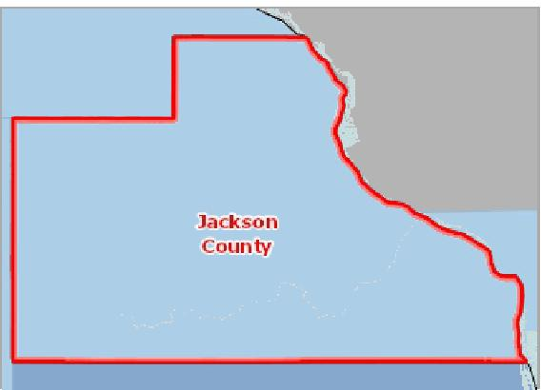

[](https://engagementnetwork.org/map-room/?ids=5452,t11&def=t11:FIPS%20In%20('19097')&bbox=-10120449.27515,5164829.551058,-10034264.57655,5219471.283242) View larger map

**Adults with Poor or Fair Health, Percent by County, BRFSS 2006‐12**

Over 22.0%

16.1 ‐ 22.0%

12.1 ‐ 16.0%

Under 12.1%

No Data or Data Suppressed

Jackson County, IA



## STI ‐ Chlamydia Incidence

This indicator reports the number chlamydia cases occurring in the report area. Rates are presented per 100,000 population.

The number of cases are based on laboratory‐confirmed diagnoses that occurred between January 1st and December 31st of the latest reporting year. These data are delivered to and analyzed by the CDC as part of the Nationally notifiable STD surveillance system.

|  |  |  |  |
| --- | --- | --- | --- |
| **Report Area** | **Total Population** | **Chlamydia Infections** | **Chlamydia Infections,  Rate per 100,000 Pop.** |
| Jackson County, IA | 19,366 | 48 | **247.9** |
| Iowa | 3,145,711 | 14,682 | 466.7 |
| United States | 325,719,178 | 1,758,668 | 539.9 |

*Note: This indicator is compared to the state average.*

*Data Source: Centers for Disease Control and Prevention,* [*National Center for HIV/AIDS, Viral Hepatitis, STD, and TB Prevention*](http://www.cdc.gov/nchhstp/)*. 2018. Source geography: County*

Chlamydia Infection Rate   
(Per 100,000 Pop.)

|  |  |
| --- | --- |
|  | |
|  | 0 700  Jackson County (247.9)  Iowa (466.7)  United States (539.9) |

**Chlamydia, Infection Rate per 100,000 Population by County, NCHHSTP 2018**

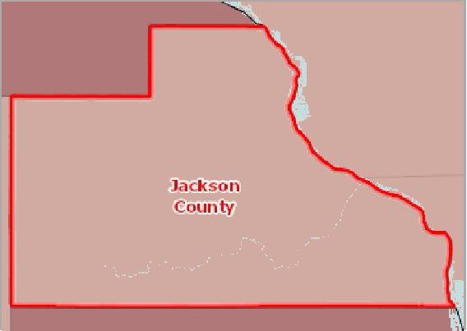

[](https://engagementnetwork.org/map-room/?ids=32566,t11&def=t11:FIPS%20In%20('19097')&bbox=-10120449.27515,5164829.551058,-10034264.57655,5219471.283242) View larger map

Over 500.0

300.1 ‐ 500.0

150.1 ‐ 300.0

0.1 ‐ 150.0

Data Suppressed ( <4 Cases )

Jackson County, IA



Chlamydia Incidence Rate by Race / Ethnicity

The table below displays national, state, and local variation in the rate of diagnosed chlamydia cases for the latest report year by population race and ethnicity.

|  |  |  |  |  |  |  |  |  |  |
| --- | --- | --- | --- | --- | --- | --- | --- | --- | --- |
| **Report Area** | **Non‐Hispanic White** | | **Non‐Hispanic Black** | | **Asian** | **American Indian or Alaska Native** | | **Hispanic or Latino** | |
| Jackson County, IA | No data |  | No data |  | No data | No data |  | No data |  |
| Iowa |  | 337.9 |  | 2,504.4 | 238.7 |  | 897.5 |  | 632.7 |
| United States |  | 212.1 |  | 1,192.5 | 132.1 |  | 784.8 |  | 392.6 |

Chlamydia Incidence Rate by Year

The table below displays trends in the rate of diagnosed chlamydia cases for years 2005 through 2018. Rates are expressed per 100,000 total population.

|  |  |  |  |  |  |  |  |  |  |  |  |  |  |  |
| --- | --- | --- | --- | --- | --- | --- | --- | --- | --- | --- | --- | --- | --- | --- |
| **Report Area** | **2005** | **2006** | **2007** | **2008** | **2009** | **2010** | **2011** | **2012** | **2013** | **2014** | **2015** | **2016** | **2017** | **2018** |
| Jackson County, IA | 113.1 | 142.9 | 204.6 | 200.4 | 187.6 | 241.8 | 197.0 | 257.6 | 209.3 | 194.0 | 267.4 | 174.9 | 232.4 | 247.9 |
| Iowa | 250.5 | 282.9 | 290.0 | 313.0 | 312.7 | 345.6 | 349.4 | 370.0 | 354.4 | 382.0 | 386.9 | 415.6 | 441.6 | 466.7 |
| United States | 330.3 | 345.4 | 367.7 | 398.0 | 405.7 | 422.8 | 453.4 | 453.4 | 443.5 | 456.1 | 475.0 | 497.3 | 524.6 | 539.9 |

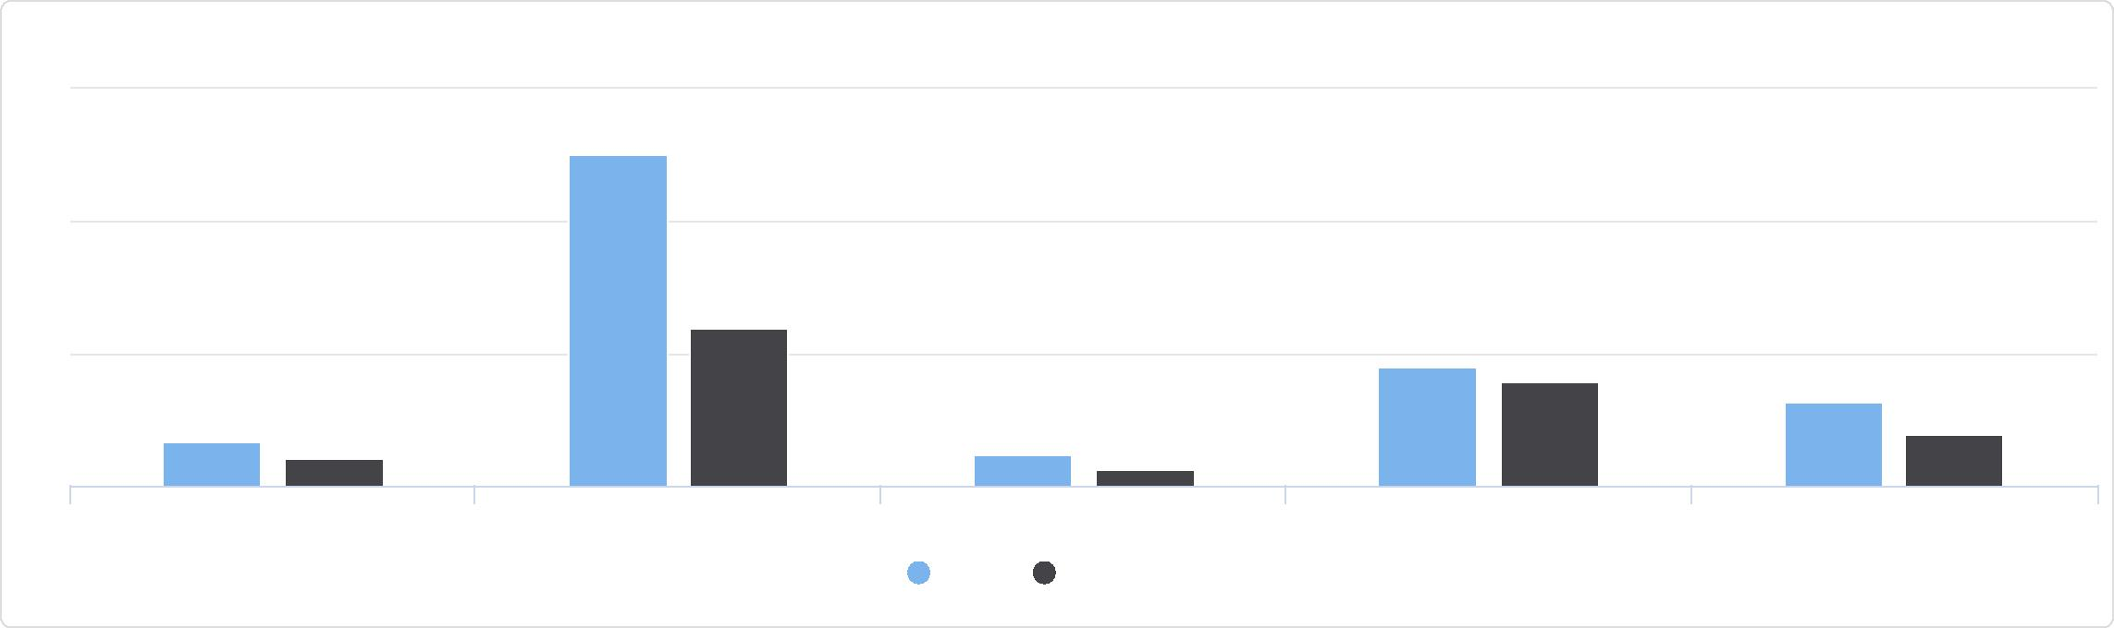

Chlamydia Incidence Rate by Race / Ethnicity

3k

Non-Hispanic White Non-Hispanic Black Asian American Indian or Alaska Native Hispanic or Latino

Iowa United States

2k

1k

0

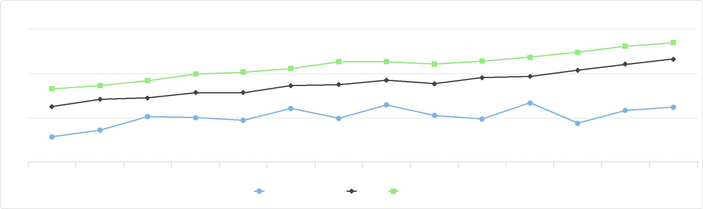

Chlamydia Incidence Rate by Year

600

400

200

0

2005 2006 2007 2008 2009 2010 2011 2012 2013 2014 2015 2016 2017 2018

Jackson County, IA Iowa United States

## STI ‐ Gonorrhea Incidence

This indicator reports the number gonorrhea cases occurring in the report area. Rates are presented per 100,000 population.

The number of cases are based on laboratory‐confirmed diagnoses that occurred between January 1st and December 31st of the latest reporting year. These data are delivered to and analyzed by the CDC as part of the Nationally notifiable STD surveillance system.

|  |  |  |  |
| --- | --- | --- | --- |
| **Report Area** | **Total Population** | **Gonorrhea Infections** | **Gonorrhea Infections,  Rate per 100,000 Pop.** |
| Jackson County, IA | 19,366 | 5 | **25.8** |
| Iowa | 3,145,711 | 4,839 | 153.8 |
| United States | 325,719,178 | 583,405 | 179.1 |

*Note: This indicator is compared to the state average.*

*Data Source: Centers for Disease Control and Prevention,* [*National Center for HIV/AIDS, Viral Hepatitis, STD, and TB Prevention*](http://www.cdc.gov/nchhstp/)*. 2018. Source geography: County*

Gonorrhea Infection Rate   
(Per 100,000 Pop.)

|  |  |
| --- | --- |
|  | |
| 0 700 | |
|  | Jackson County (25.8)  Iowa (153.8)  United States (179.1) |

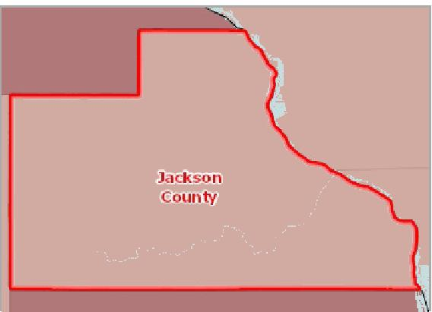

[](https://engagementnetwork.org/map-room/?ids=32567,t11&def=t11:FIPS%20In%20('19097')&bbox=-10120449.27515,5164829.551058,-10034264.57655,5219471.283242) View larger map

**Gonorrhea, Infection Rate per 100,000 Population by County, NCHHSTP 2018**

Over 120.0

60.01 ‐ 120.00

20.01 ‐ 60.00

0.1 ‐ 20.0

Data Suppressed ( <4 Cases )

Jackson County, IA



Gonorrhea Incidence Rate by Race / Ethnicity

The table below displays national, state, and local variation in the rate of diagnosed gonorrhea cases for the latest report year by population race and ethnicity.

|  |  |  |  |  |  |  |  |  |  |
| --- | --- | --- | --- | --- | --- | --- | --- | --- | --- |
| **Report Area** | **Non‐Hispanic White** | | **Non‐Hispanic Black** | | **Asian** | **American Indian or Alaska Native** | | **Hispanic or Latino** | |
| Jackson County, IA | No data |  | No data |  | No data | No data |  | No data |  |
| Iowa |  | 103.6 |  | 1,199.1 | 54.4 |  | 715.9 |  | 174.4 |
| United States |  | 71.1 |  | 548.9 | 35.1 |  | 329.5 |  | 115.9 |

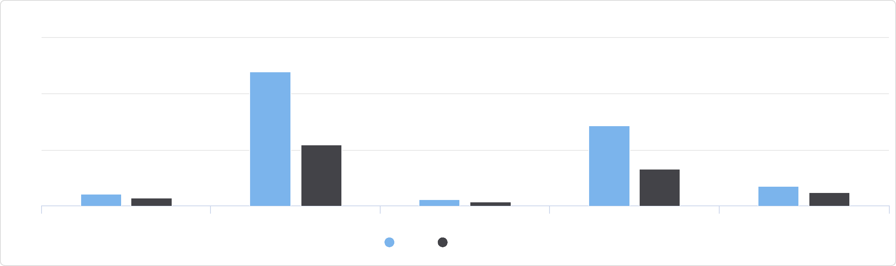

Gonorrhea Incidence Rate by Race / Ethnicity

1500

Non-Hispanic White Non-Hispanic Black Asian American Indian or Alaska Native Hispanic or Latino

Iowa United States

1000

500

0

Gonorrhea Incidence Rate by Year

The table below displays trends in the rate of diagnosed gonorrhea cases for years 2005 through 2018. Rates are expressed per 100,000 total population.

|  |  |  |  |  |  |  |  |  |  |  |  |  |  |  |
| --- | --- | --- | --- | --- | --- | --- | --- | --- | --- | --- | --- | --- | --- | --- |
| **Report Area** | **2005** | **2006** | **2007** | **2008** | **2009** | **2010** | **2011** | **2012** | **2013** | **2014** | **2015** | **2016** | **2017** | **2018** |
| Jackson County, IA | 14.8 | 4.9 | 15.0 | 10.0 | 0.0 | 5.0 | 5.1 | 10.1 | 15.3 | 25.5 | 5.1 | 36.0 | 25.8 | 25.8 |
| Iowa | 54.4 | 66.3 | 64.7 | 56.8 | 55.1 | 59.1 | 62.7 | 65.2 | 47.6 | 53.1 | 71.9 | 83.2 | 119.5 | 153.8 |
| United States | 114.9 | 120.1 | 118.1 | 110.7 | 98.2 | 100.0 | 103.3 | 106.7 | 105.3 | 110.7 | 123.0 | 145.8 | 170.6 | 179.1 |

Gonorrhea Incidence Rate by Year

## STI ‐ HIV Prevalence

This indicator reports the prevalence of HIV in the report area as a rate per 100,000 population over age 13. The data reflect persons living with diagnosed HIV infection at the end of the latest reporting year, or persons living with infection ever classified as stage 3 (AIDS) at the end of the latest report year.

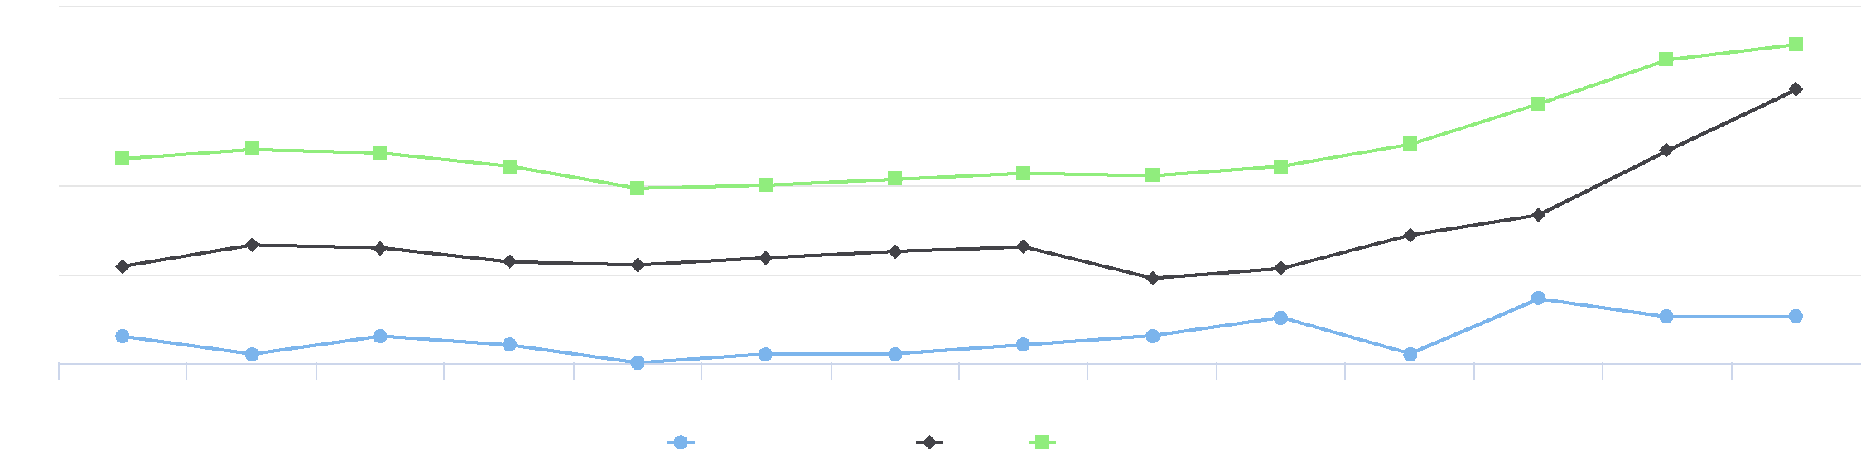

150

100

200

50

0

2005 2006 2007 2008 2009 2010 2011 2012 2013 2014 2015 2016 2017 2018

Jackson County, IA Iowa United States

Population with HIV / AIDS, Rate per 100,000 Pop.

|  |  |
| --- | --- |
|  | |
| 0 700 | |
|  | Jackson County (48.8)  Iowa (106.0)  United States (372.8) |

|  |  |  |  |
| --- | --- | --- | --- |
| **Report Area** | **Population Age 13+** | **Population with HIV / AIDS** | **Population with HIV / AIDS,  Rate per 100,000 Pop.** |
| Jackson County, IA | 16,405 | 8 | **48.8** |
| Iowa | 2,630,539 | 2,788 | 106.0 |
| United States | 274,605,948 | 1,023,832 | 372.8 |

*Note: This indicator is compared to the state average.*

*Data Source: Centers for Disease Control and Prevention,* [*National Center for HIV/AIDS, Viral Hepatitis, STD, and TB Prevention*](http://www.cdc.gov/nchhstp/)*. 2018. Source geography: County*

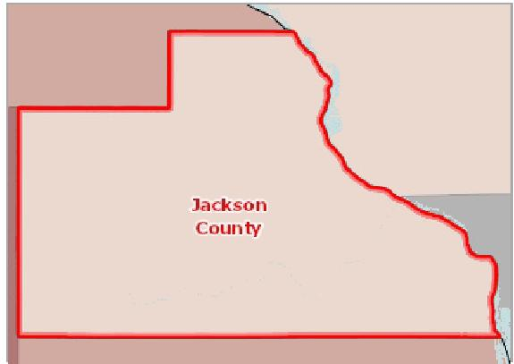

[](https://engagementnetwork.org/map-room/?ids=32569,t11&def=t11:FIPS%20In%20('19097')&bbox=-10120449.27515,5164829.551058,-10034264.57655,5219471.283242) View larger map

**HIV Prevalence, Rate (Per 100,000 Pop.) by County, NCHHSTP 2018**

Over 200.0

100.1 ‐ 200.0

50.1 ‐ 100.0

Under 50.1

Data Suppressed ( <4 Cases )

Jackson County, IA



HIV Prevalence Rate by Race / Ethnicity

The table below displays trends in the prevalence rate for HIV/AIDS for the latest report year by population race and ethnicity.

|  |  |  |  |  |  |  |  |
| --- | --- | --- | --- | --- | --- | --- | --- |
| **Report Area** | **Non‐Hispanic White** | **Non‐Hispanic Black** | | **Asian** | **American Indian or Alaska Native** | | **Hispanic or Latino** |
| Jackson County, IA | 44.4 | No data |  | No data | No data |  | 0.0 |
| Iowa | 72.7 |  | 692.7 | 85.6 |  | 78.9 | 203.0 |
| United States | 1,004.4 |  | 1,252.9 | 93.6 |  | 158.2 | 499.9 |

HIV Prevalence Rate by Year

The table below displays trends in the prevalence rate for HIV/AIDS for years 2009 through 2018. Rates are expressed per 100,000 population age 13 and older.

|  |  |  |  |  |  |  |  |  |  |  |
| --- | --- | --- | --- | --- | --- | --- | --- | --- | --- | --- |
| **Report Area** | **2009** | **2010** | **2011** | **2012** | **2013** | **2014** | **2015** | **2016** | **2017** | **2018** |
| Jackson County, IA | No data | Suppressed | No data | 30.1 | 30.5 | No data | 30.4 | 42.7 | 42.8 | 48.8 |
| Iowa | 64.4 | 71.5 | 76.0 | 79.4 | 81.7 | 90.7 | 93.5 | 97.7 | 102.0 | 106.0 |
| United States | 322.2 | 329.7 | 336.8 | 343.5 | 353.2 | 355.8 | 362.3 | 361.1 | 367.0 | 372.8 |

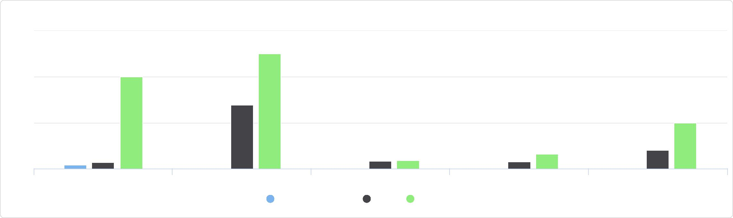

HIV Prevalence Rate by Race / Ethnicity

1500

Non-Hispanic White Non-Hispanic Black Asian American Indian or Alaska Native Hispanic or Latino

Jackson County, IA Iowa United States

1000

500

0

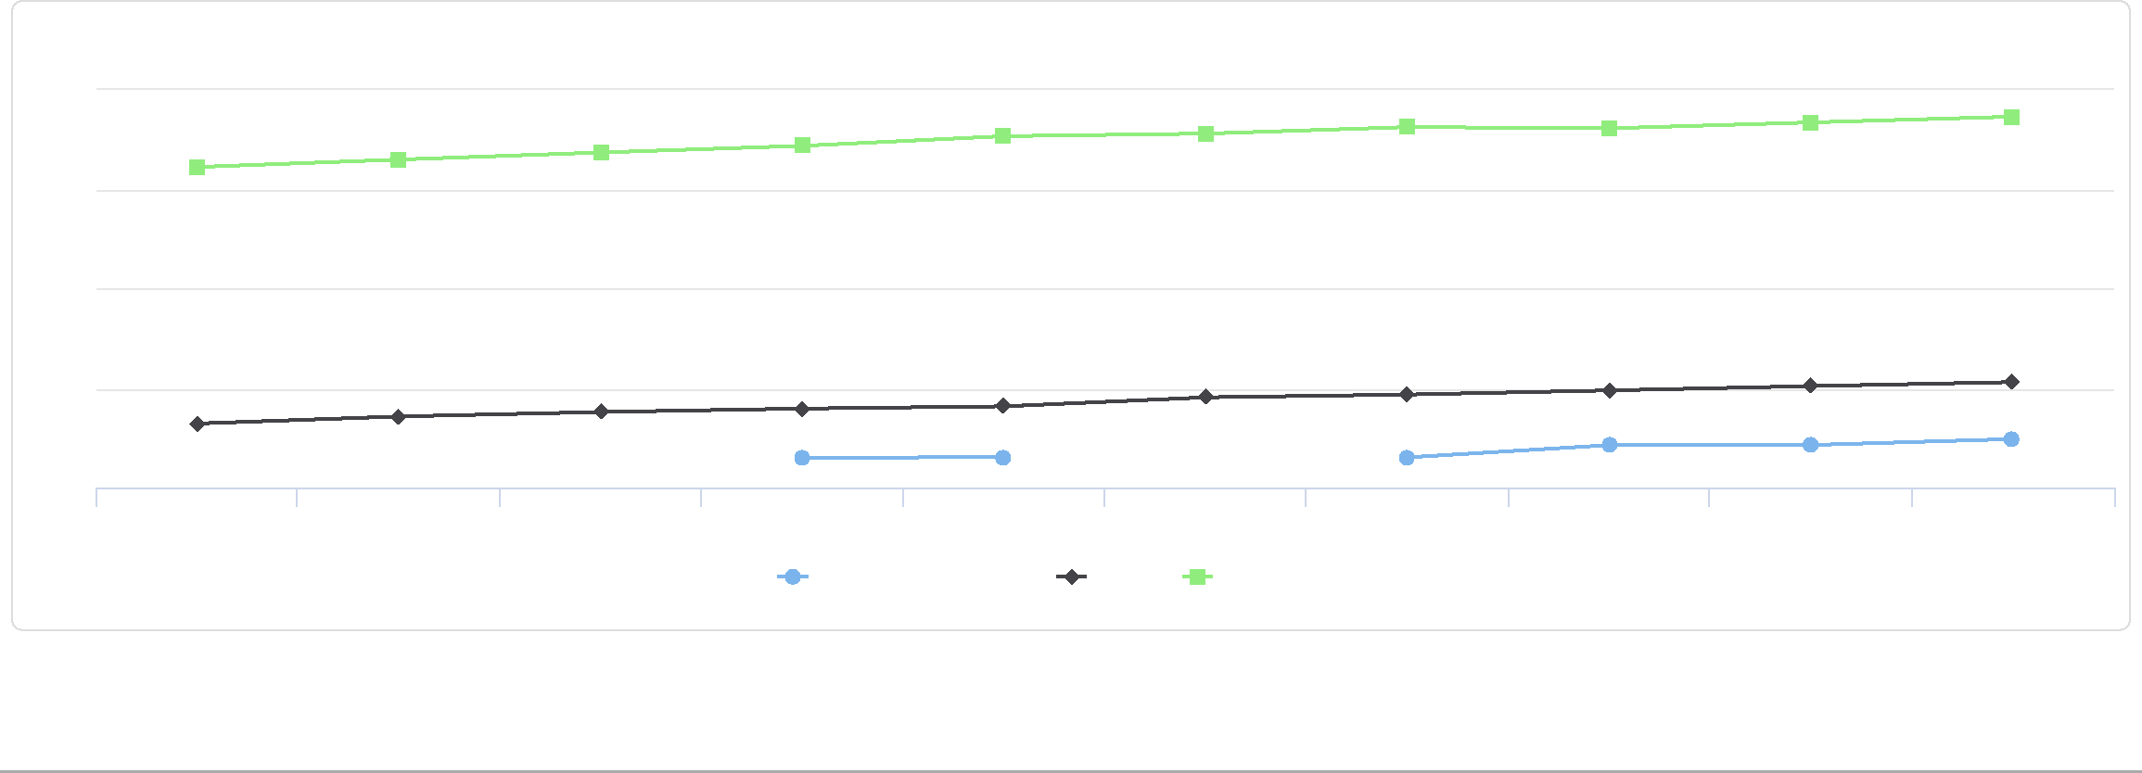

300

200

100

HIV Prevalence Rate by Year

2009 2010 2011 2012 2013 2014 2015 2016 2017 2018

Jackson County, IA Iowa United States

0

400

# Sources

Please see [Health Indicators Report footnotes](http://legacyassessment.communitycommons.org/CHNA/footnotes?reporttype=libraryCHNA&areatype=county&areaid=19097) (<http://legacyassessment.communitycommons.org/CHNA/footnotes?reporttype=libraryCHNA&areatype=county&areaid=19097>) for information about the data background, analysis methodologies and other related notes.

Report prepared by [Community Commons](http://www.communitycommons.org), (<https://www.communitycommons.org/>) January 18, 2021.